RDB Catch and Effort Overview North Sea and Eastern Arctic, 2020 

2022-02-06

Table of Contents

1 Introduction 3

1.1 Reading the graphs 4

1.1.1 Barplots 4

1.1.2 Maps 5

2 Overall fleet evolution (All RCGs) 5

2.1 Number of vessels 5

2.2 Power 5

2.3 Gross tonnage 6

3 Landings (CL) 7

3.1 Overall landings 7

3.1.1 Landings by species 7

3.1.2 Landings by catch_group 9

3.1.3 Landings by fleet 10

3.1.4 Landings by area 11

3.1.5 Landings by metier 13

3.1.6 Landings by harbour 17

3.1.7 Landings abroad 21

3.1.8 Spatial distribution of landings 22

3.2 Small pelagic landings 23

3.2.1 Landings by country, small pelagic 23

3.2.2 Landings by species, small pelagic 24

3.2.3 Landings by fleet, small pelagic 26

3.2.4 Landings by area, small pelagic 28

3.2.5 Landings by metier, small pelagic 32

3.2.6 Landings by harbour, small pelagic 36

3.2.7 Landings abroad, small pelagic 40

3.2.8 Spatial distribution of landings, small pelagic 41

3.3 Demersal landings (without flatfish) 42

3.3.1 Landings by country, demersal (without flatfish) 42

3.3.2 Landings by species, demersal (without flatfish) 43

3.3.3 Landings by fleet, demersal (without flatfish) 45

3.3.4 Landings by area, demersal (without flatfish) 47

3.3.5 Landings by metier, demersal (without flatfish) 51

3.3.6 Landings by harbour, demersal (without flatfish) 55

3.3.7 Landings abroad, demersal (without flatfish) 59

3.3.8 Spatial distribution of landings, demersal 60

3.4 Flatfish landings 61

3.4.1 Landings by country, flatfish 61

3.4.2 Landings by species, flatfish 62

3.4.3 Landings by fleet, flatfish 64

3.4.4 Landings by area, flatfish 66

3.4.5 Landings by metier, flatfish 70

3.4.6 Landings by harbour, flatfish 74

3.4.7 Landings abroad, flatfish 78

3.4.8 Spatial distribution of landings, flatfish 79

4 Effort (CE) 80

4.1 Effort by country 80

4.1.1 Overall 80

4.2 Effort by fleet 83

4.2.1 Overall 83

4.3 Effort by area 85

4.3.1 Below 10 meters 85

4.3.2 10 meter and above 87

4.4 Effort by metier 89

4.4.1 Below 10 meters 89

4.4.2 10 meter and above 92

4.5 Effort by harbour 95

4.5.1 Below 10 meters 95

4.5.2 10 meter and above 98

4.6 Spatial distribution of effort 101

4.6.1 Below 10 meters 101

4.6.2 10 meter and above 102

Appendix A. Dates of data extraction 103

Appendix B. Catch groups 103

Appendix C. Mean Landings per stock, 2018-2020 110

**Disclaimer**

Tables, plots and graphs presented in this document and overviews are made for the coordination purposes of regional fisheries data collection and are not designed for any other use. Data used for the outputs are extracted from the Regional Database (RDB) and EU Fleet Register. Dates of data extractions are stated in Appendix A. Due to different aggregations and reporting authorities, data can differ to those e.g. used for assessments or technical reports. Member States (MS) are responsible for uploading latest data and the latest year should be viewed as provisional. Data can be resubmitted by a MS for more than one previous year so there might be differences in earlier year reports if countries update back in time. Responsibility for the quality of the data and comparability to other data sources lies with the MS that provided these data.

The respective scripts and calculations used for data displaying are publicly available via the RCG github (<https://github.com/ices-eg/RCGs>) and subject to change as the work of the group progresses.

# Introduction

The present Catch and Effort Overview displays summary information on the commercial landings (CL) and commercial effort (CE) statistics included in the Regional Data Base (RDB), which is used to store detailed commercial fisheries and sampling data.

Before the subgroup on Catch, effort and sampling overviews was set up, the different RCGs conducted data analysis and overviews separately with minimal exchange, resulting in redundancies and efficiency loss. Furthermore, a substantial part of the work was being carried out during the RCG meetings themselves and so not readily available to inform RCG preparation and meeting discussions. This group was established to streamline and facilitate the work on the fisheries and sampling data of the MS and prepare data overviews in advance of the RCG meetings.

The RDB is hosted at the International Council for Exploration of the Sea (ICES) and its data is property of EU Member States with usage governed by the RDB data policy (<https://www.ices.dk/data/Documents/Data_Policy_RDB.pdf>). It’s a regionally coordinated database platform covering fisheries in the North Atlantic Ocean, the North Sea and the Baltic Sea and is a main resource used by the Regional Coordination Groups to coordinate data collection of EU fisheries. This database aims also: 1) To ensure that data can be made available for the coordination of regional fisheries data sampling plans, in particular for the DCF Regional Coordination Groups (RCGs); 2) To provide a regional estimation system such that statistical estimates of quantities of interest can be produced from sample data, in order to deliver data for ICES stock assessments and advice, 3) To serve and facilitate the production of fisheries management advice and status reports, 4) To increase the awareness of fisheries data collected by the users of the RDB and the overall usage of these data. 5) Addresses fishery management needs related to the European Union Common Fisheries

However, it has been recognised for many years that there is a need to have a new version of the RDB which would also store details about how the sampling was performed and enable statistical estimations to be made.

In fact, the current Regional Data Base stores the commercial catch and sample data at detailed level, and here the data format and estimations does not support statistical estimations, even though most of the countries’ sampling are not done in a statistical way the countries never used the RDB for raising/estimating their data. The countries have raised/estimated the data nationally at the institutes and uploaded the data to InterCatch for the stock assessment Expert Groups. That means the stock assessment EG have no information of how the data have been raised/estimated until the data are uploaded into InterCatch, from that point and through the international raising the data and processes are fully documented. InterCatch does neither support statistical estimations. It has therefore been requested to write specifications for a new version of the RDB, which have been given the name ‘Regional DataBase and Estimation System’, RDBES, to make it more obvious that the major part of the RDB is the estimation part.

## Reading the graphs

### Barplots

In (bar)plots, subtitles indicate if all RDB data could be used and are displayed. Some data can not be displayed in the plots, e.g. due to missing or incorrect values or due to missing referring data (e.g. if no statistical rectangle is given or harbor names are missing, landings in the respective plots can’t be displayed). The factor x:% in subtitle indicates the percentage of RDB data that are displayed in the x-variable. y:% in subtitle indicates the percentage of RDB data in the respective y-variable. z:% in subtitle indicate the percentage of complete (i.e., non-missing) RDB rows in variable.

### Maps

The maps are generated based on complete and available data from the RDB. The subtitles of the header state the subselection that is displayed (e.g. “all Data”, “pelagics”, etc.). if data cannot be shown on a map (e.g. due to missing information on the area or harbor code), the missing values is given in the figure text below.

# Overall fleet evolution (All RCGs)

## Number of vessels

Number of vessels by flag country and length class in the EU vessel register (licence indicator == “Y” in 1st January 2020. Parentesis: variation relative to 2019; red = number decreases; green = number increases; white = number maintains).

| **name_row** | **BEL** | **DEU** | **DNK** | **ESP** | **EST** | **FIN** | **FRA** | **GBR** | **IRL** | **LTU** | **LVA** | **NLD** | **POL** | **PRT** | **SWE** |
| --- | --- | --- | --- | --- | --- | --- | --- | --- | --- | --- | --- | --- | --- | --- | --- |
| [0-8[ | 0 (=) | 811 (-15) | 1301 (-23) | 4673 (-52) | 1255 (-59) | 2419 (-19) | 2943 (-144) | 2966 (-24) | 1106 (-16) | 70 (=) | 153 (+9) | 212 (-5) | 331 (+2) | 2398 (+115) | 529 (-39) |
| [8-10[ | 0 (=) | 142 (-6) | 314 (-17) | 1204 (-8) | 219 (-20) | 517 (-13) | 1451 (-7) | 1430 (+3) | 373 (+1) | 4 (=) | 24 (-2) | 94 (+3) | 201 (-3) | 497 (+24) | 236 (-24) |
| [10-12[ | 1 (=) | 72 (=) | 98 (-2) | 627 (-3) | 61 (-7) | 144 (-3) | 904 (-2) | 384 (-8) | 232 (-1) | 9 (=) | 4 (-1) | 37 (=) | 132 (=) | 231 (=) | 170 (-19) |
| [12-18[ | 4 (=) | 133 (-5) | 217 (+1) | 1035 (-15) | 8 (-3) | 25 (-2) | 421 (-1) | 435 (-11) | 86 (-3) | 1 (=) | 8 (-2) | 46 (=) | 53 (-3) | 276 (+11) | 80 (+1) |
| [18-24[ | 29 (=) | 85 (=) | 64 (+3) | 648 (-3) | 6 (=) | 7 (=) | 256 (-12) | 212 (-5) | 80 (=) | 4 (=) | 3 (=) | 195 (+2) | 60 (+3) | 119 (+5) | 39 (-1) |
| [24-40[ | 34 (=) | 31 (-1) | 38 (-1) | 589 (-13) | 18 (-1) | 7 (=) | 154 (+2) | 173 (-4) | 87 (+5) | 23 (-2) | 40 (-2) | 151 (+1) | 46 (=) | 114 (+3) | 20 (-2) |
| [40+[ | 0 (=) | 16 (-1) | 28 (-5) | 106 (+3) | 4 (-1) | 1 (=) | 40 (-3) | 43 (-2) | 26 (+1) | 8 (-3) | 0 (-5) | 98 (+1) | 3 (=) | 16 (+3) | 6 (-2) |
| **Total** | **68 (=)** | **1290 (-28)** | **2060 (-44)** | **8882 (-91)** | **1571 (-91)** | **3120 (-37)** | **6169 (-167)** | **5643 (-51)** | **1990 (-13)** | **119 (-5)** | **232 (-3)** | **833 (+2)** | **826 (-1)** | **3651 (+161)** | **1080 (-86)** |

## Power

Power (1000*kW) by flag country and length class in the EU vessel register (licence indicator == “Y” in 1st January 2020. Parentesis: variation relative to 2019).

| **name_row** | **BEL** | **DEU** | **DNK** | **ESP** | **EST** | **FIN** | **FRA** | **GBR** | **IRL** | **LTU** | **LVA** | **NLD** | **POL** | **PRT** | **SWE** |
| --- | --- | --- | --- | --- | --- | --- | --- | --- | --- | --- | --- | --- | --- | --- | --- |
| [0-8[ | 0 (=) | 13.1 (-0.1) | 27.3 (-0.1) | 80.2 (-0.4) | 11.8 (-0.6) | 72.4 (+0.3) | 216.8 (-8.5) | 97.3 (-1.3) | 15.6 (-0.2) | 1.5 (=) | 0.4 (=) | 9.9 (-0.5) | 5.9 (+0.1) | 69 (+5.1) | 18 (-0.4) |
| [8-10[ | 0 (=) | 7.7 (-0.1) | 20.8 (-1) | 40.2 (-0.4) | 5.3 (-0.4) | 44 (-0.7) | 204.3 (+2.4) | 154.7 (+1.2) | 20.6 (-0.2) | 0.1 (=) | 0.7 (-0.1) | 11.9 (+0.6) | 8.6 (-0.1) | 24.3 (+1.3) | 22.9 (-1.7) |
| [10-12[ | 0.2 (=) | 6.3 (-0.1) | 10.4 (-0.1) | 32.6 (-0.2) | 3.1 (-0.4) | 23.3 (+0.1) | 137.9 (+1.8) | 54.1 (-1) | 18.5 (-0.1) | 0.5 (=) | 0.2 (=) | 5.2 (-0.2) | 8.8 (=) | 18.3 (+0.1) | 27.5 (-2.2) |
| [12-18[ | 0.8 (=) | 25.5 (-1) | 38.4 (+0.6) | 88.5 (-1.8) | 0.8 (-0.2) | 5.4 (-1.2) | 101.2 (+1) | 90.1 (-1.1) | 11.7 (-0.2) | 0.1 (=) | 1.5 (-0.3) | 6.9 (+0.2) | 6.8 (-0.4) | 34.6 (+1.2) | 19 (+0.4) |
| [18-24[ | 6.4 (=) | 18.7 (=) | 18.6 (+1.5) | 122.1 (-0.7) | 1.9 (=) | 2.9 (=) | 98.6 (-4.7) | 80.3 (-0.2) | 30.5 (+0.2) | 0.8 (=) | 0.7 (=) | 40.7 (+0.3) | 13.6 (+0.4) | 31.6 (+1.2) | 15.8 (=) |
| [24-40[ | 35.4 (+0.1) | 14.9 (-1.1) | 25.5 (+0.1) | 226.6 (-4.2) | 6.1 (-0.2) | 5 (=) | 85.2 (+1.4) | 107.7 (+1.1) | 44.1 (+1.7) | 6.3 (-0.5) | 13.9 (-0.6) | 78 (+0.9) | 18.5 (=) | 53.1 (+3.2) | 13.6 (-2.3) |
| [40+[ | 0 (=) | 37.6 (-0.1) | 61.2 (-12.3) | 187.1 (+6.5) | 10.7 (-4.7) | 1 (=) | 105.8 (-8.1) | 157.4 (+9.2) | 49.3 (+0.7) | 32.3 (-1) | 0 (-14.2) | 149 (-3.8) | 18.1 (=) | 29.3 (+7.8) | 15.7 (-6.3) |
| **Total** | **42.8 (+0.1)** | **123.9 (-2.4)** | **202.3 (-11.3)** | **777.3 (-1.2)** | **39.8 (-6.4)** | **154 (-1.4)** | **949.8 (-14.7)** | **741.6 (+7.9)** | **190.3 (+1.8)** | **41.7 (-1.5)** | **17.4 (-15.2)** | **301.6 (-2.5)** | **80.2 (-0.1)** | **260.3 (+19.8)** | **132.5 (-12.5)** |

## Gross tonnage

Gross Tonnage(1000*GT) by flag country and length class in the EU vessel register (licence indicator == “Y” in 1st January 2020. Parentesis: variation relative to 2019).

| **name_row** | **BEL** | **DEU** | **DNK** | **ESP** | **EST** | **FIN** | **FRA** | **GBR** | **IRL** | **LTU** | **LVA** | **NLD** | **POL** | **PRT** | **SWE** |
| --- | --- | --- | --- | --- | --- | --- | --- | --- | --- | --- | --- | --- | --- | --- | --- |
| [0-8[ | 0 (=) | 1.1 (=) | 1.9 (=) | 6.2 (-0.1) | 0.9 (=) | 3.1 (=) | 5.5 (-0.3) | 6.7 (+1.6) | 1.6 (=) | 0.1 (=) | 0.1 (=) | 0.3 (=) | 0.6 (=) | 3.6 (+0.2) | 0.7 (-0.1) |
| [8-10[ | 0 (=) | 0.7 (=) | 1.9 (-0.1) | 4.4 (=) | 0.7 (-0.1) | 2.6 (=) | 6.9 (=) | 10.2 (+0.1) | 2.1 (=) | 0 (=) | 0.1 (=) | 0.3 (=) | 0.9 (=) | 2.2 (+0.1) | 1.3 (-0.1) |
| [10-12[ | 0 (=) | 0.8 (=) | 1.2 (=) | 4.3 (=) | 0.4 (=) | 1.5 (=) | 10.9 (+0.1) | 6.1 (+0.5) | 2.5 (=) | 0.1 (=) | 0 (=) | 0.3 (=) | 1.4 (=) | 2.2 (=) | 2 (-0.2) |
| [12-18[ | 0.1 (=) | 4.2 (-0.2) | 8.3 (+0.1) | 19.6 (-0.3) | 0.1 (=) | 0.7 (-0.1) | 19.4 (+0.5) | 18.7 (-0.3) | 2.9 (-0.1) | 0 (=) | 0.2 (-0.1) | 1 (=) | 1.6 (-0.1) | 6.1 (+0.2) | 2.9 (=) |
| [18-24[ | 2.5 (=) | 6 (=) | 7.2 (+0.7) | 39.3 (-0.1) | 0.7 (=) | 0.6 (=) | 30.3 (-1.1) | 29.9 (=) | 11.3 (+0.1) | 0.4 (=) | 0.2 (=) | 13.2 (+0.2) | 3.5 (+0.1) | 8.3 (+0.5) | 4.6 (-0.1) |
| [24-40[ | 10.3 (=) | 7.3 (+0.3) | 11.7 (+0.1) | 114 (-2.8) | 2.5 (-0.1) | 1.7 (=) | 34 (+0.8) | 45.3 (+1) | 18.5 (+0.9) | 3.1 (-0.2) | 5.5 (-0.2) | 26.7 (+1.1) | 7.4 (=) | 21.8 (+1.1) | 4.8 (-0.6) |
| [40+[ | 0 (=) | 34.6 (-0.5) | 35.9 (-6.7) | 144.9 (+4.4) | 7.1 (-2.8) | 0.4 (=) | 65 (-5.1) | 79.8 (+5.3) | 26.4 (+0.5) | 32.4 (-0.7) | 0 (-11.5) | 74.2 (-5.8) | 16.9 (=) | 25.2 (+6.2) | 6.2 (-1.9) |
| **Total** | **12.9 (=)** | **54.8 (-0.4)** | **68 (-6)** | **332.6 (+1)** | **12.4 (-3.1)** | **10.6 (-0.1)** | **171.9 (-5)** | **196.7 (+8.2)** | **65.3 (+1.4)** | **36.2 (-1)** | **6.2 (-11.7)** | **116 (-4.5)** | **32.3 (=)** | **69.5 (+8.4)** | **22.6 (-3)** |

###### Page break

# Landings (CL)

## Overall landings

### Landings by species

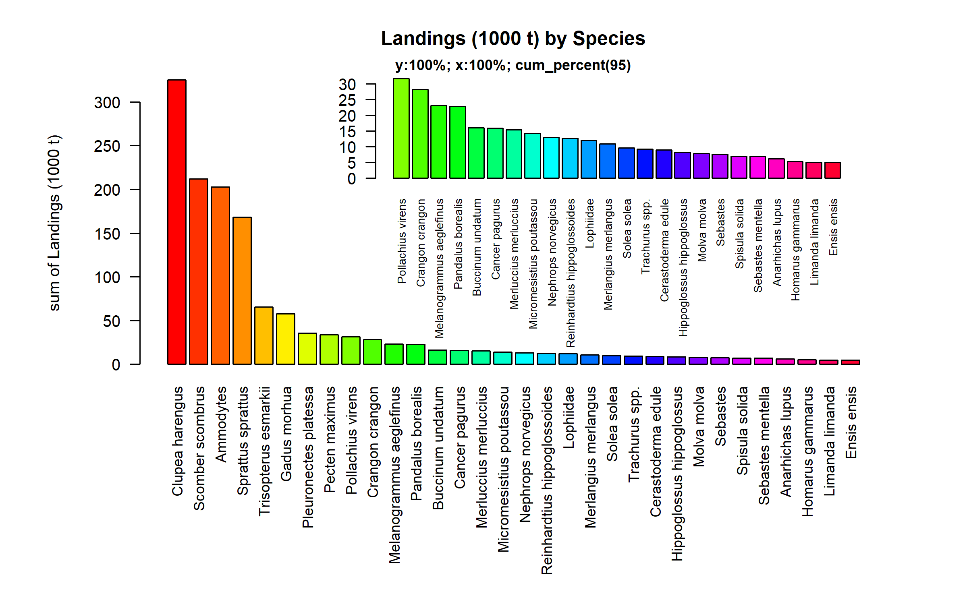 Figure 3.1.1.1. Landings (1000 t) by Species. Species displayed comprise 95% of the total Landings (1000 t).

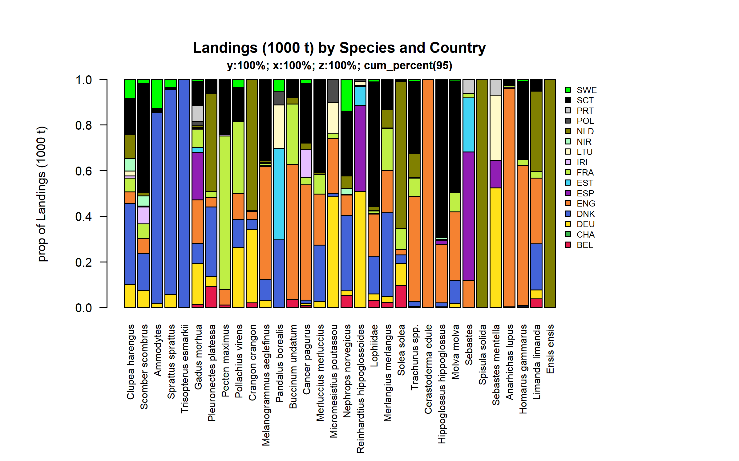 Figure 3.1.1.2. Landings (1000 t) by Species and Country . Species and Country displayed comprise 95 % of the total Landings (1000 t) .

### Landings by catch_group

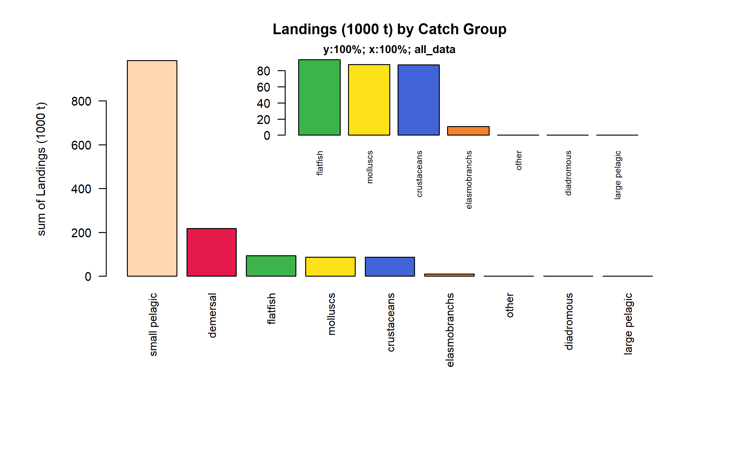 Figure 3.1.2.1. Landings (1000 t) by Catch Group.

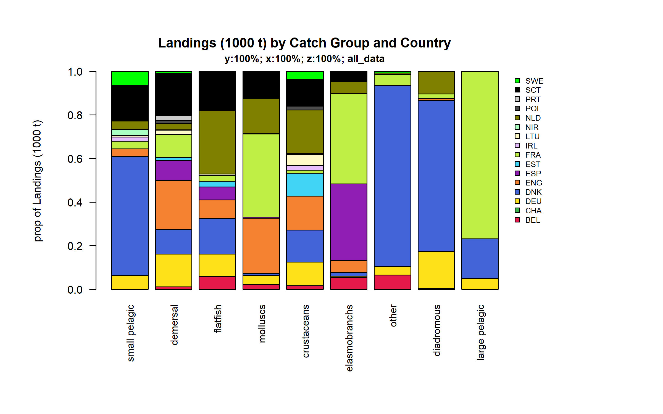 Figure 3.1.2.2. Landings (1000 t) by Catch Group and Country.

### Landings by fleet

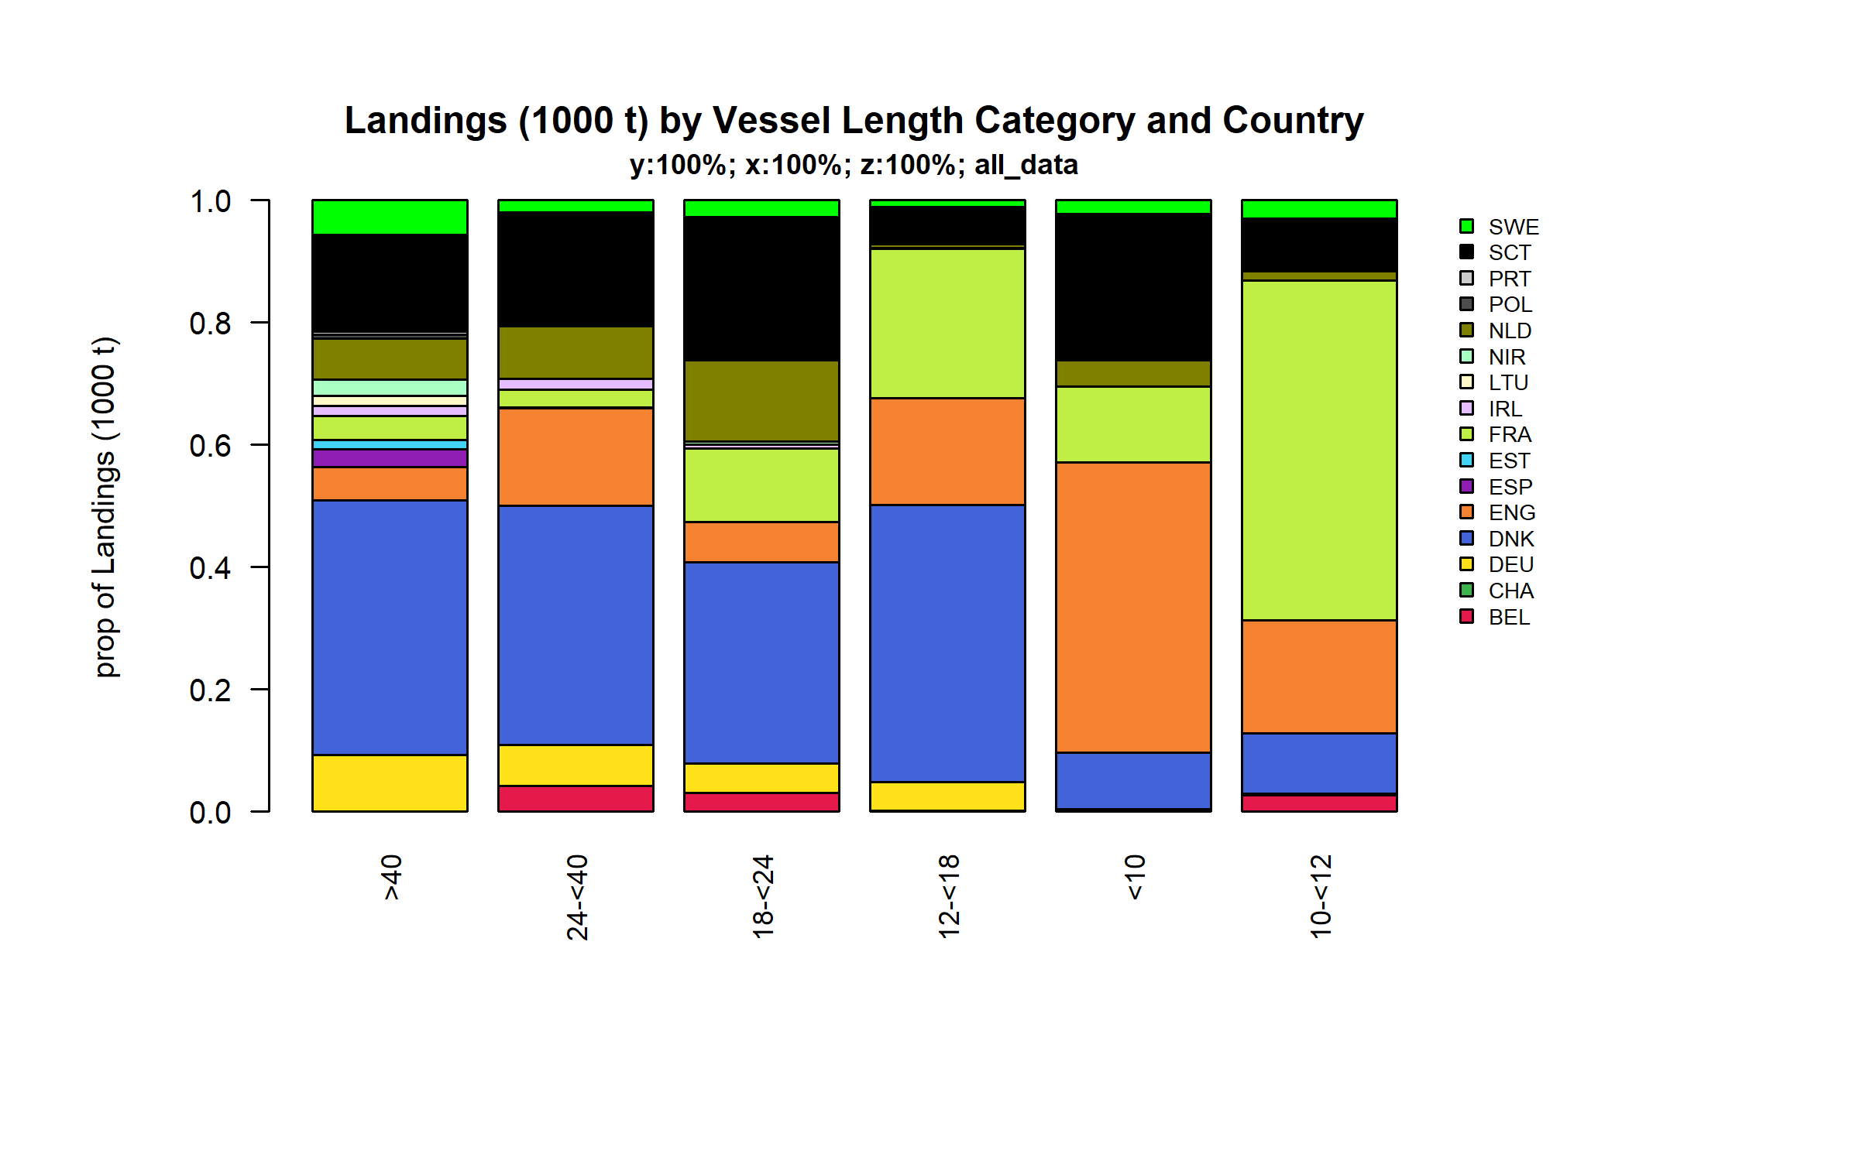 Figure 3.1.3.1. Landings (1000 t) by Vessel Length Category and Country.

### Landings by area

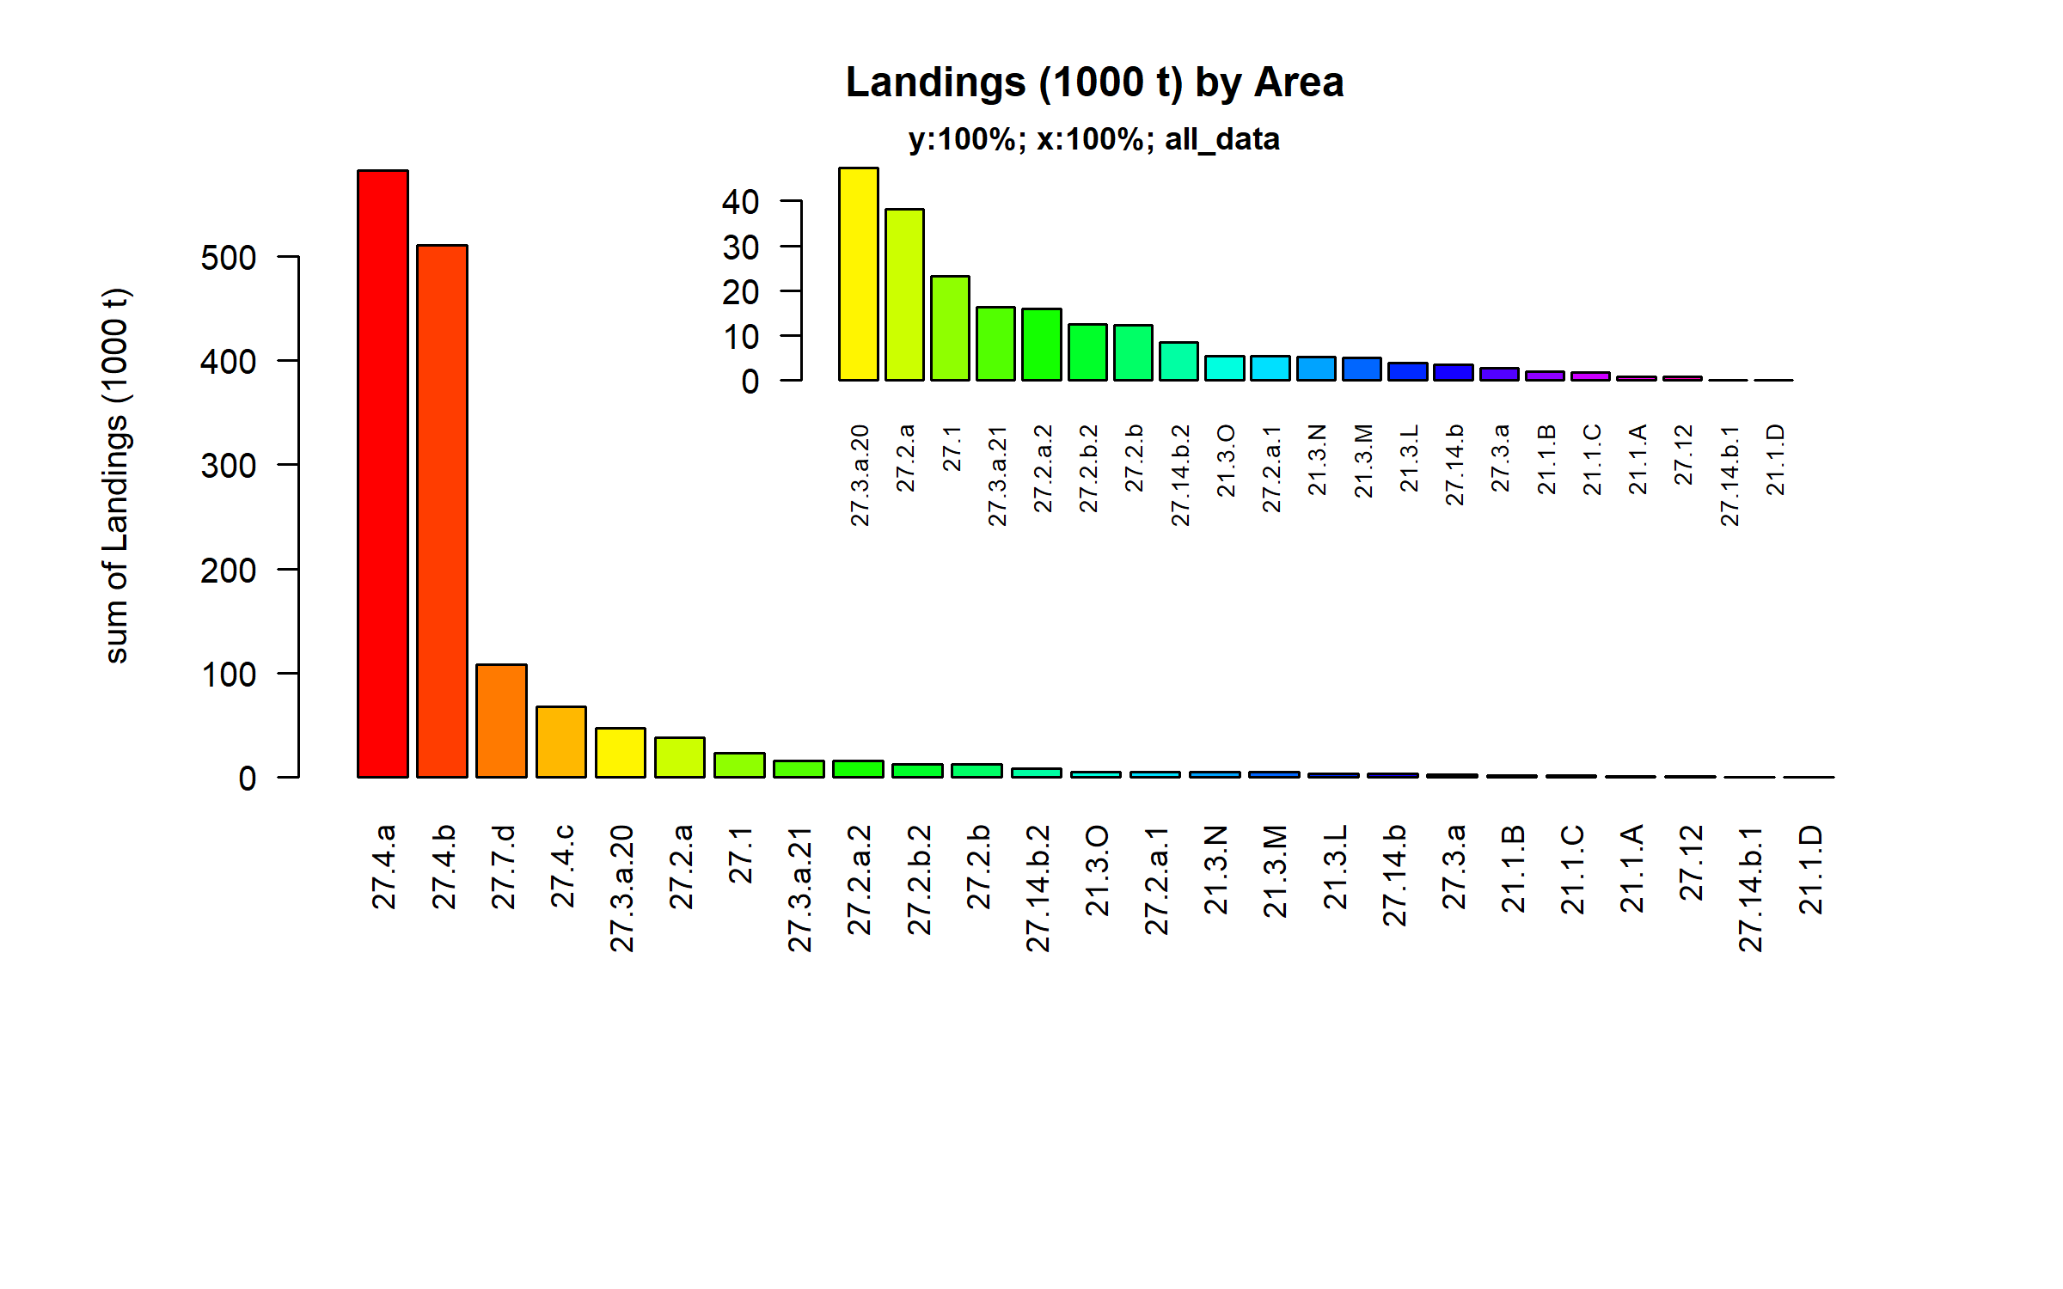 Figure 3.1.4.1. Landings (1000 t) by Area.

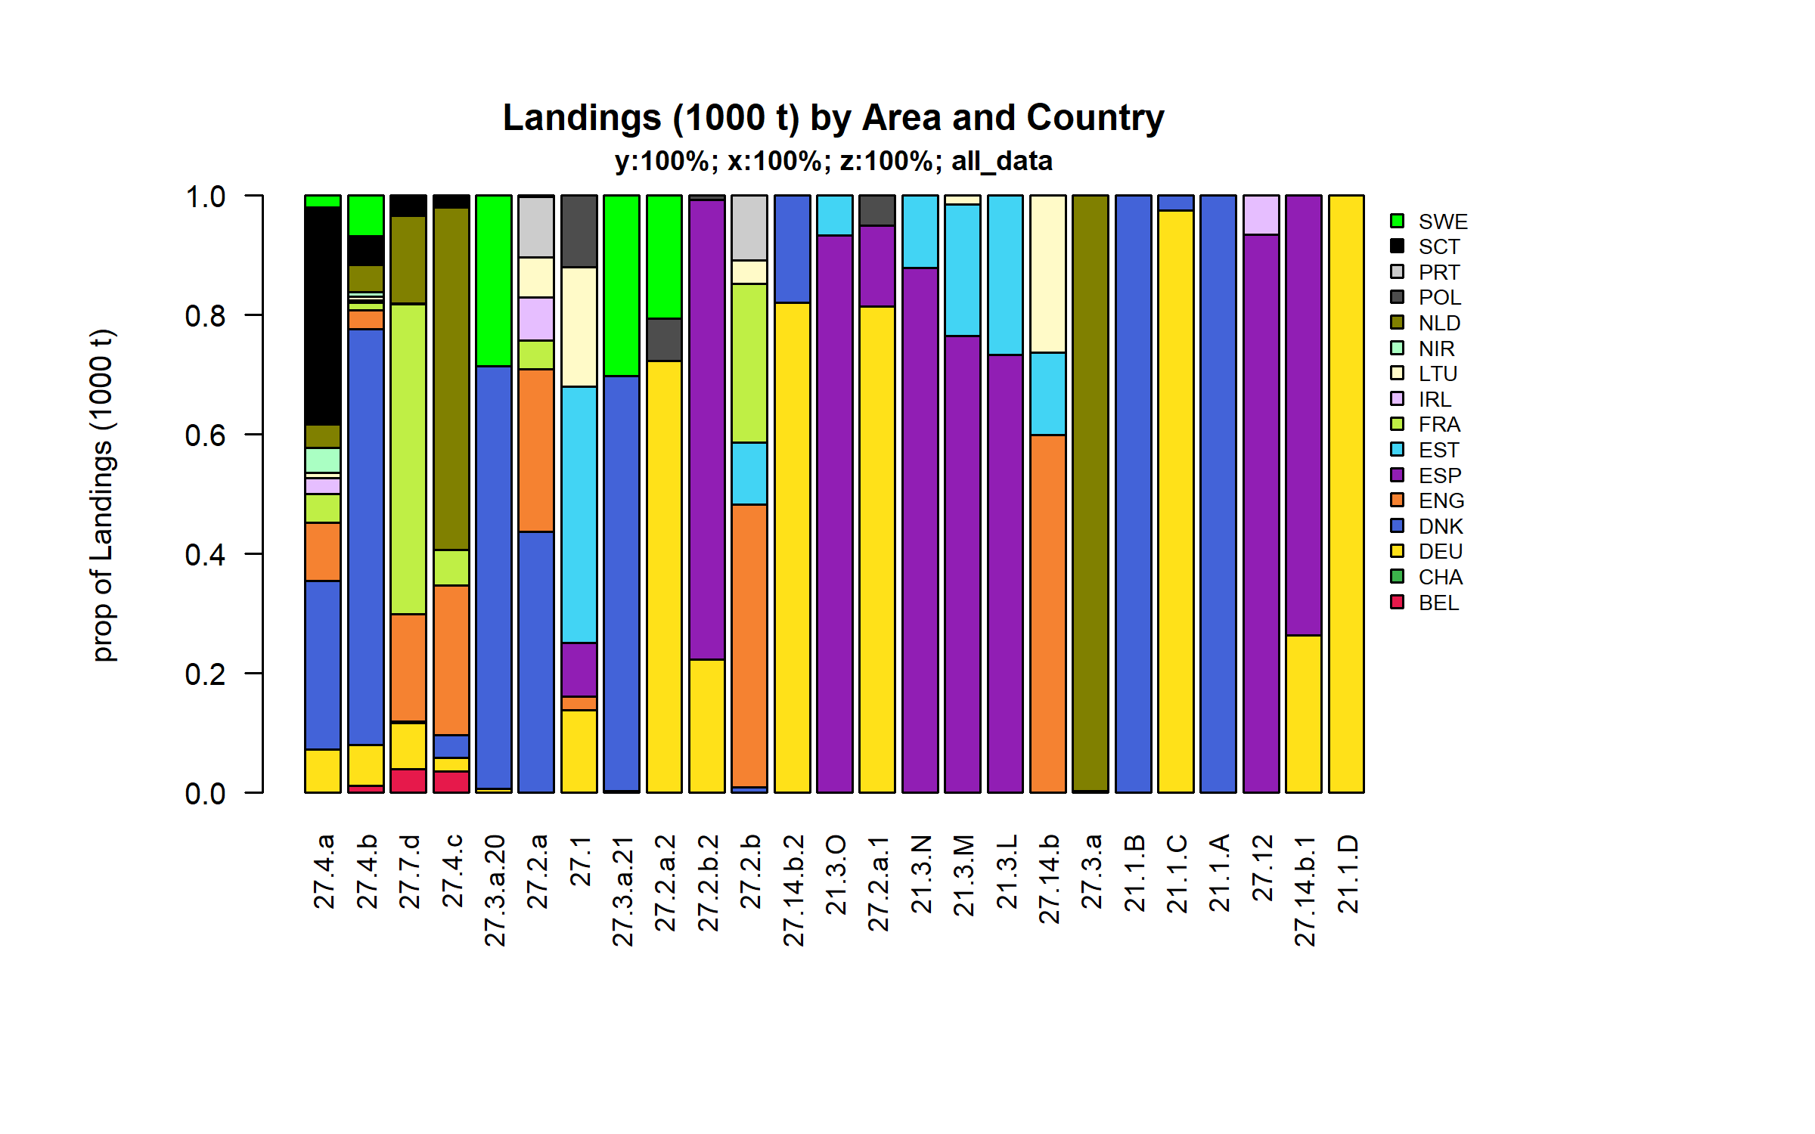 Figure 3.1.4.2. Landings (1000 t) by Area and Country.

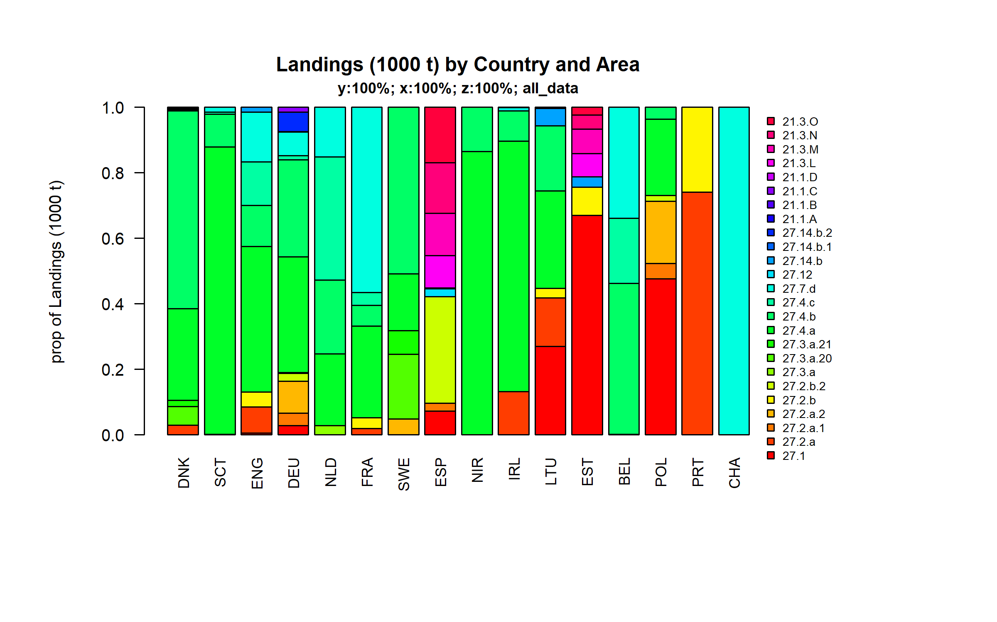 Figure 3.1.4.3. Landings (1000 t) by Country and Area.

### Landings by metier

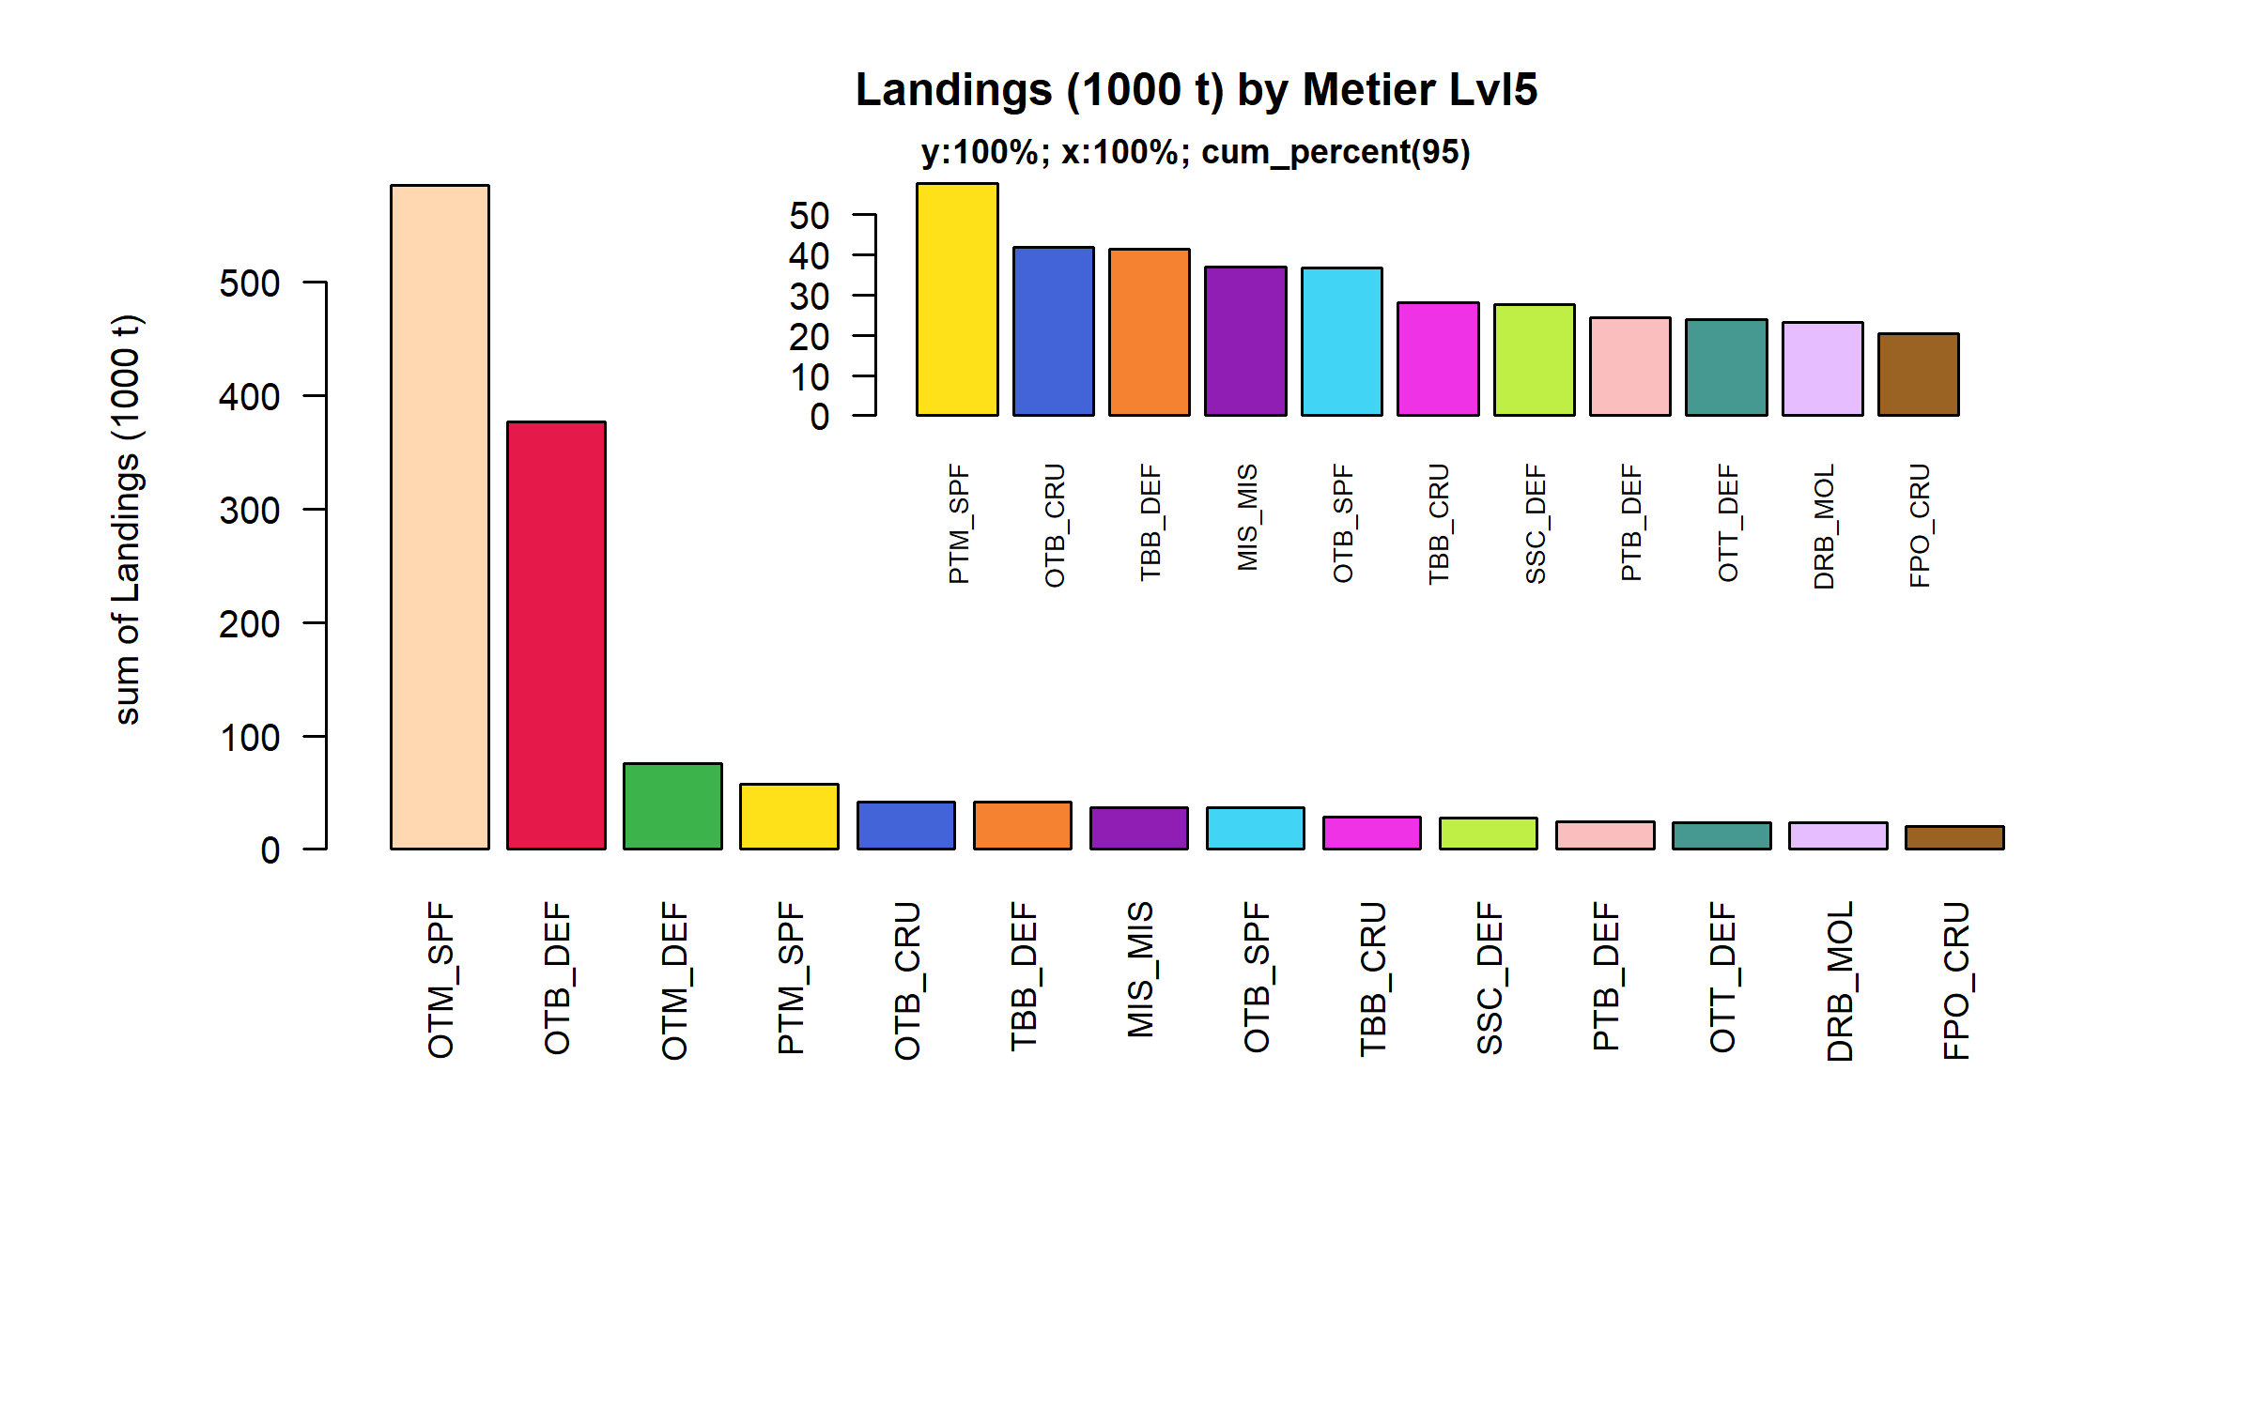 Figure 3.1.5.1. Landings (1000 t) by Metier Lvl5. Metier Lvl5 displayed comprise 95% of the total Landings (1000 t).

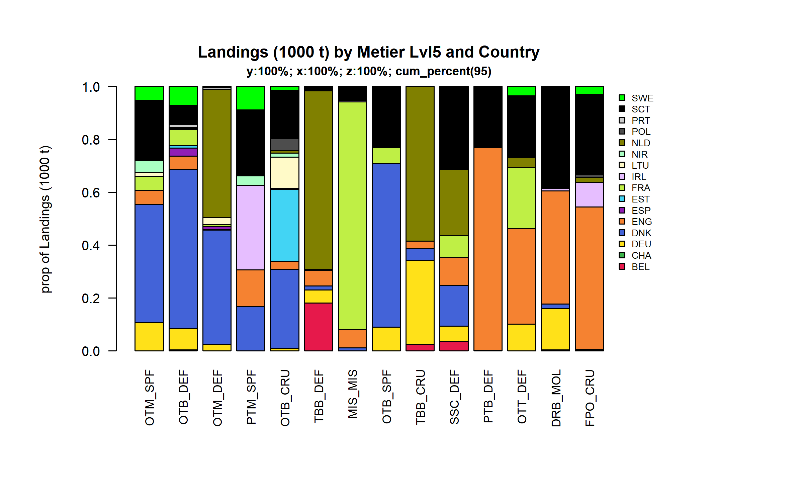 Figure 3.1.5.2. Landings (1000 t) by Metier Lvl5 and Country . Metier Lvl5 and Country displayed comprise 95 % of the total Landings (1000 t) .

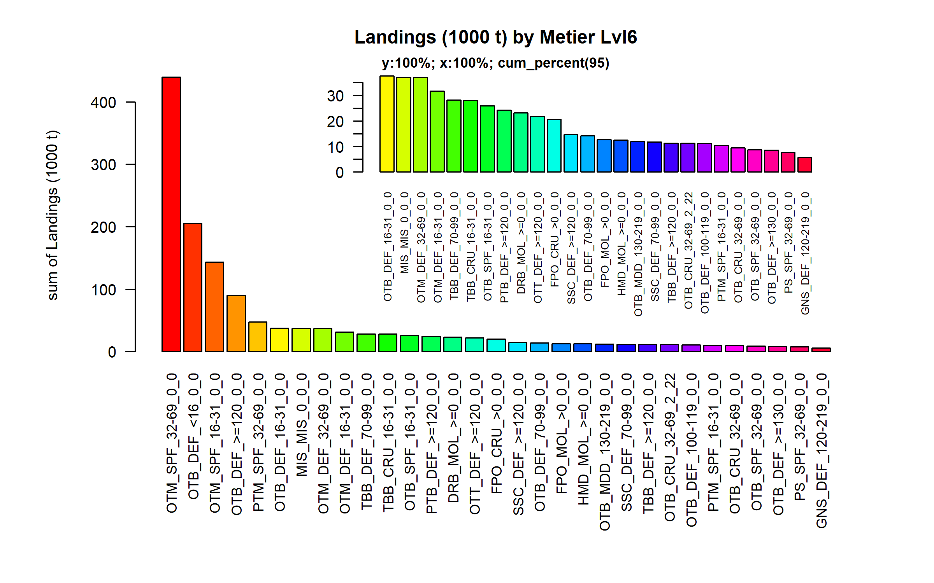 Figure 3.1.5.3. Landings (1000 t) by Metier Lvl6. Metier Lvl6 displayed comprise 95% of the total Landings (1000 t).

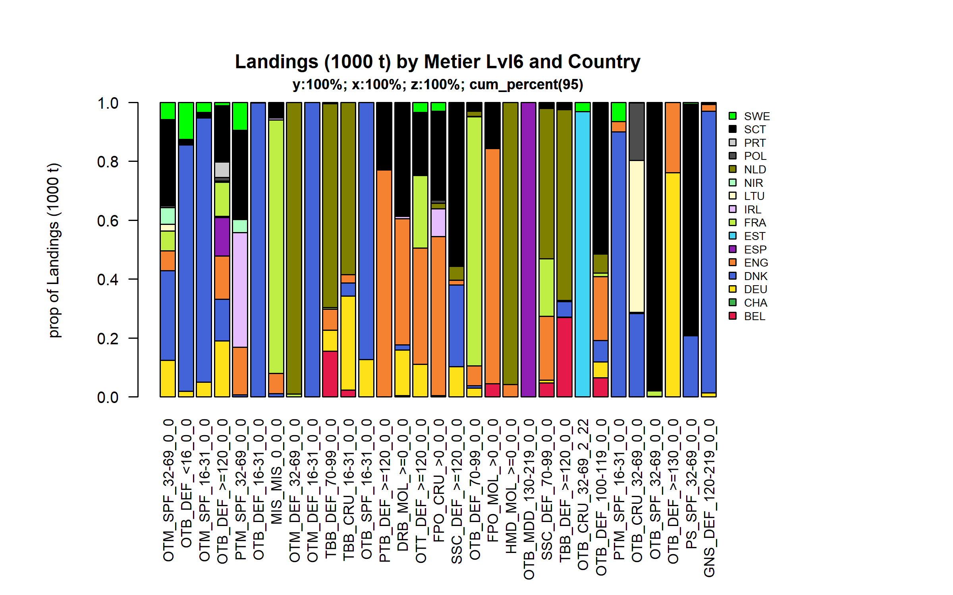 Figure 3.1.5.4. Landings (1000 t) by Metier Lvl6 and Country . Metier Lvl6 and Country displayed comprise 95 % of the total Landings (1000 t) .

### Landings by harbour

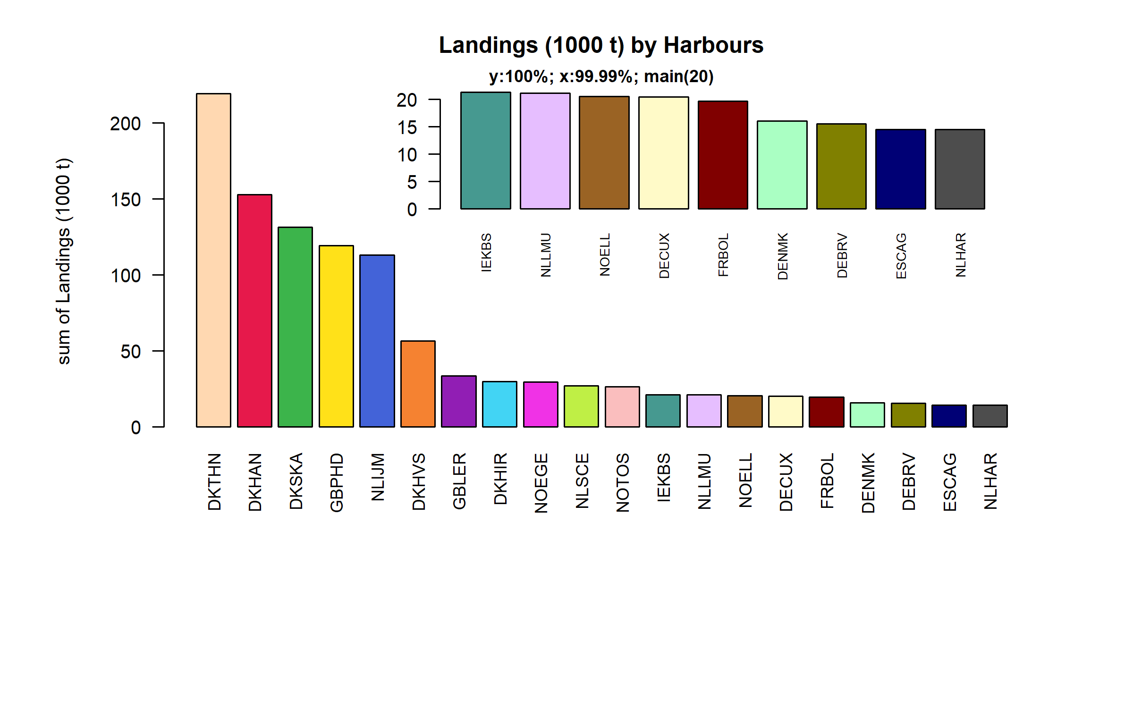 Figure 3.1.6.1. Landings (1000 t) in the 20 main Harbours ( 99.99% of rows entering analysis had known Harbours).

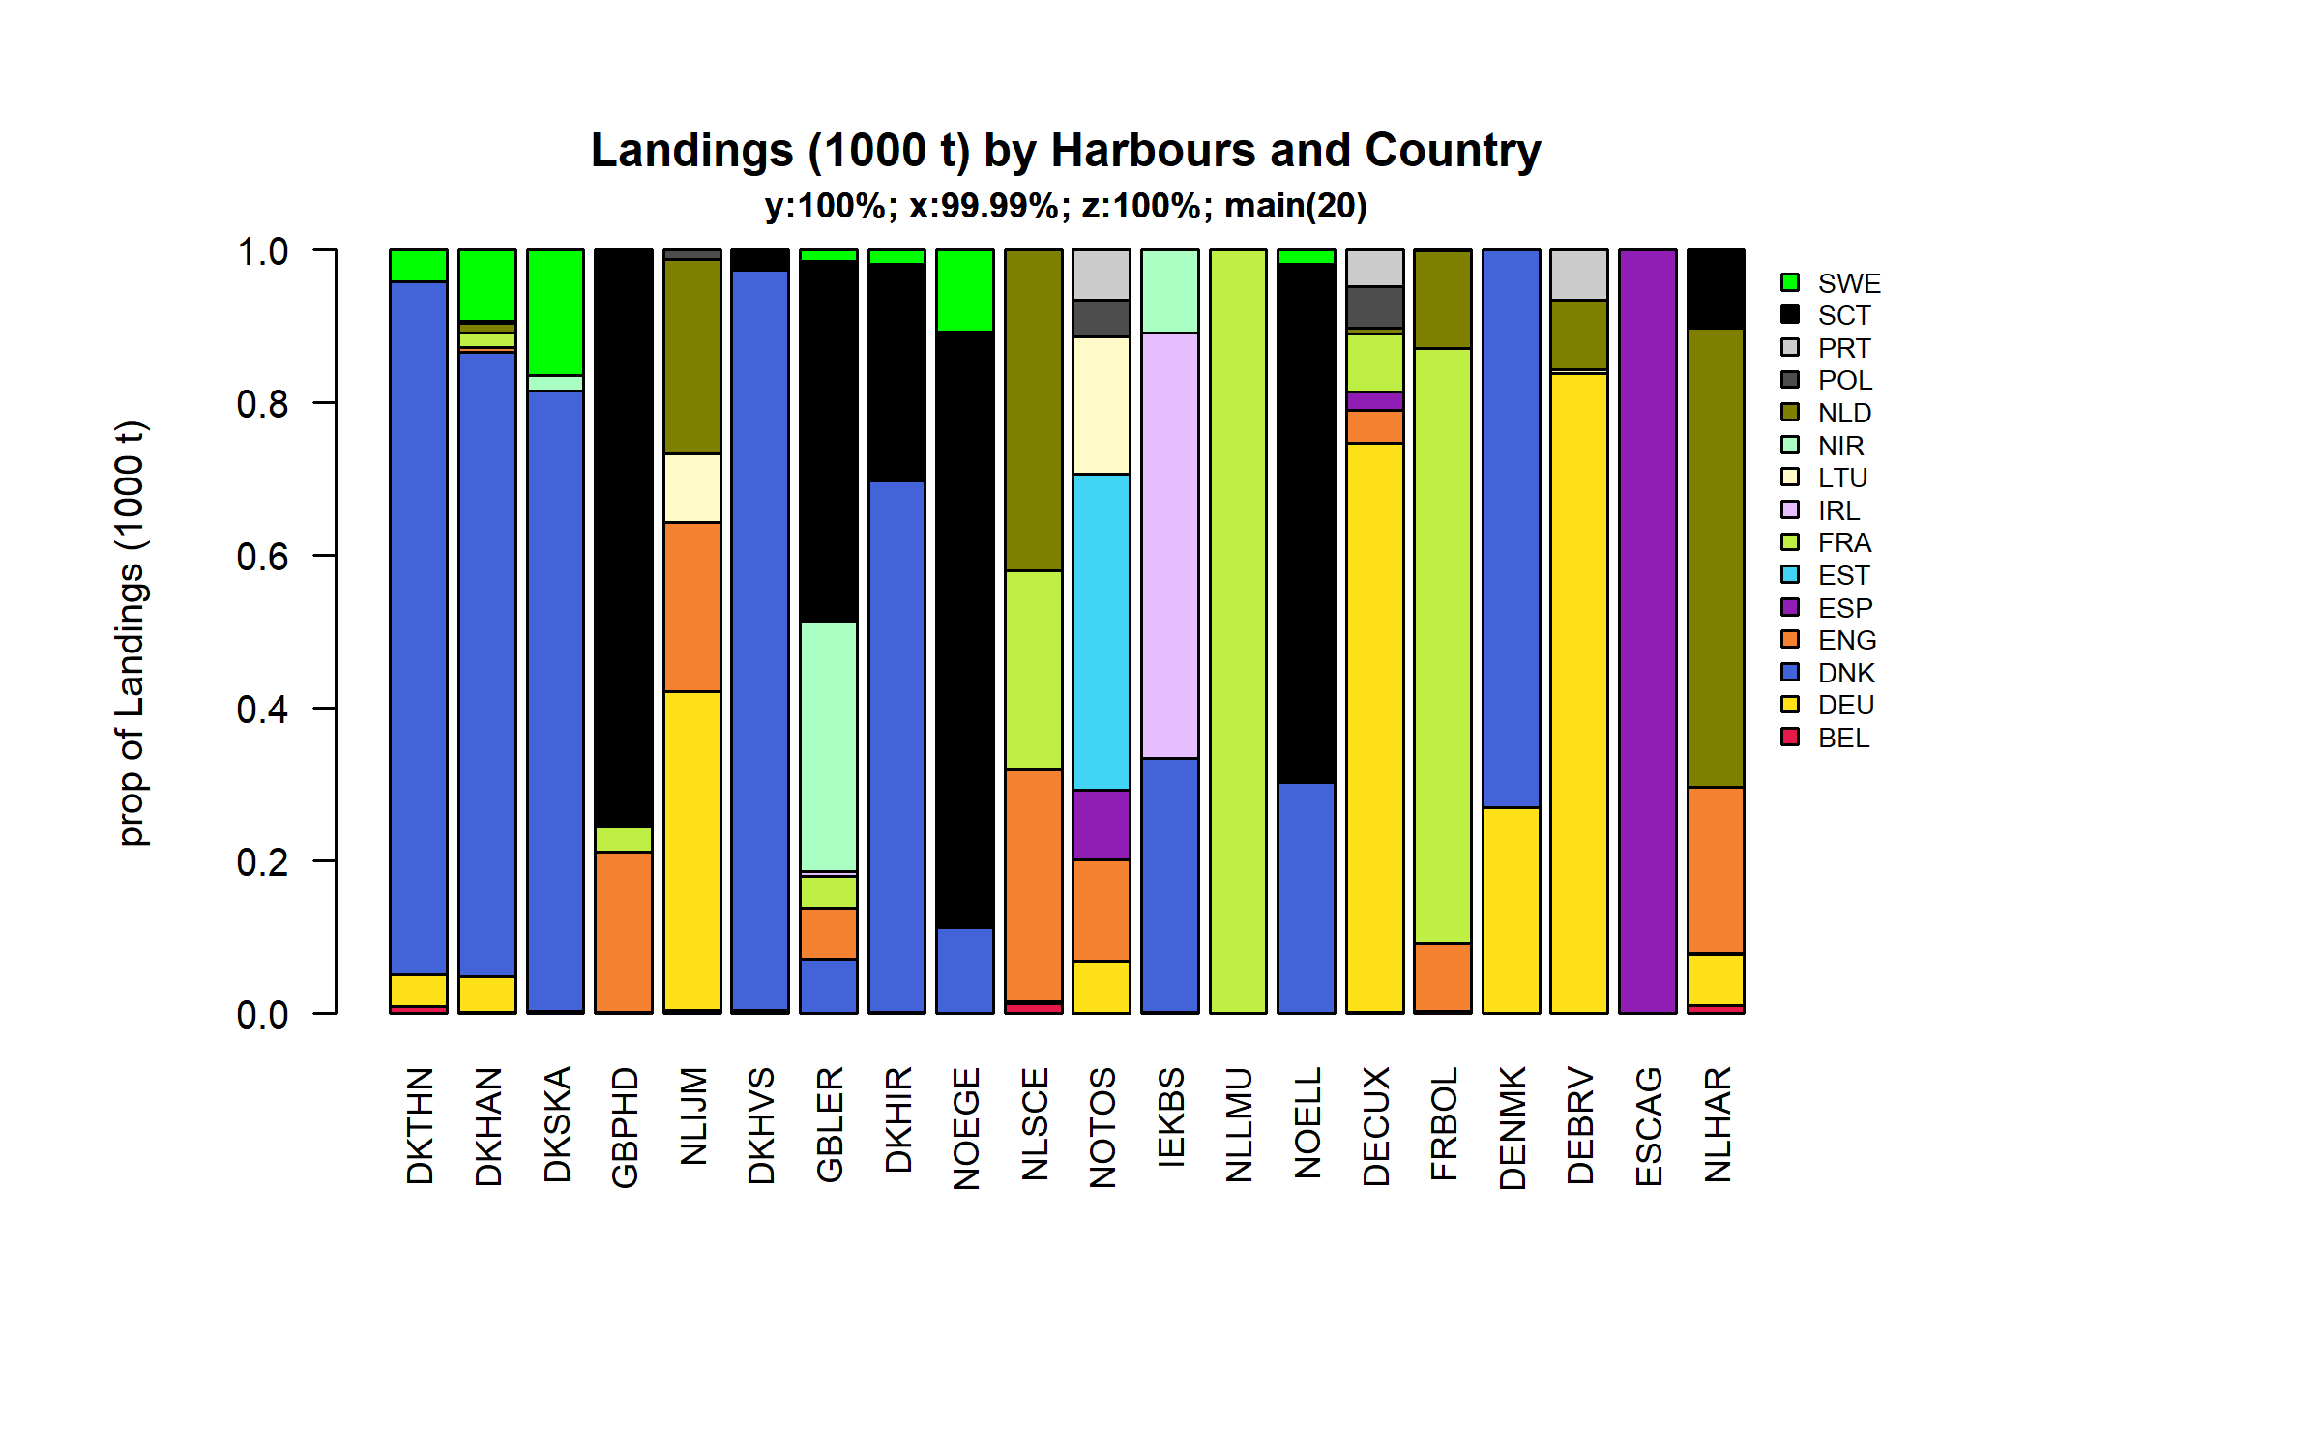 Figure 3.1.6.2. Landings (1000 t) in the 20 main Harbours ( 99.99 % of rows entering analysis had known Harbours ) and Country .

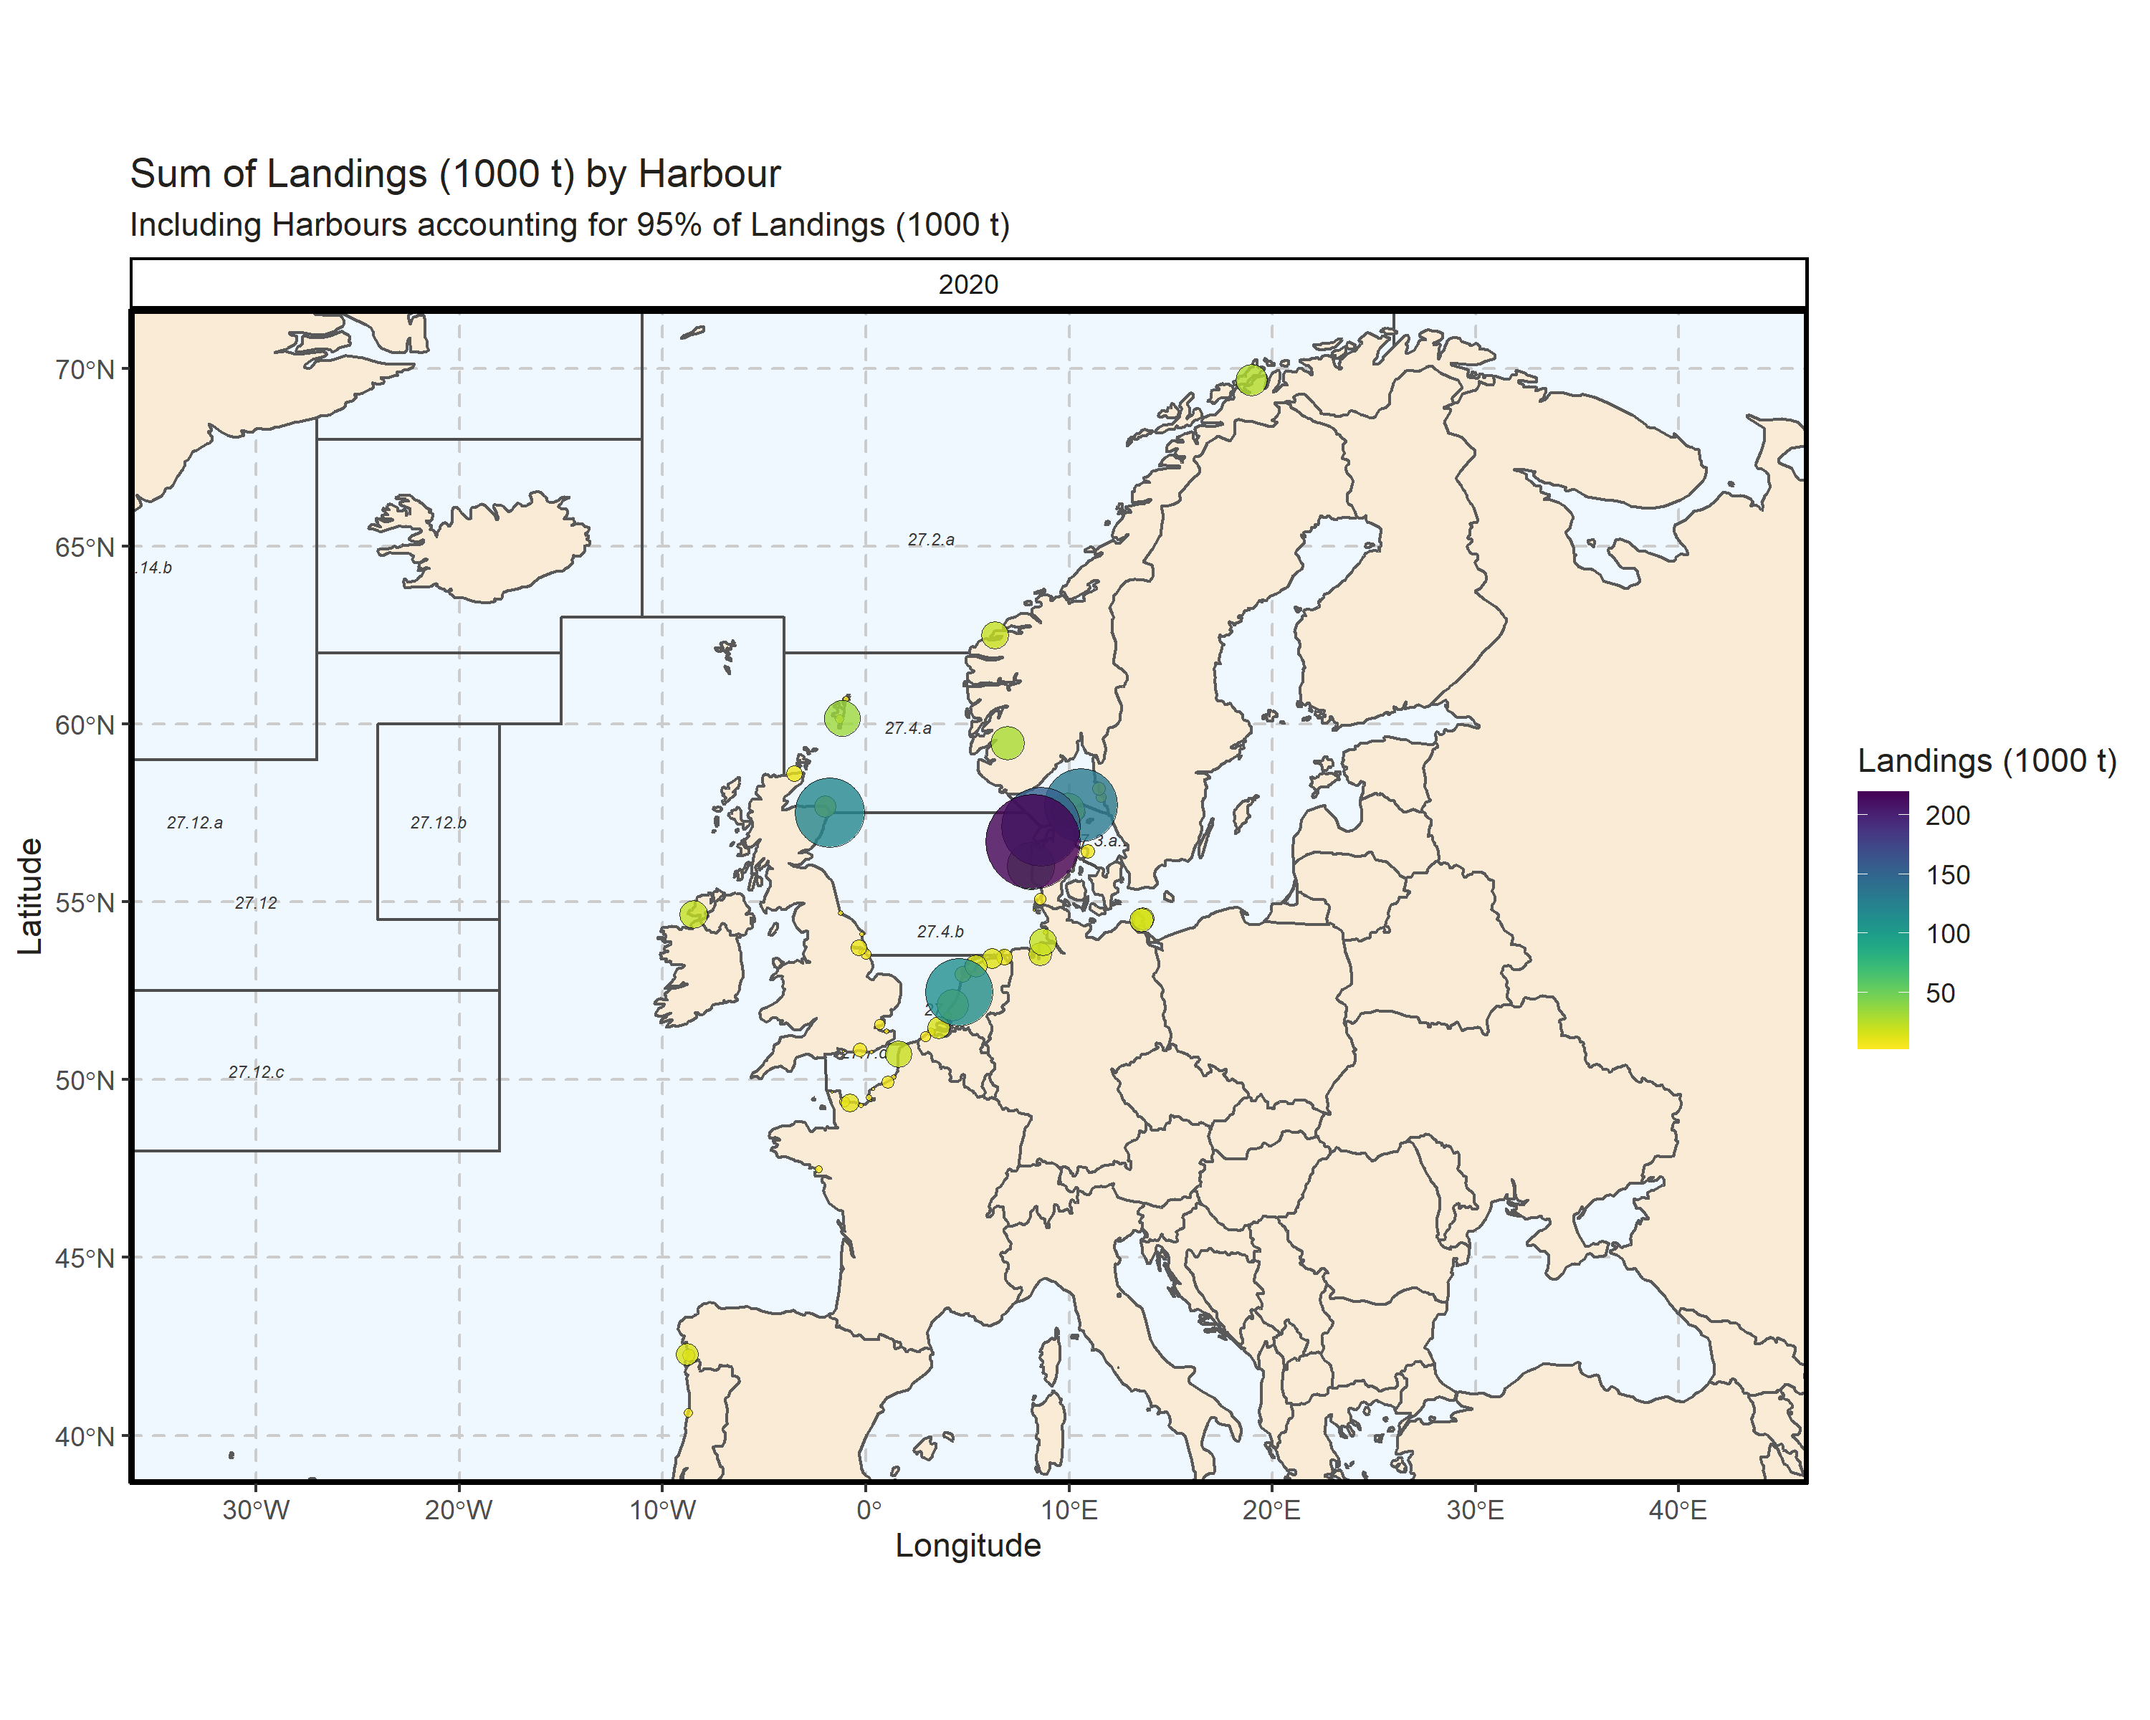 Figure 3.1.6.3. Sum of Landings (1000 t) by Harbour. Including Harbours accounting for 95% of Landings (1000 t). 0.08% of Landings (1000 t) - reported for missing Harbour 16 Harbour with missing coordinates (6.81% of Landings (1000 t)) - not presented on the map.

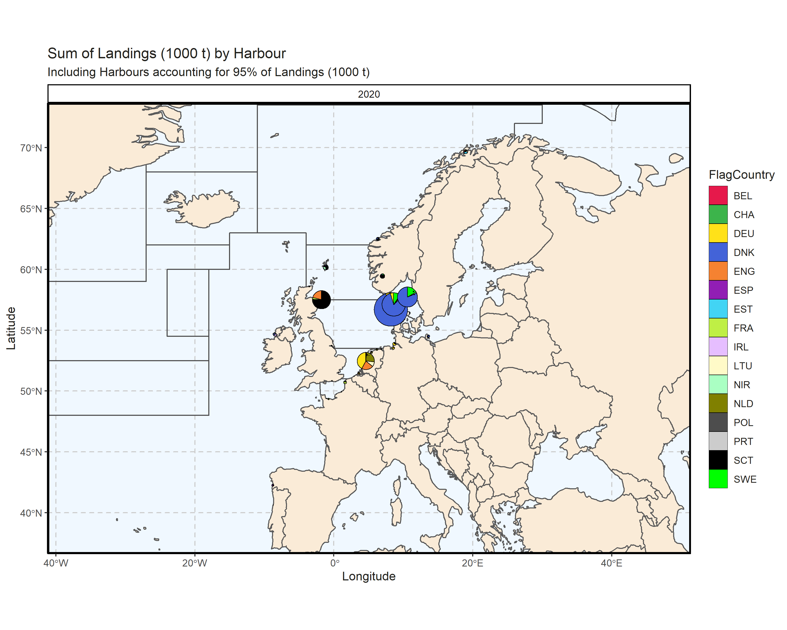 Figure 3.1.6.4. Sum of Landings (1000 t) by Harbour. Including Harbours accounting for 95% of Landings (1000 t). 0.08% of Landings (1000 t) - reported for missing Harbour. 16 Harbour with missing coordinates (6.81% of Landings (1000 t)) - not presented on the map.

### Landings abroad

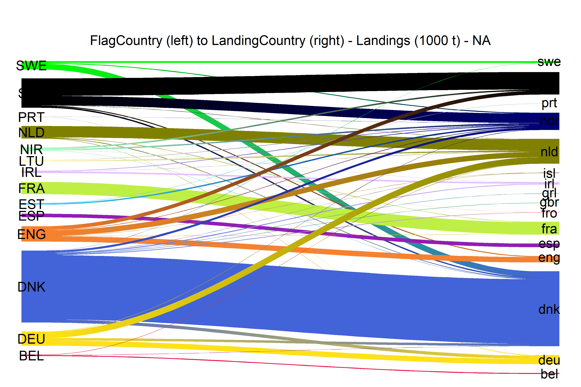  
Figure 3.1.7.1.River plot of Landings (1000 t) between Country (left) and Landing Country (right). Width of line is proportional to landings

### Spatial distribution of landings

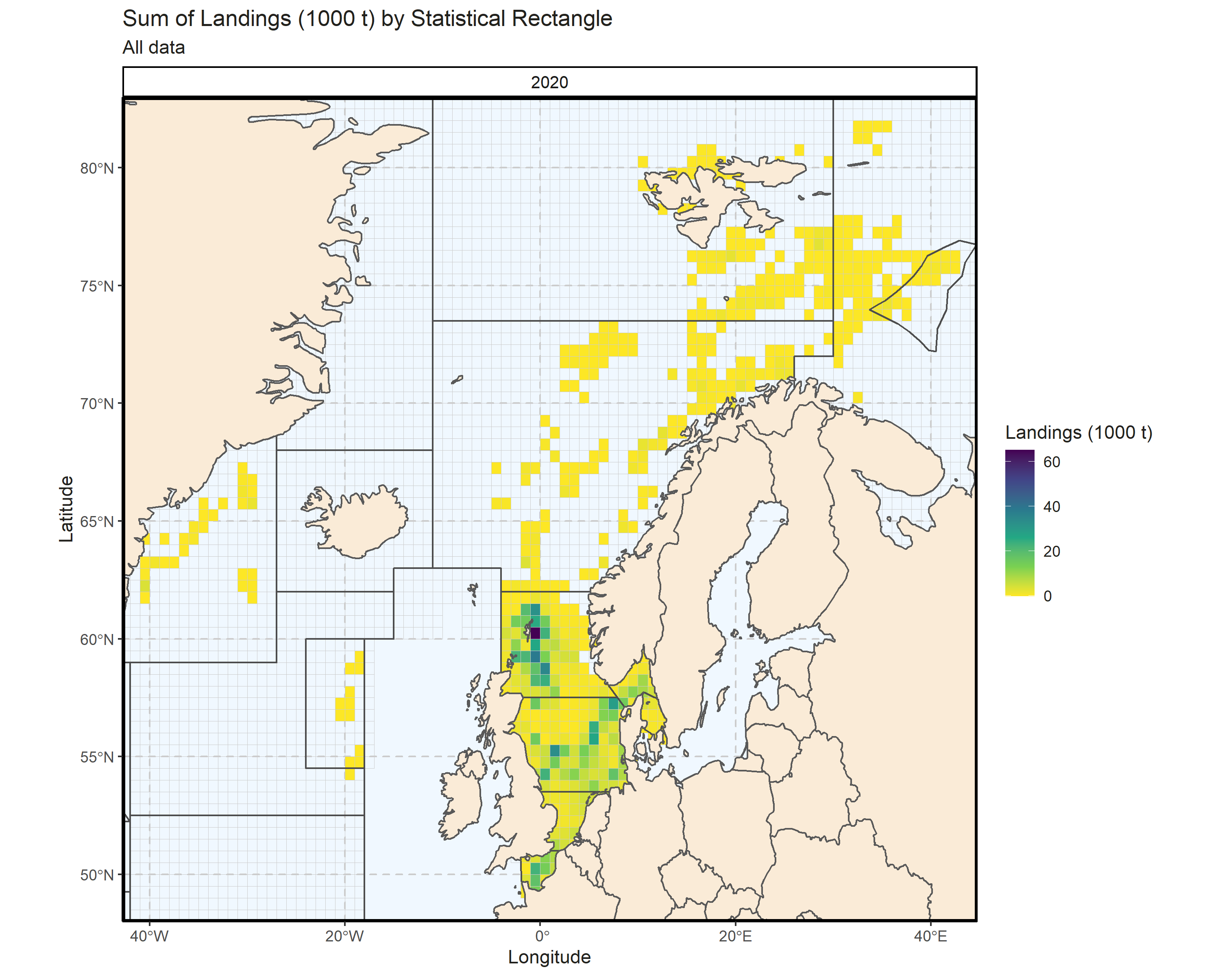 Figure 3.1.8.1. Sum of Landings (1000 t) by Statistical Rectangle. All data. 2.6% of Landings (1000 t) - reported for missing Statistical Rectangle. 2 Statistical Rectangle with missing coordinates (1.66% of Landings (1000 t)) - not presented on the map.

## Small pelagic landings

### Landings by country, small pelagic

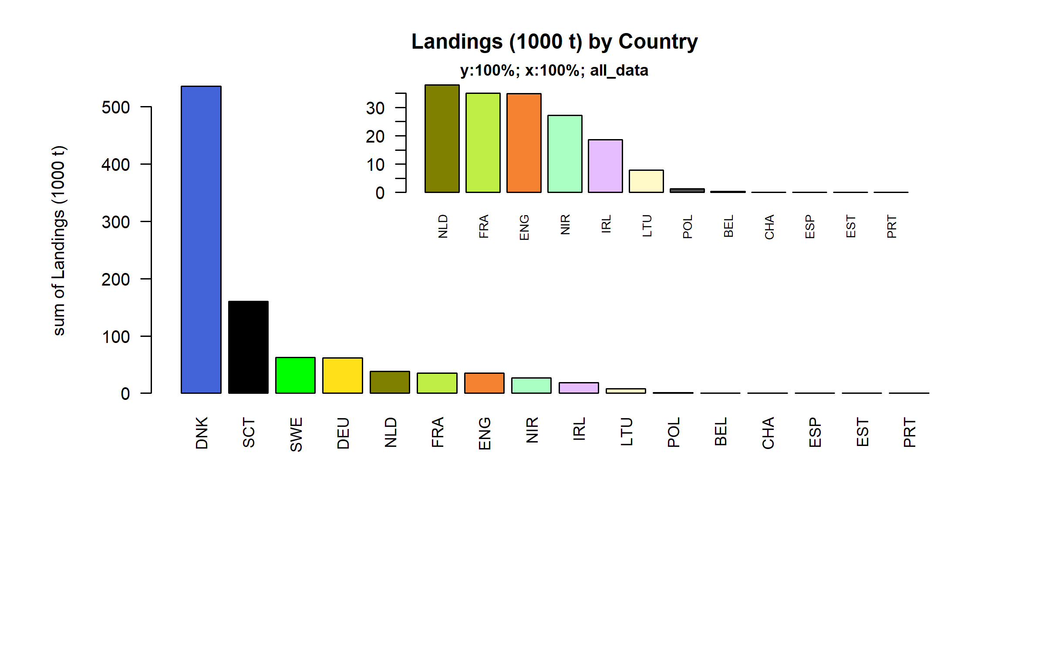 Figure 3.2.1.1. Landings (1000 t) of small pelagic by Country.

### Landings by species, small pelagic

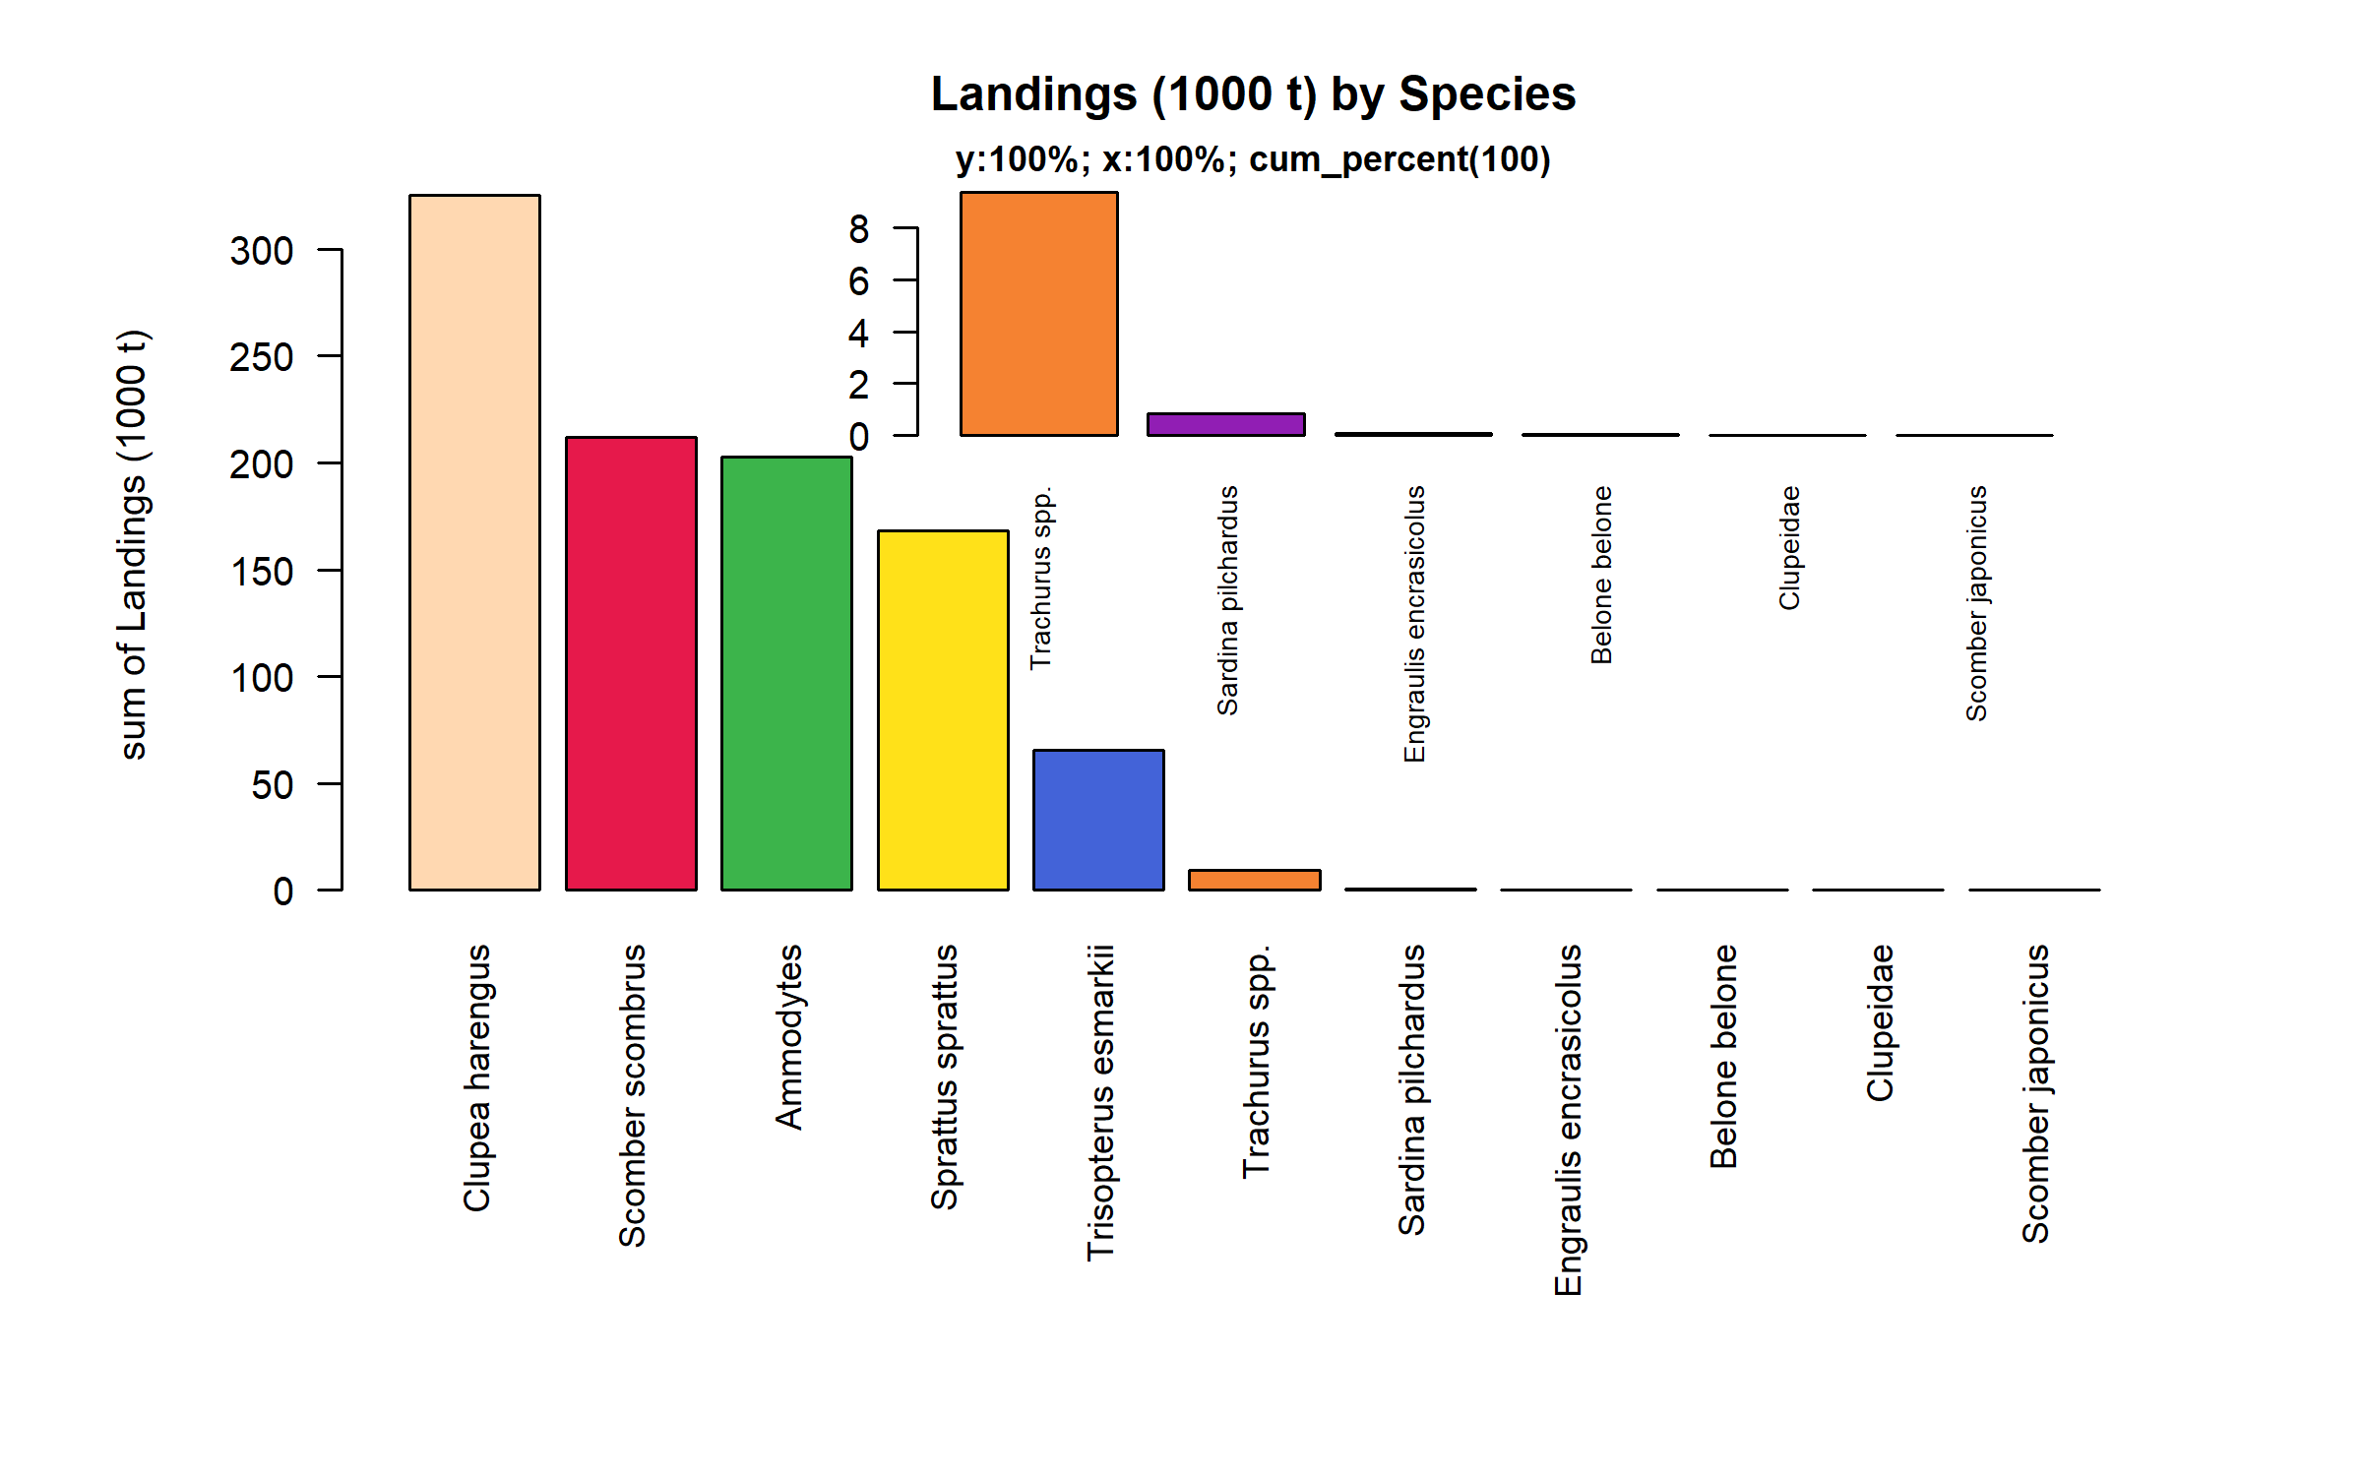 Figure 3.2.2.1. Landings (1000 t) of small pelagic by Species. Species displayed comprise 100% of the total Landings (1000 t).

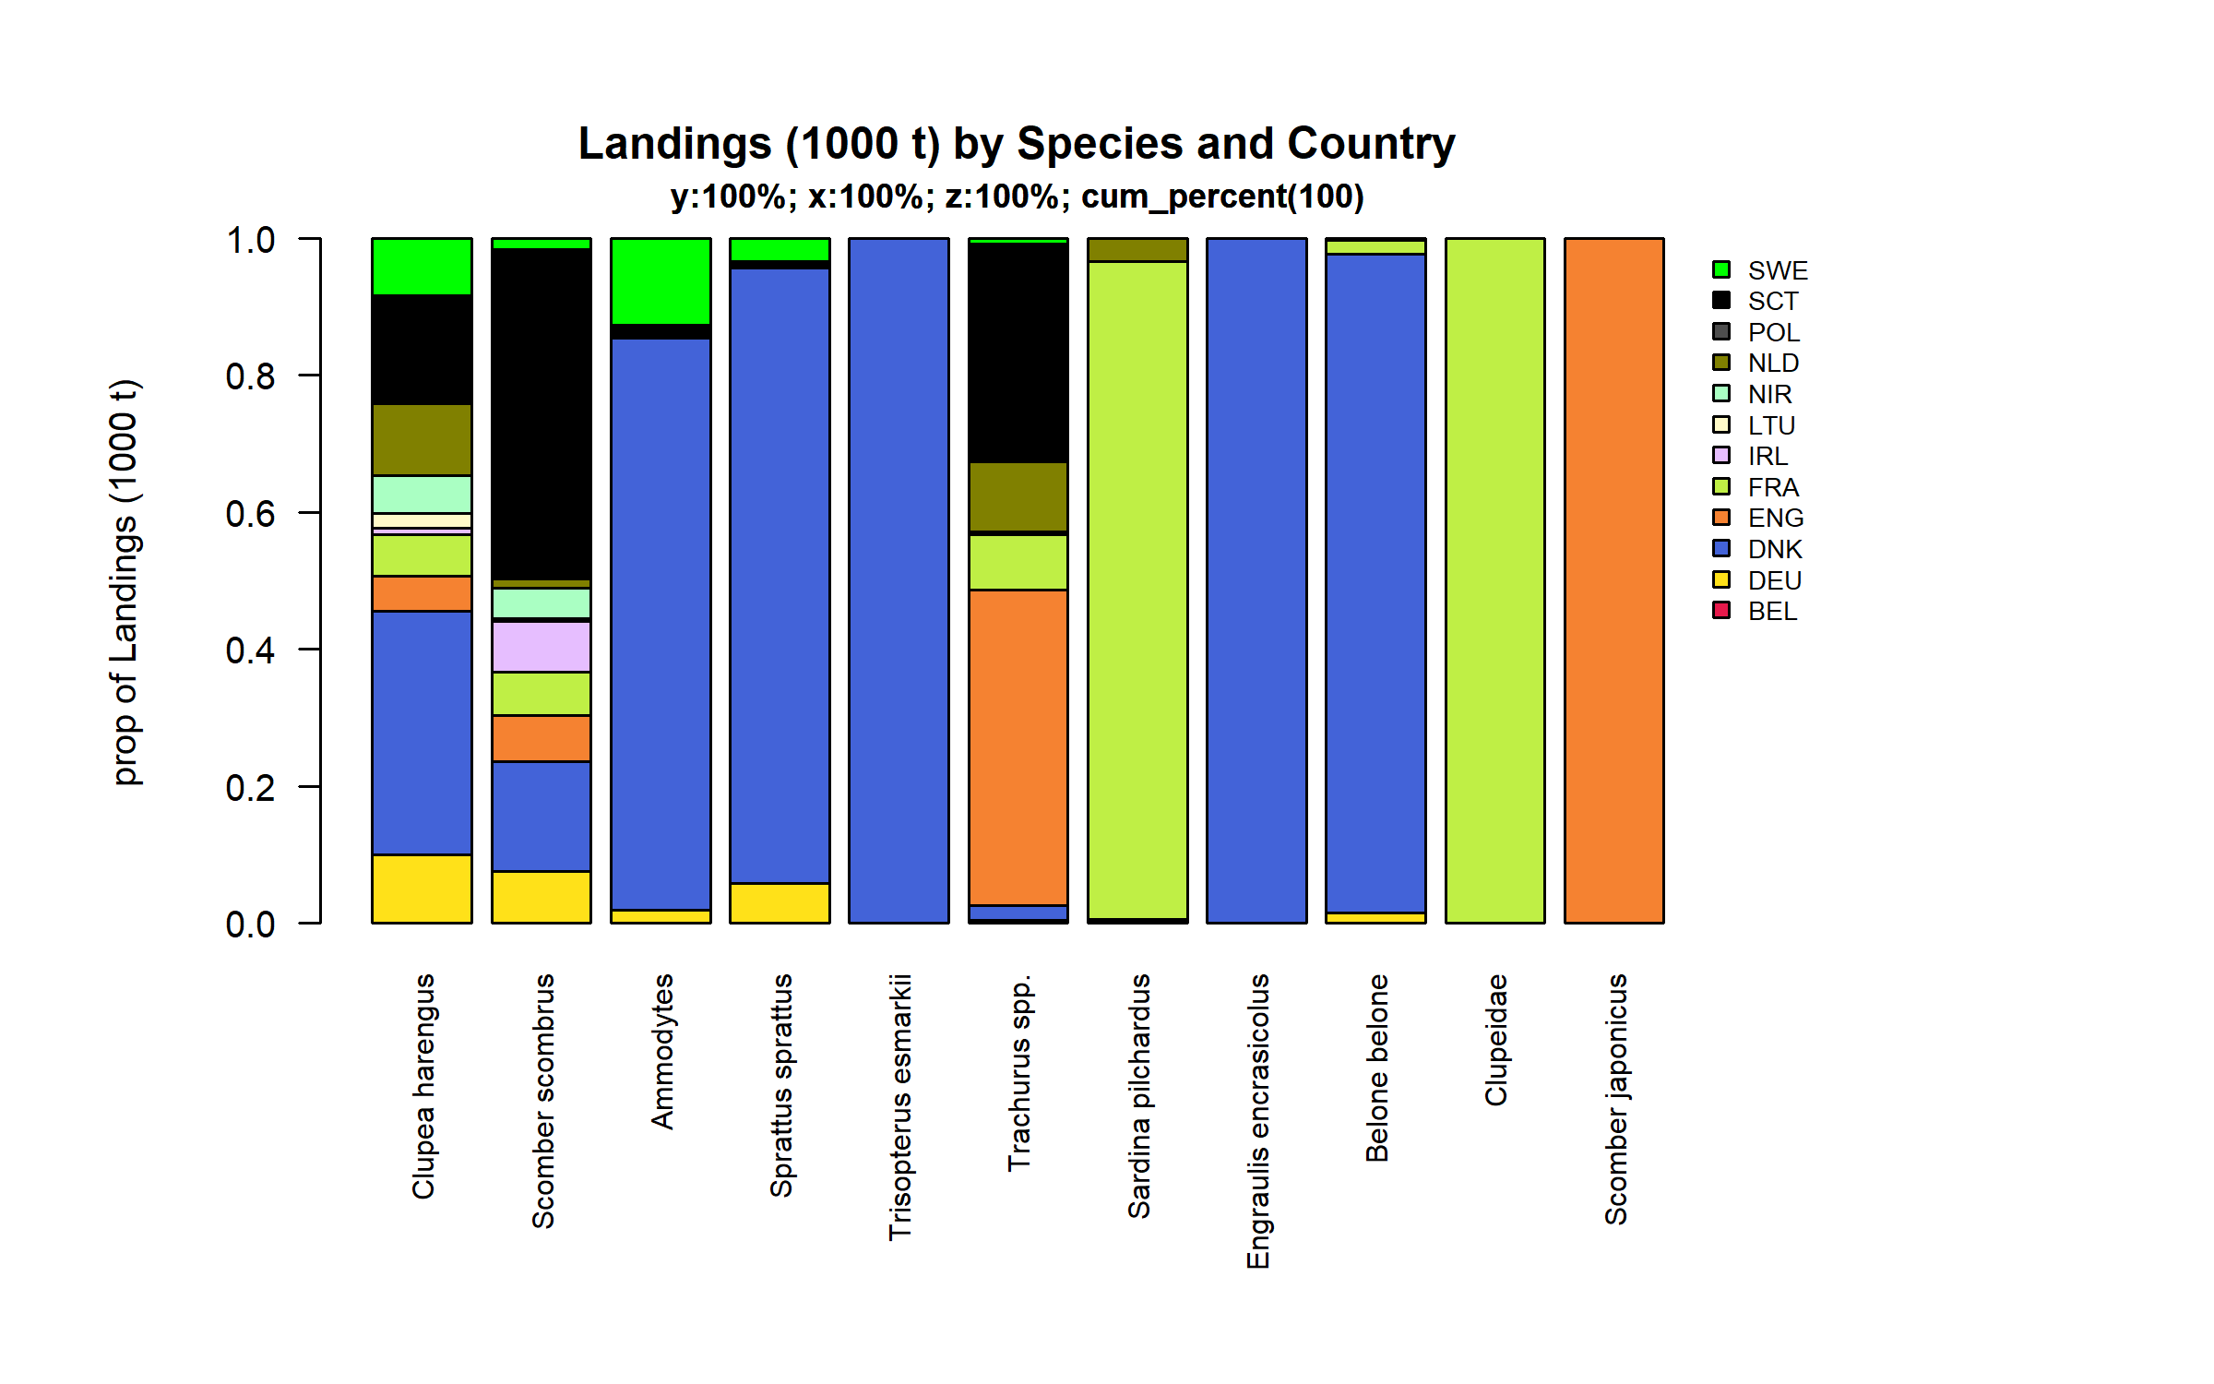 Figure 3.2.2.2. Landings (1000 t) of small pelagic by Species and Country . Species and Country displayed comprise 100 % of the total Landings (1000 t) .

### Landings by fleet, small pelagic

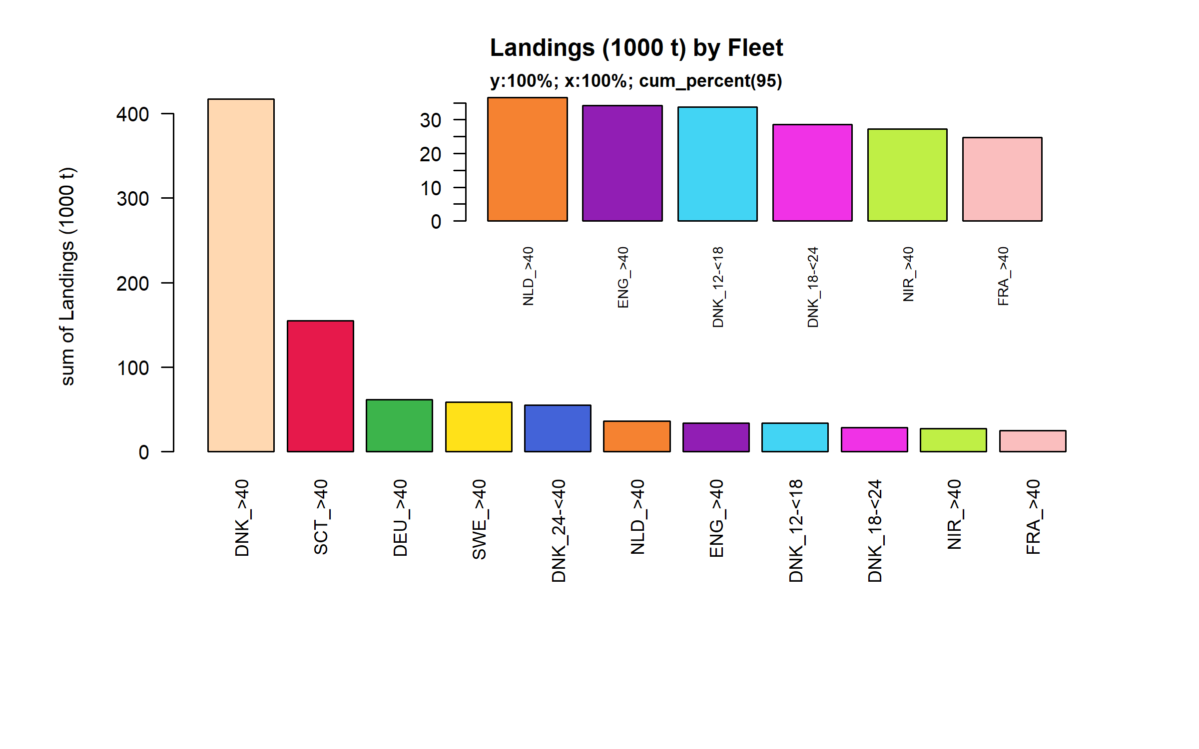 Figure 3.2.3.1. Landings (1000 t) of small pelagic by Fleet. Fleet displayed comprise 95% of the total Landings (1000 t).

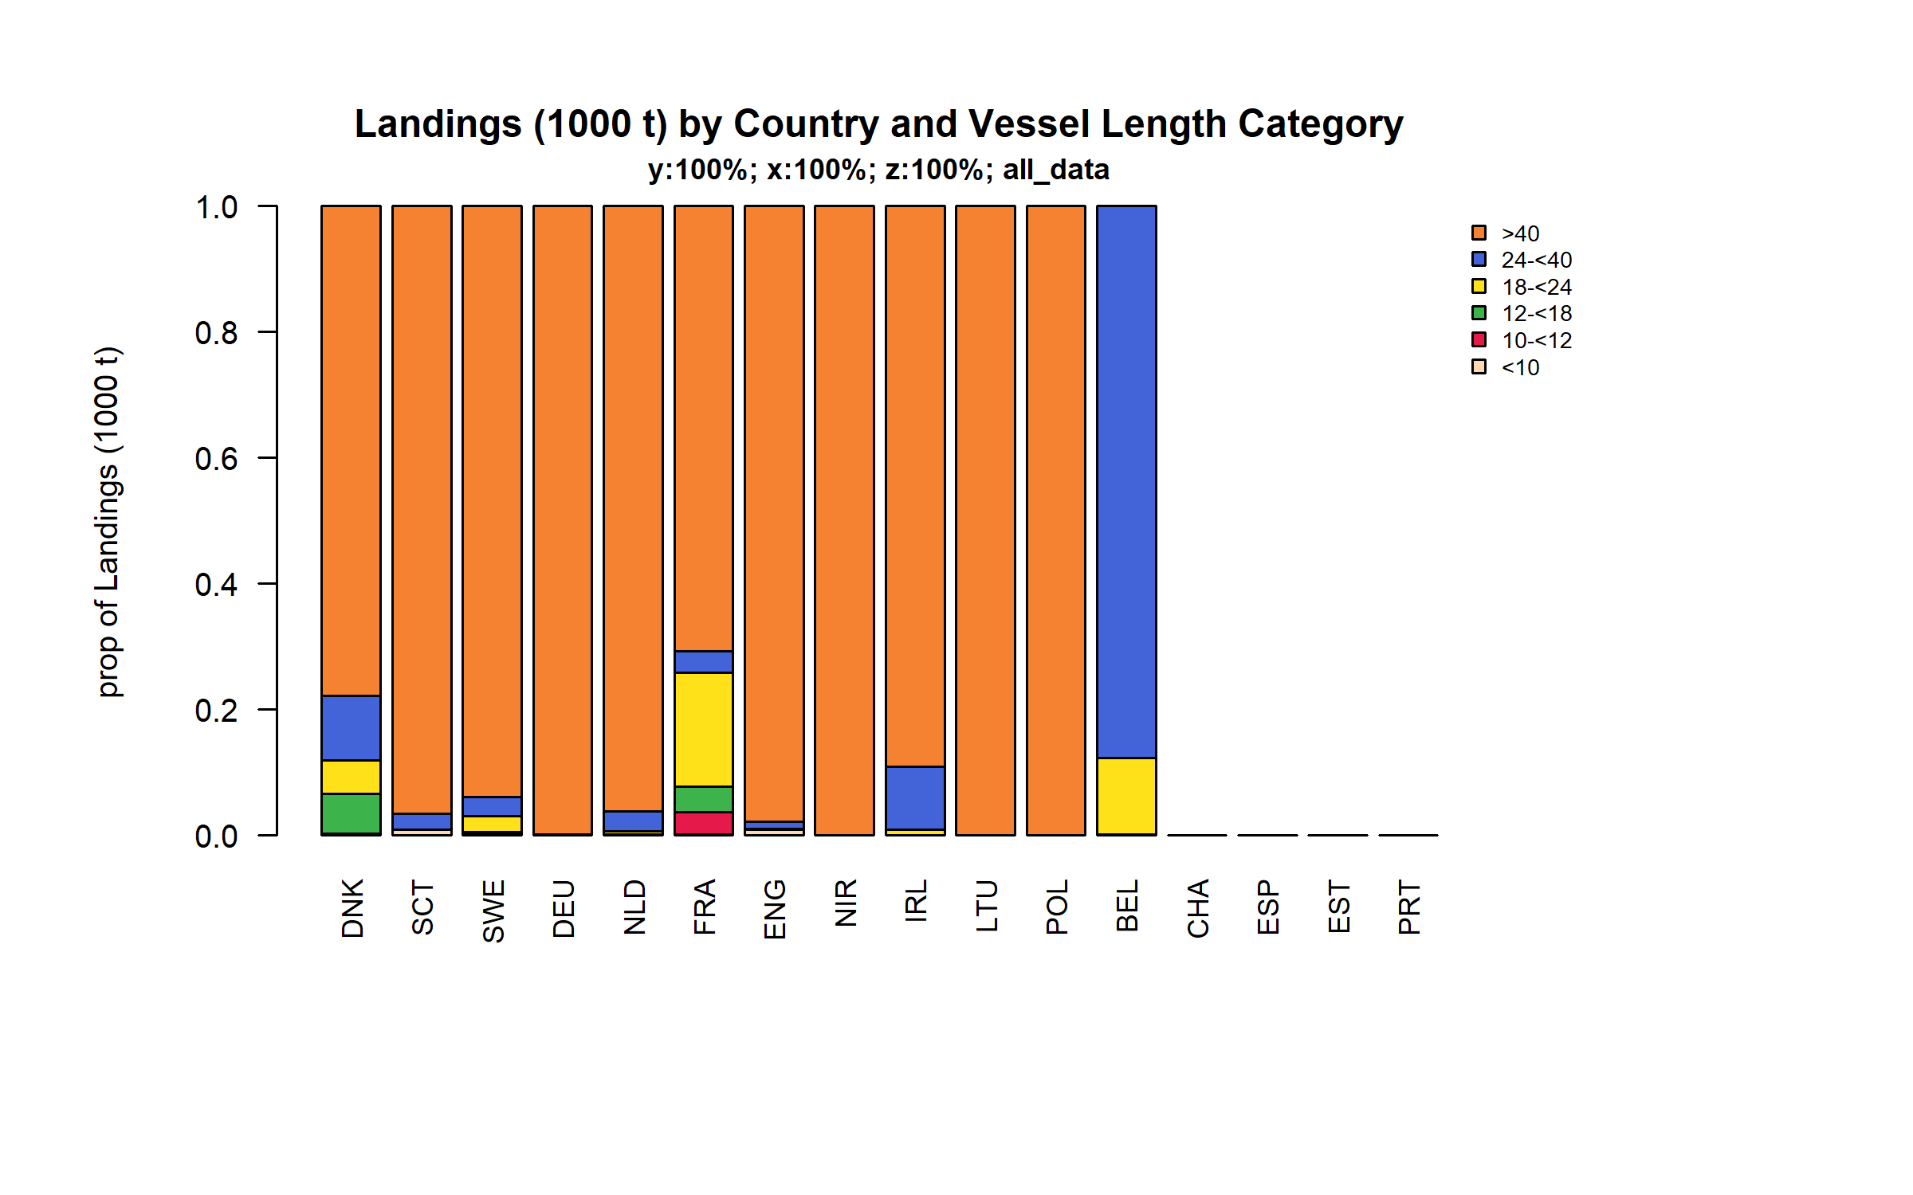 Figure 3.2.3.2. Landings (1000 t) of small pelagic by Country and Vessel Length Category.

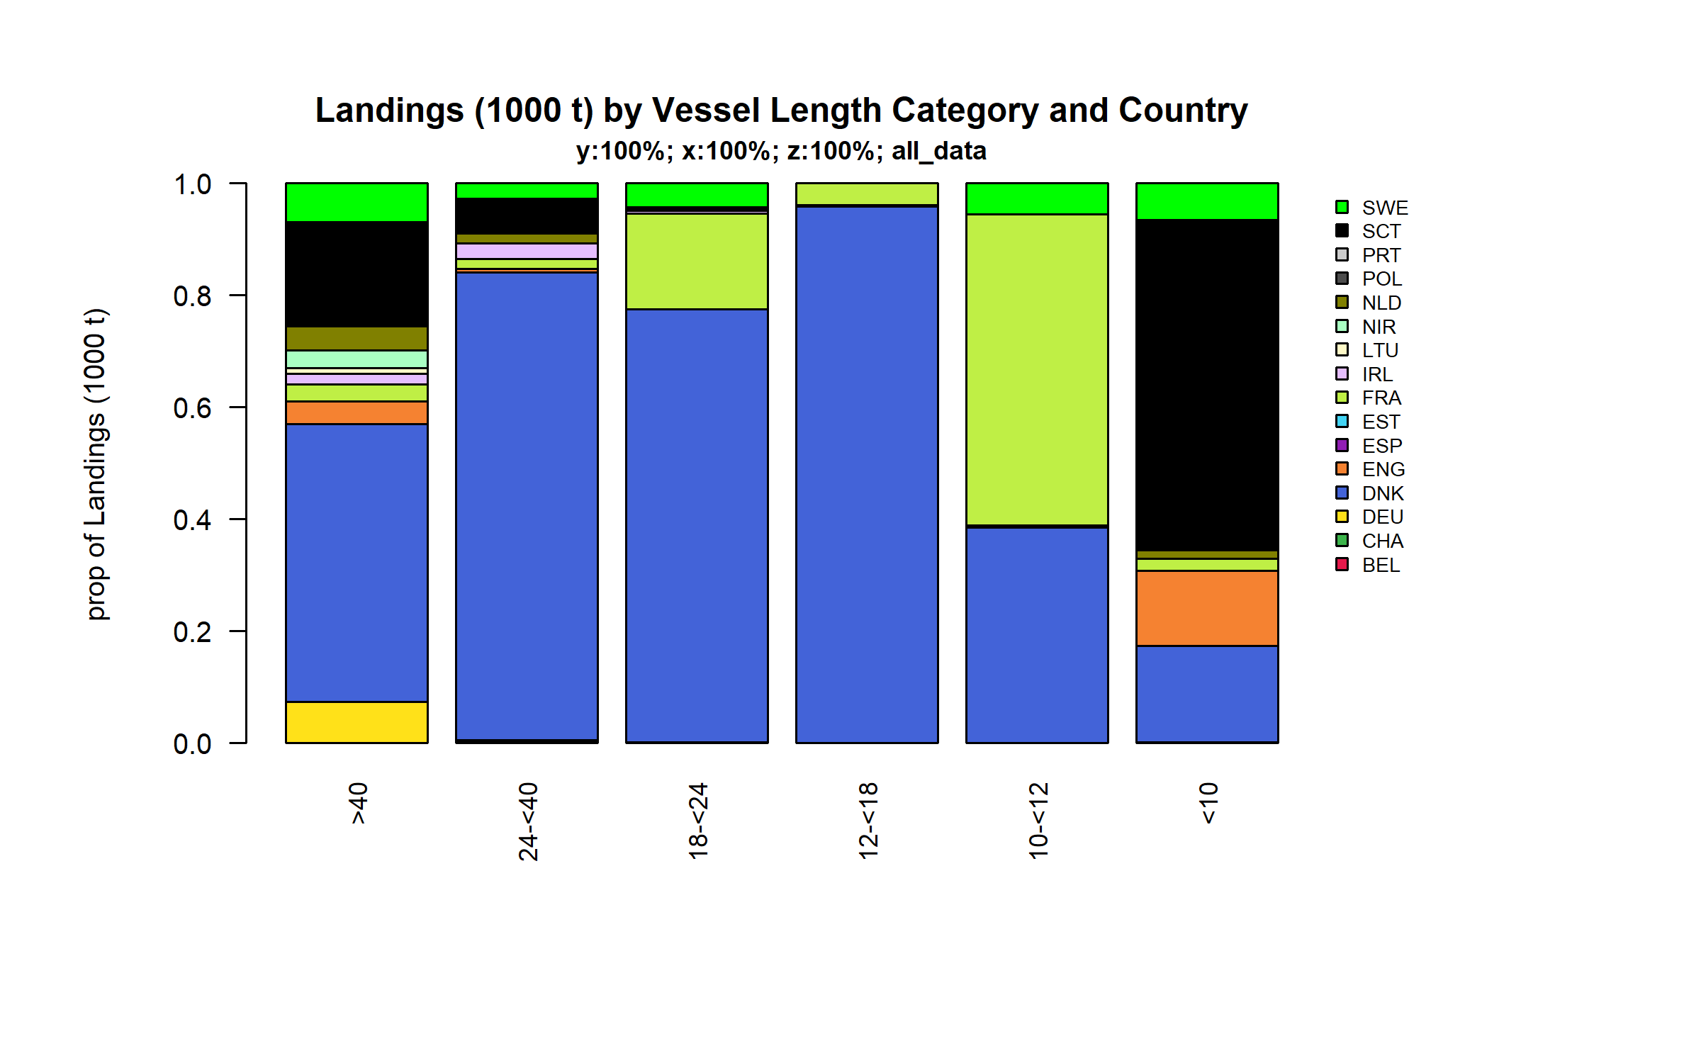 Figure 3.2.3.3. Landings (1000 t) of small pelagic by Vessel Length Category and Country.

### Landings by area, small pelagic

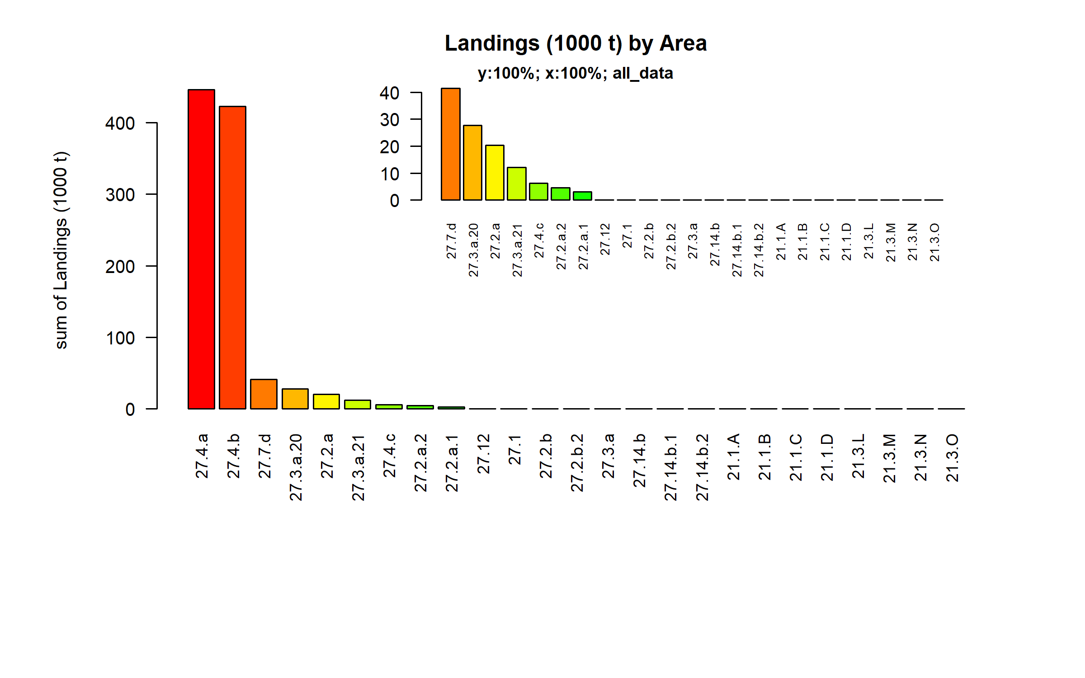 Figure 3.2.4.1. Landings (1000 t) of small pelagic by Area.

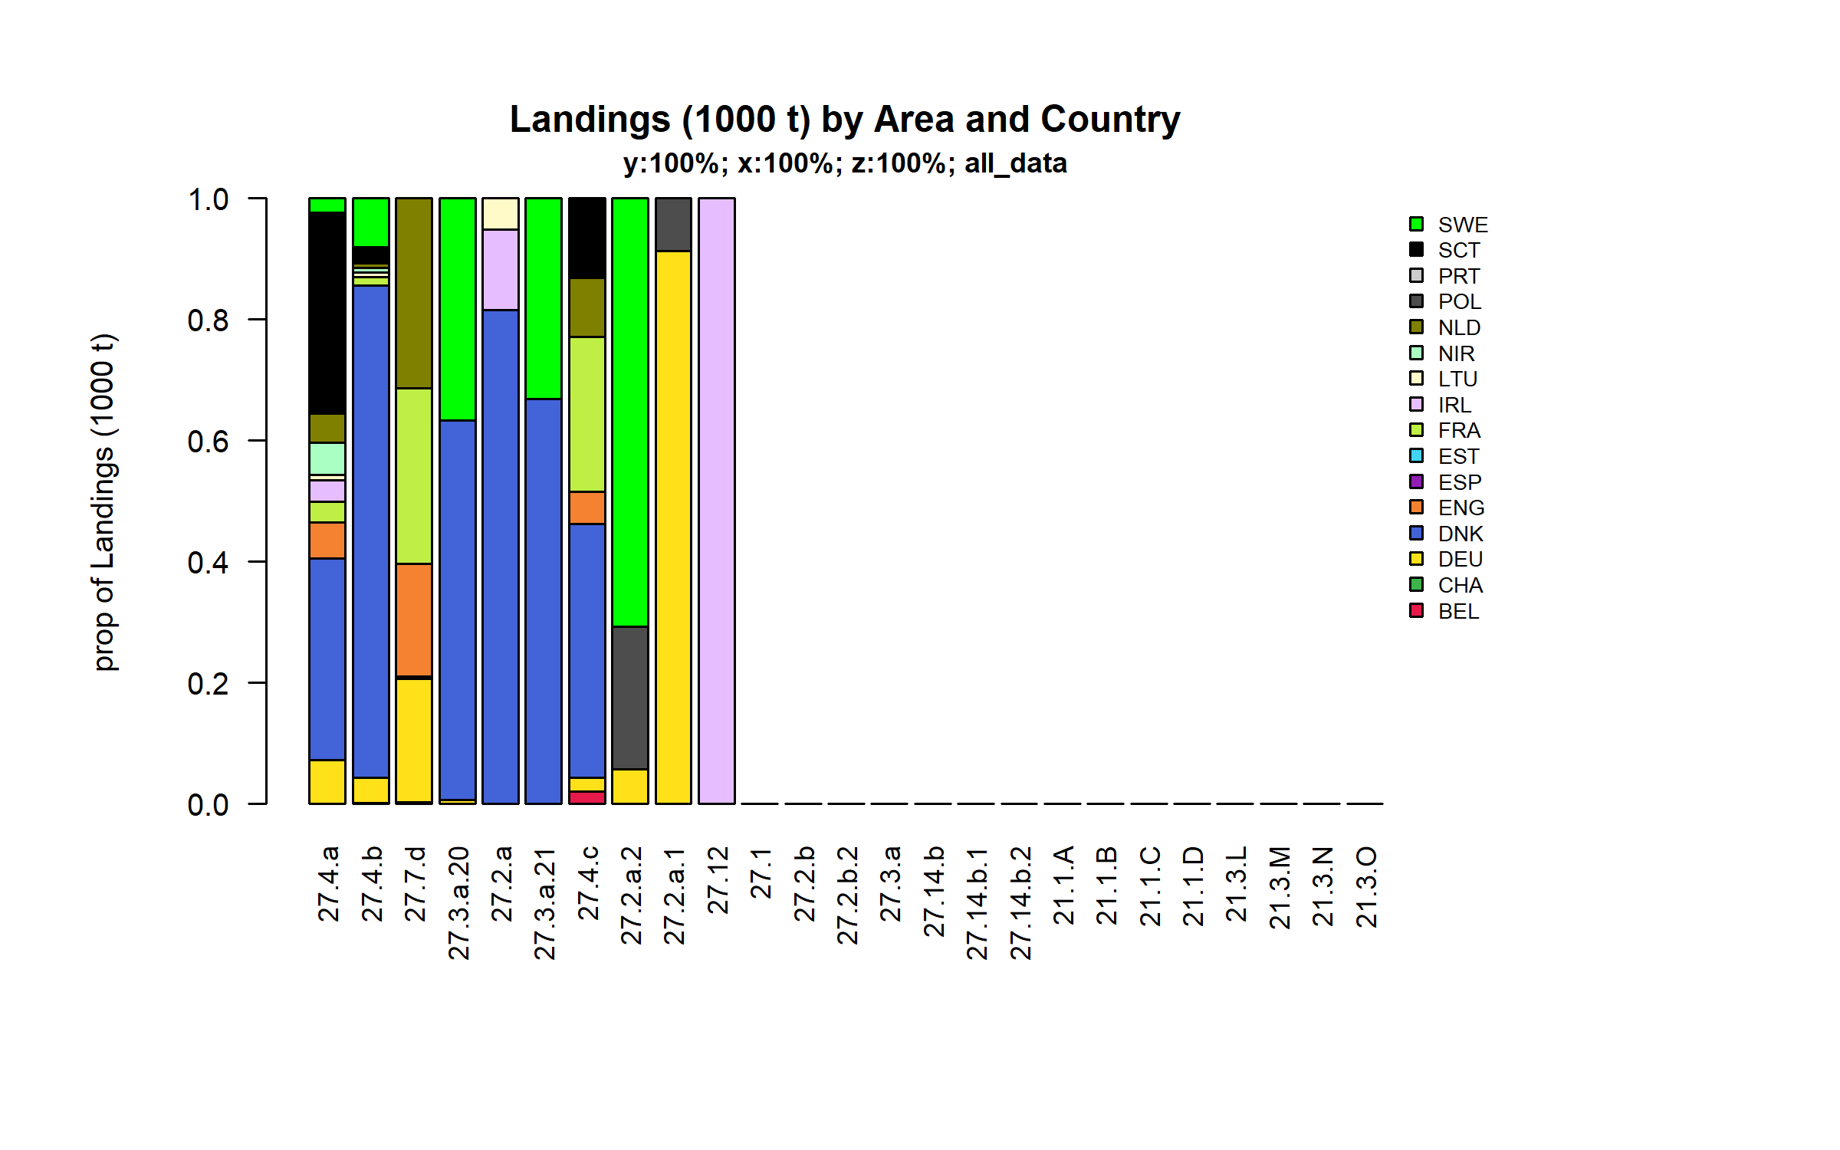 Figure 3.2.4.2. Landings (1000 t) of small pelagic by Area and Country.

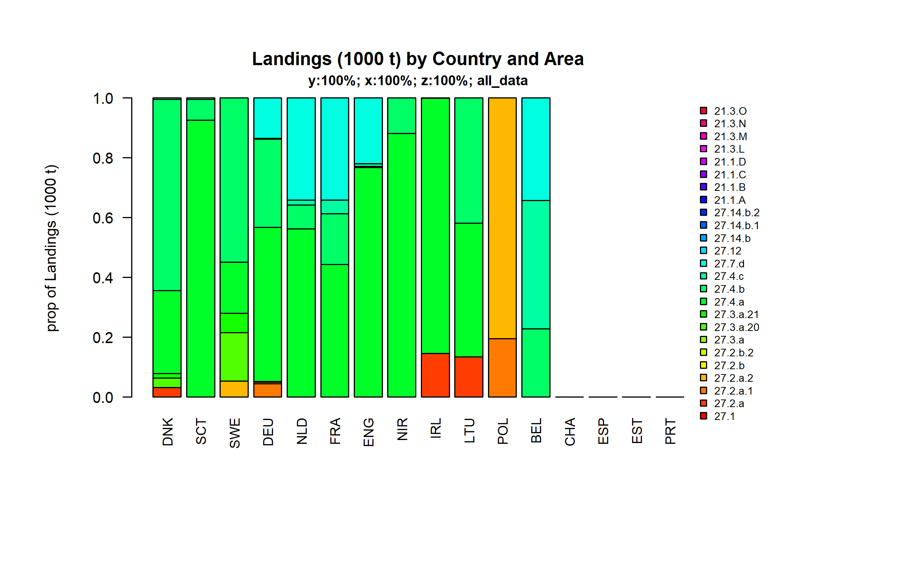 Figure 3.2.4.3. Landings (1000 t) of small pelagic by Country and Area.

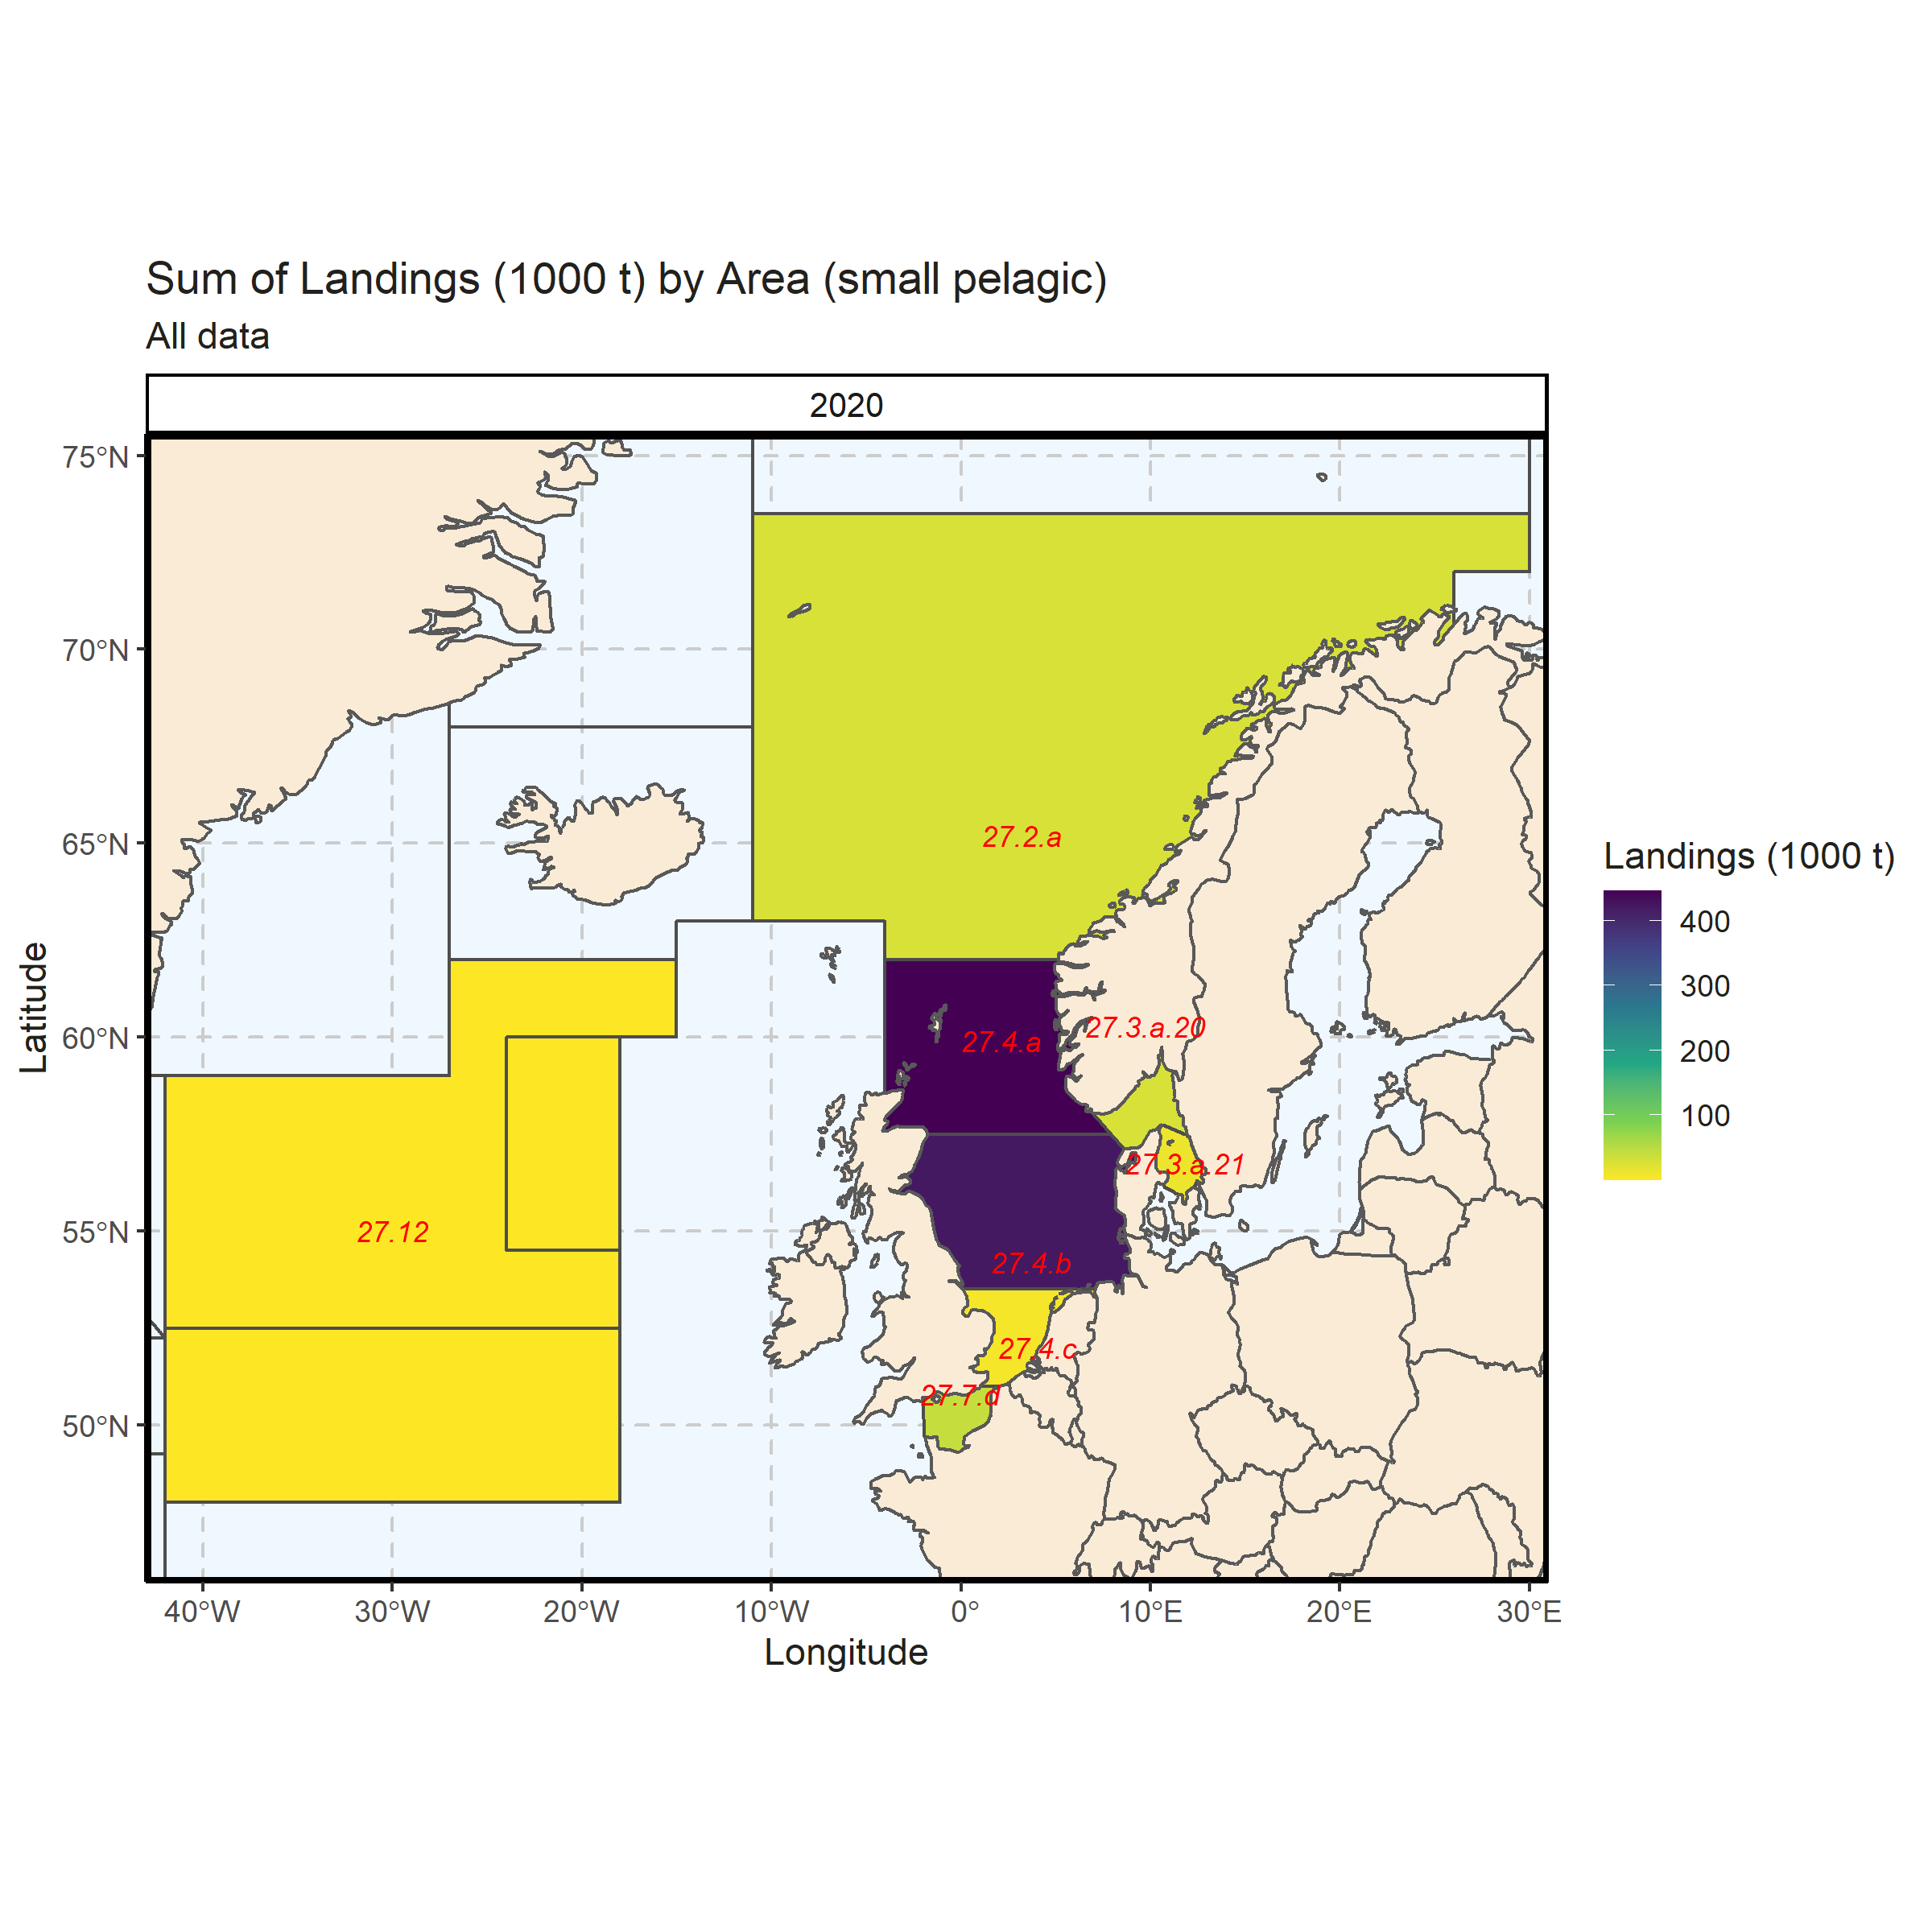 Figure 3.2.4.4. Sum of Landings (1000 t) by Area (small pelagic). All data. 0% of Landings (1000 t) - reported for missing Area.

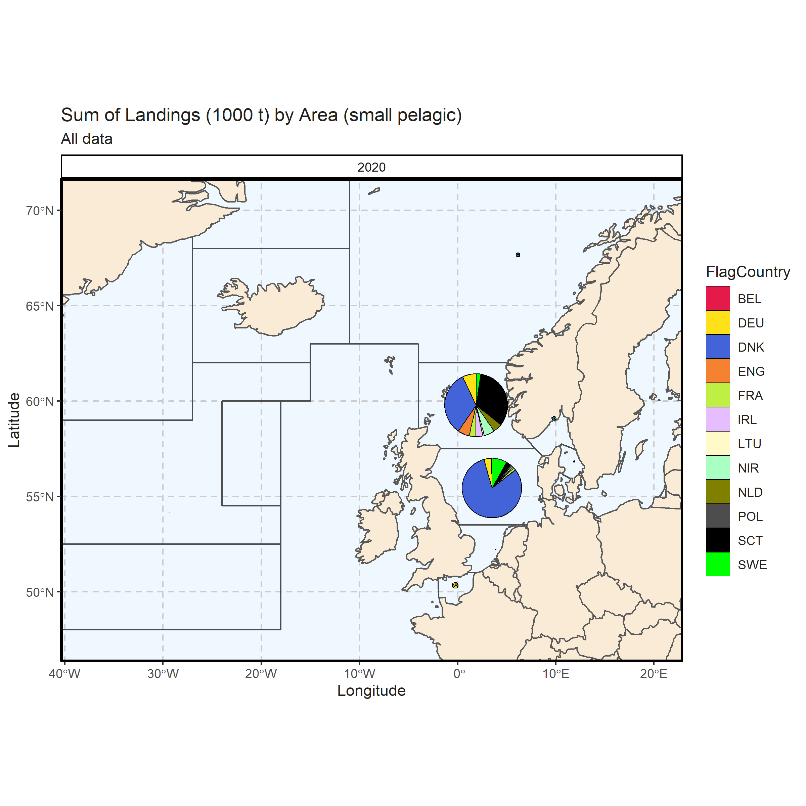 Figure 3.2.4.5. Sum of Landings (1000 t) by Area (small pelagic). All data. 0% of Landings (1000 t) - reported for missing Area.

### Landings by metier, small pelagic

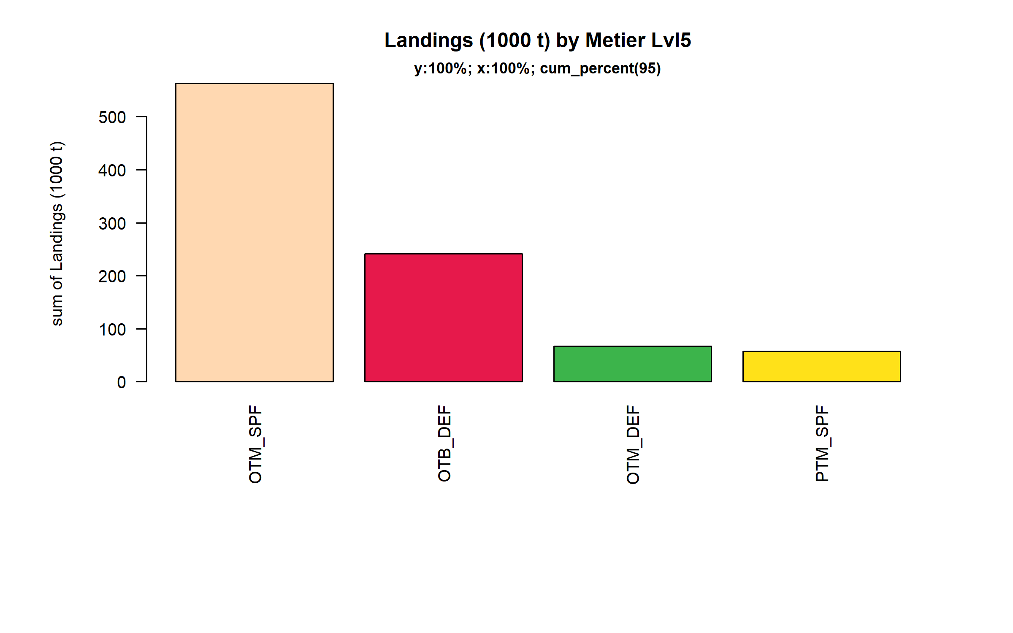 Figure 3.2.5.1. Landings (1000 t) of small pelagic by Metier Lvl5. Metier Lvl5 displayed comprise 95% of the total Landings (1000 t).

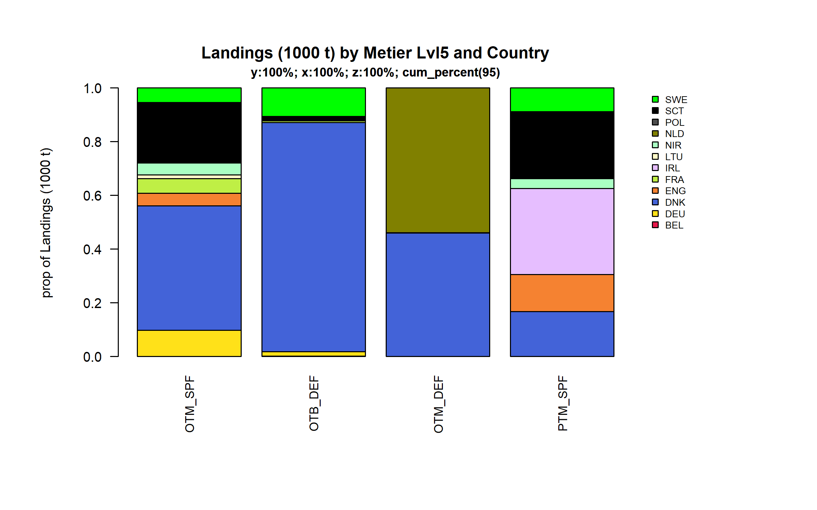 Figure 3.2.5.2. Landings (1000 t) of small pelagic by Metier Lvl5 and Country . Metier Lvl5 and Country displayed comprise 95 % of the total Landings (1000 t) .

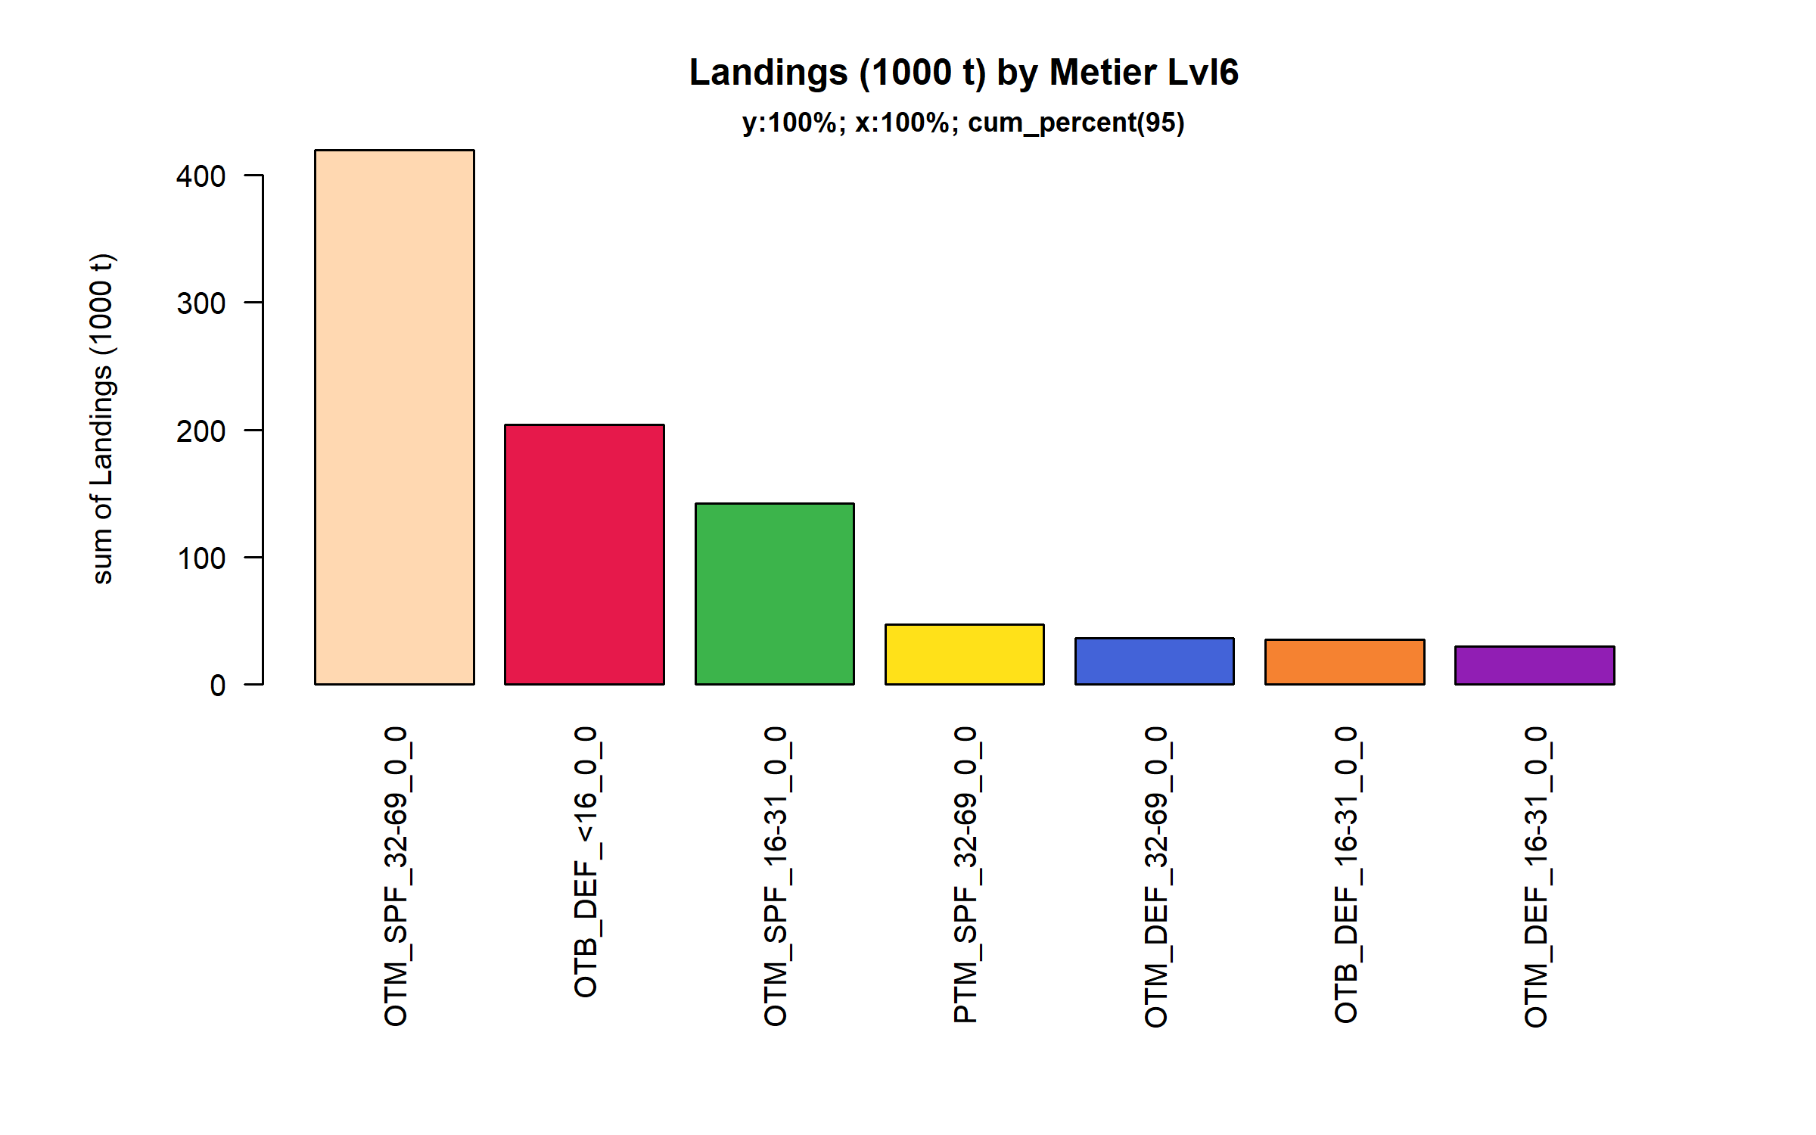 Figure 3.2.5.3. Landings (1000 t) of small pelagic by Metier Lvl6. Metier Lvl6 displayed comprise 95% of the total Landings (1000 t).

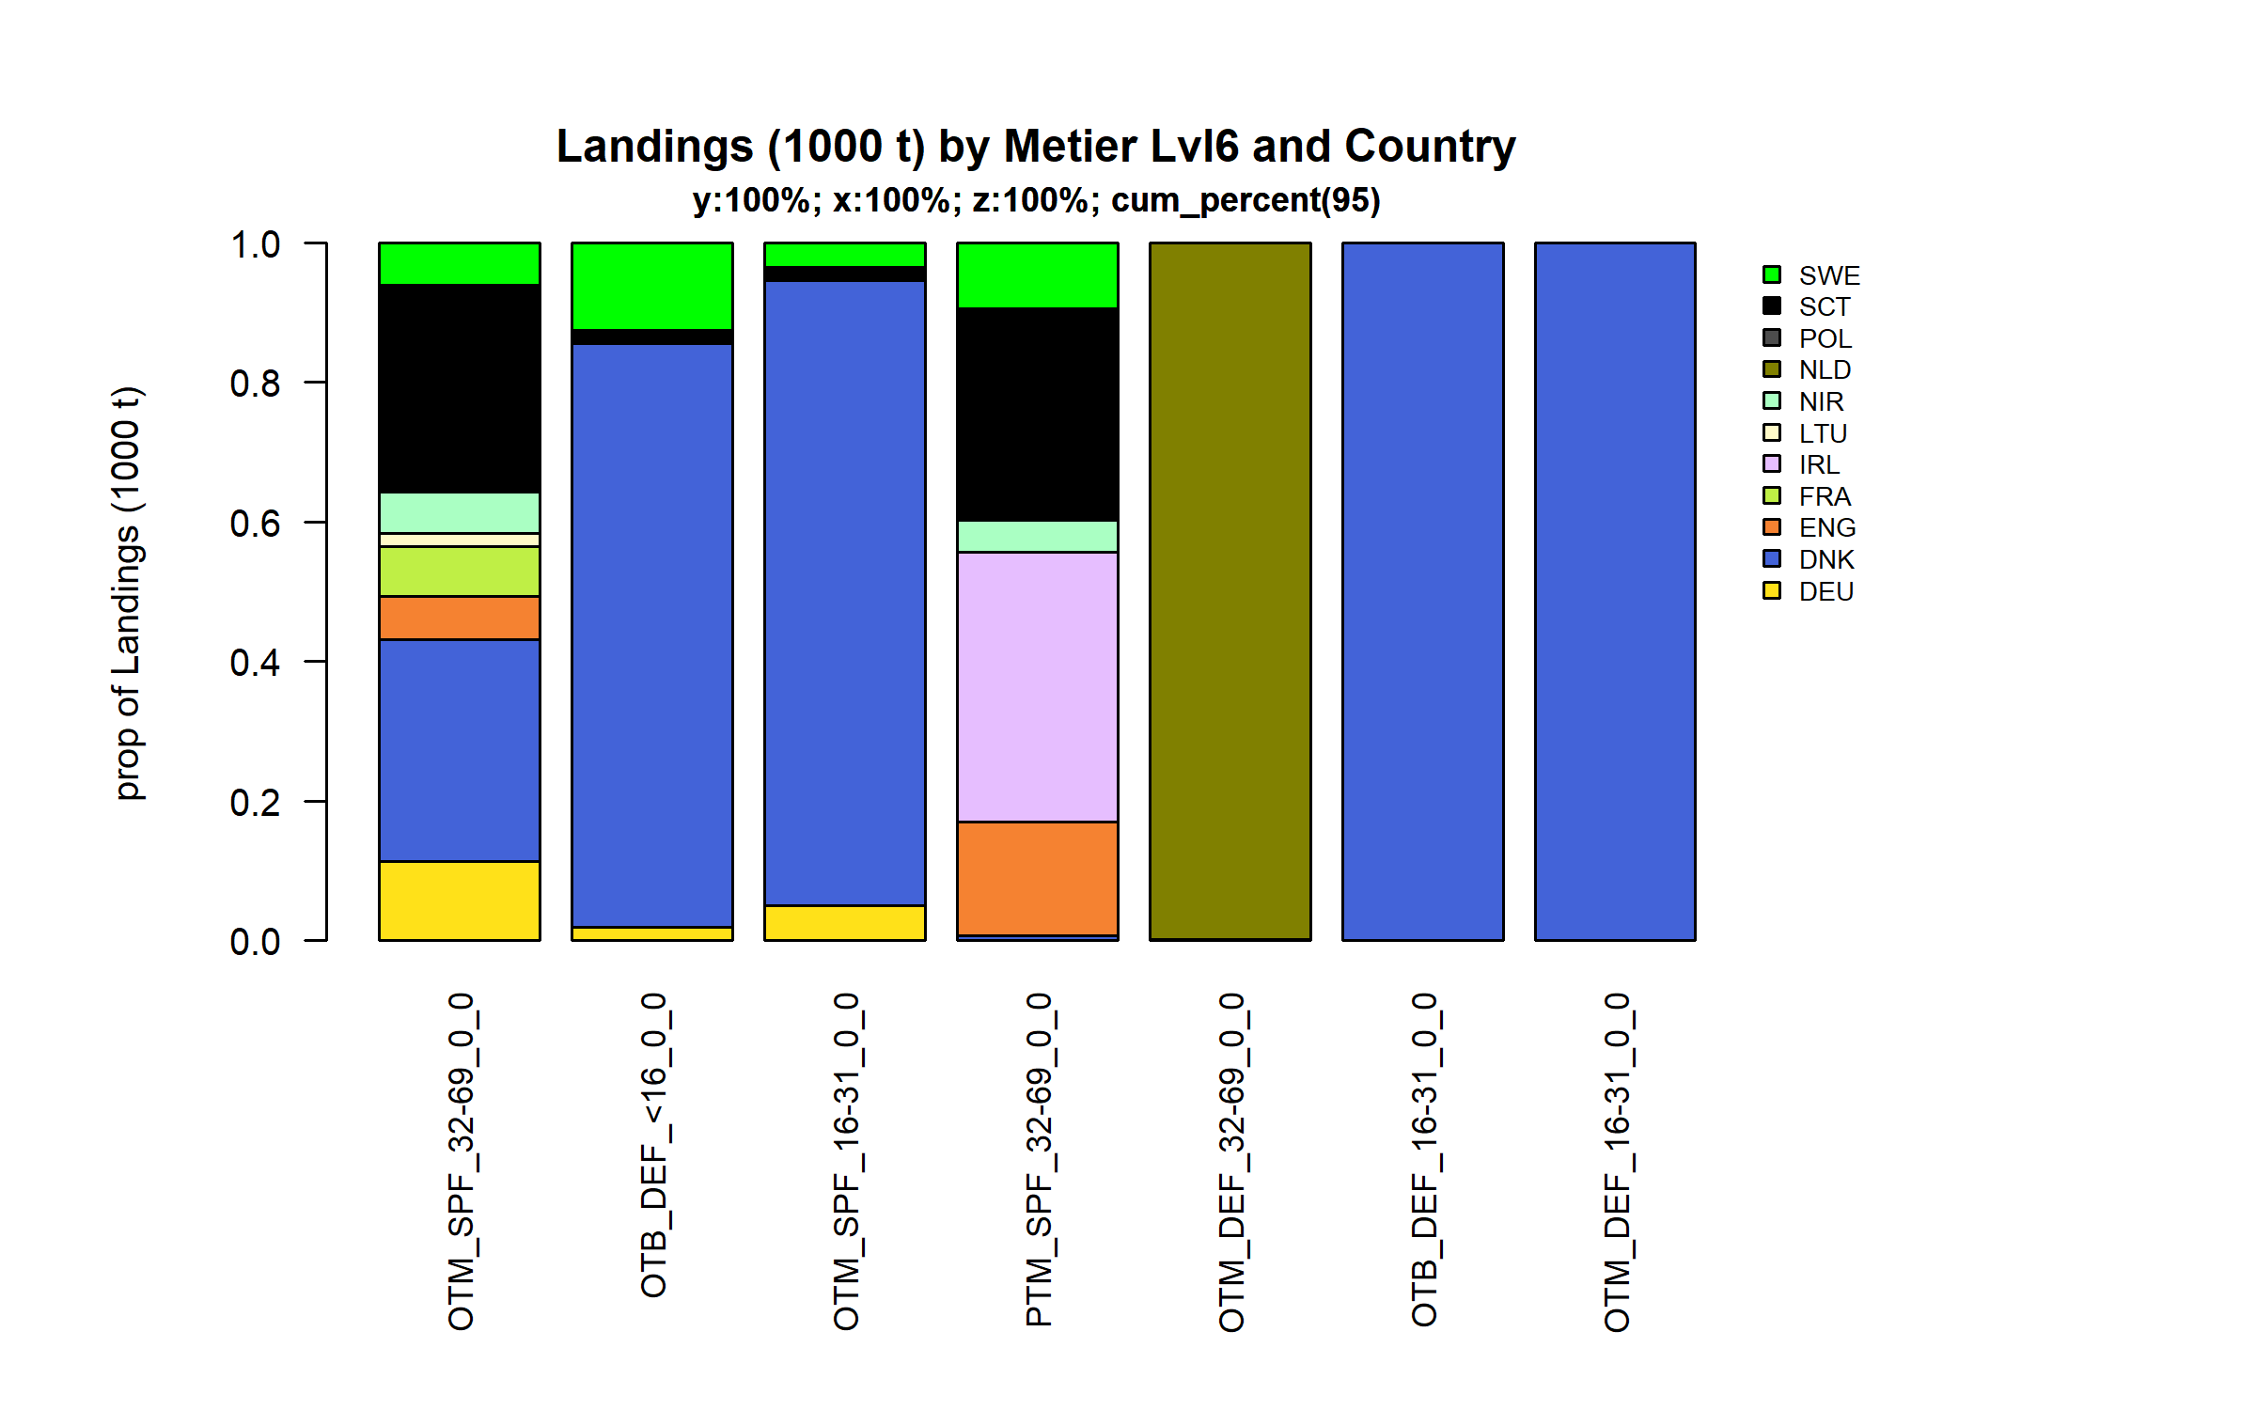 Figure 3.2.5.4. Landings (1000 t) of small pelagic by Metier Lvl6 and Country . Metier Lvl6 and Country displayed comprise 95 % of the total Landings (1000 t) .

### Landings by harbour, small pelagic

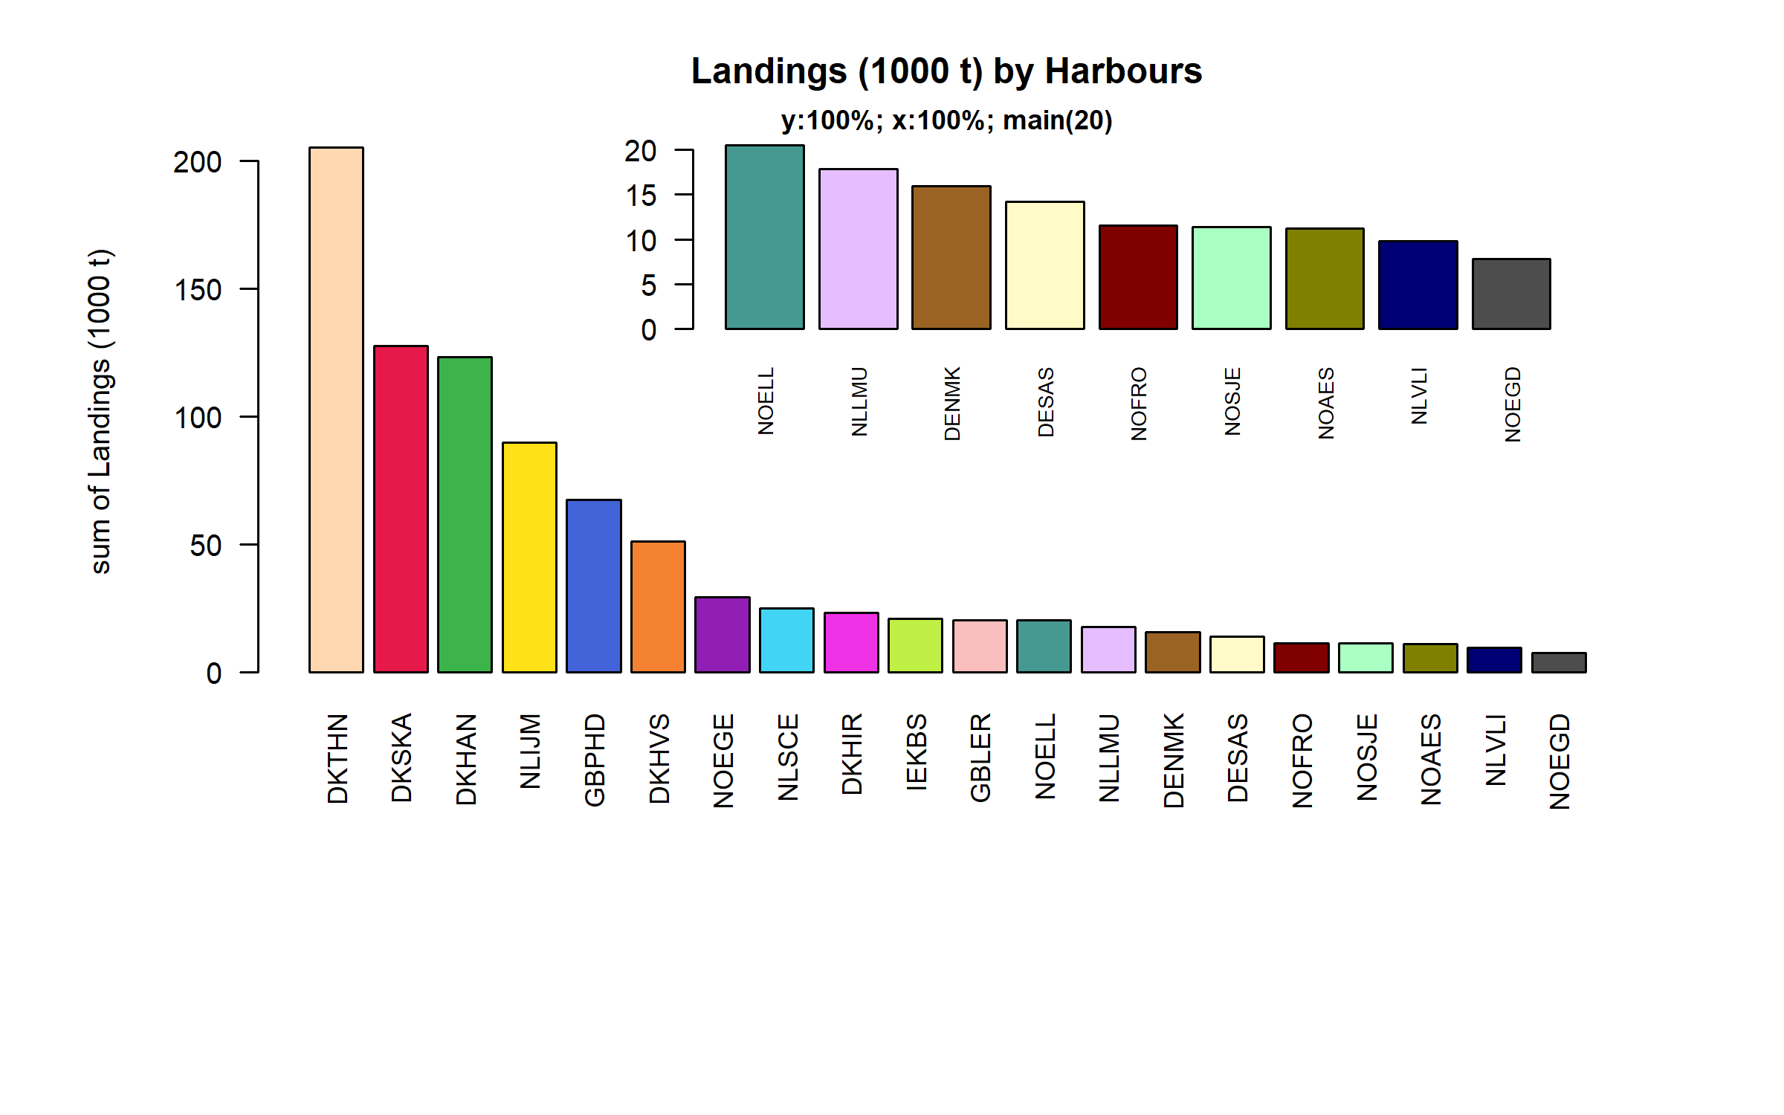 Figure 3.2.6.1. Landings (1000 t) of small pelagic in the 20 main Harbours (100% of rows entering analysis had known Harbours).

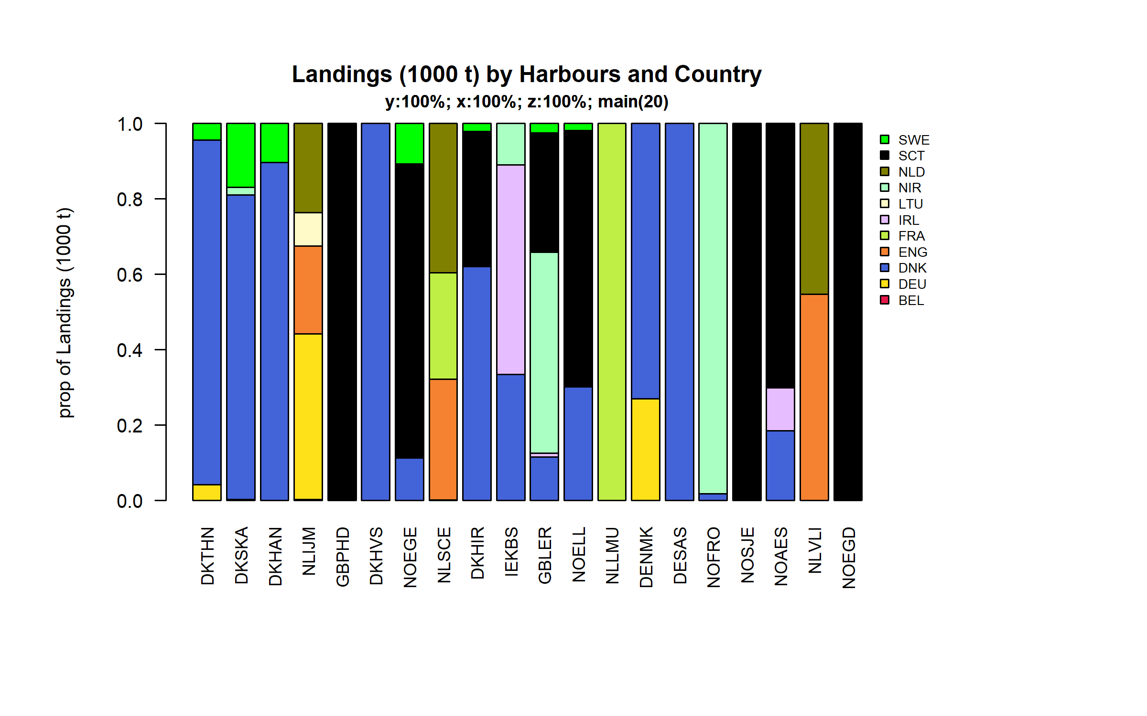 Figure 3.2.6.2. Landings (1000 t) of small pelagic by 20 main Harbours and Country .

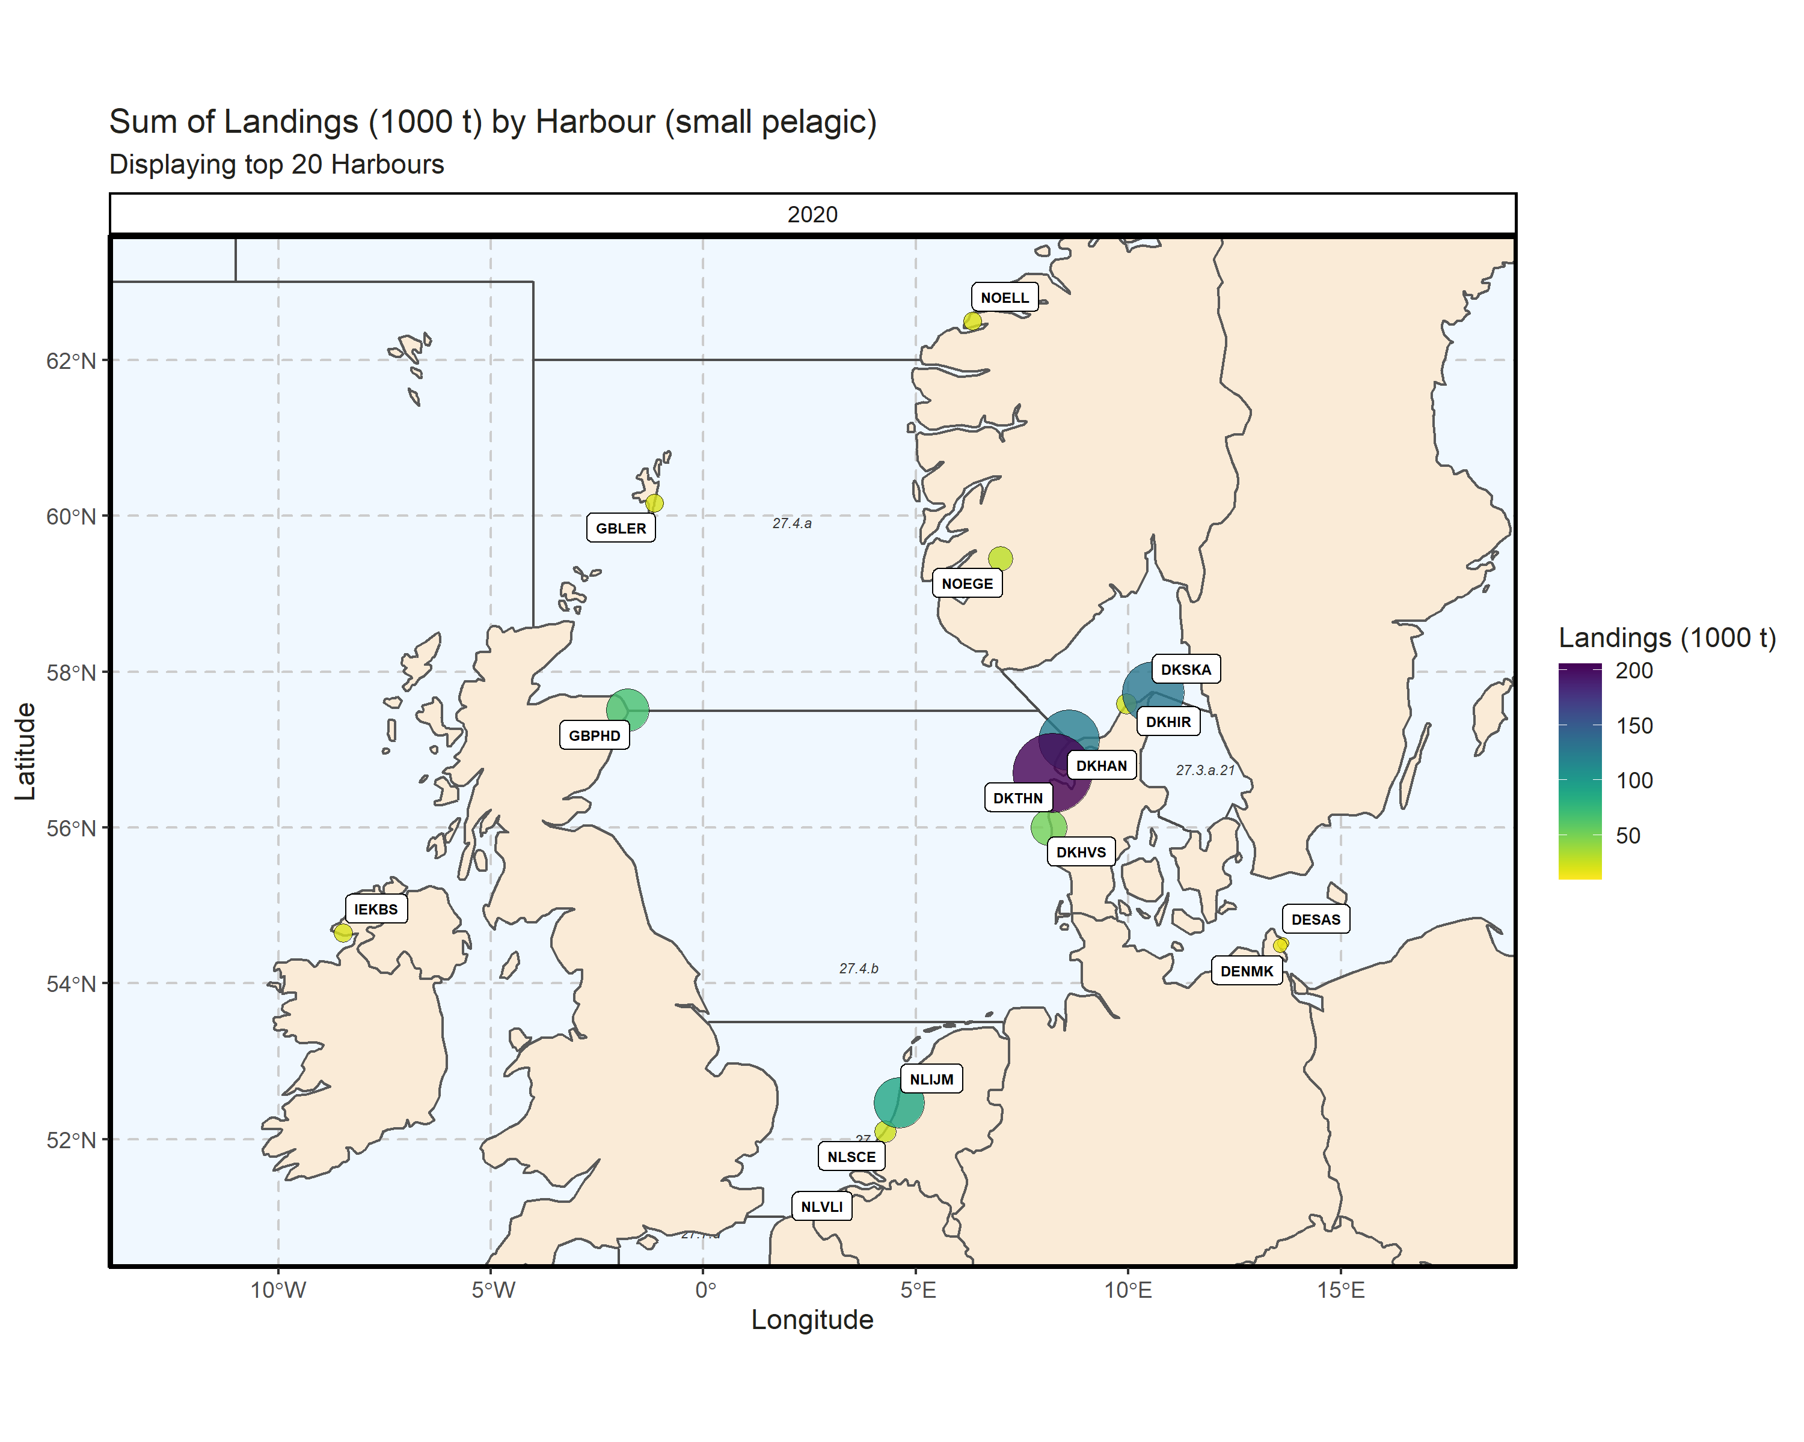 Figure 3.2.6.3. Sum of Landings (1000 t) by Harbour (small pelagic). Displaying top 20 Harbours. 0% of Landings (1000 t) - reported for missing Harbour 5 Harbour with missing coordinates (6.06% of Landings (1000 t)) - not presented on the map.

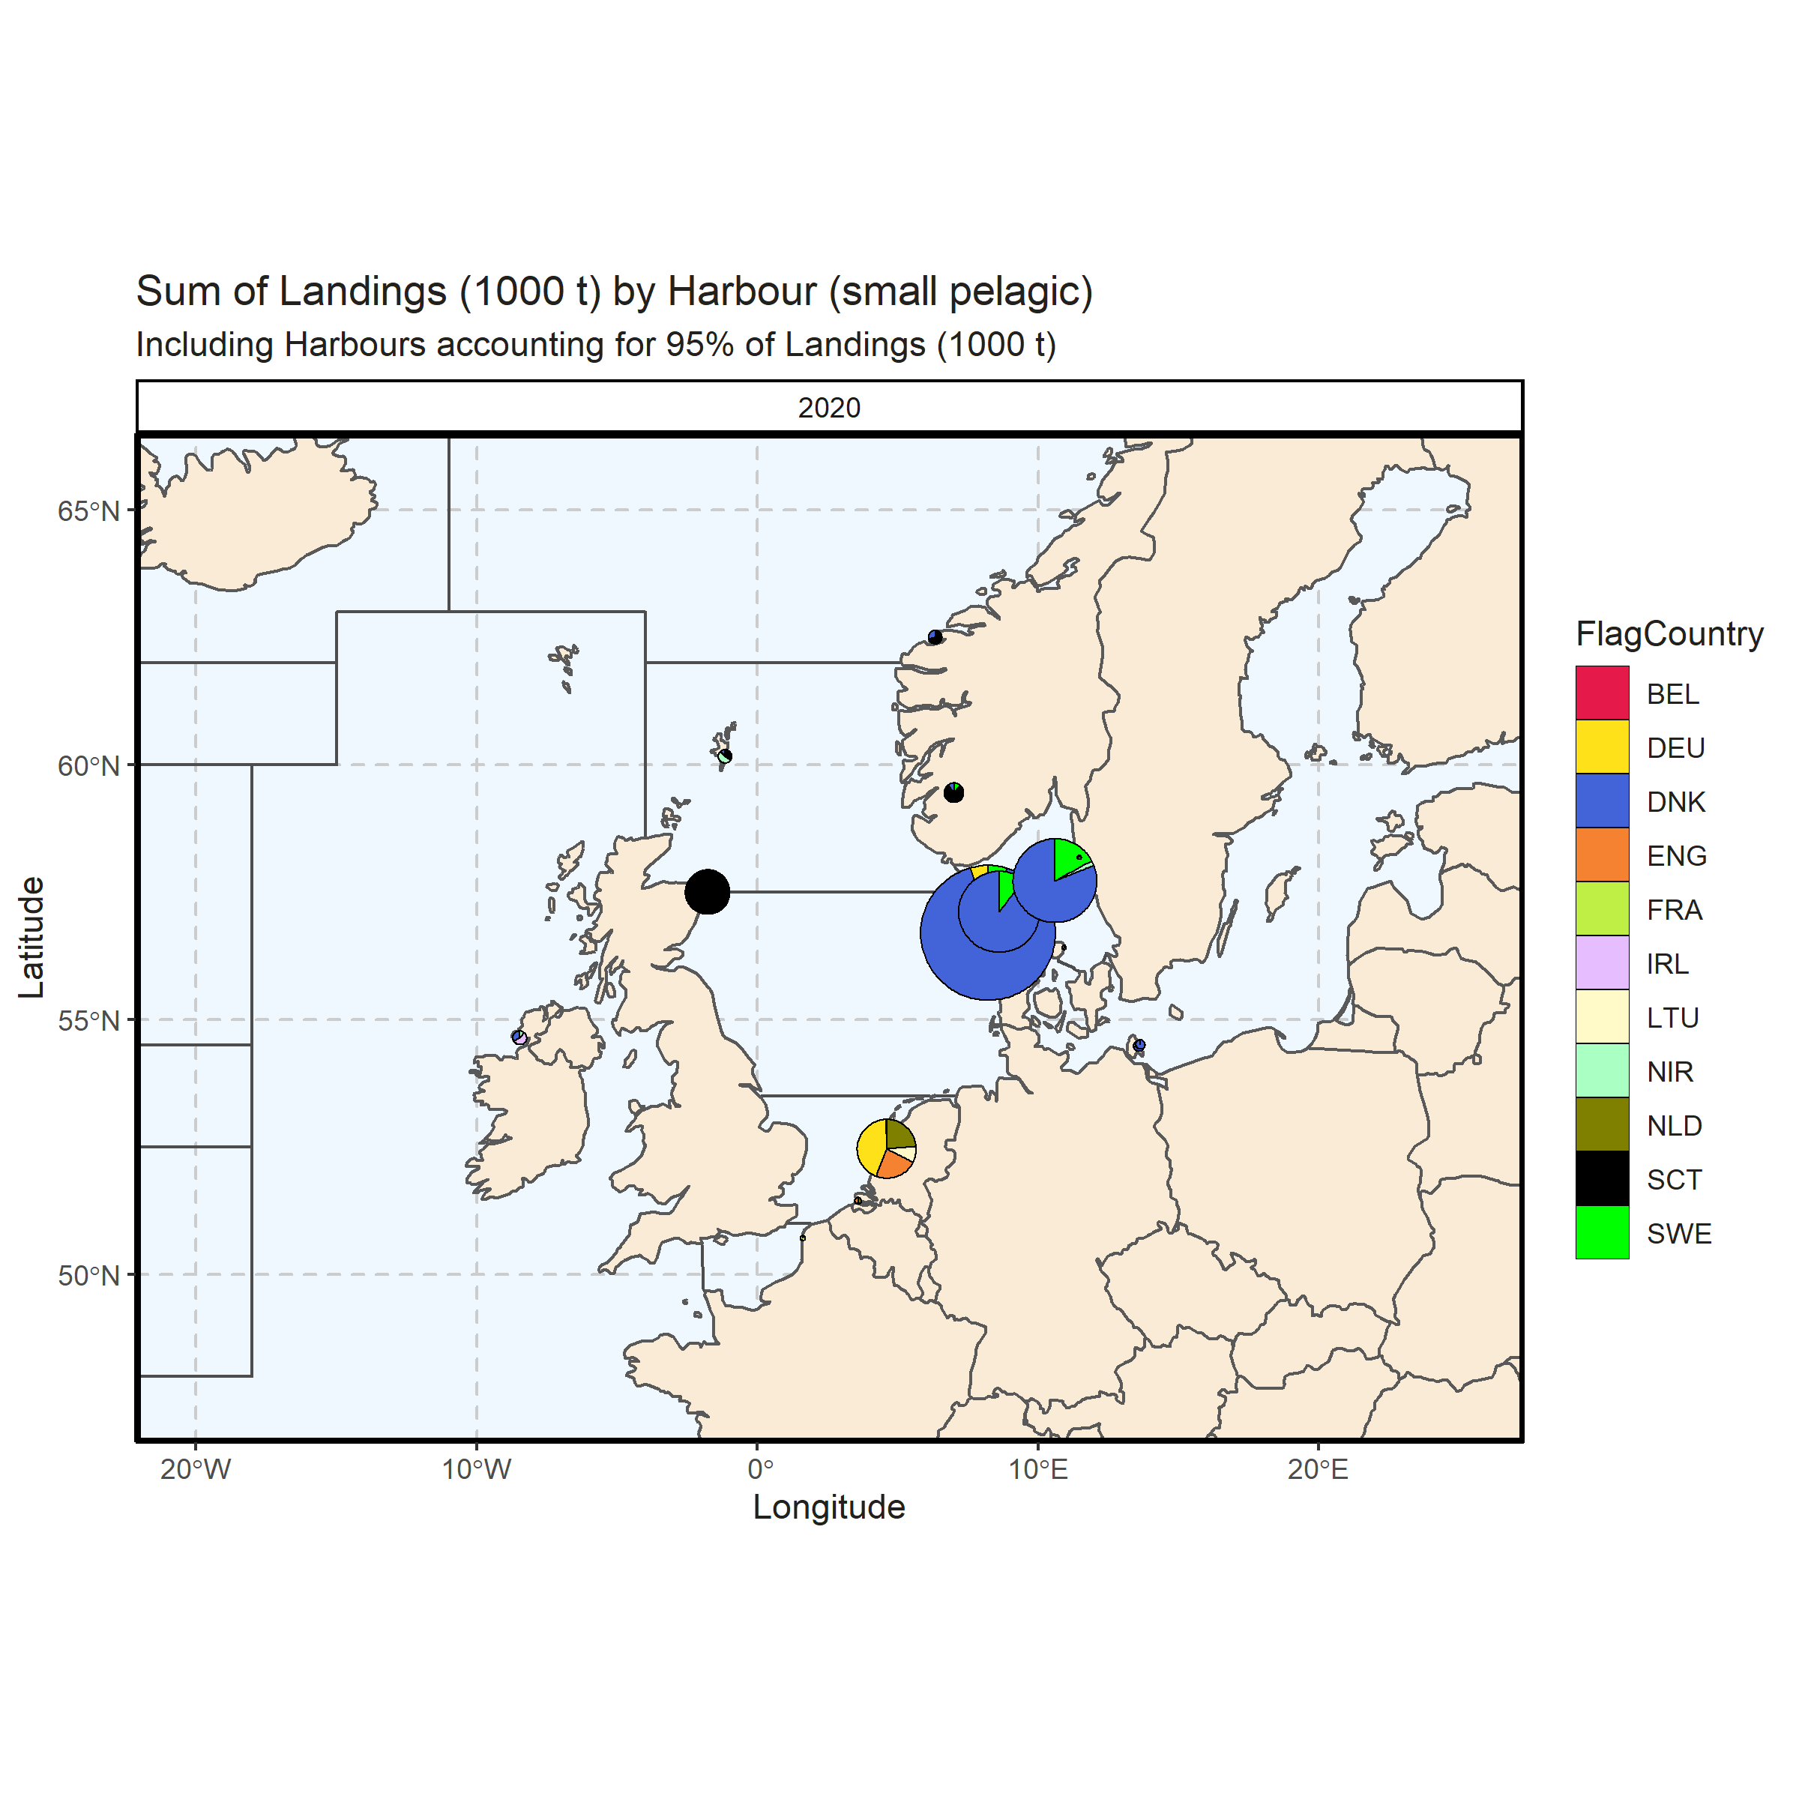 Figure 3.2.6.4. Sum of Landings (1000 t) by Harbour (small pelagic). Including Harbours accounting for 95% of Landings (1000 t). 0% of Landings (1000 t) - reported for missing Harbour. 6 Harbour with missing coordinates (6.67% of Landings (1000 t)) - not presented on the map.

### Landings abroad, small pelagic

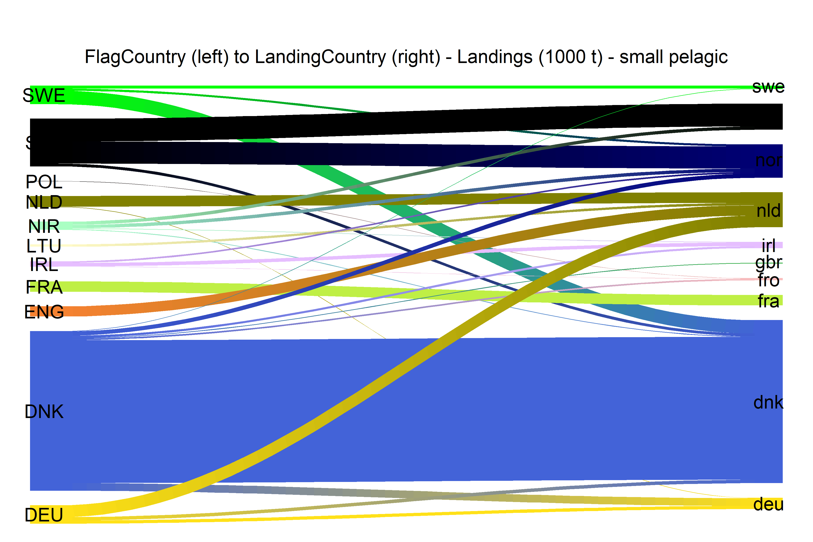  
Figure 3.2.7.1.River plot of Landings (1000 t) between Country (left) and Landing Country (right). Width of line is proportional to landings

### Spatial distribution of landings, small pelagic

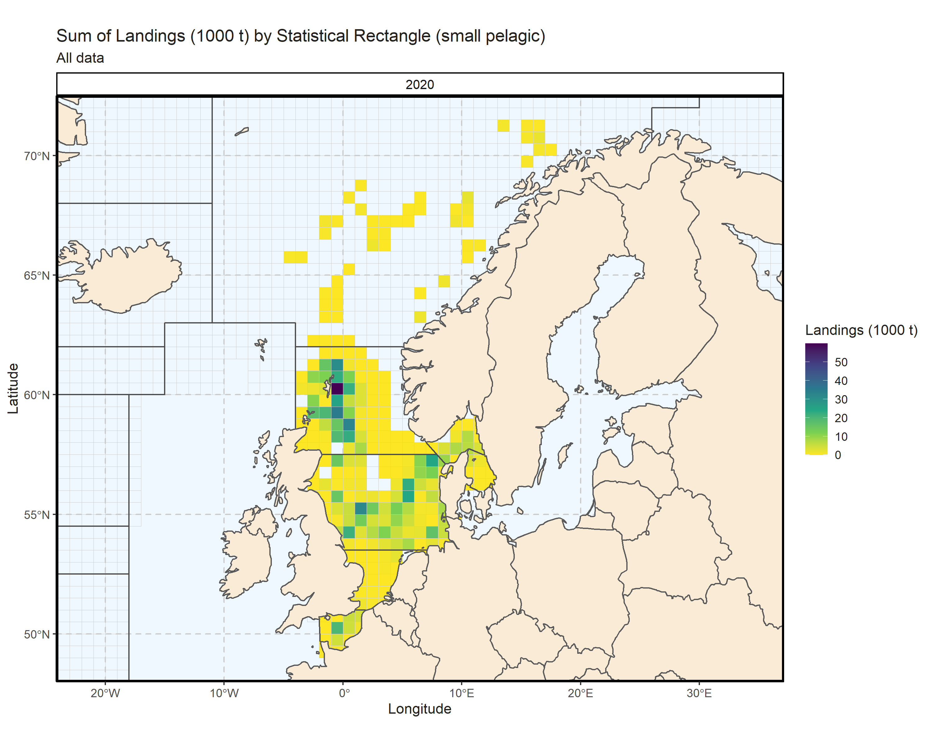 Figure 3.2.8.1. Sum of Landings (1000 t) by Statistical Rectangle (small pelagic). All data. 1.93% of Landings (1000 t) - reported for missing Statistical Rectangle.

## Demersal landings (without flatfish)

### Landings by country, demersal (without flatfish)

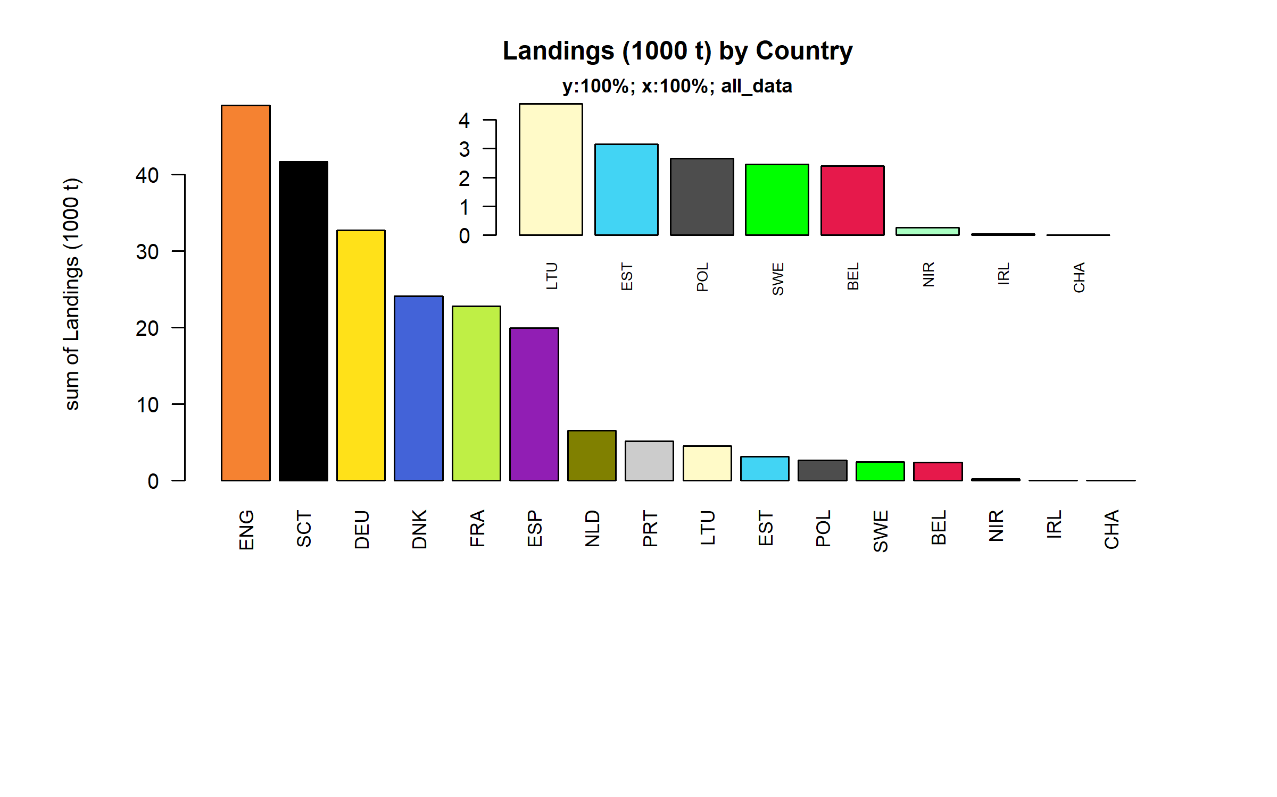 Figure 3.3.1.1. Landings (1000 t) of demersal by Country.

### Landings by species, demersal (without flatfish)

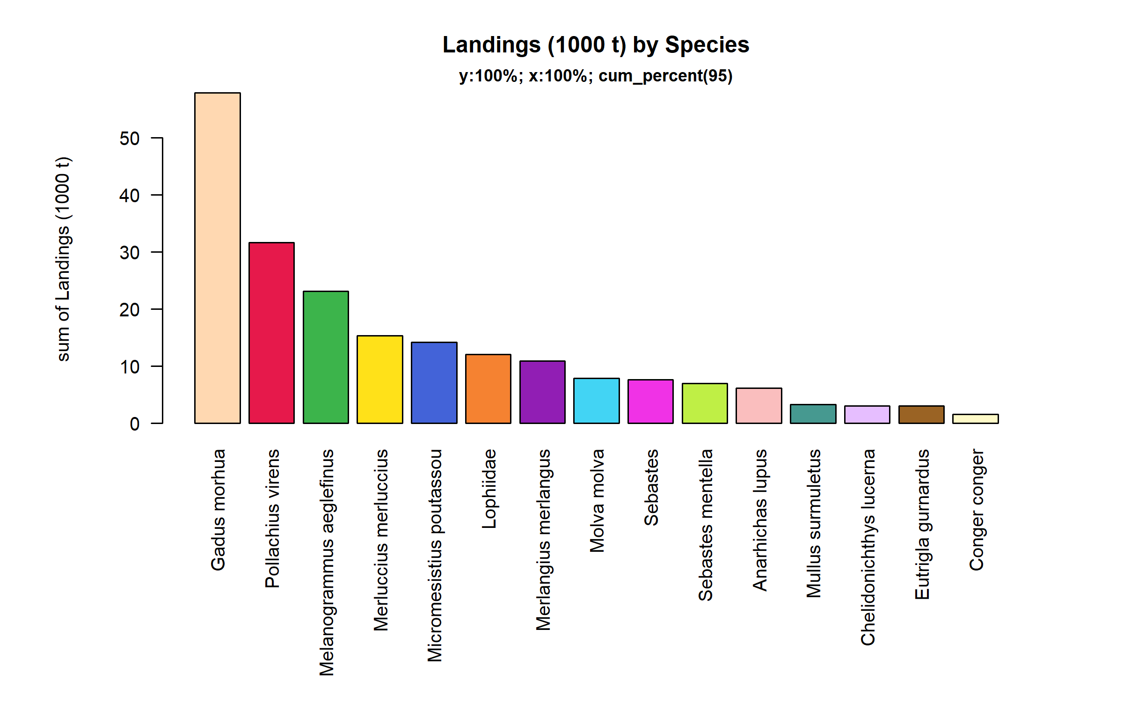 Figure 3.3.2.1. Landings (1000 t) of demersal by Species. Species displayed comprise 95% of the total Landings (1000 t).

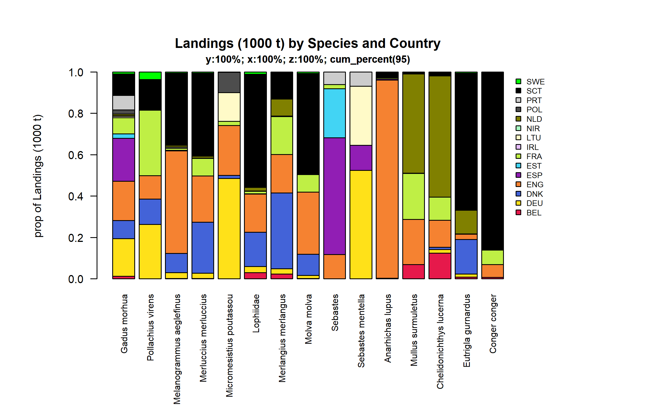 Figure 3.3.2.2. Landings (1000 t) of demersal by Species and Country . Species and Country displayed comprise 95 % of the total Landings (1000 t) .

### Landings by fleet, demersal (without flatfish)

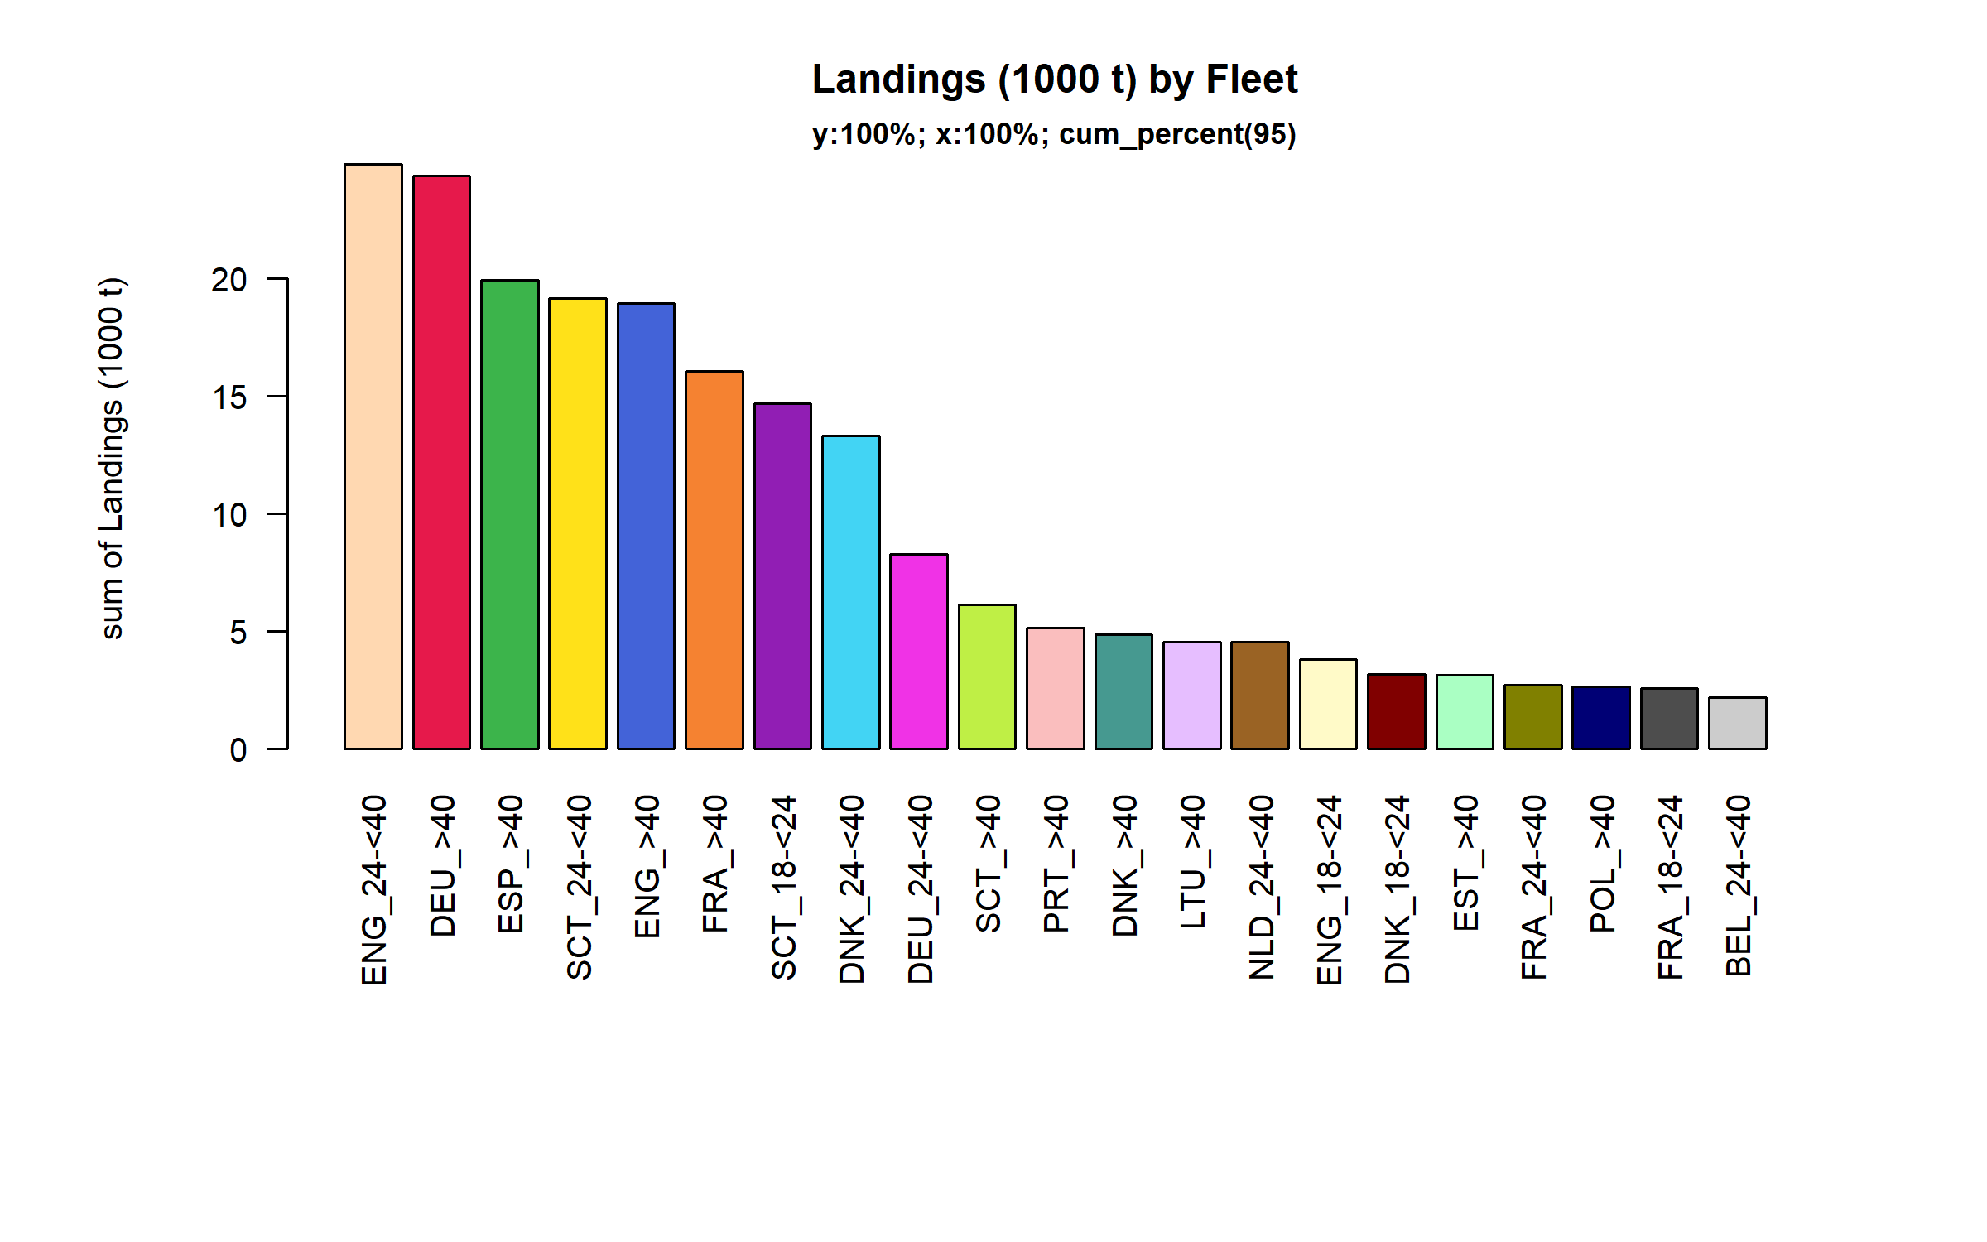 Figure 3.3.3.1. Landings (1000 t) of demersal by Fleet. Fleet displayed comprise 95% of the total Landings (1000 t).

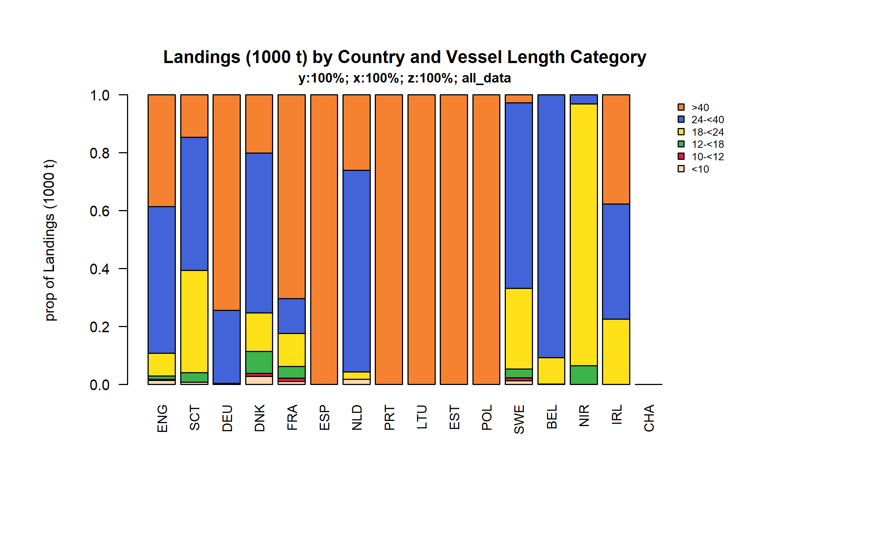 Figure 3.3.3.2. Landings (1000 t) of demersal by Country and Vessel Length Category.

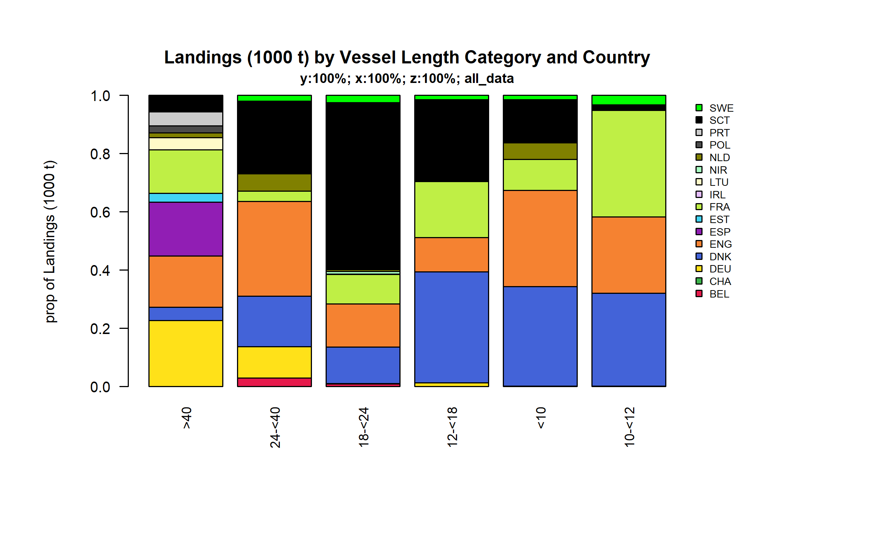 Figure 3.3.3.3. Landings (1000 t) of demersal by Vessel Length Category and Country.

### Landings by area, demersal (without flatfish)

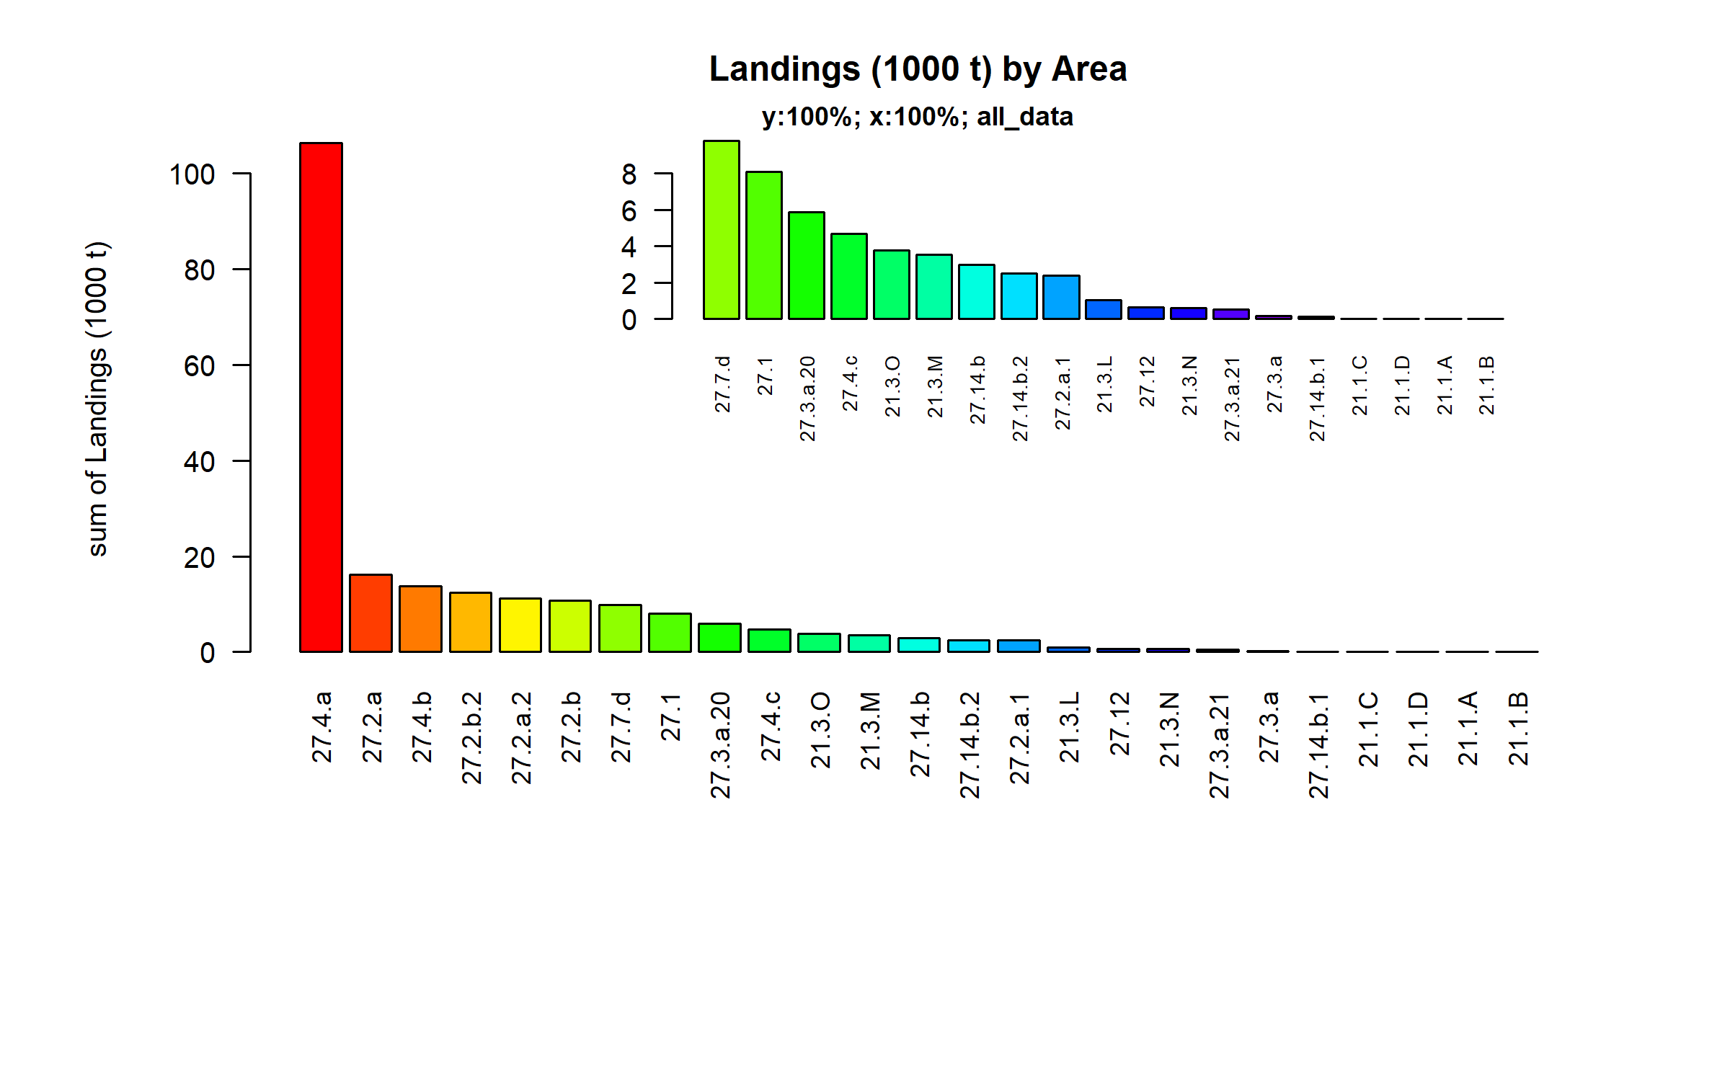 Figure 3.3.4.1. Landings (1000 t) of demersal by Area.

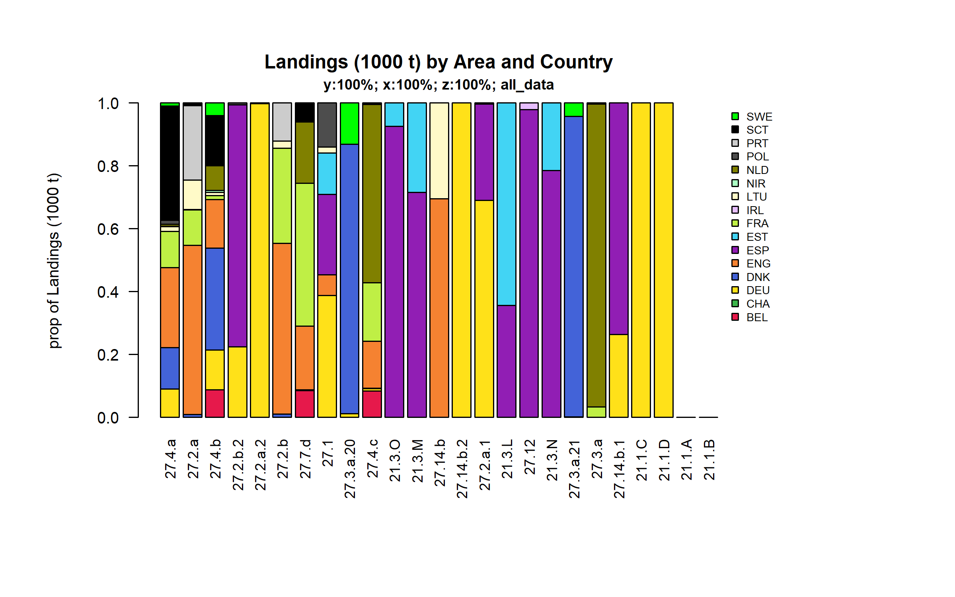 Figure 3.3.4.2. Landings (1000 t) of demersal by Area and Country.

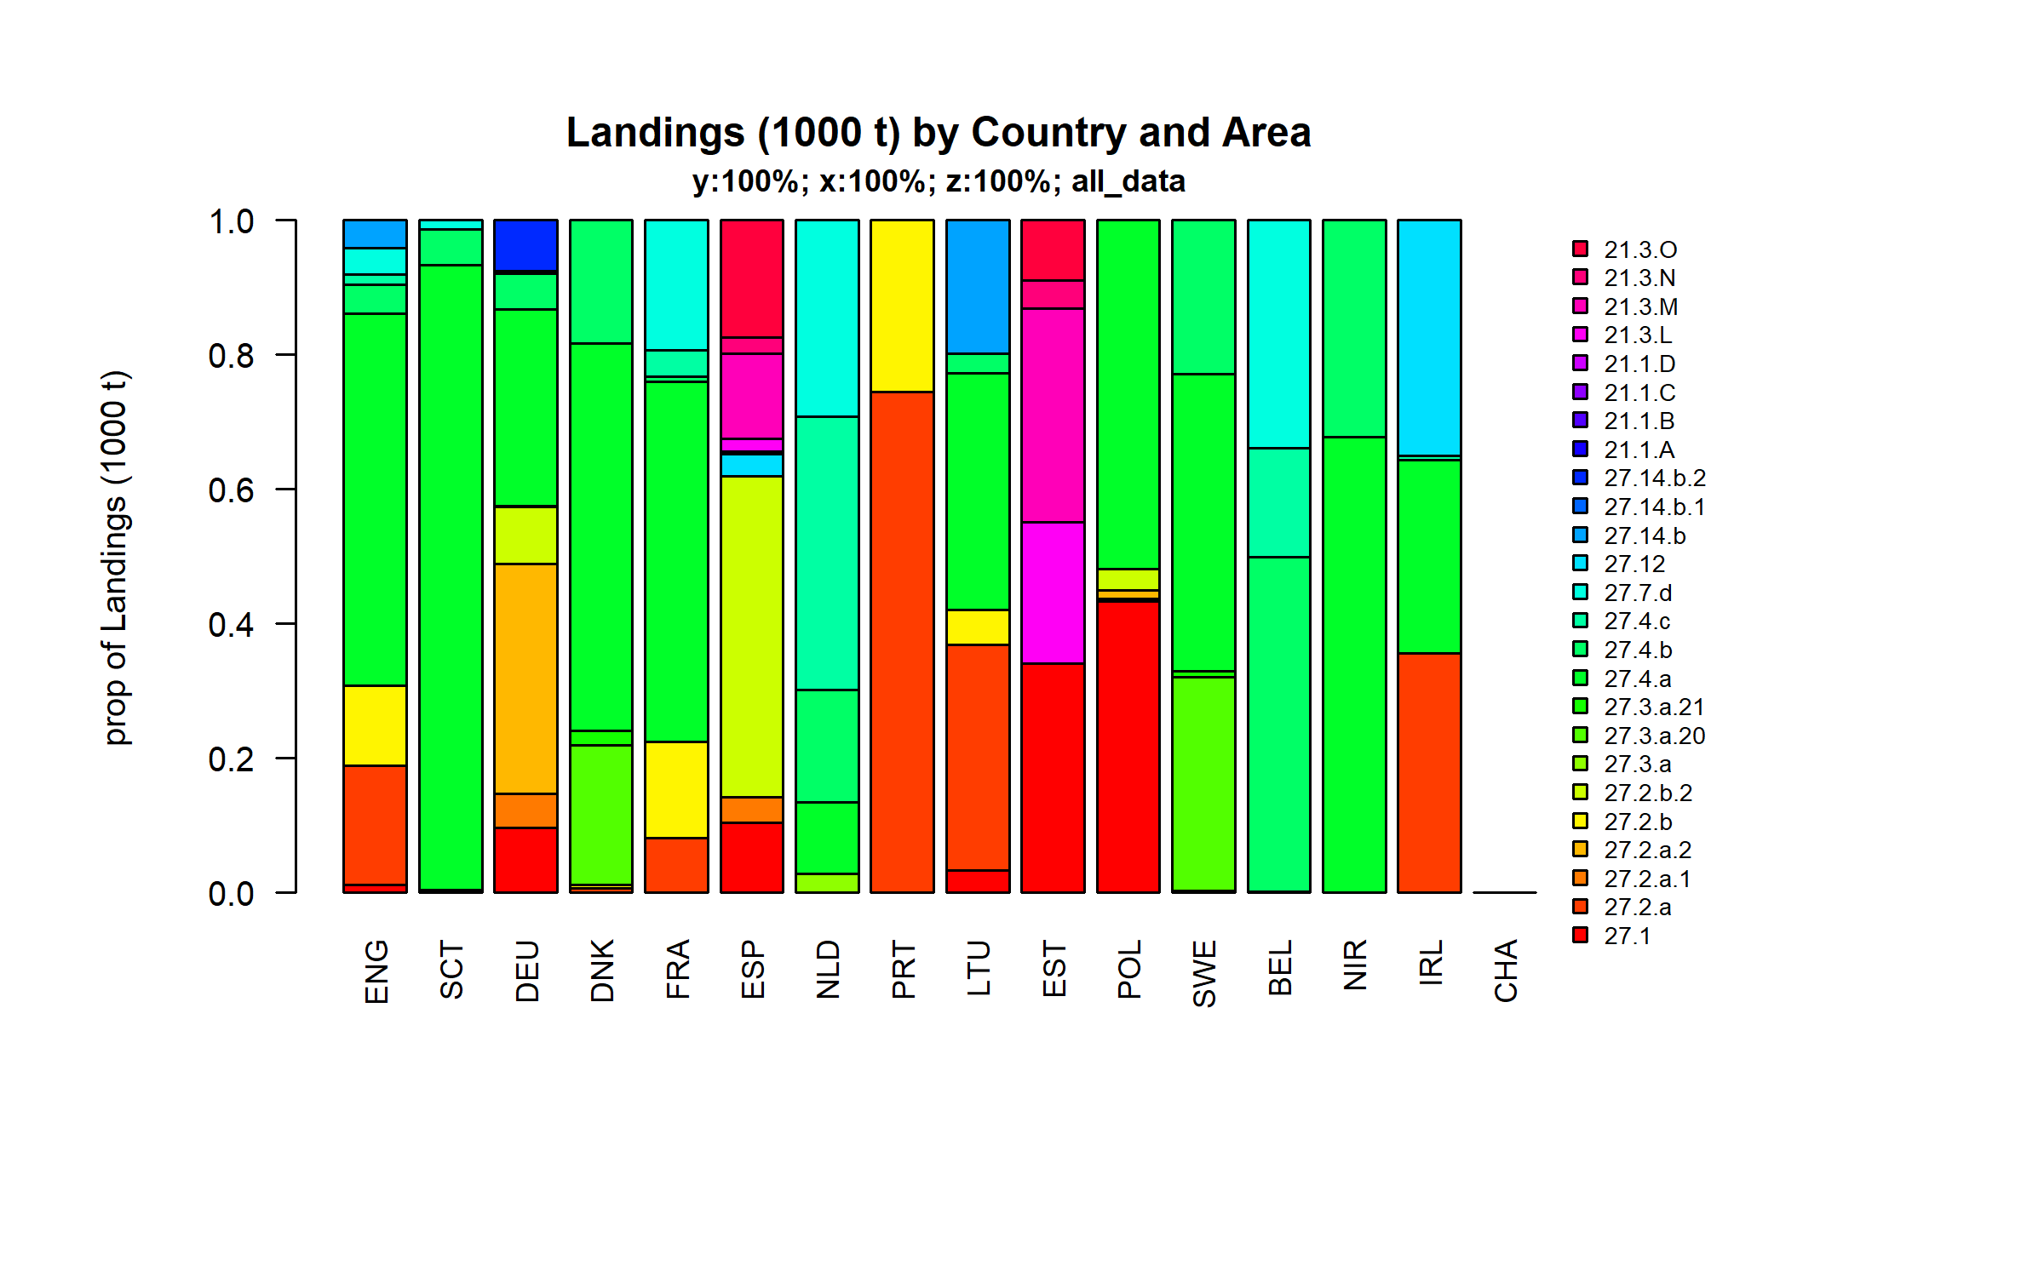 Figure 3.3.4.3. Landings (1000 t) of demersal by Country and Area.

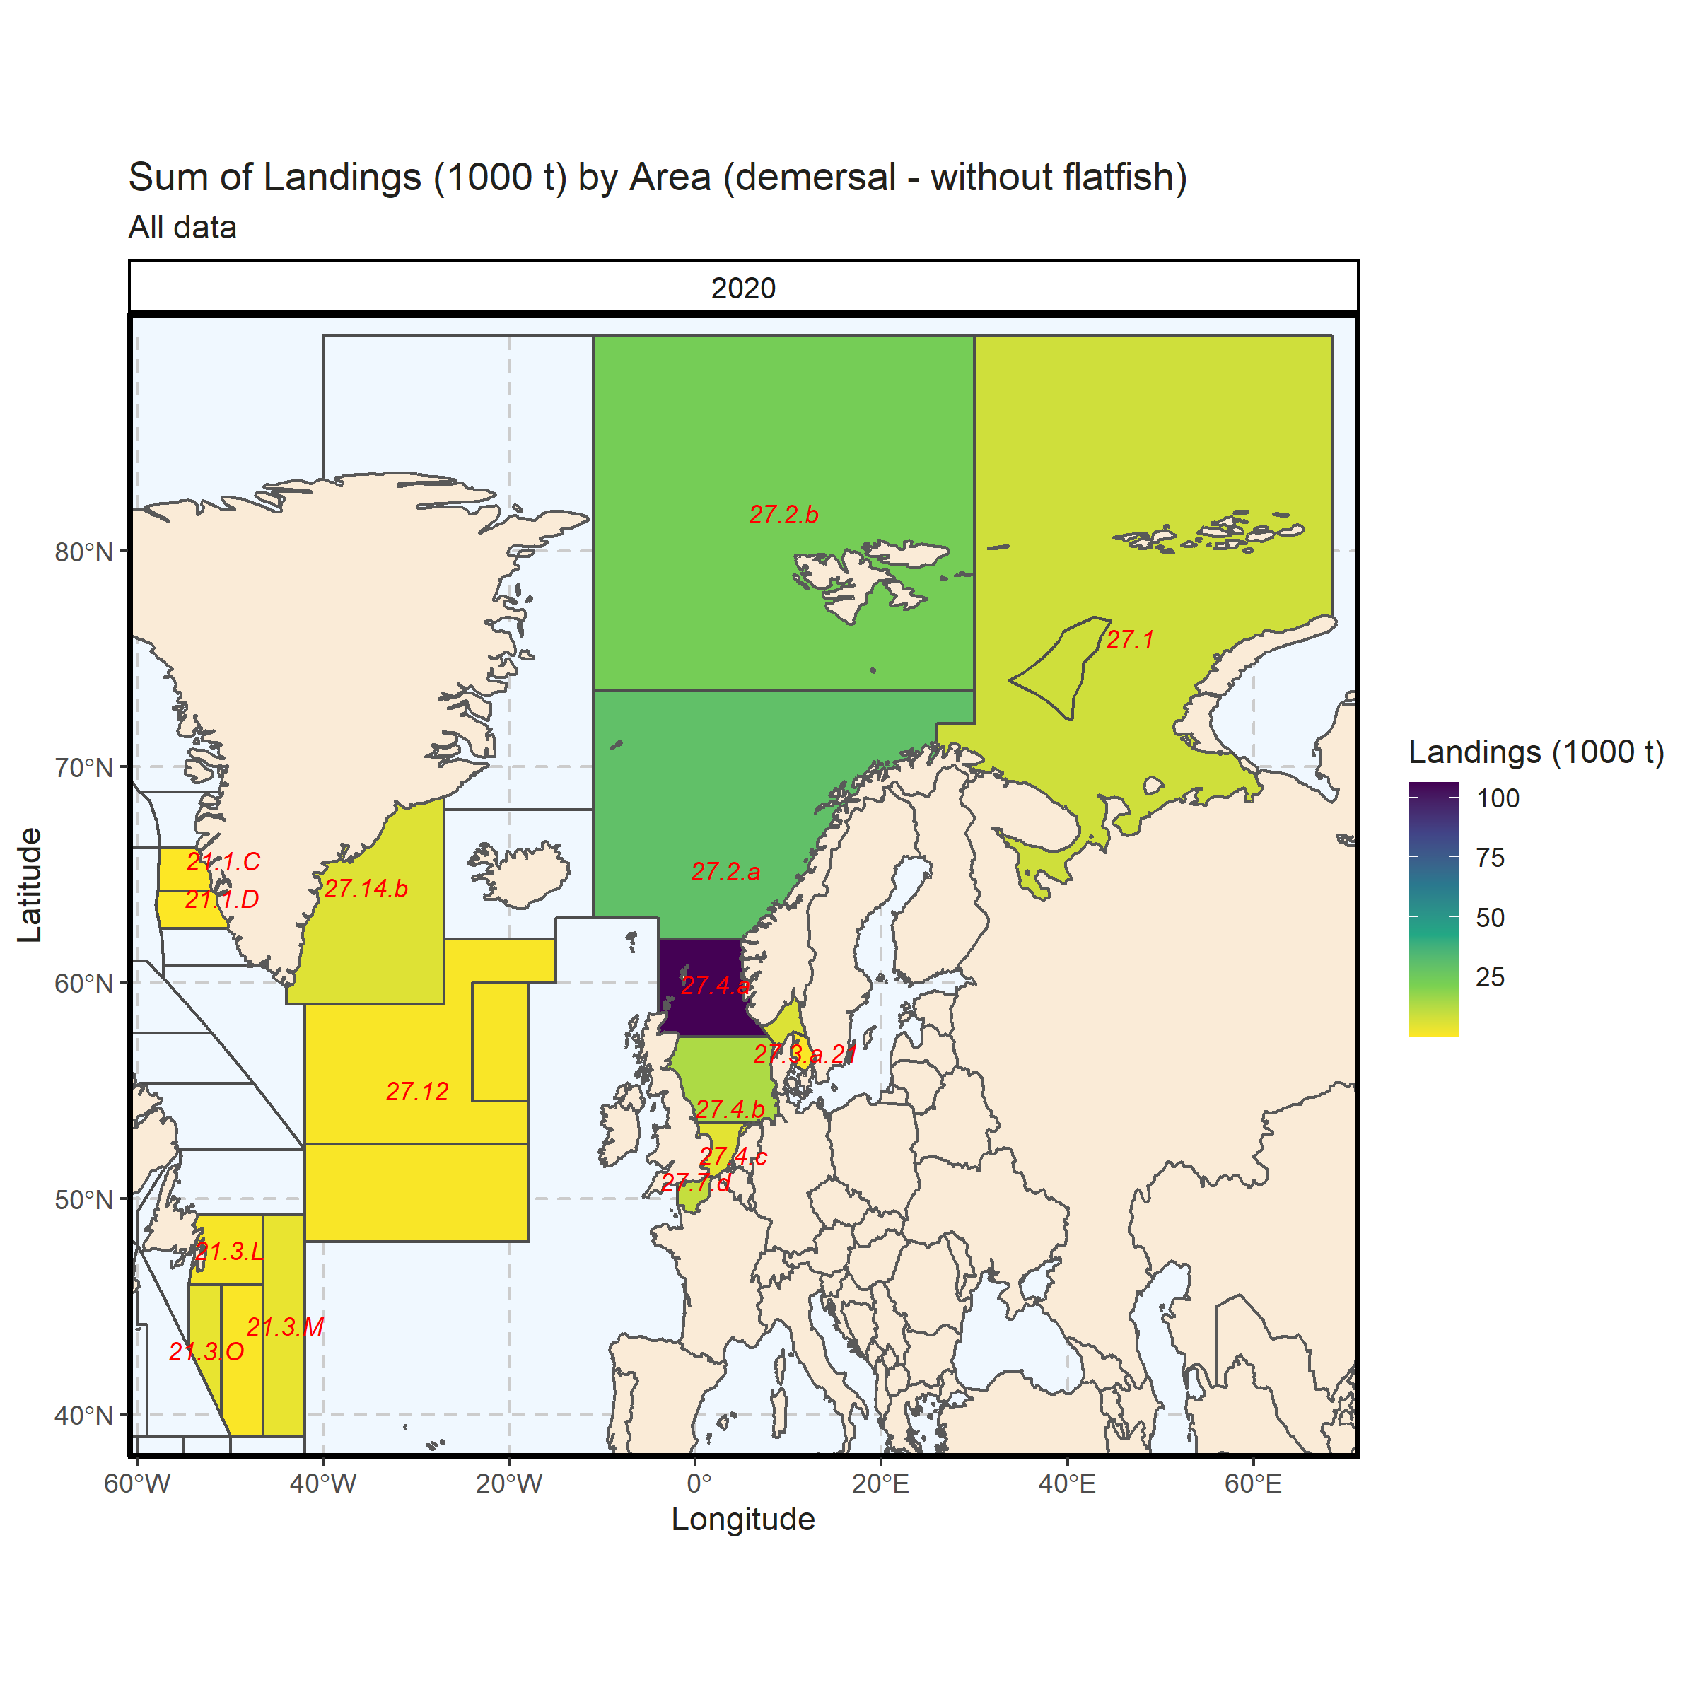 Figure 3.3.4.4. Sum of Landings (1000 t) by Area (demersal - without flatfish). All data. 0.09% of Landings (1000 t) - reported for missing Area.

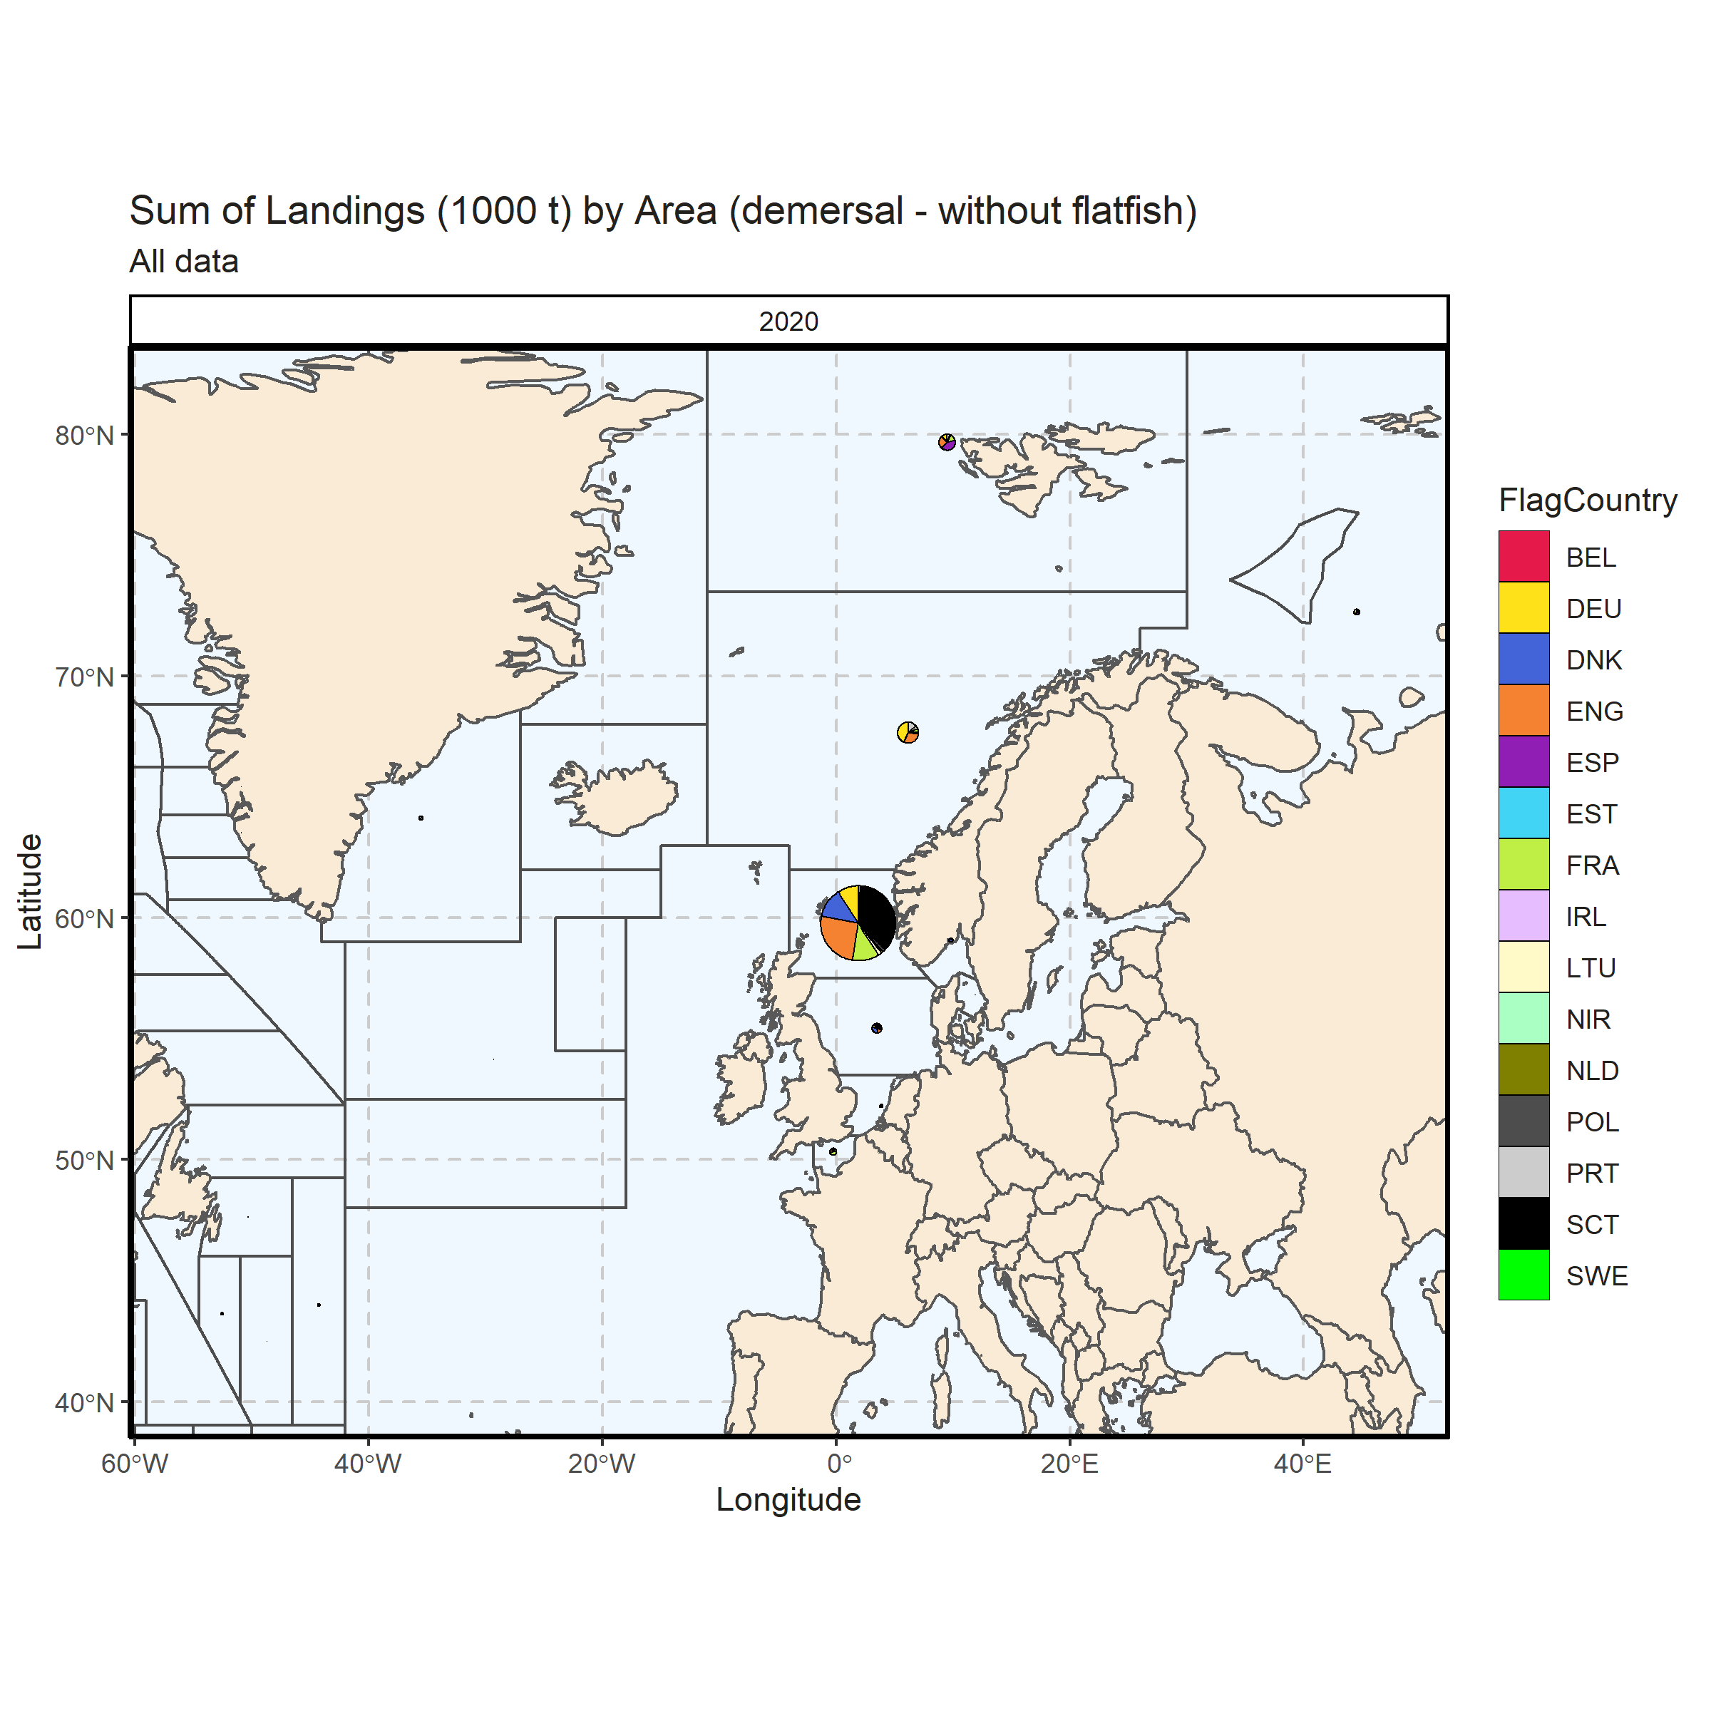 Figure 3.3.4.5. Sum of Landings (1000 t) by Area (demersal - without flatfish). All data. 0.09% of Landings (1000 t) - reported for missing Area.

### Landings by metier, demersal (without flatfish)

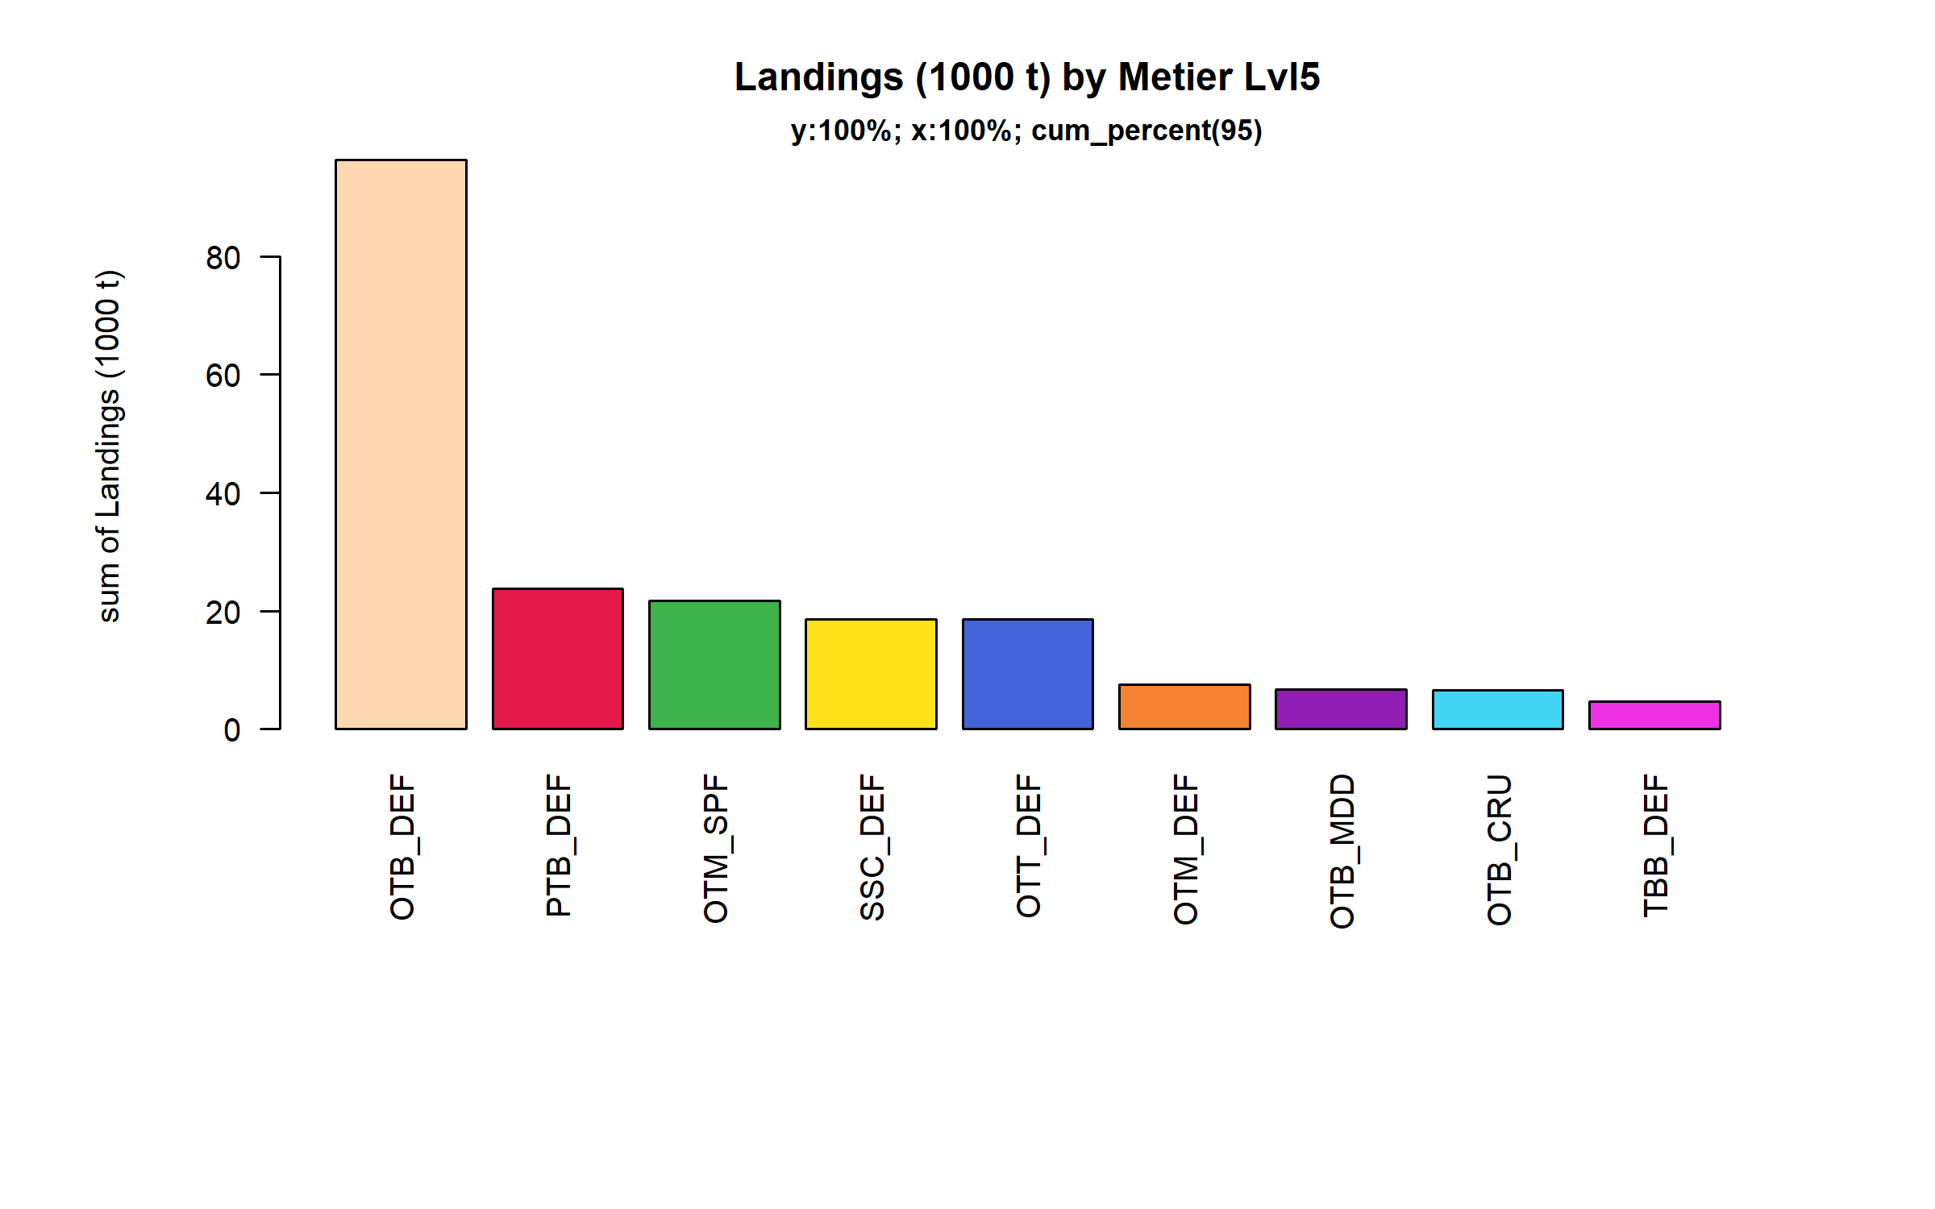 Figure 3.3.5.1. Landings (1000 t) of demersal by Metier Lvl5. Metier Lvl5 displayed comprise 95% of the total Landings (1000 t).

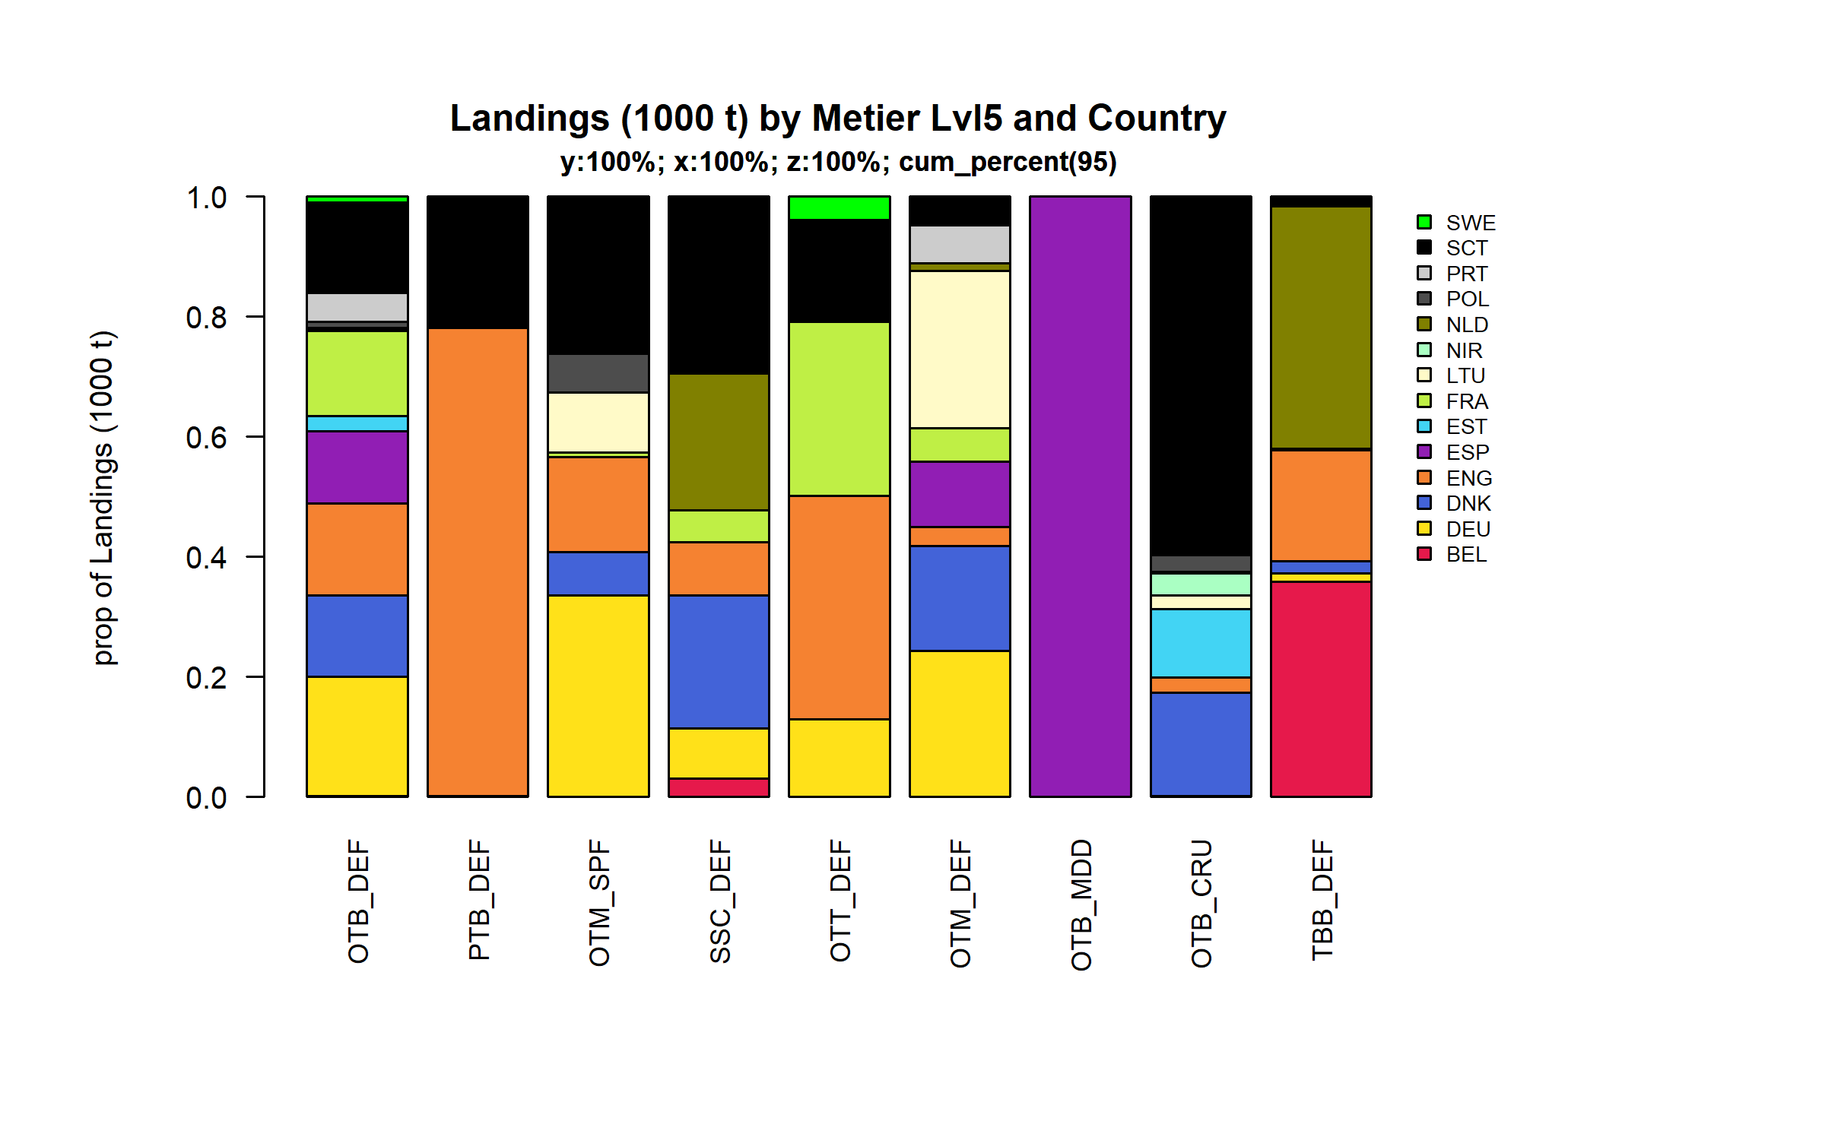 Figure 3.3.5.2. Landings (1000 t) of demersal by Metier Lvl5 and Country . Metier Lvl5 and Country displayed comprise 95 % of the total Landings (1000 t) .

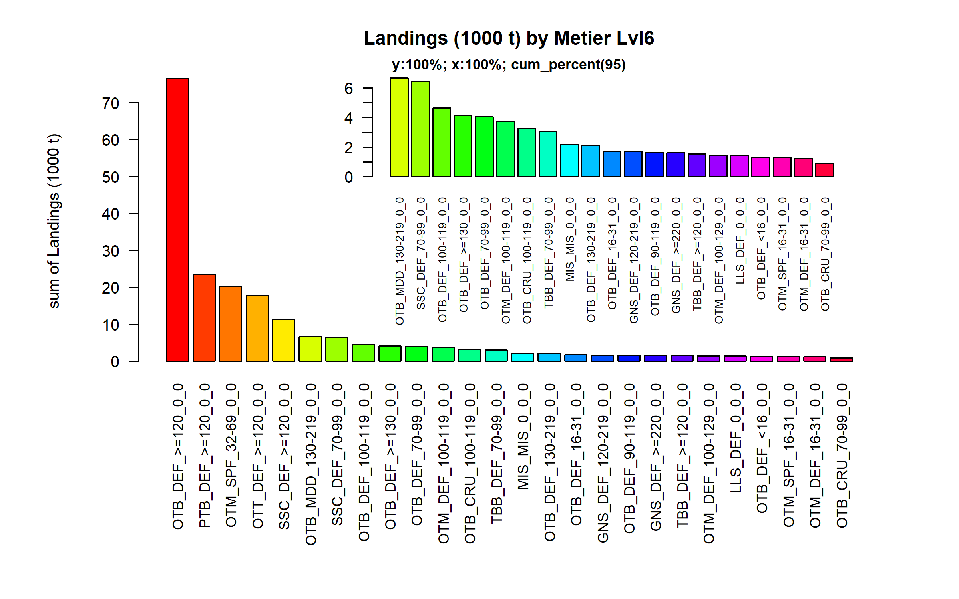 Figure 3.3.5.3. Landings (1000 t) of demersal by Metier Lvl6. Metier Lvl6 displayed comprise 95% of the total Landings (1000 t).

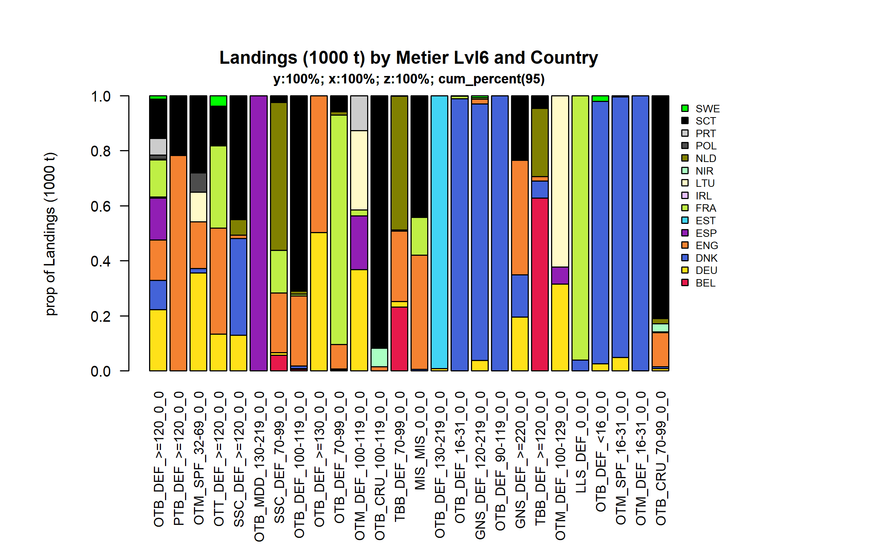 Figure 3.3.5.4. Landings (1000 t) of demersal by Metier Lvl6 and Country . Metier Lvl6 and Country displayed comprise 95 % of the total Landings (1000 t) .

### Landings by harbour, demersal (without flatfish)

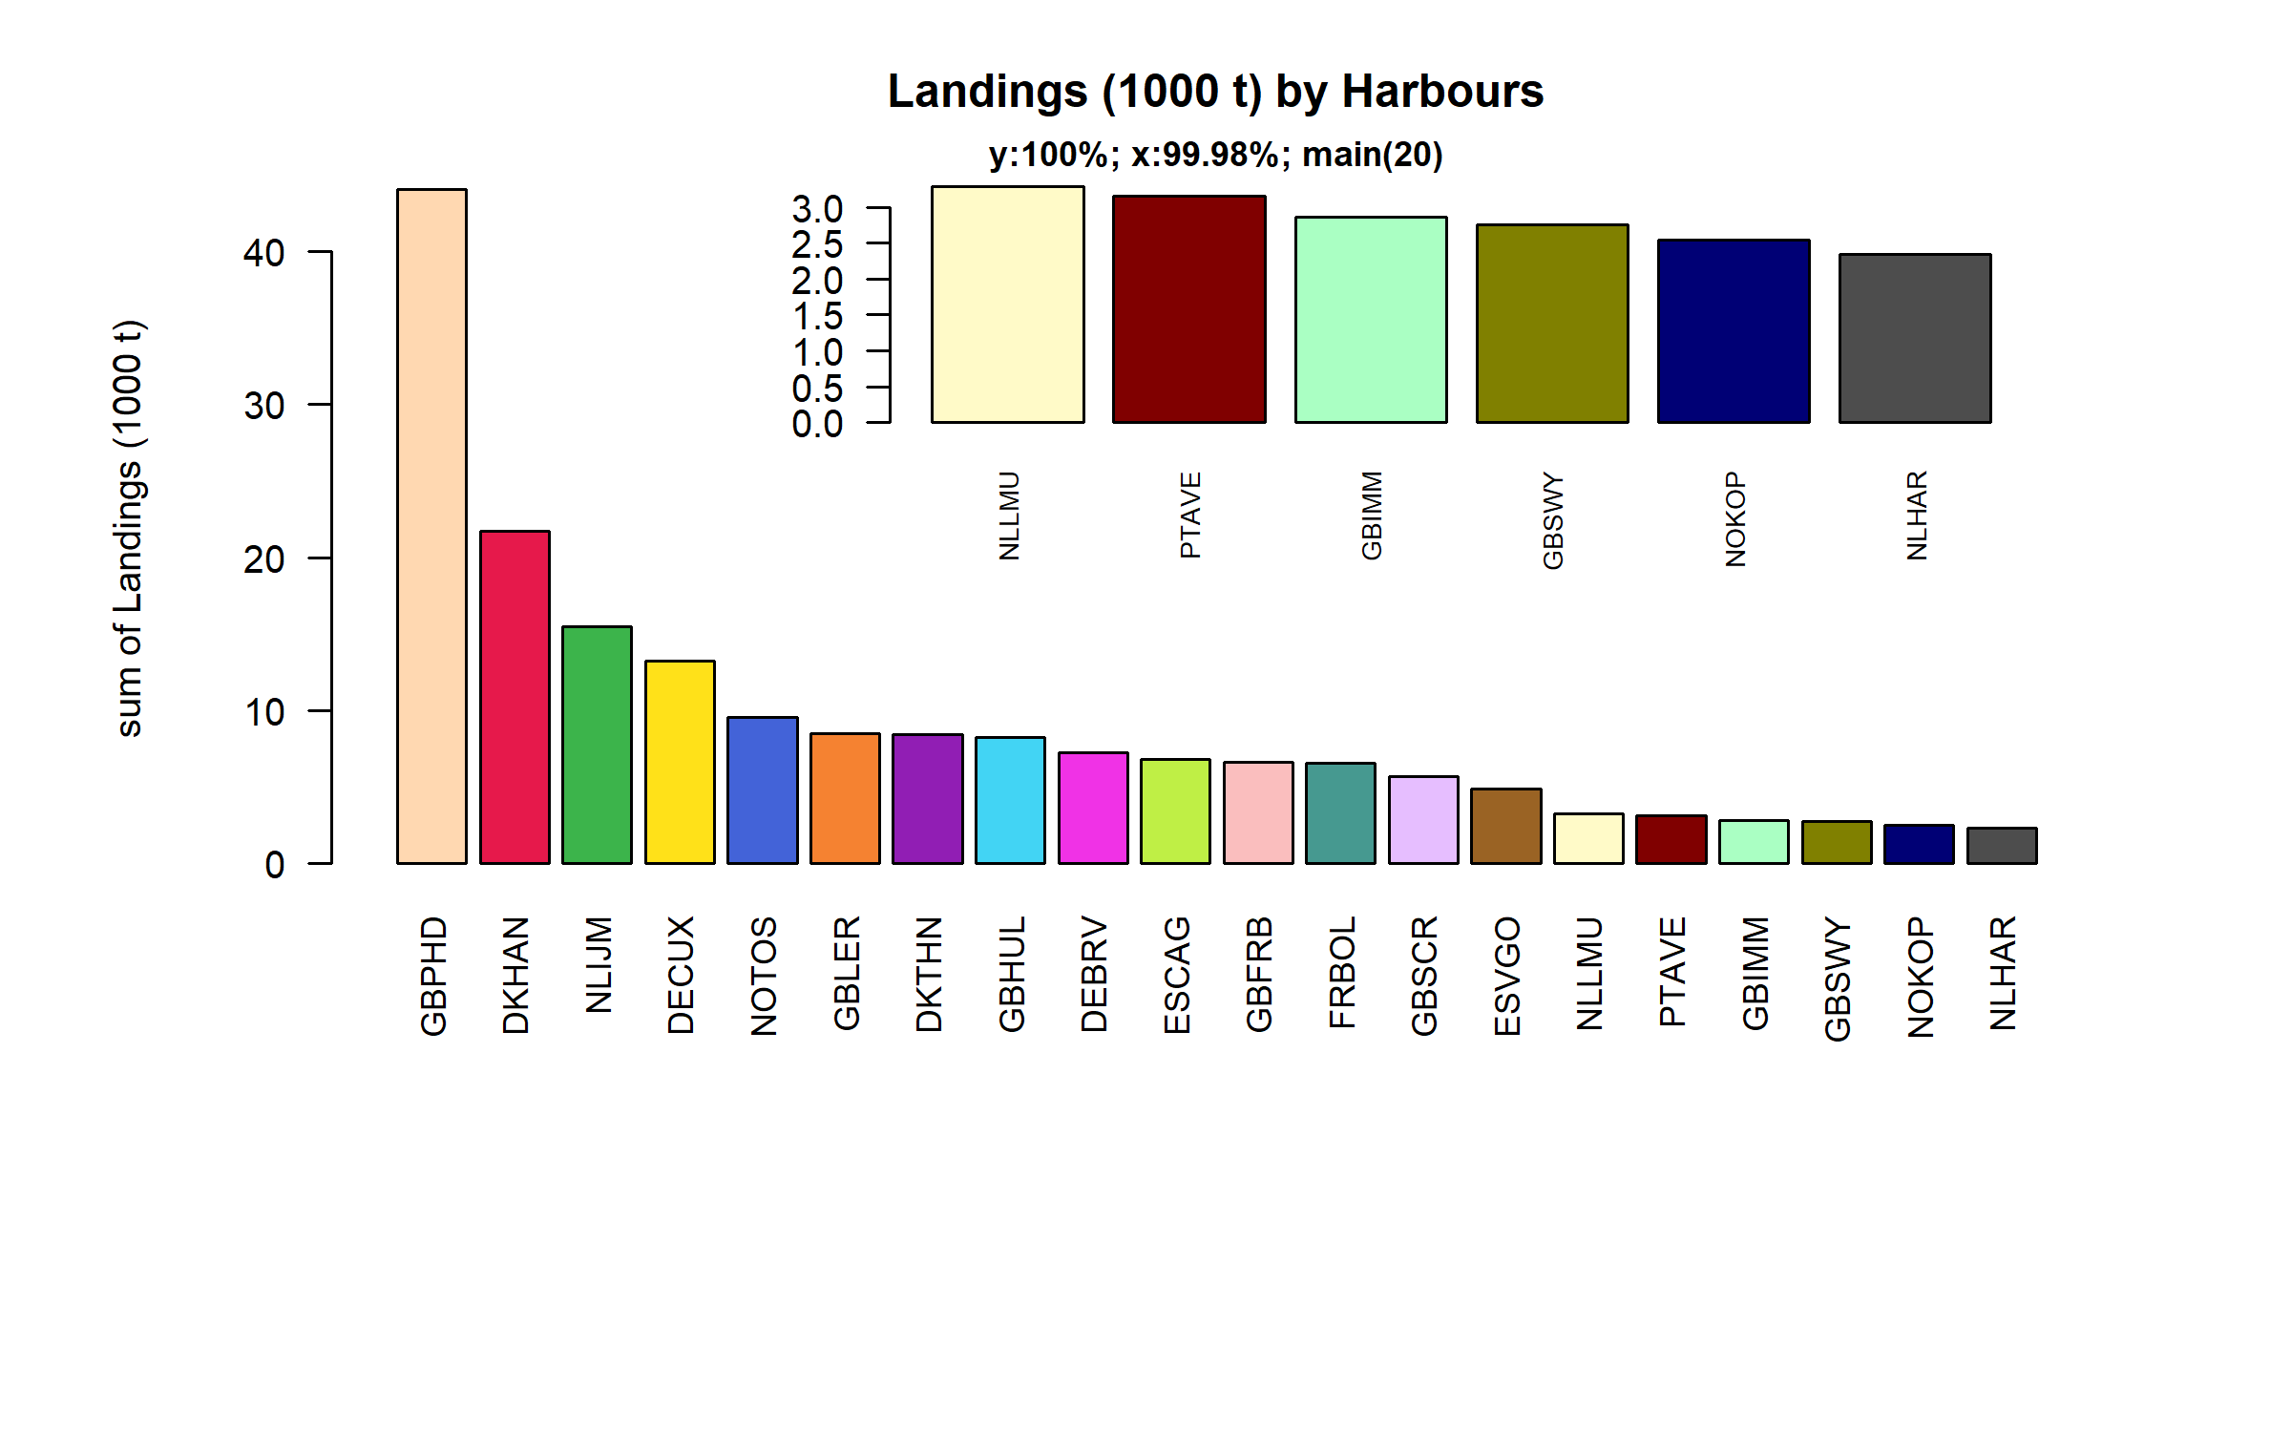 Figure 3.3.6.1. Landings (1000 t) of demersal in the 20 main Harbours (99.98% of rows entering analysis had known Harbours).

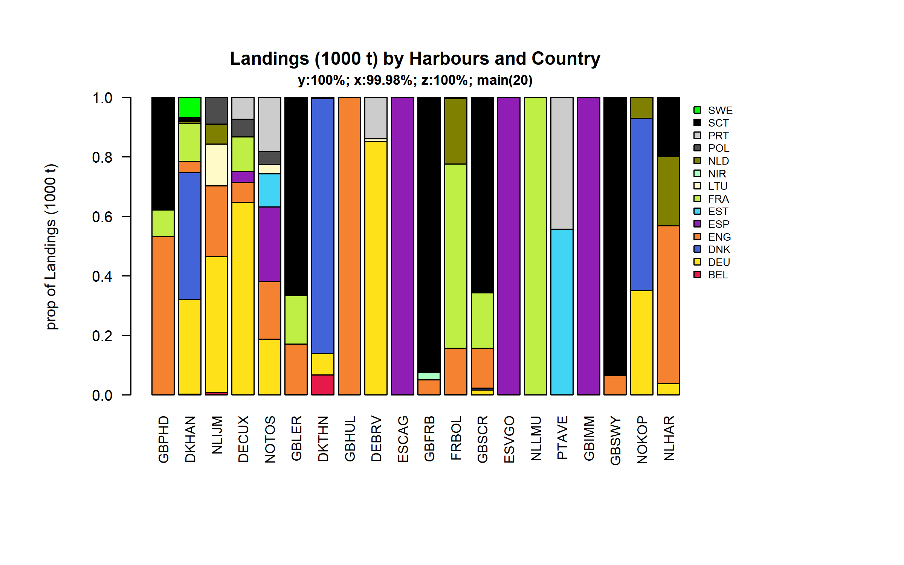 Figure 3.3.6.2. Landings (1000 t) of demersal in the 20 main Harbours ( 99.98 % of rows entering analysis had known Harbours ) and Country .

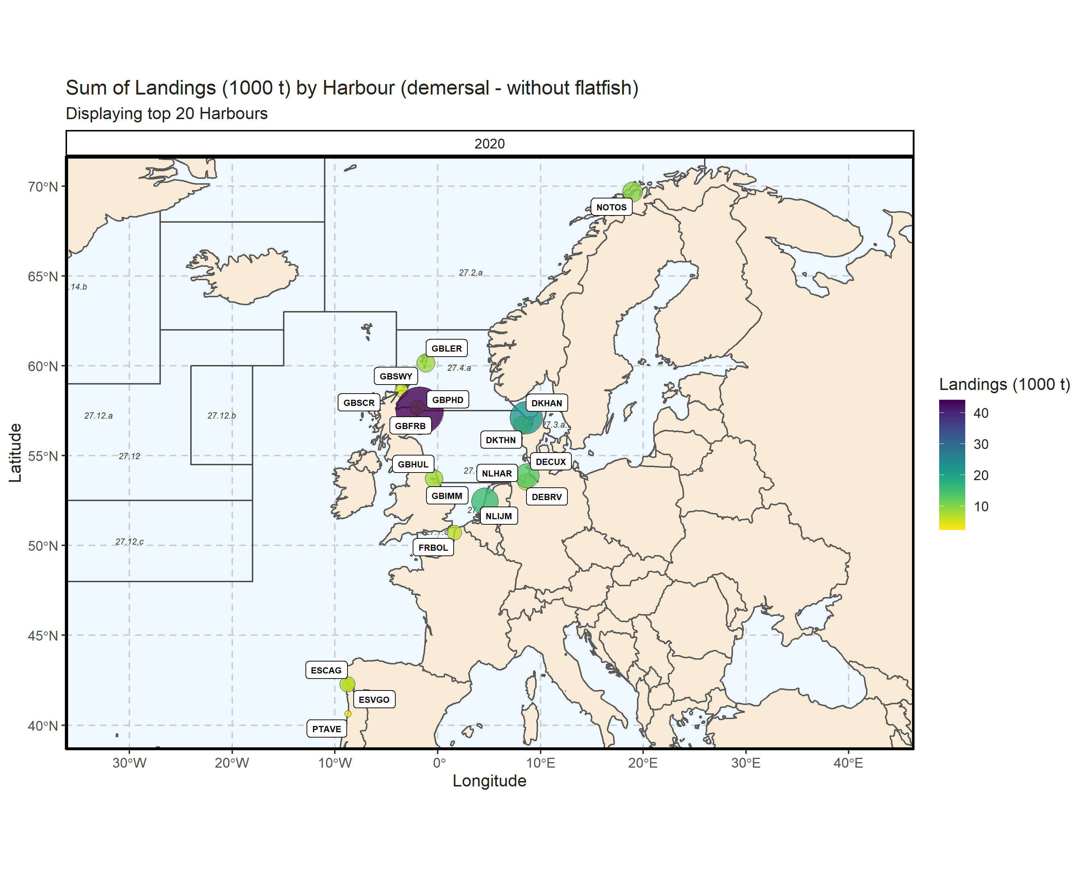 Figure 3.3.6.3. Sum of Landings (1000 t) by Harbour (demersal - without flatfish). Displaying top 20 Harbours. 0.57% of Landings (1000 t) - reported for missing Harbour 2 Harbour with missing coordinates (2.68% of Landings (1000 t)) - not presented on the map.

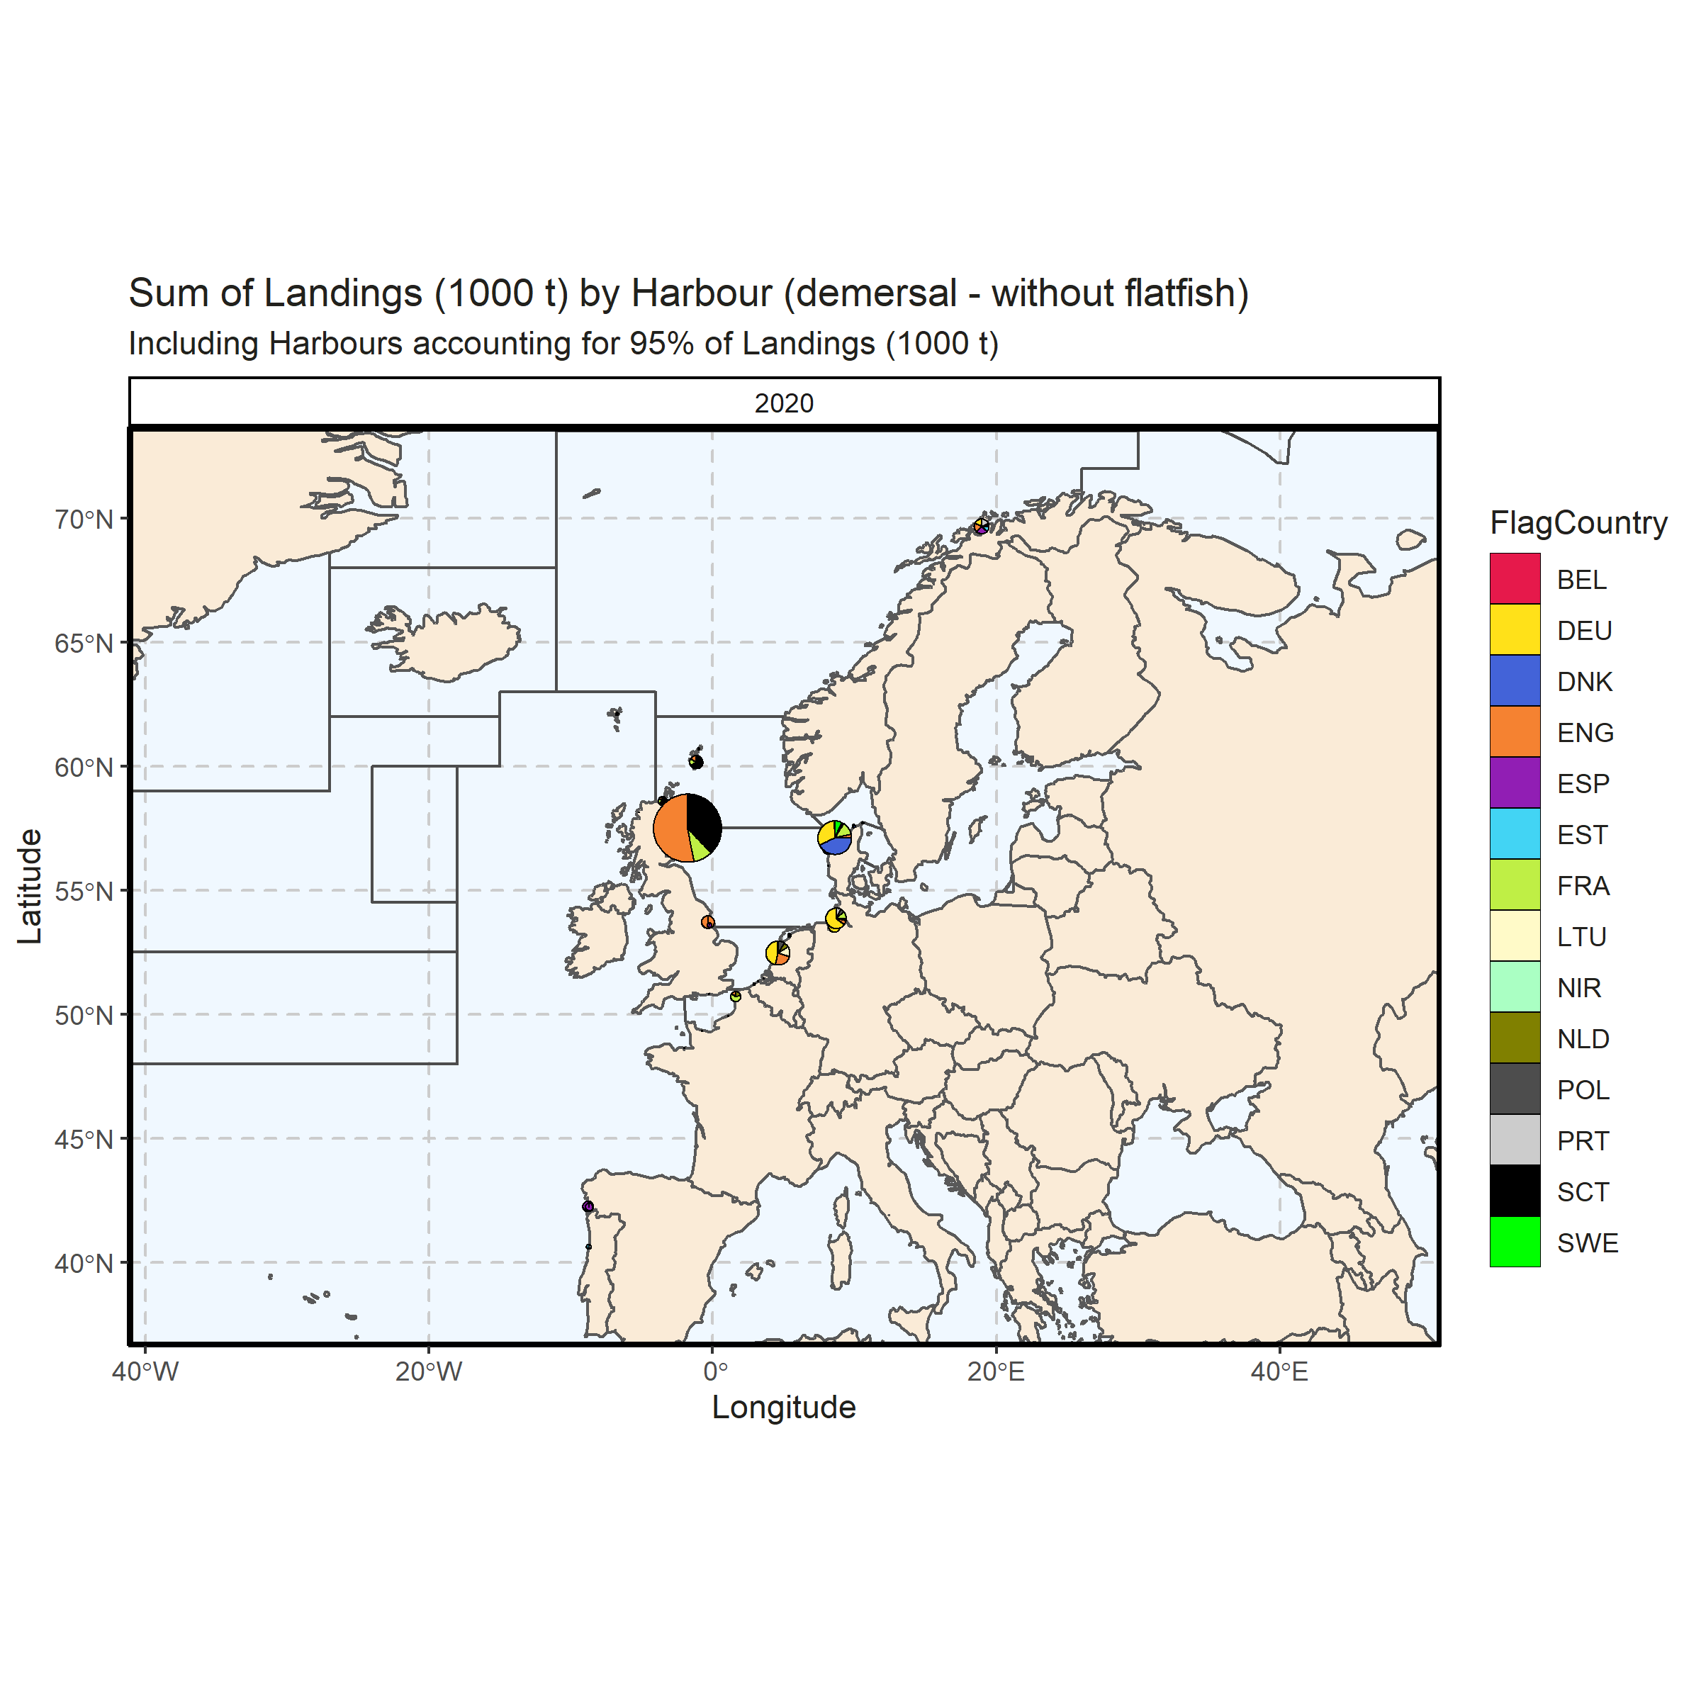 Figure 3.3.6.4. Sum of Landings (1000 t) by Harbour (demersal - without flatfish). Including Harbours accounting for 95% of Landings (1000 t). 0.57% of Landings (1000 t) - reported for missing Harbour. 6 Harbour with missing coordinates (4.88% of Landings (1000 t)) - not presented on the map.

### Landings abroad, demersal (without flatfish)

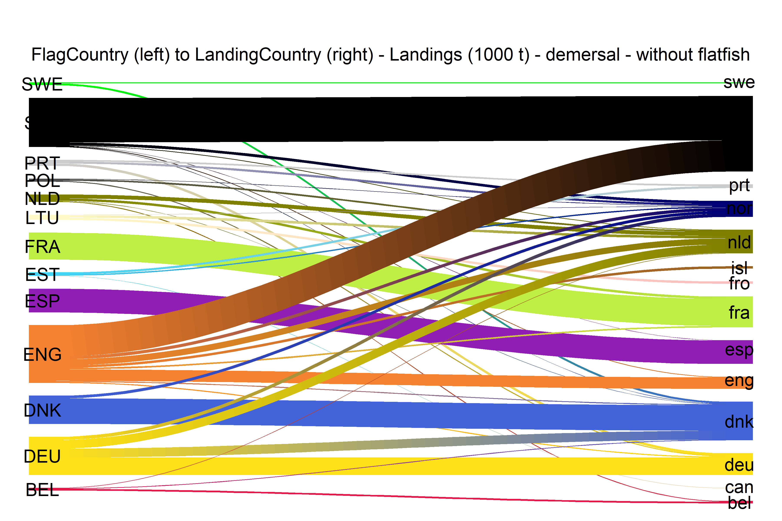  
Figure 3.3.7.1.River plot of Landings (1000 t) between Country (left) and Landing Country (right). Width of line is proportional to landings

### Spatial distribution of landings, demersal

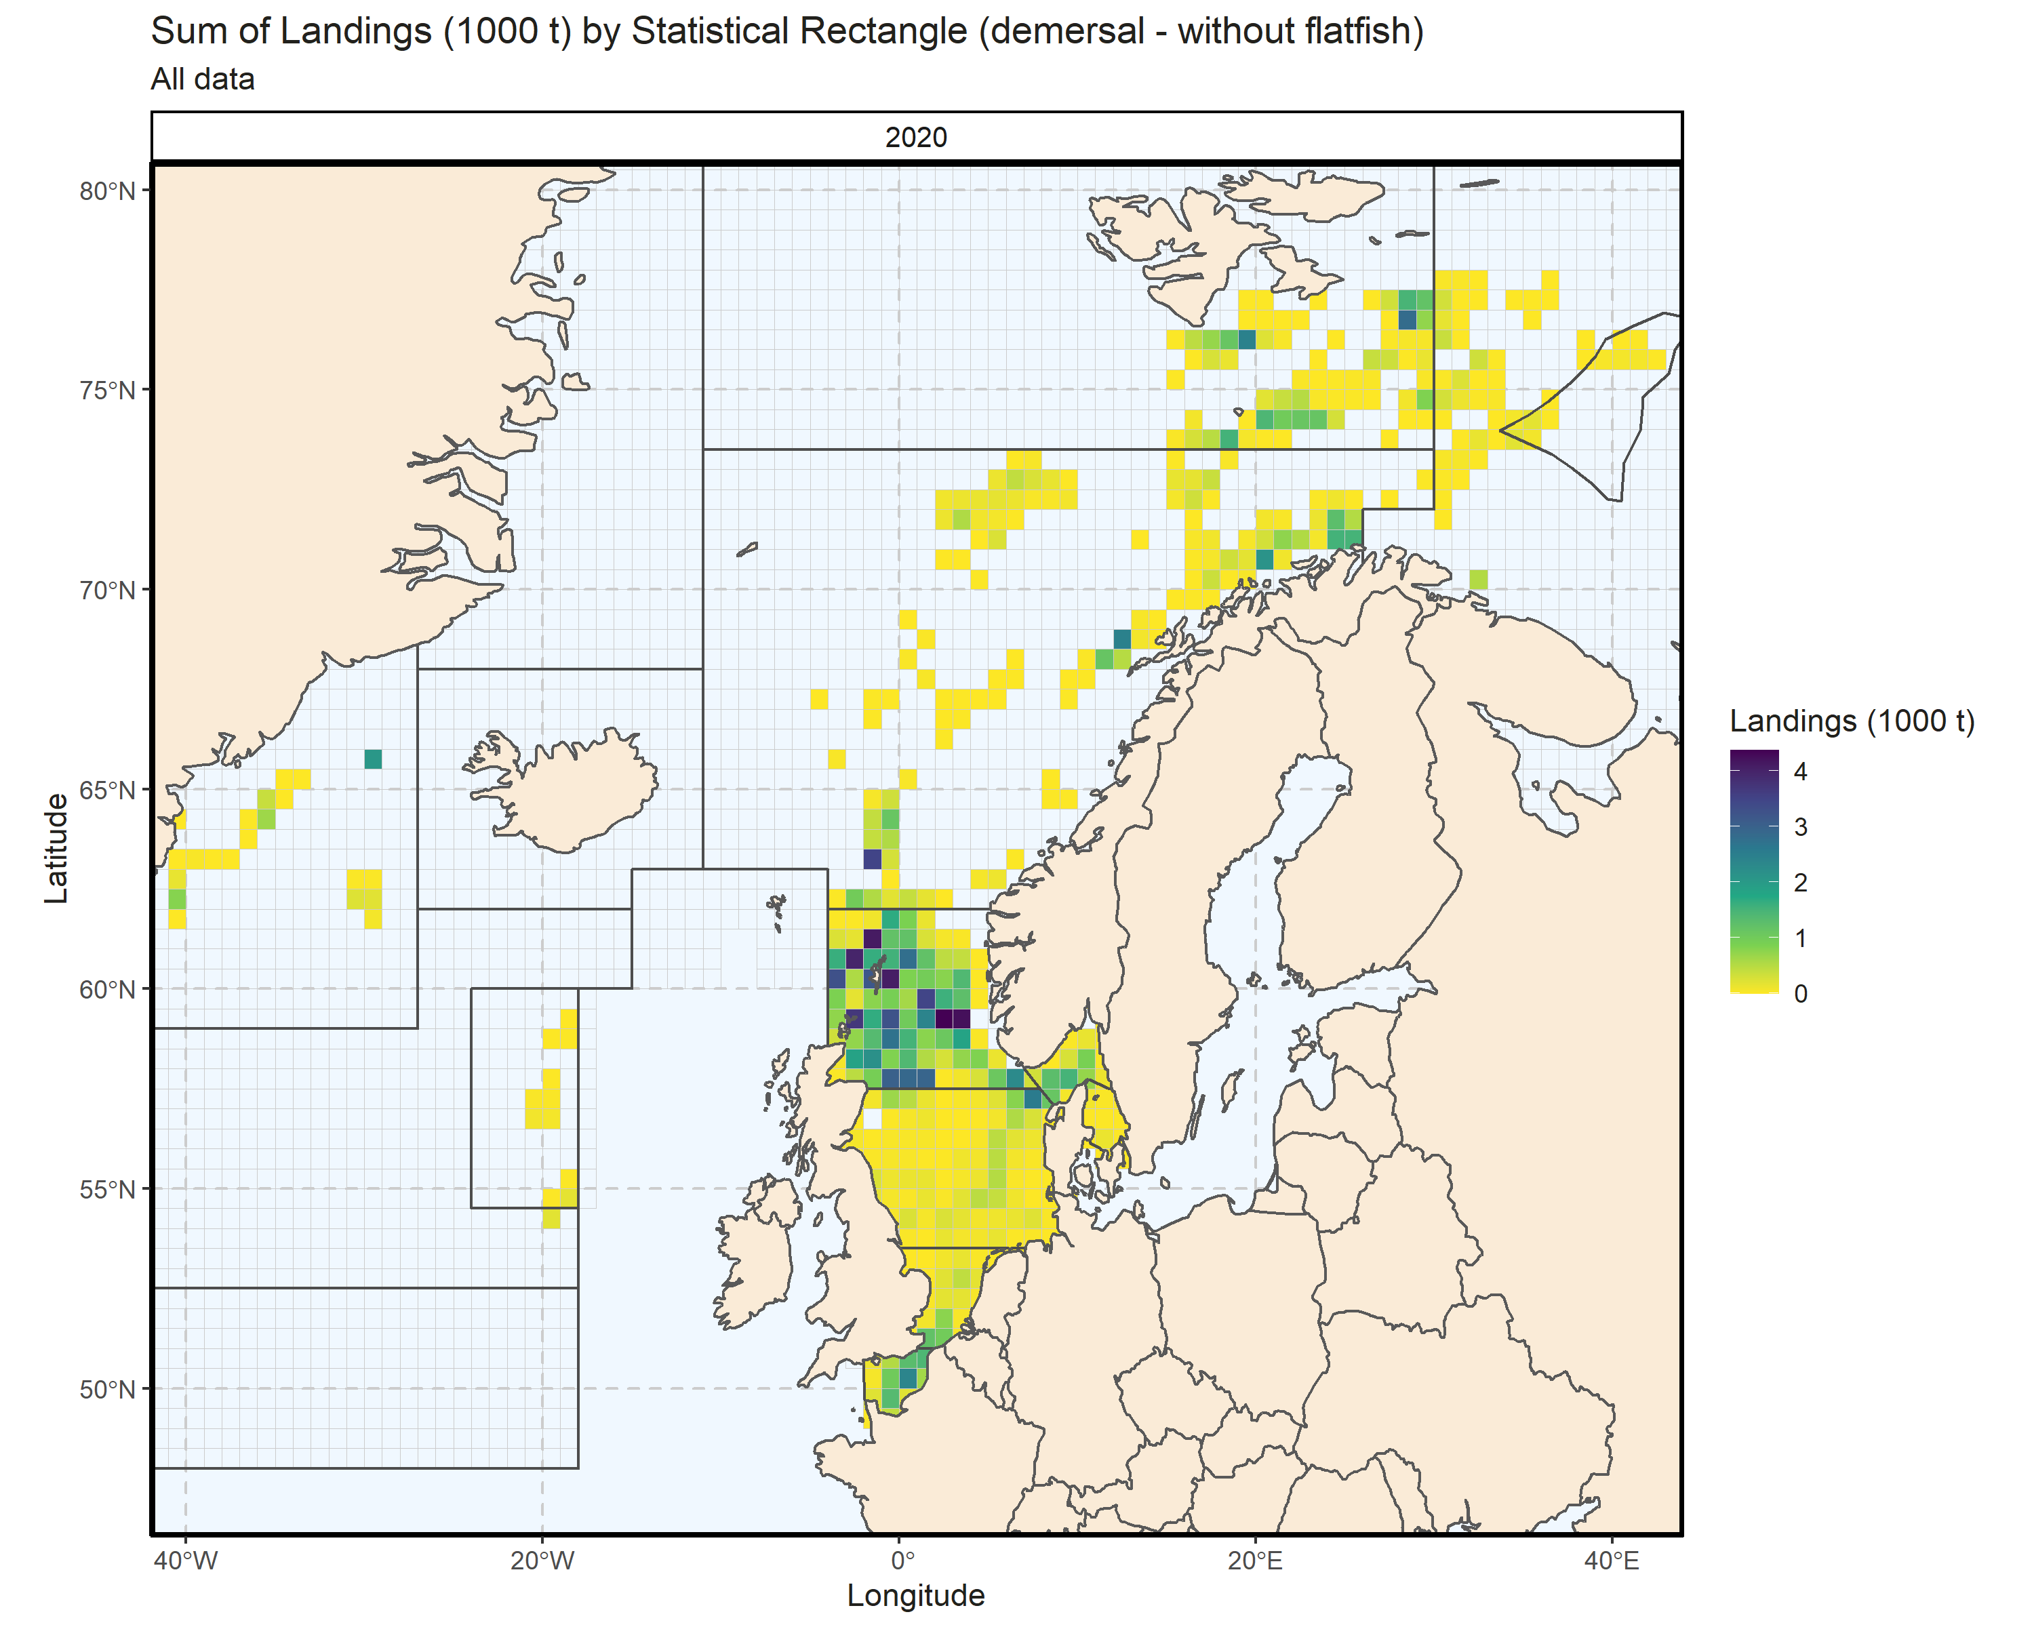 Figure 3.3.8.1. Sum of Landings (1000 t) by Statistical Rectangle (demersal - without flatfish). All data. 3.67% of Landings (1000 t) - reported for missing Statistical Rectangle. 2 Statistical Rectangle with missing coordinates (5.57% of Landings (1000 t)) - not presented on the map.

## Flatfish landings

### Landings by country, flatfish

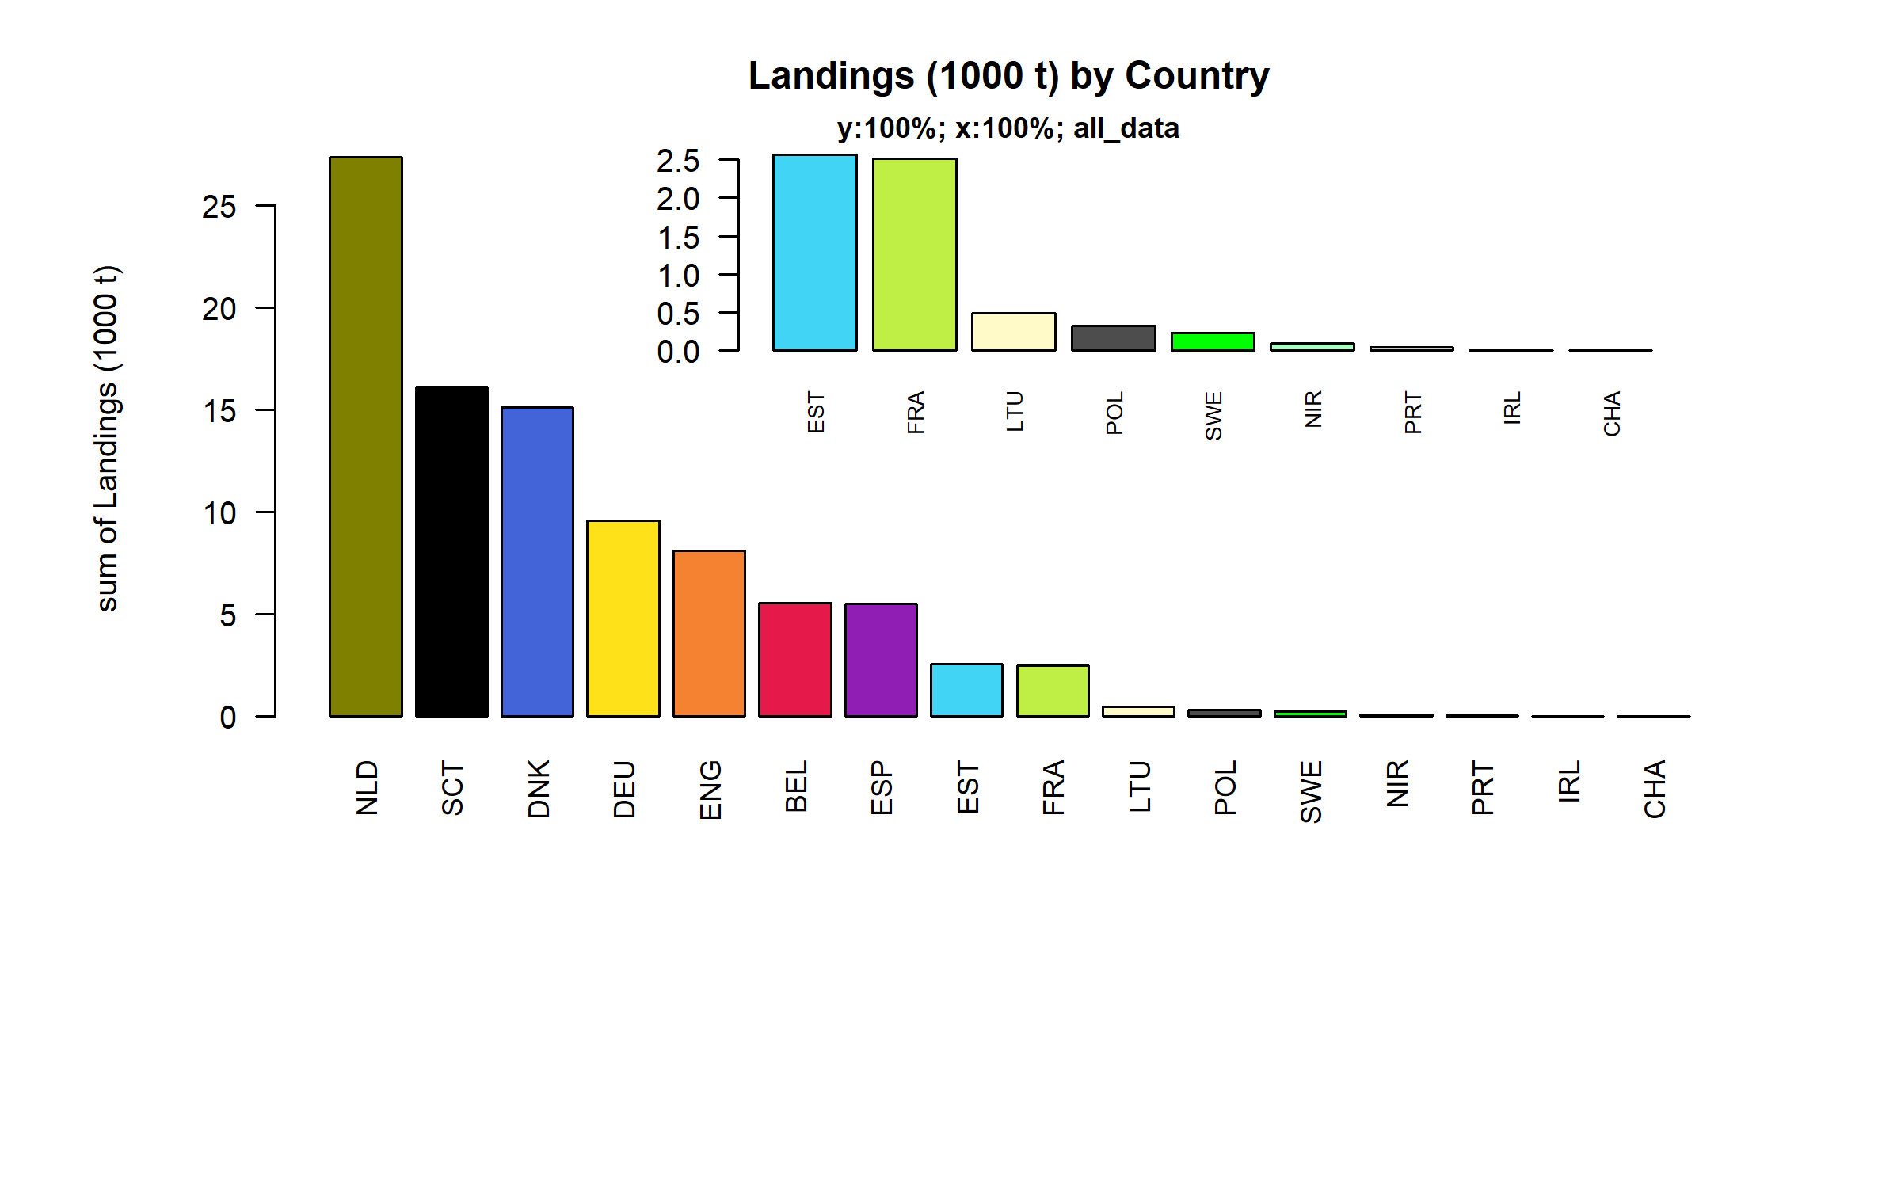 Figure 3.4.1.1. Landings (1000 t) of flatfish by Country.

### Landings by species, flatfish

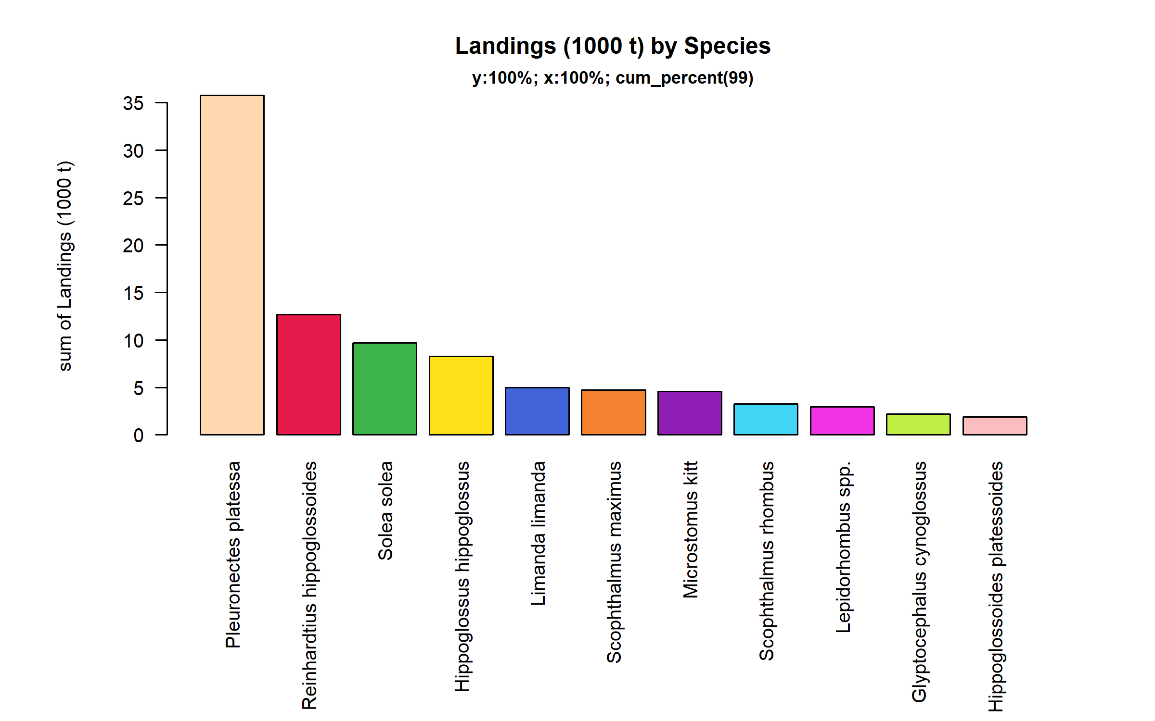 Figure 3.4.2.1. Landings (1000 t) of flatfish by Species. Species displayed comprise 99% of the total Landings (1000 t).

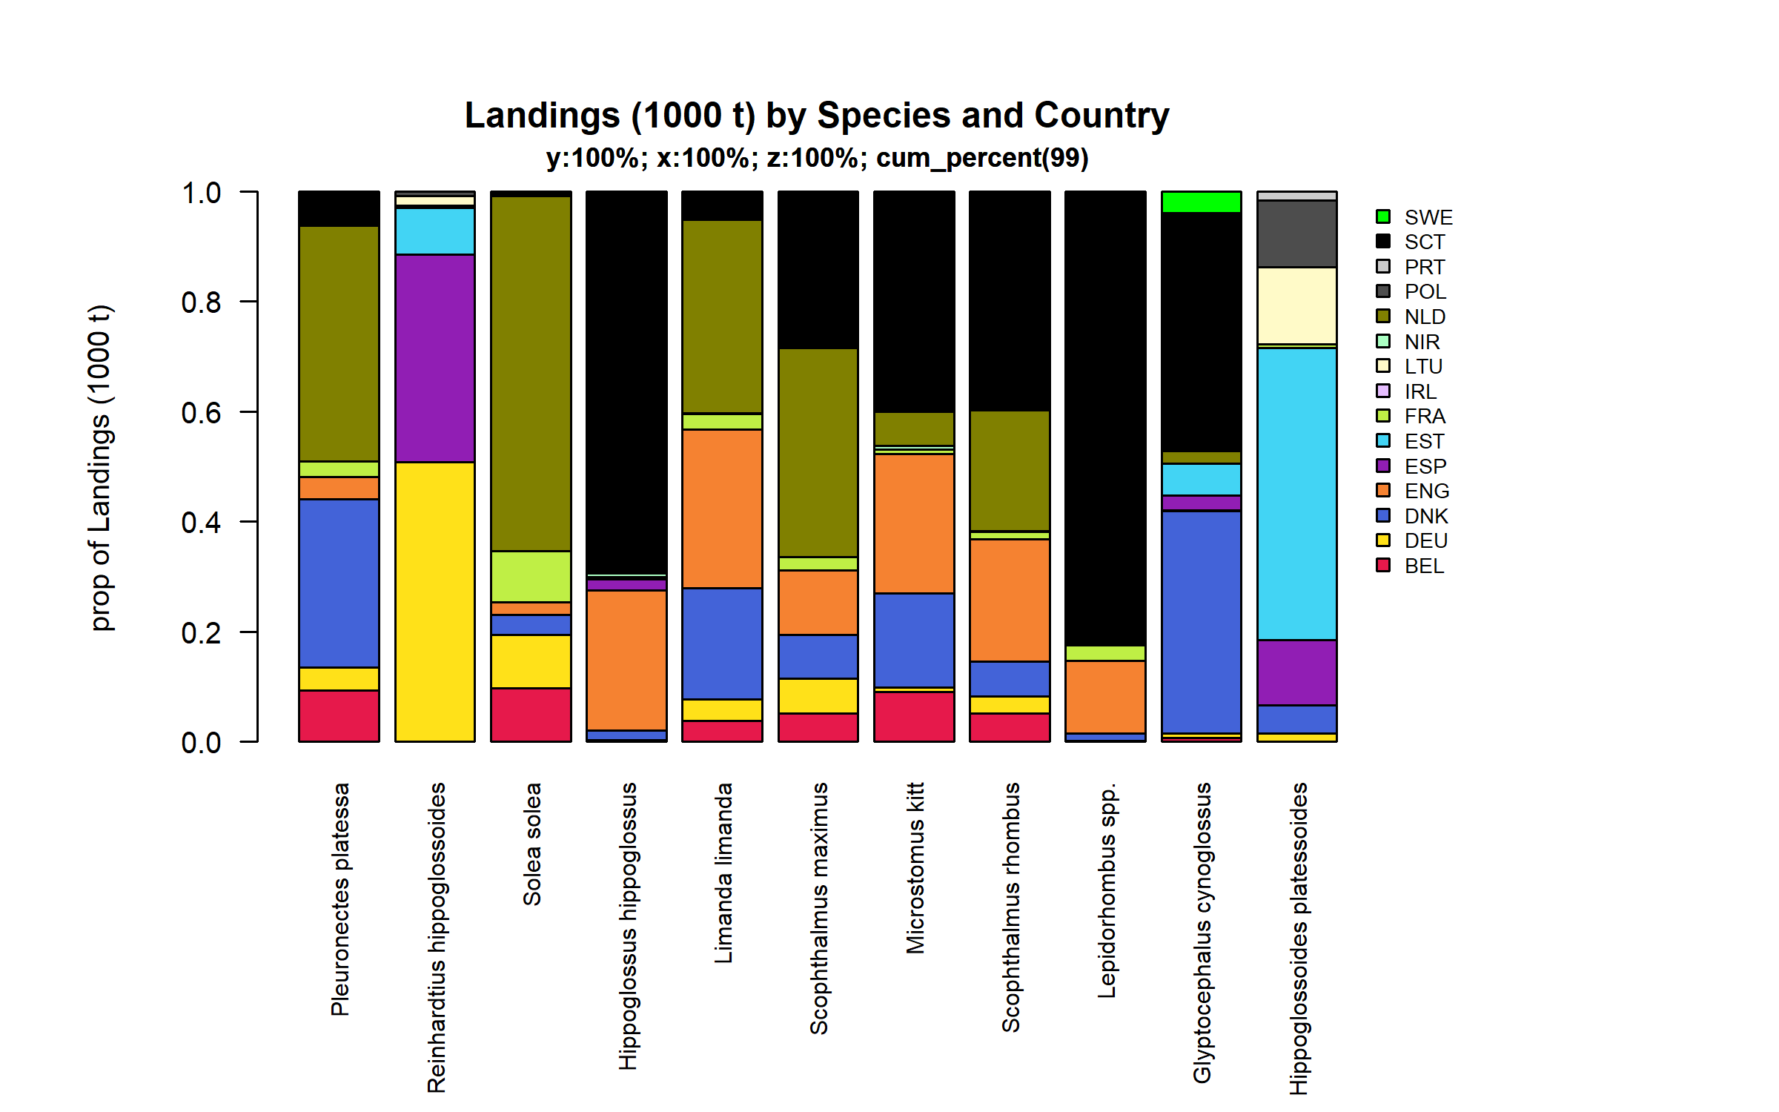 Figure 3.4.2.2. Landings (1000 t) of flatfish by Species and Country . Species and Country displayed comprise 99 % of the total Landings (1000 t) .

### Landings by fleet, flatfish

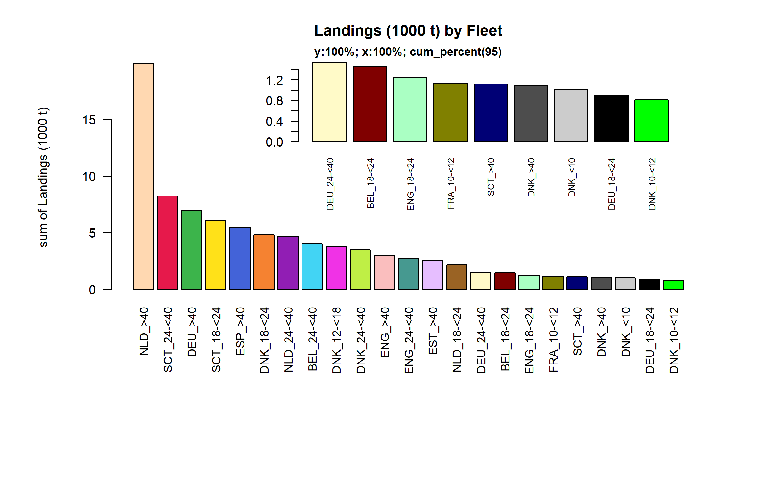 Figure 3.4.3.1. Landings (1000 t) of flatfish by Fleet. Fleet displayed comprise 95% of the total Landings (1000 t).

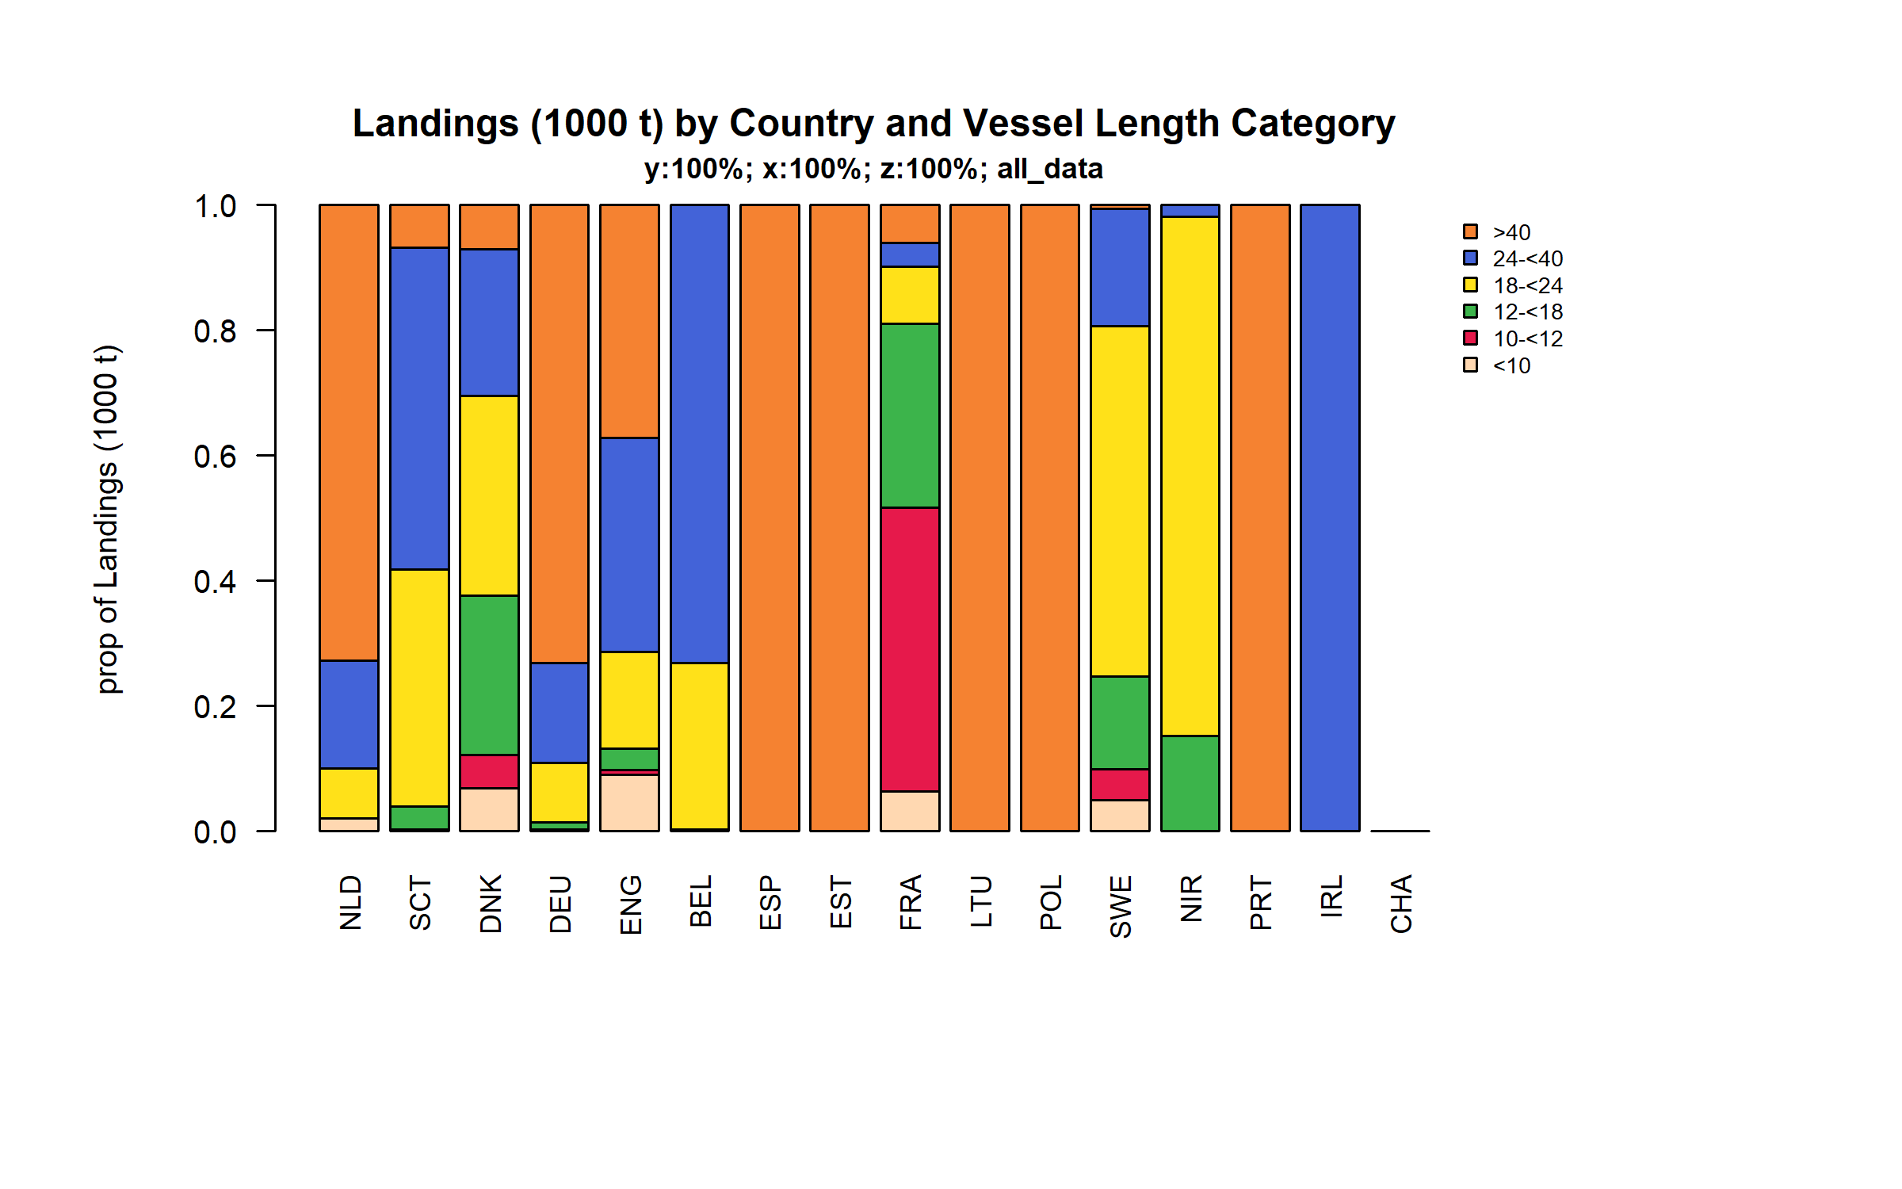 Figure 3.4.3.2. Landings (1000 t) of flatfish by Country and Vessel Length Category.

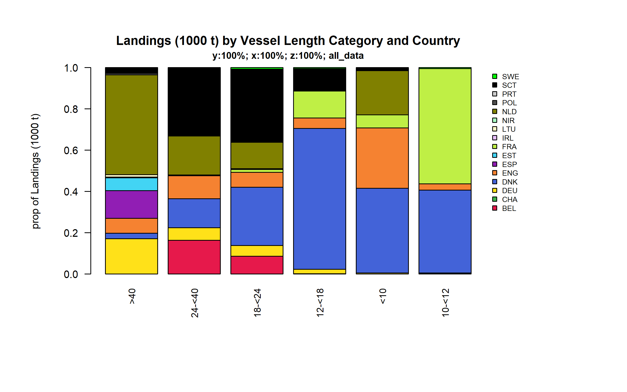 Figure 3.4.3.3. Landings (1000 t) of flatfish by Vessel Length Category and Country.

### Landings by area, flatfish

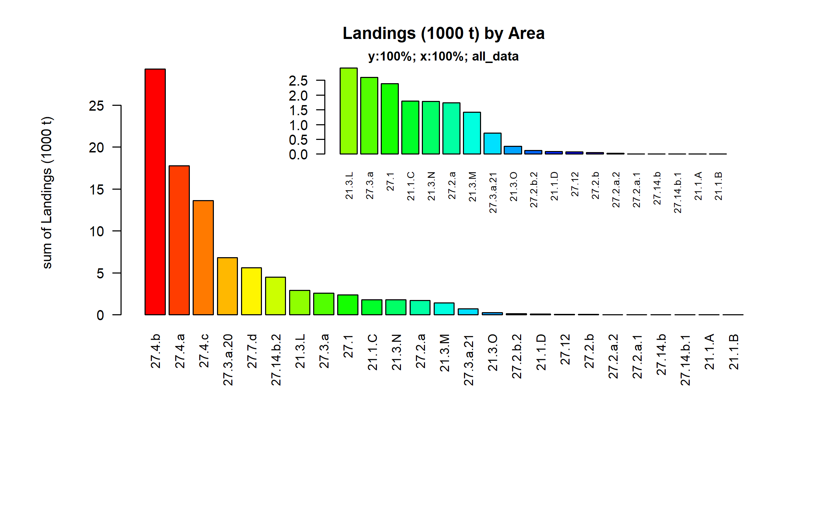 Figure 3.4.4.1. Landings (1000 t) of flatfish by Area.

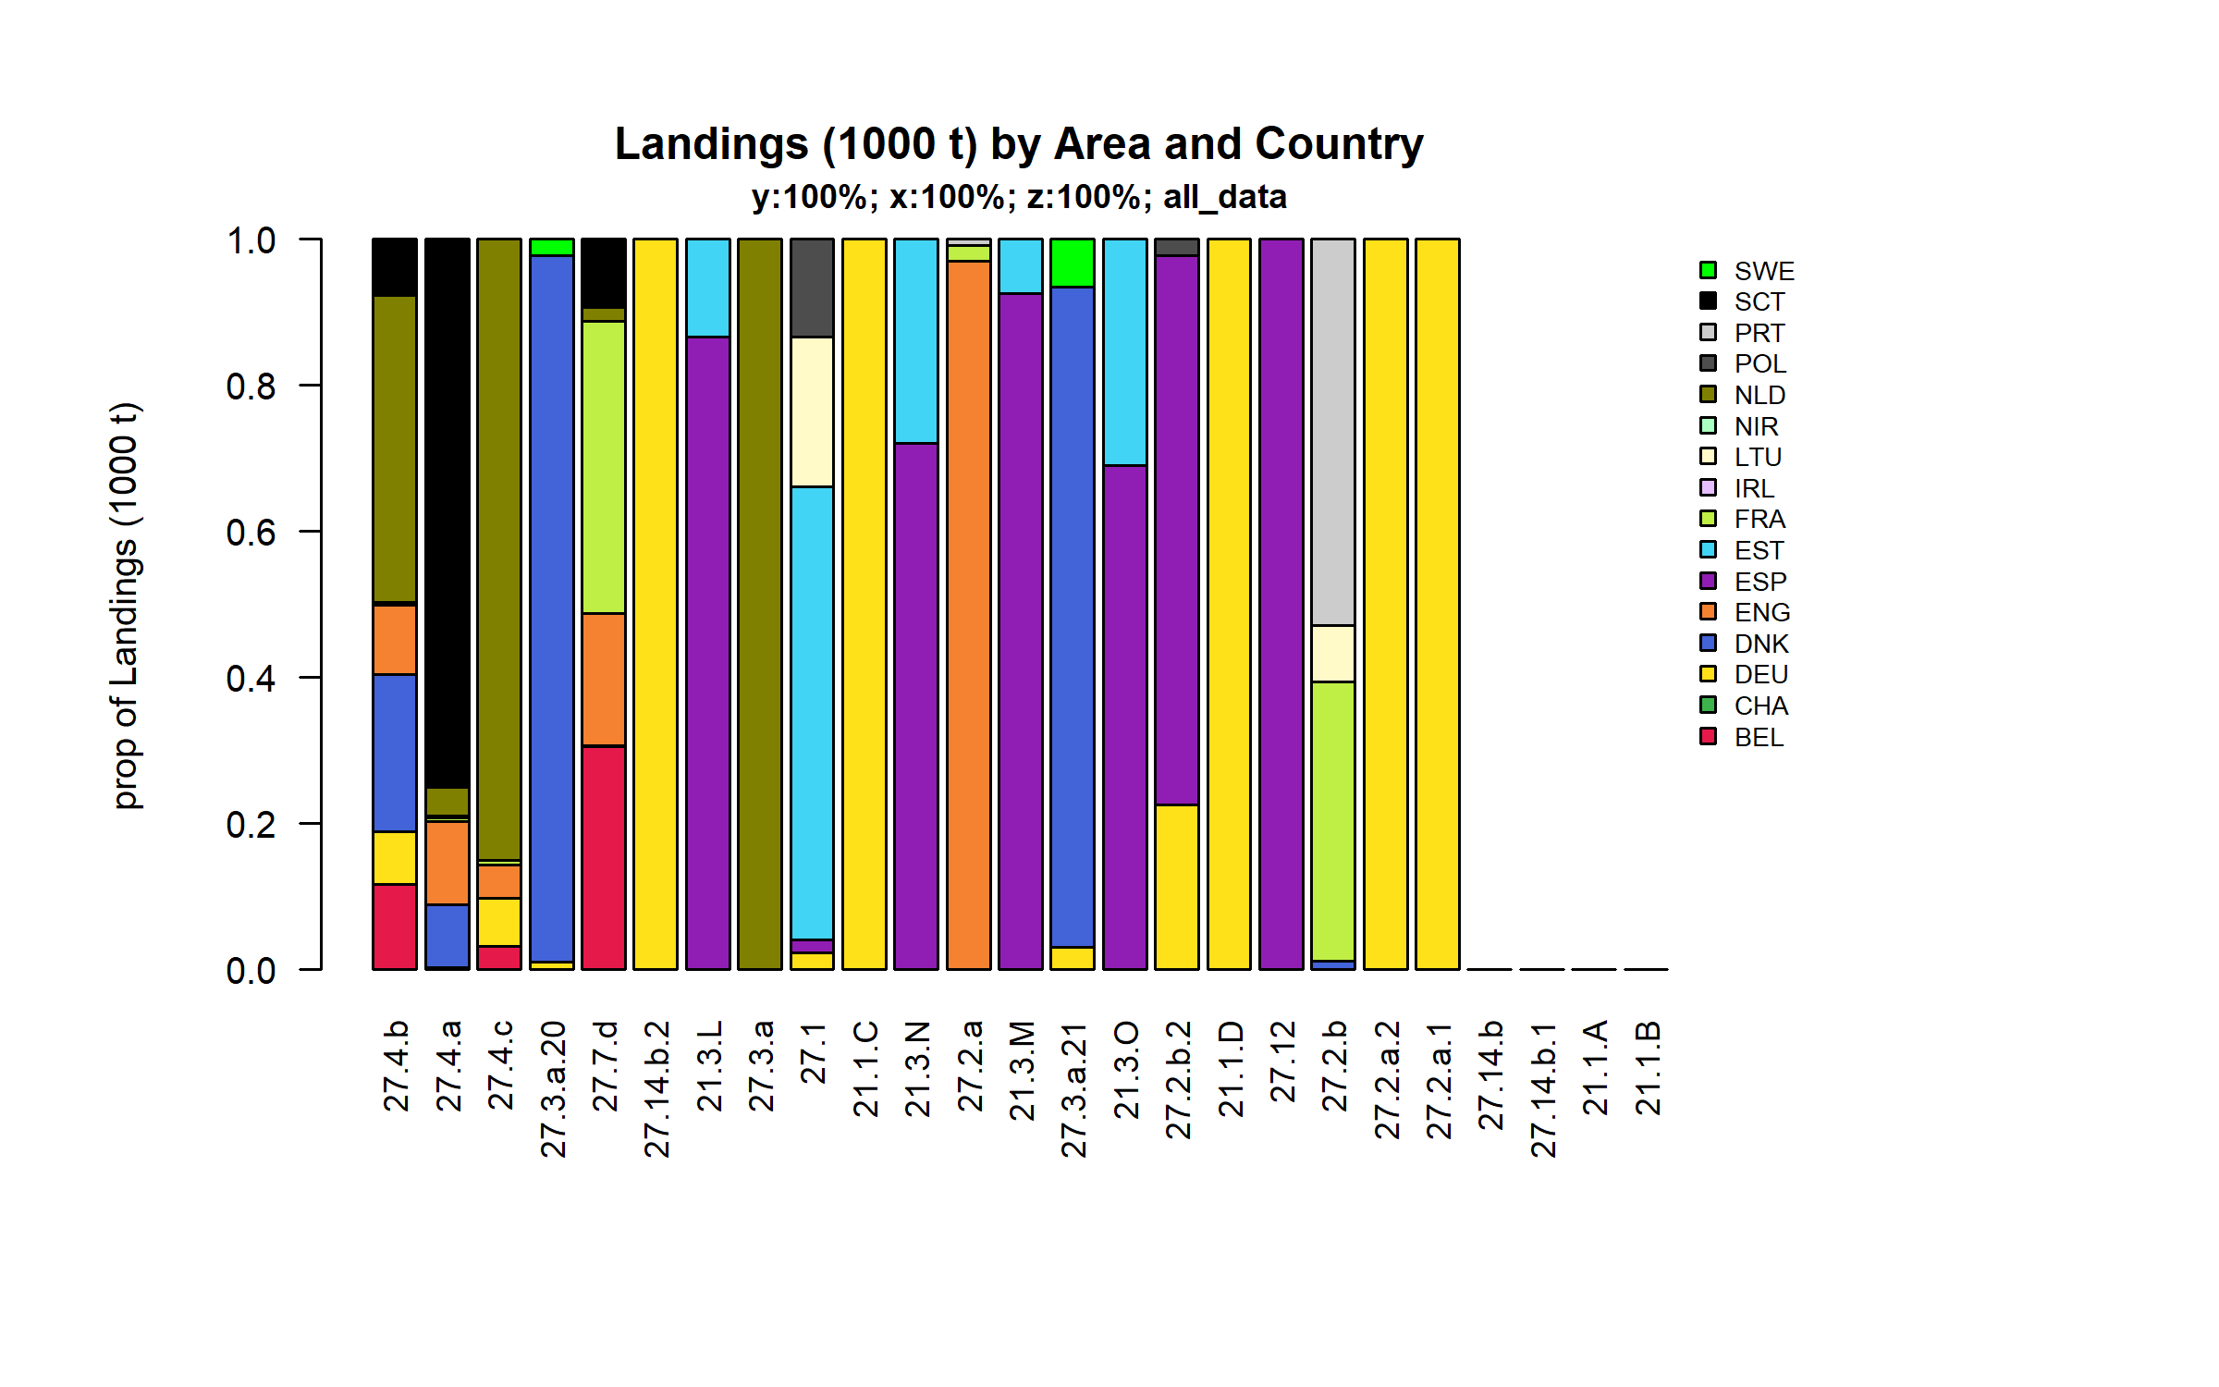 Figure 3.4.4.2. Landings (1000 t) of flatfish by Area and Country.

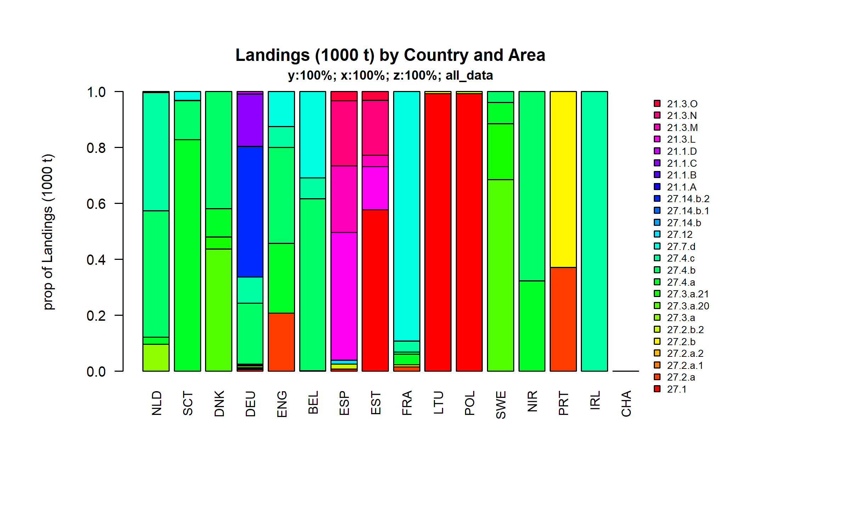 Figure 3.4.4.3. Landings (1000 t) of flatfish by Country and Area.

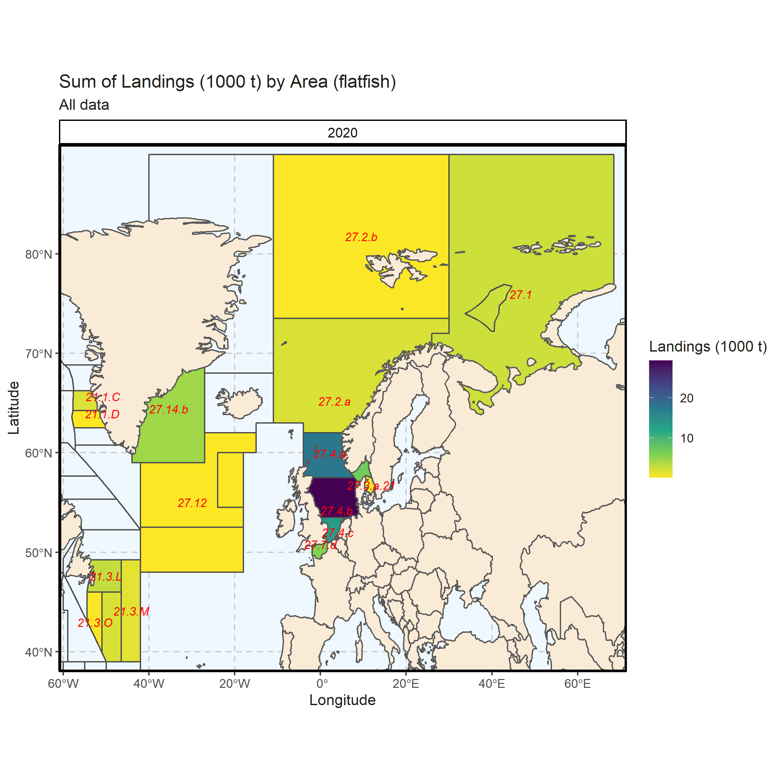 Figure 3.4.4.4. Sum of Landings (1000 t) by Area (flatfish). All data. 2.78% of Landings (1000 t) - reported for missing Area.

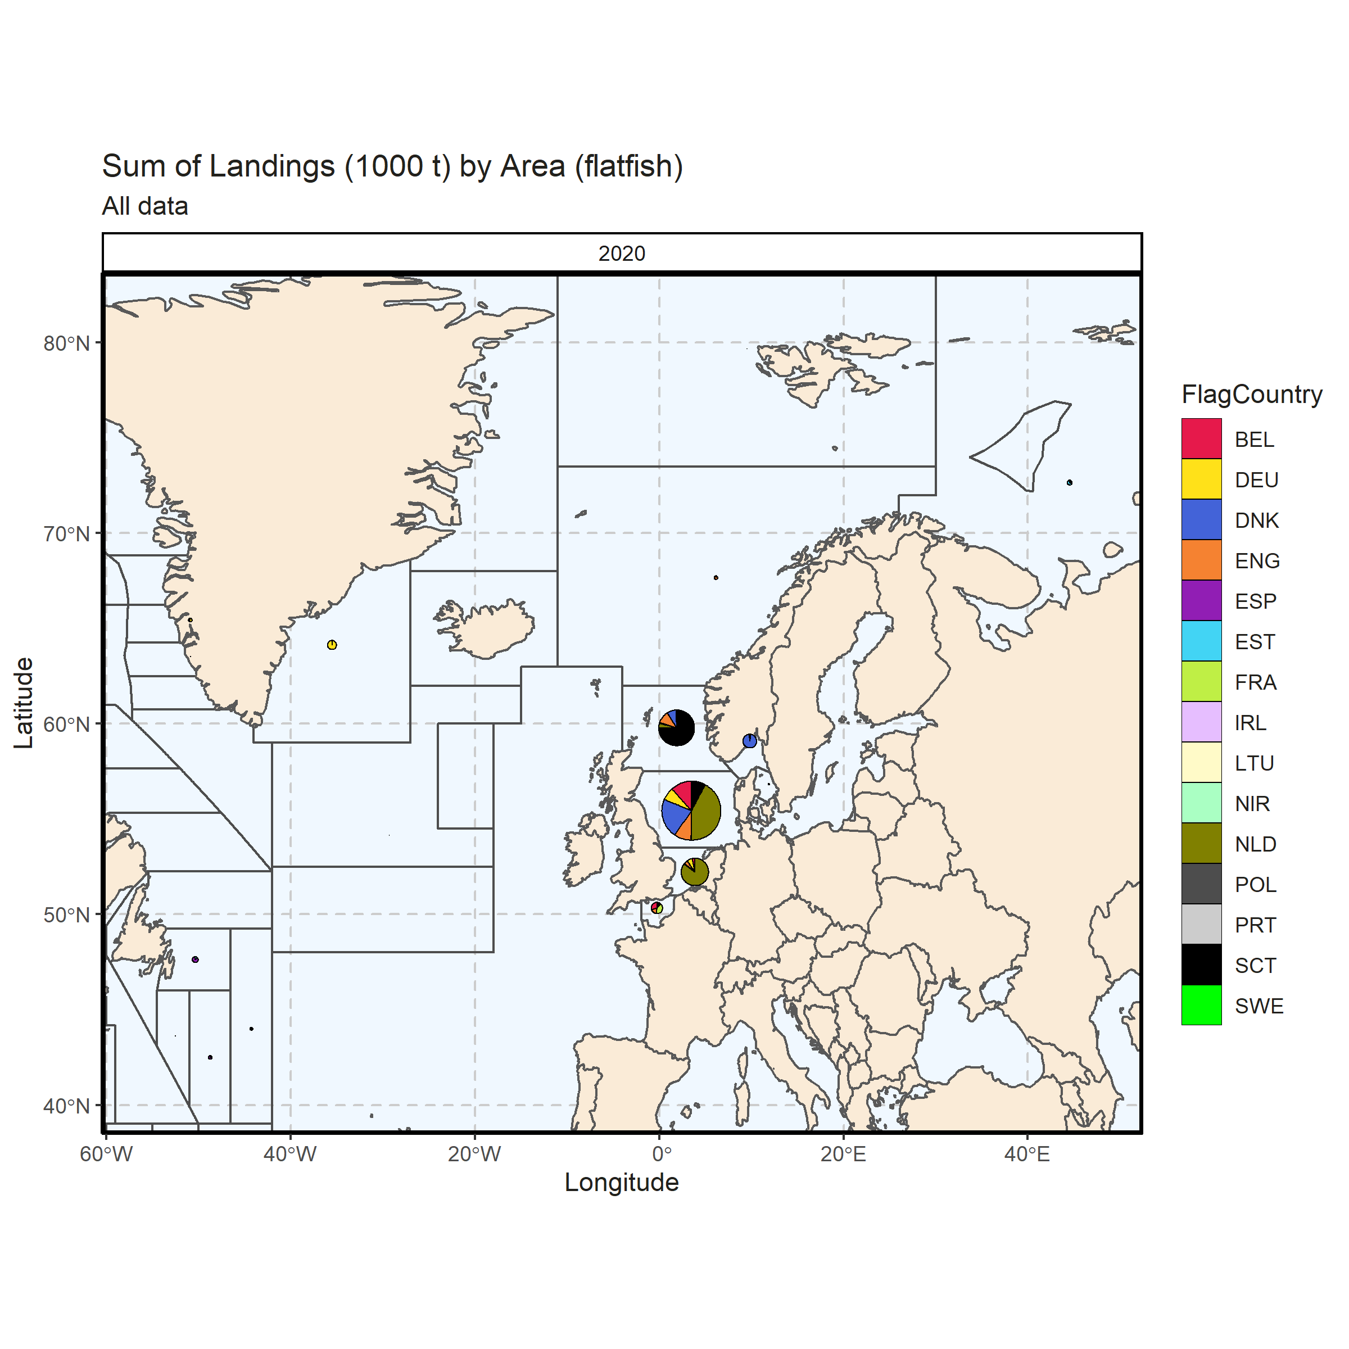 Figure 3.4.4.5. Sum of Landings (1000 t) by Area (flatfish). All data. 2.78% of Landings (1000 t) - reported for missing Area.

### Landings by metier, flatfish

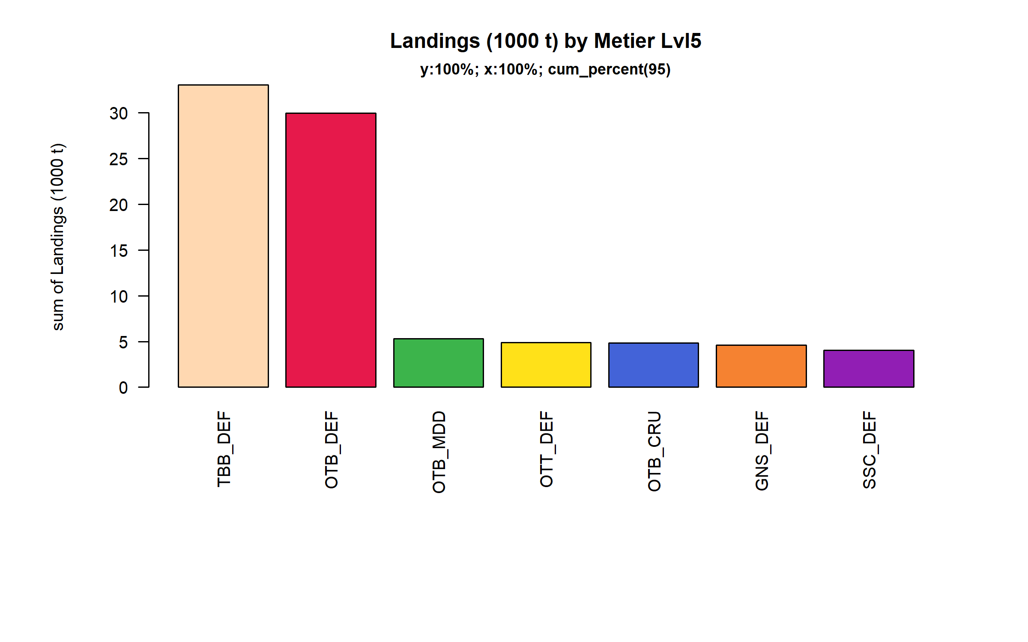 Figure 3.4.5.1. Landings (1000 t) of flatfish by Metier Lvl5. Metier Lvl5 displayed comprise 95% of the total Landings (1000 t).

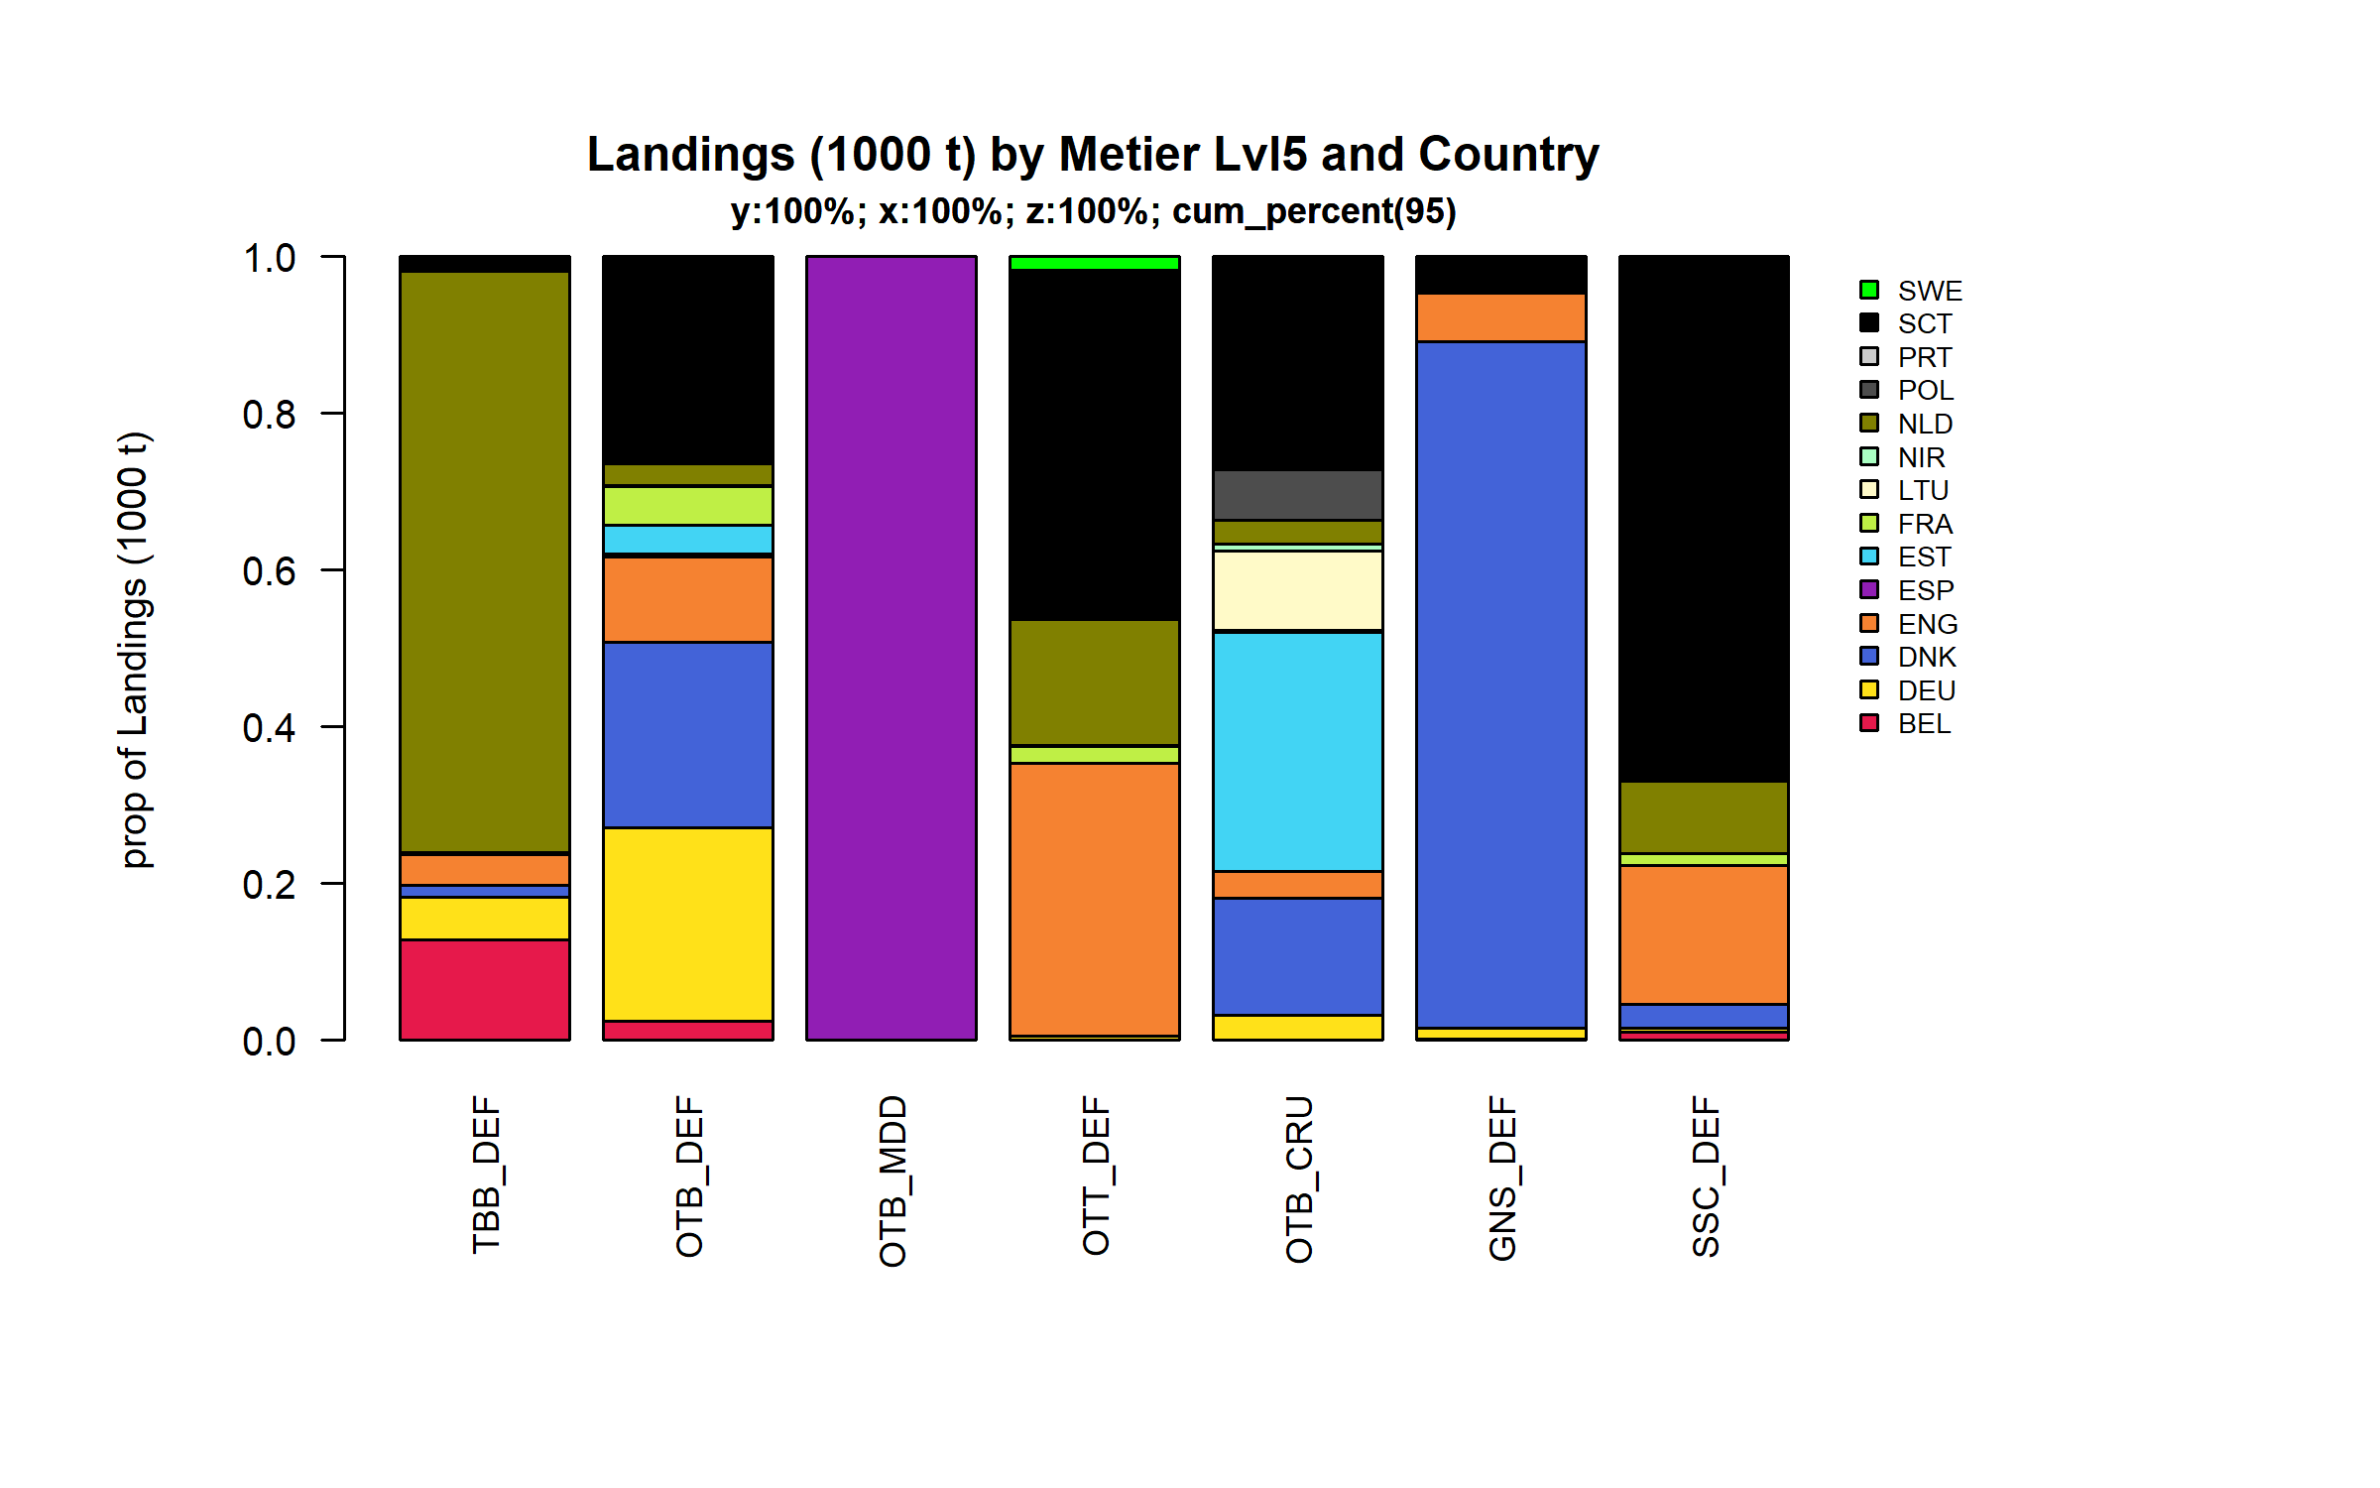 Figure 3.4.5.2. Landings (1000 t) of flatfish by Metier Lvl5 and Country . Metier Lvl5 and Country displayed comprise 95 % of the total Landings (1000 t) .

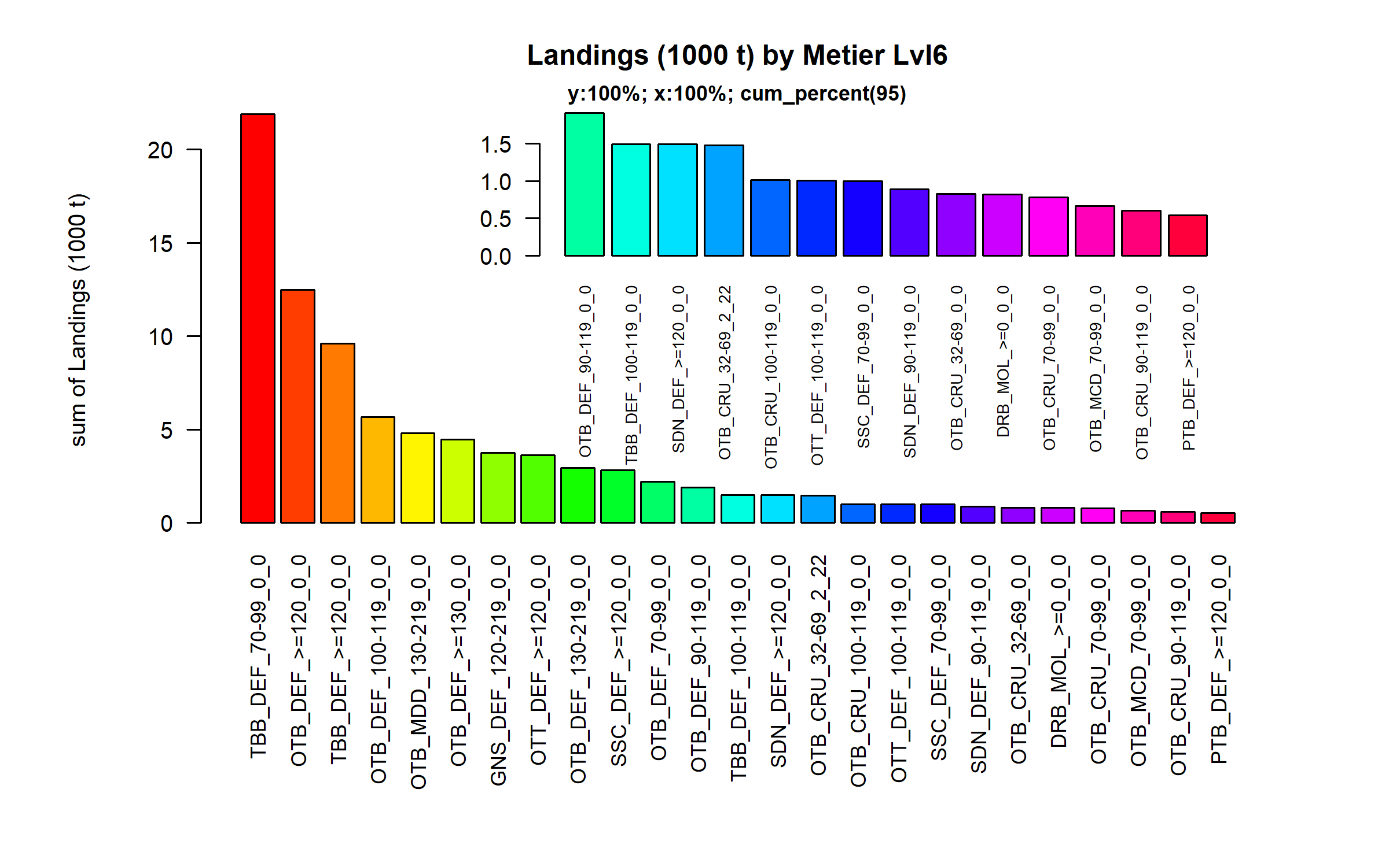 Figure 3.4.5.3. Landings (1000 t) of flatfish by Metier Lvl6. Metier Lvl6 displayed comprise 95% of the total Landings (1000 t).

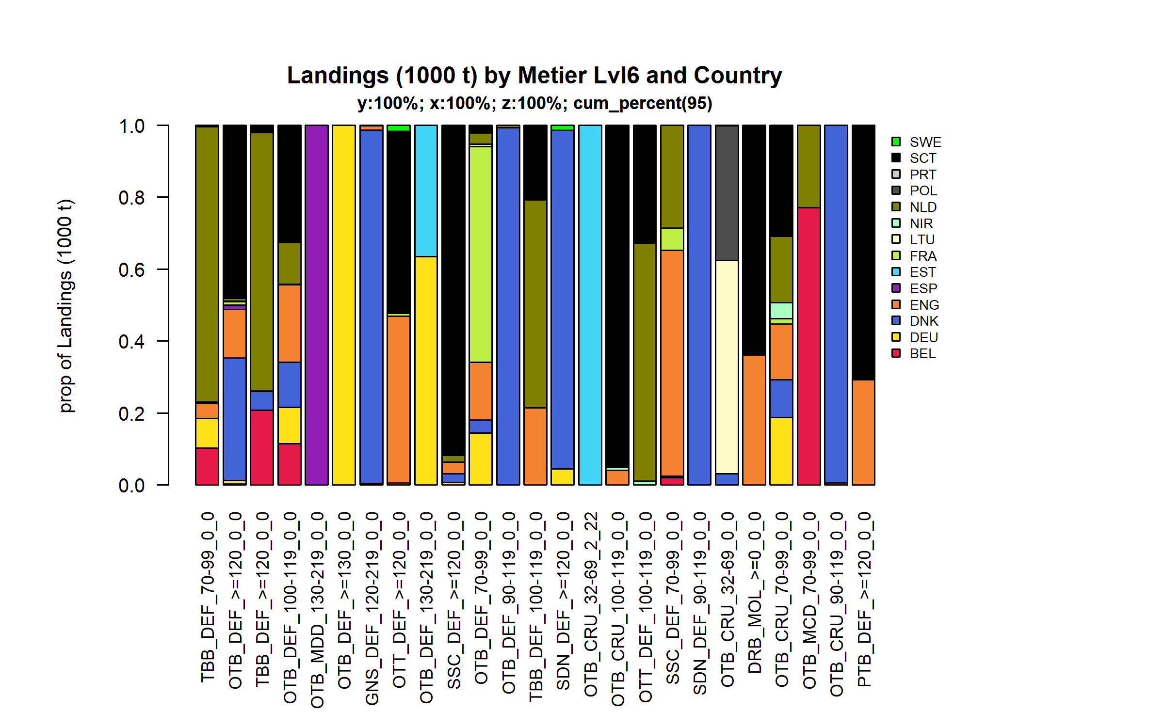 Figure 3.4.5.4. Landings (1000 t) of flatfish by Metier Lvl6 and Country . Metier Lvl6 and Country displayed comprise 95 % of the total Landings (1000 t) .

### Landings by harbour, flatfish

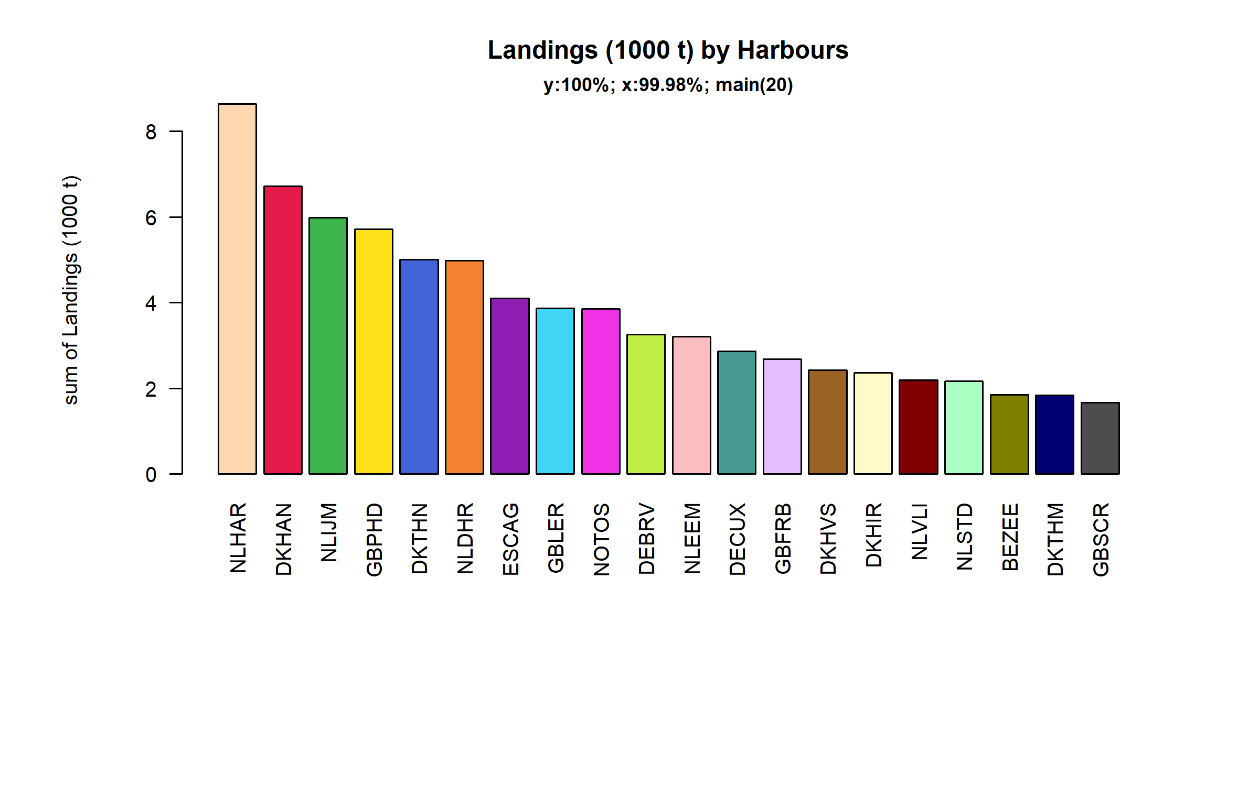 Figure 3.4.6.1. Landings (1000 t) of flatfish in the 20 main Harbours (99.98% of rows entering analysis had known Harbours).

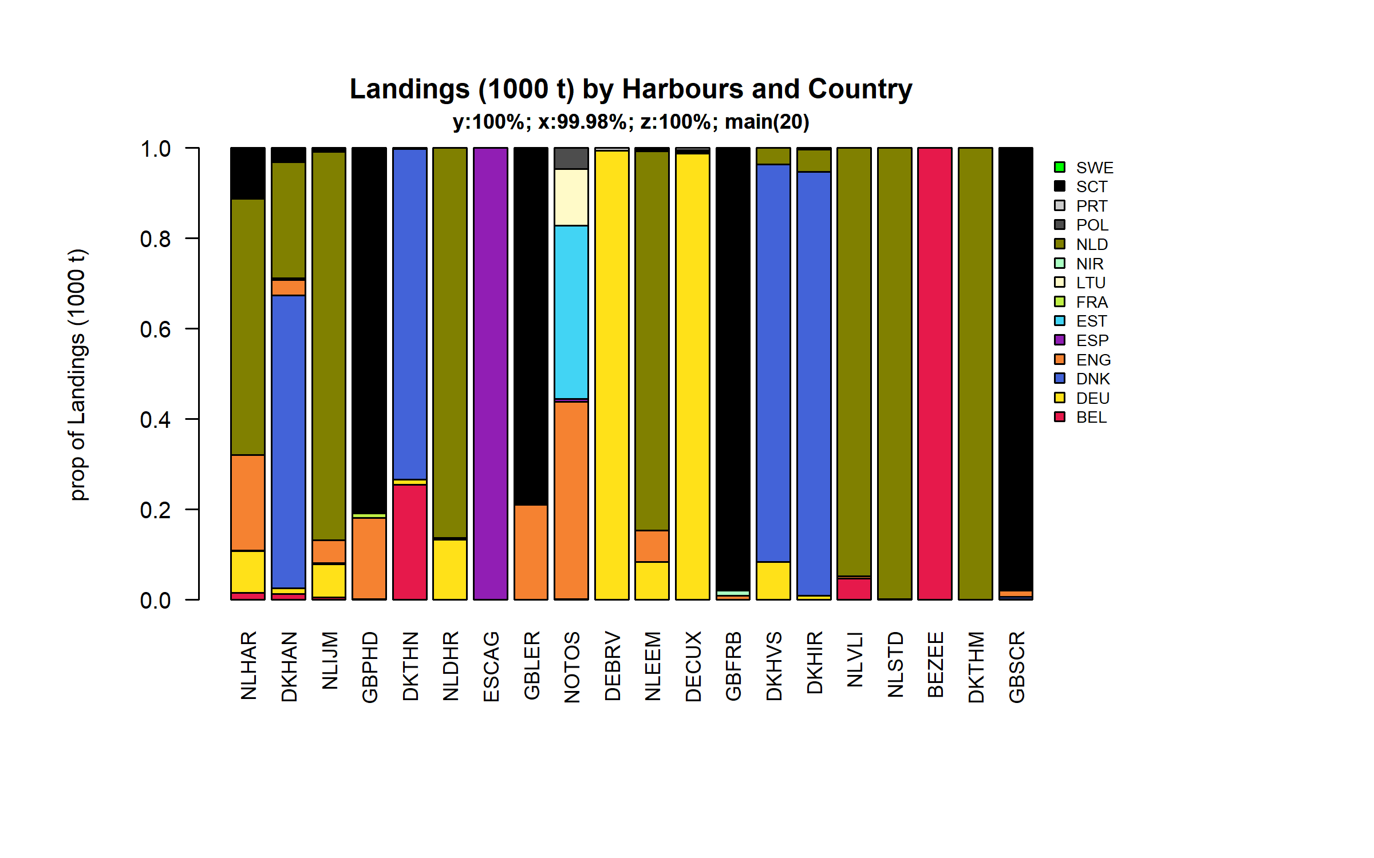 Figure 3.4.6.2. Landings (1000 t) of flatfish in the 20 main Harbours ( 99.98 % of rows entering analysis had known Harbours ) and Country .

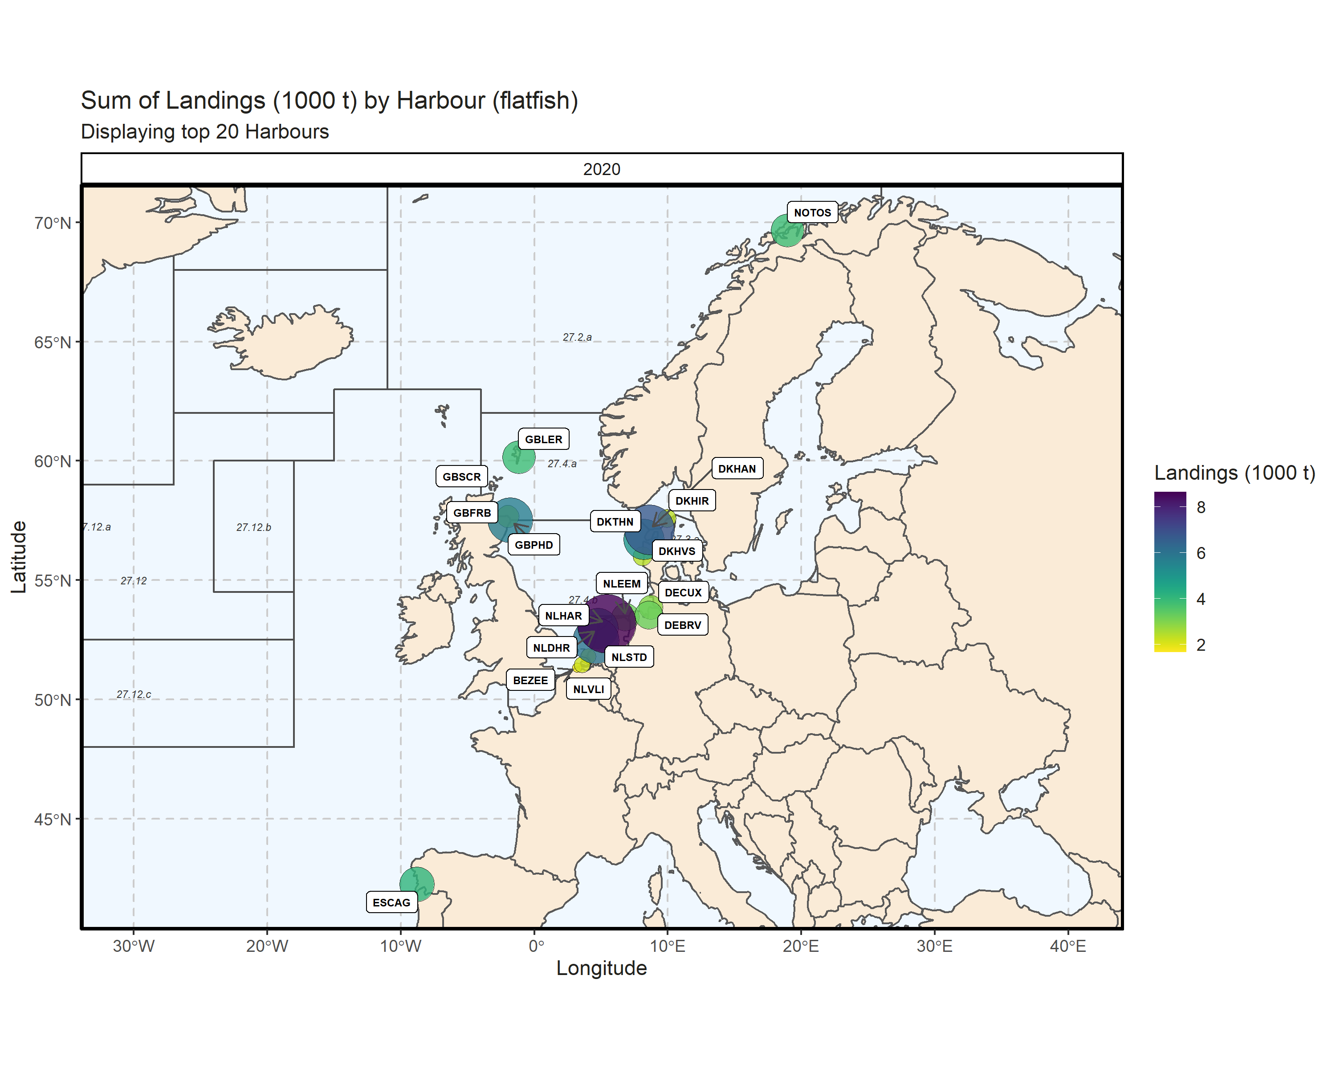 Figure 3.4.6.3. Sum of Landings (1000 t) by Harbour (flatfish). Displaying top 20 Harbours. 0.01% of Landings (1000 t) - reported for missing Harbour 1 Harbour with missing coordinates (1.97% of Landings (1000 t)) - not presented on the map.

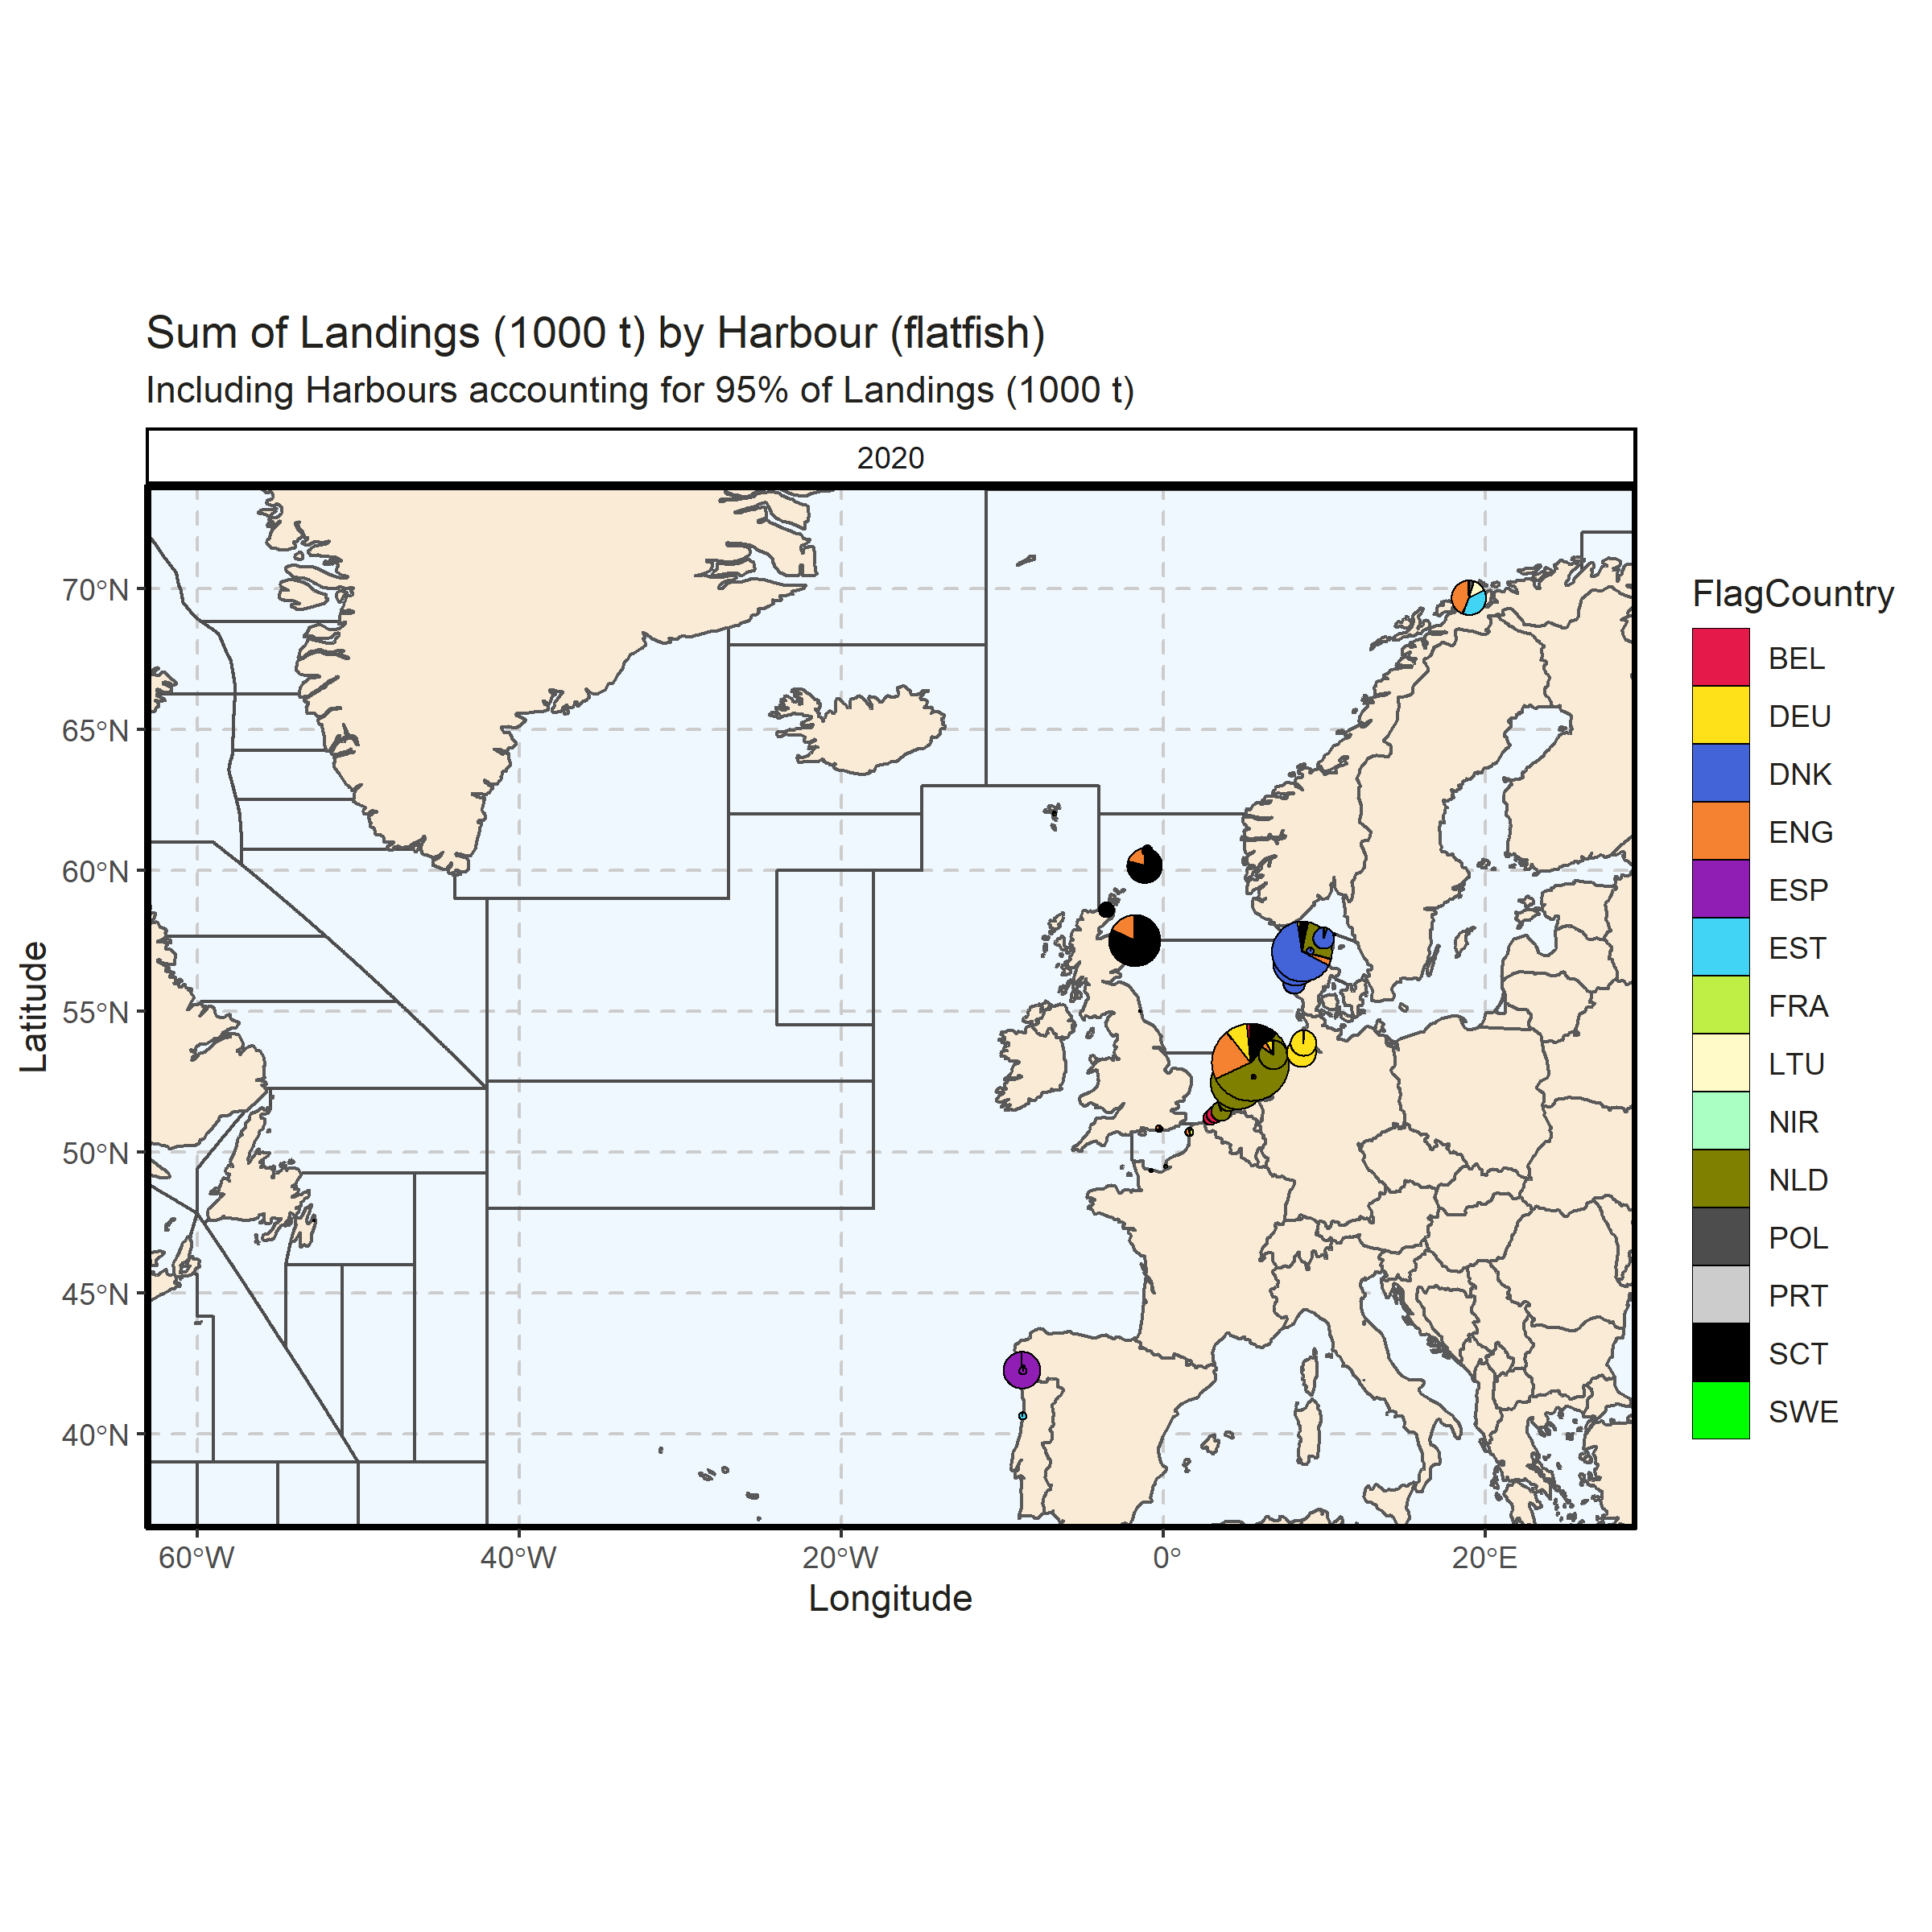 Figure 3.4.6.4. Sum of Landings (1000 t) by Harbour (flatfish). Including Harbours accounting for 95% of Landings (1000 t). 0.01% of Landings (1000 t) - reported for missing Harbour. 1 Harbour with missing coordinates (1.97% of Landings (1000 t)) - not presented on the map.

### Landings abroad, flatfish

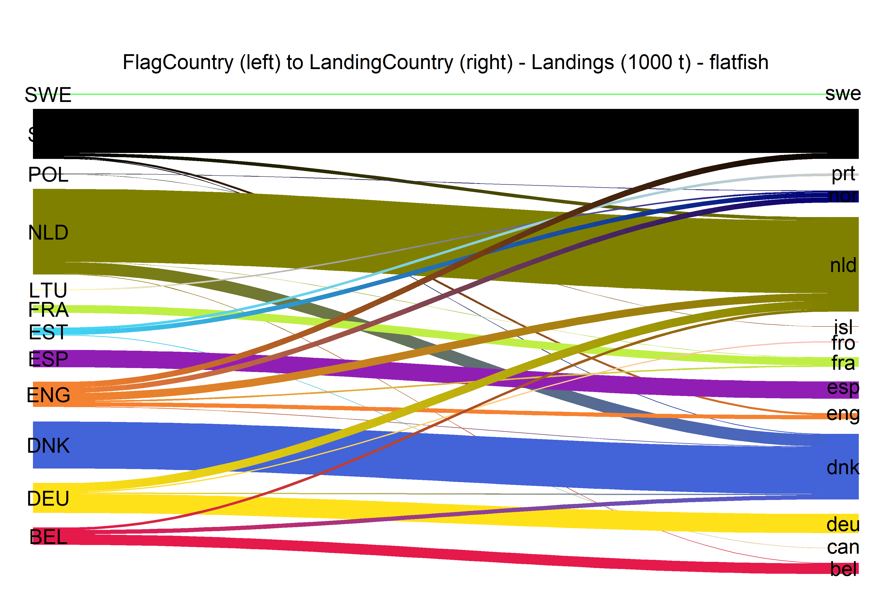  
Figure 3.4.7.1.River plot of Landings (1000 t) between Country (left) and Landing Country (right). Width of line is proportional to landings

### Spatial distribution of landings, flatfish

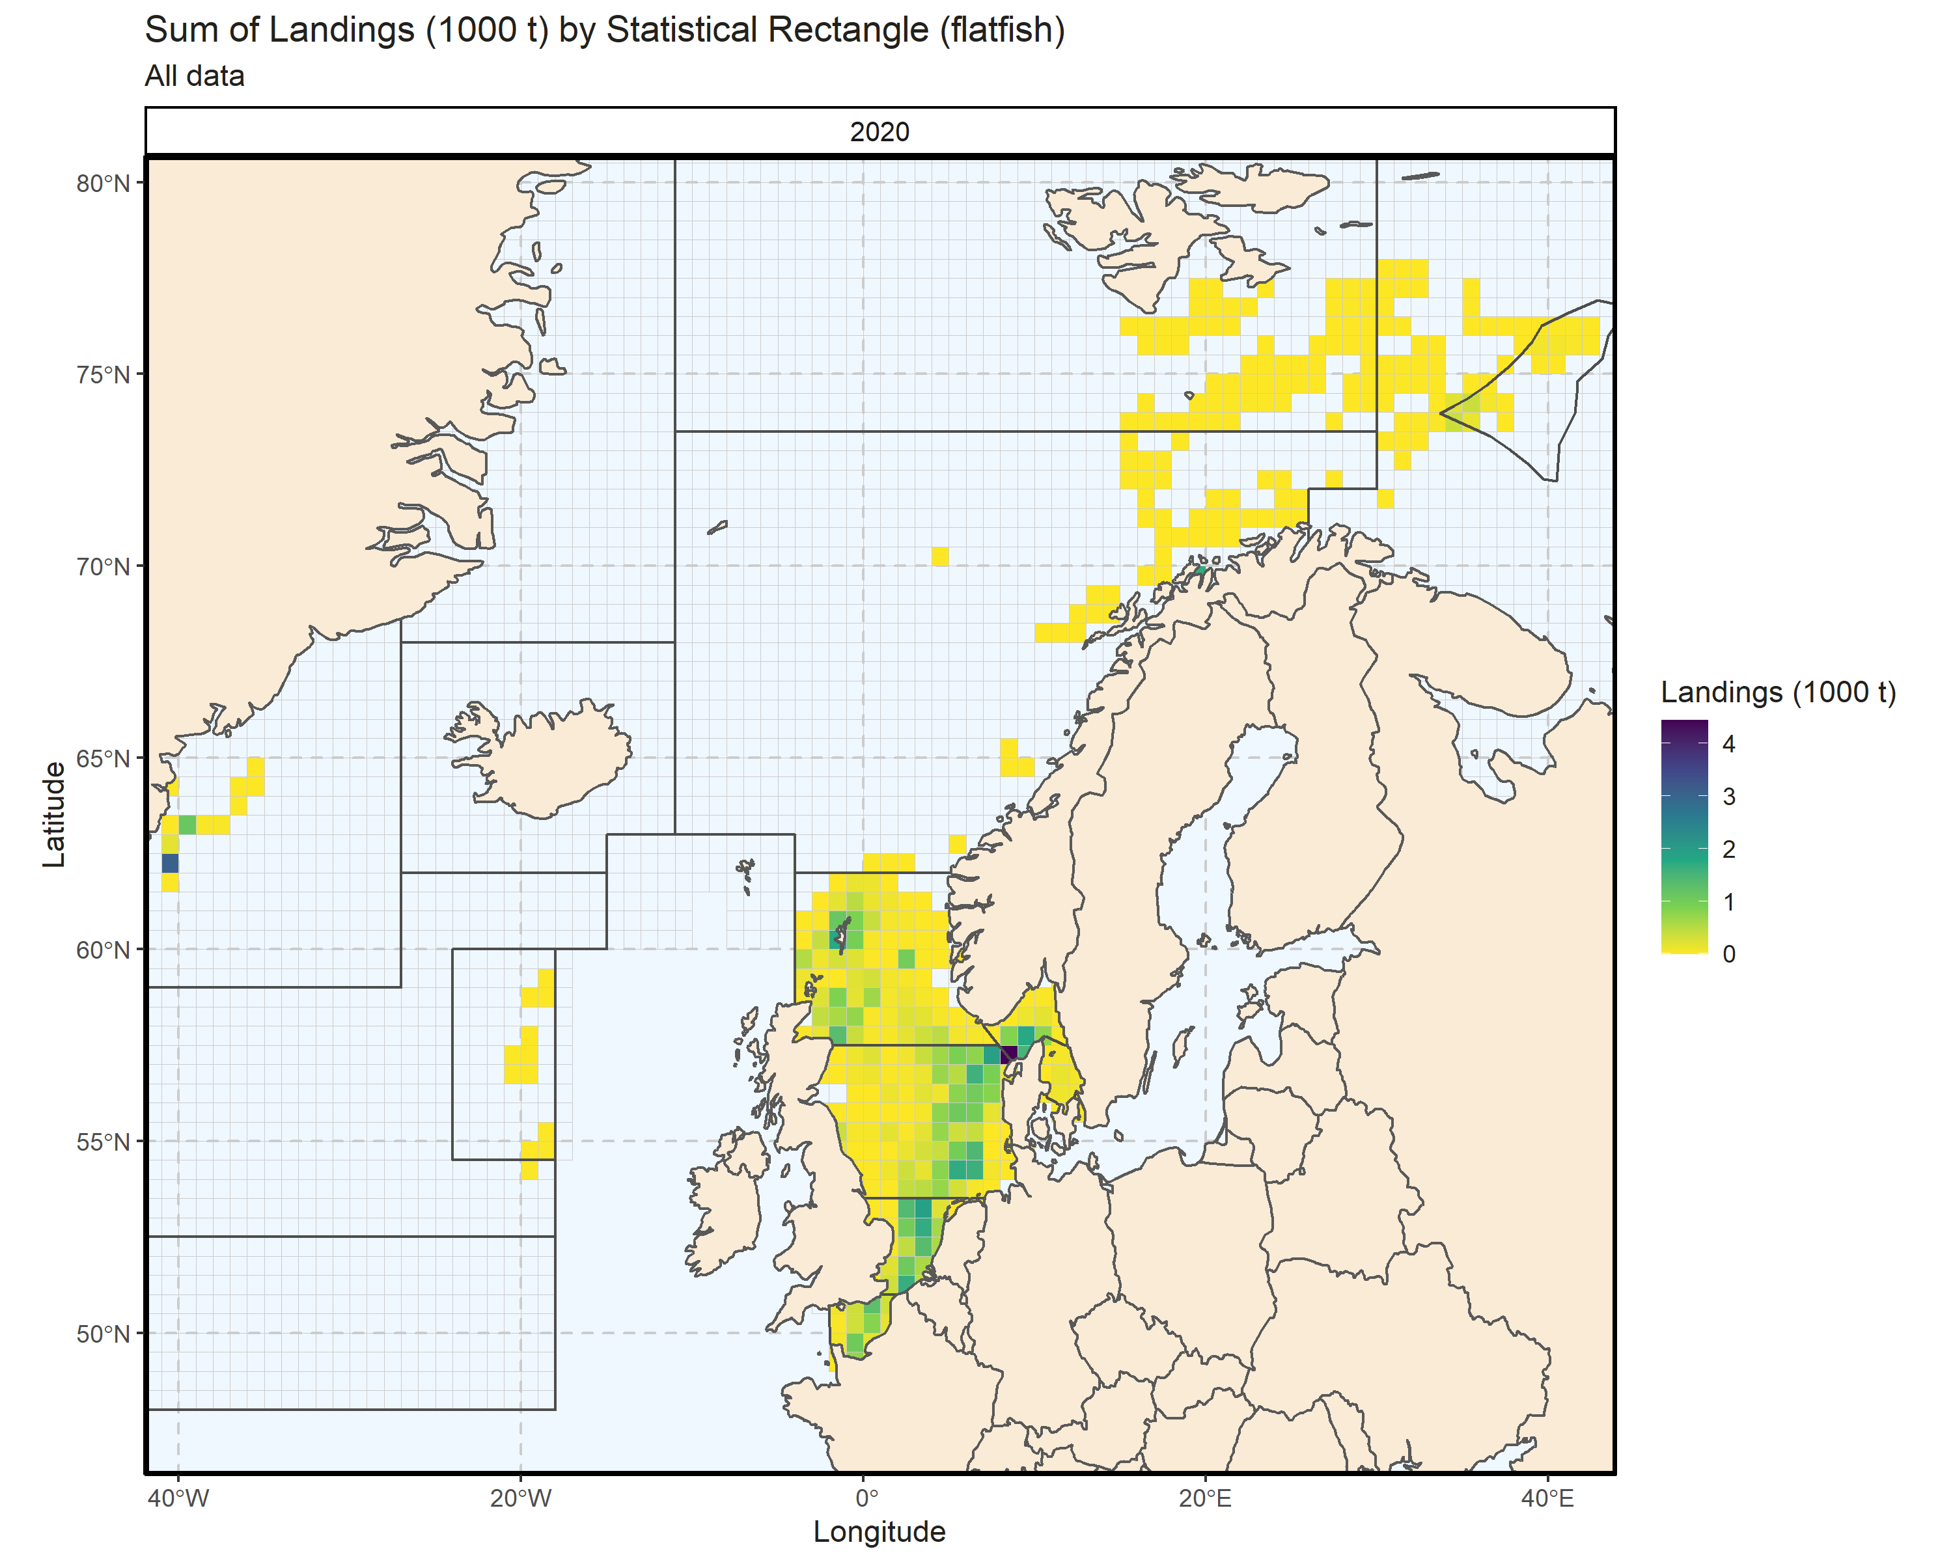 Figure 3.4.8.1. Sum of Landings (1000 t) by Statistical Rectangle (flatfish). All data. 1.9% of Landings (1000 t) - reported for missing Statistical Rectangle. 1 Statistical Rectangle with missing coordinates (8.89% of Landings (1000 t)) - not presented on the map.

# Effort (CE)

## Effort by country

### Overall

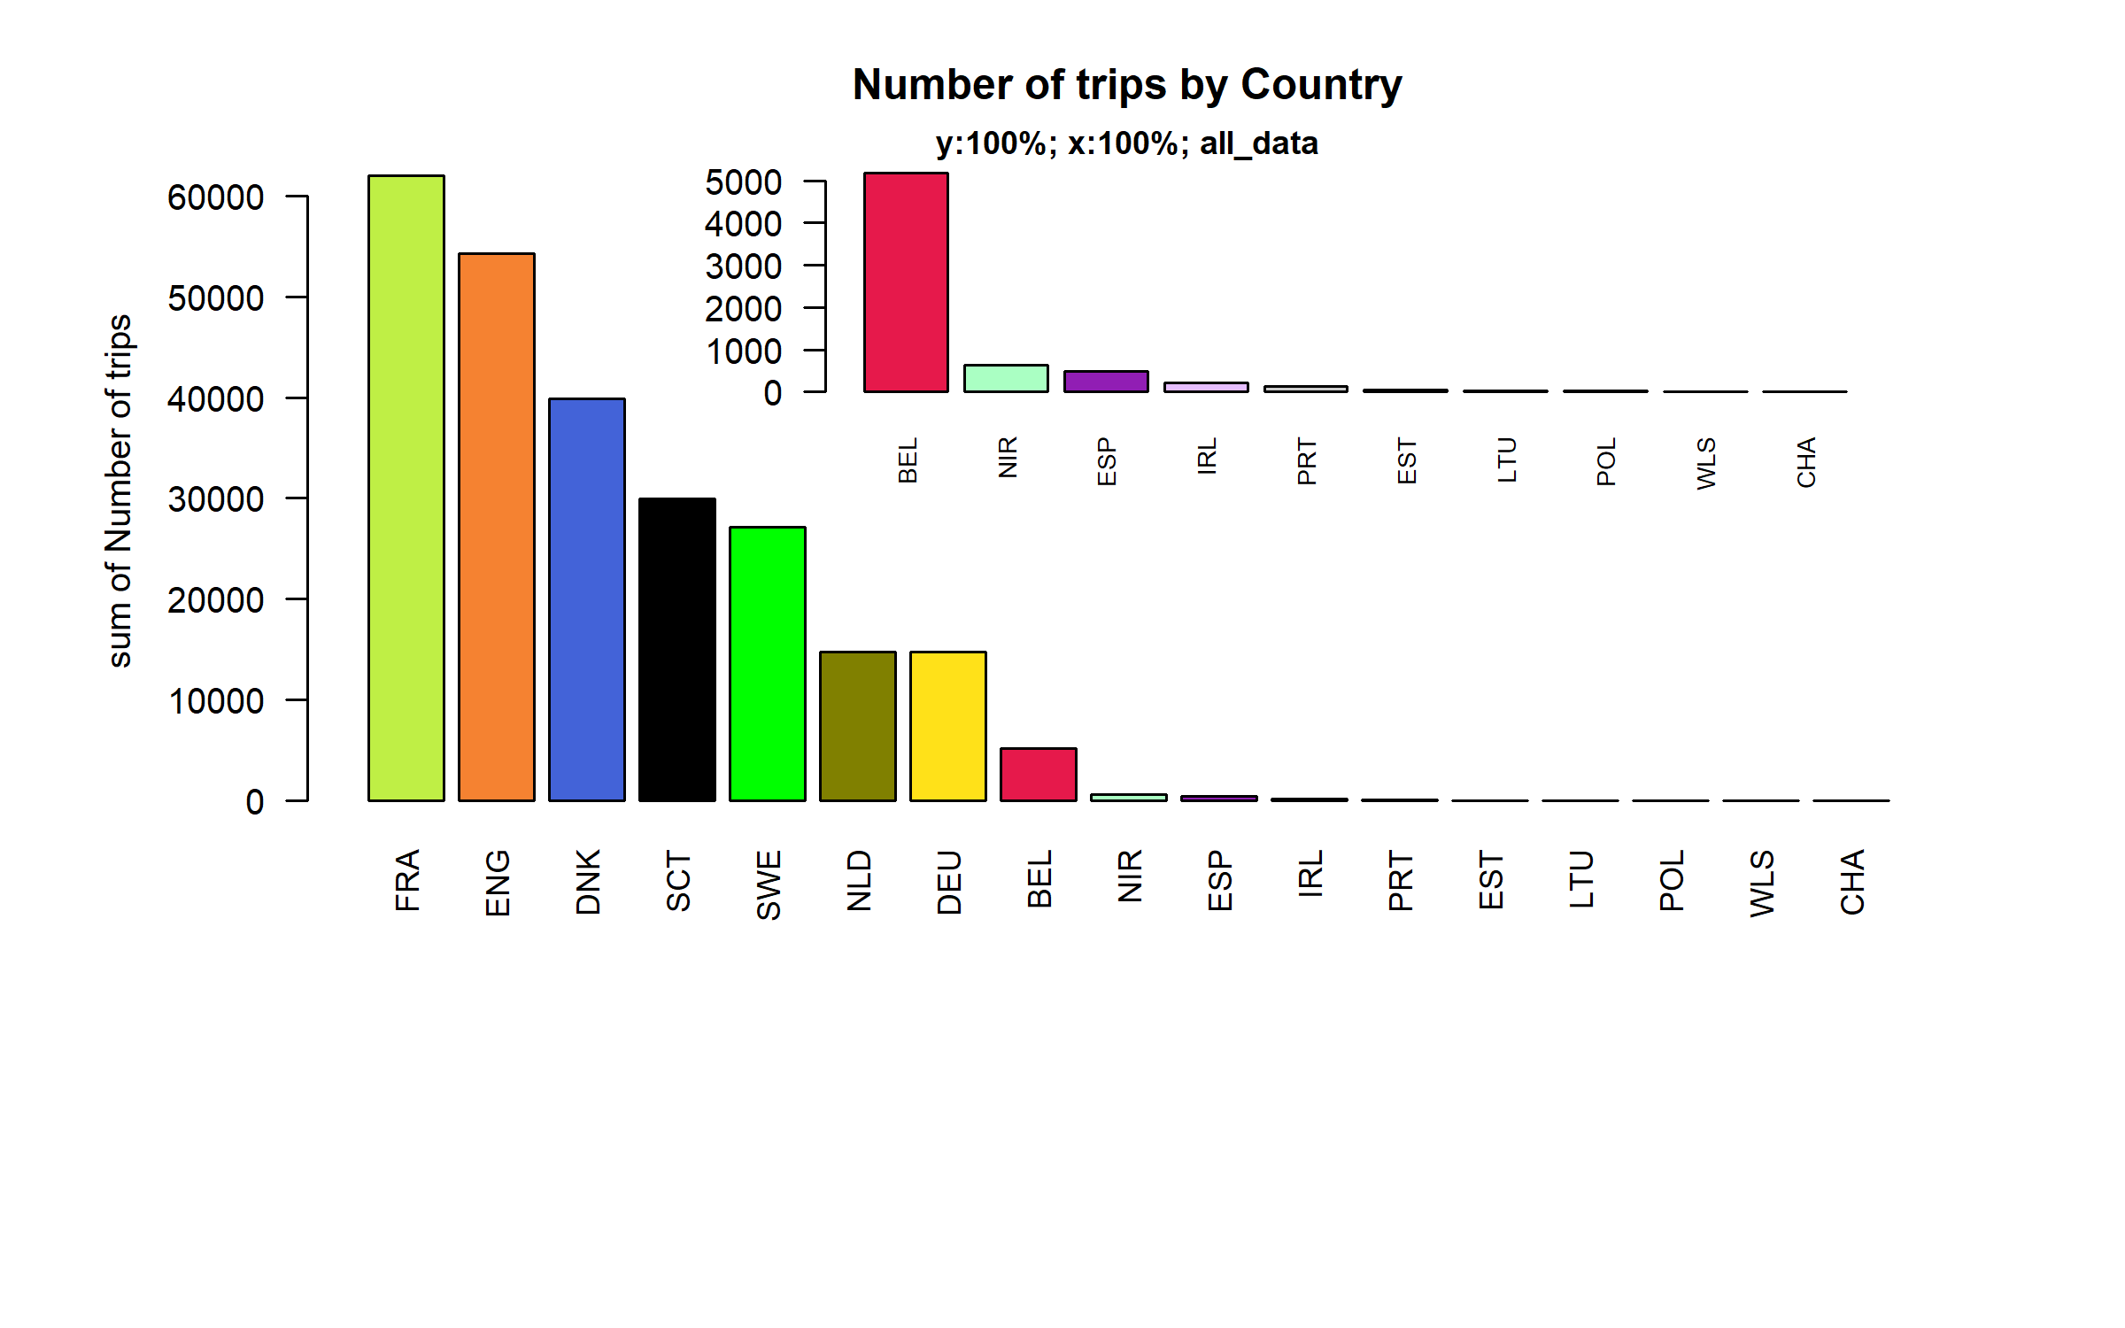 Figure 4.1.1.1. Number of trips by Country.

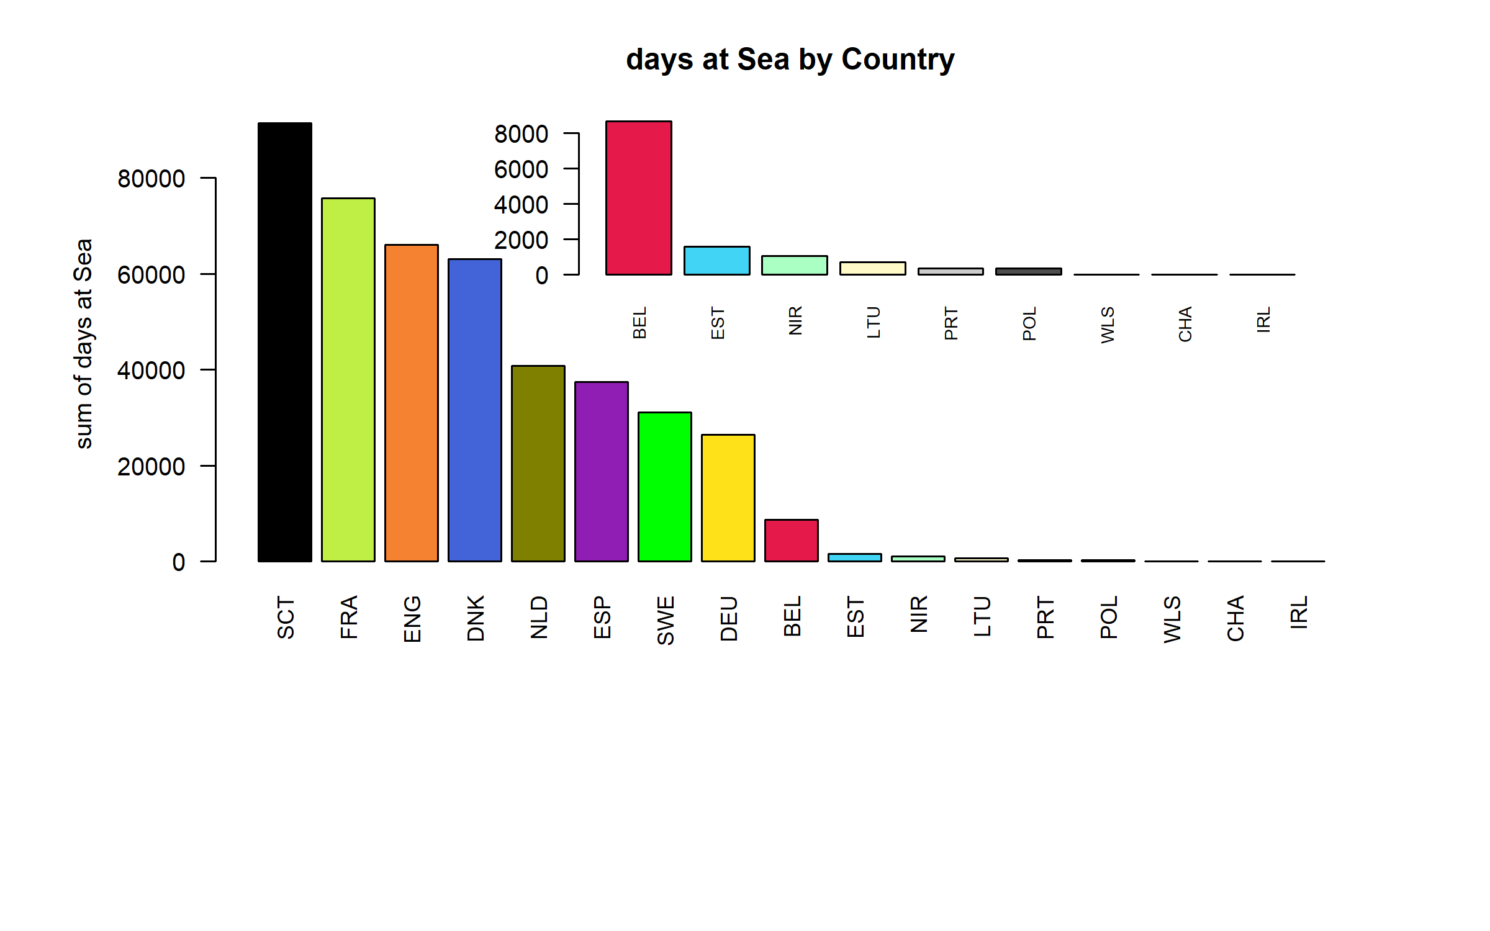 Figure 4.1.1.2. days at Sea by Country ( represent 97.04 % of all days at Sea )

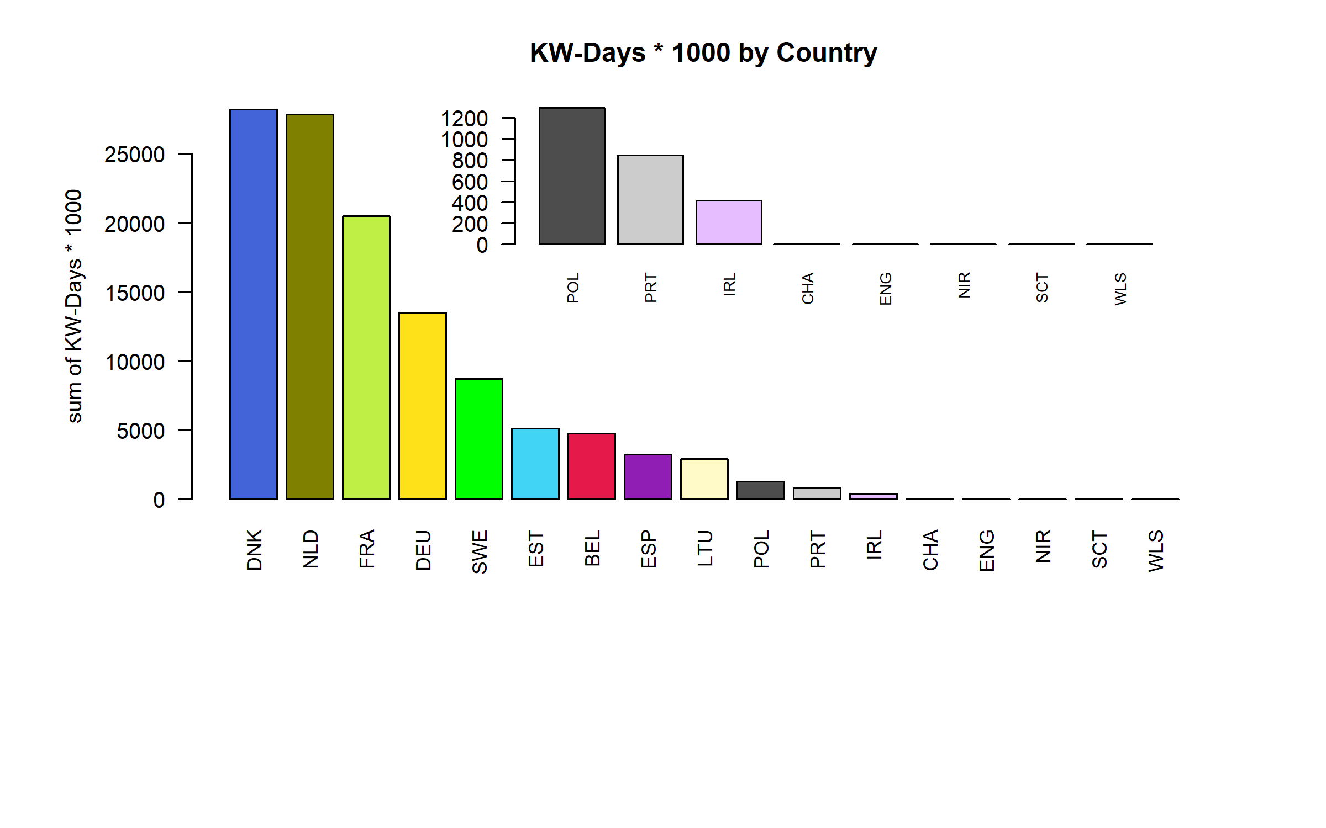 Figure 4.1.1.3. KW-Days * 1000 by Country ( represent 65.92 % of all KW-Days * 1000 )

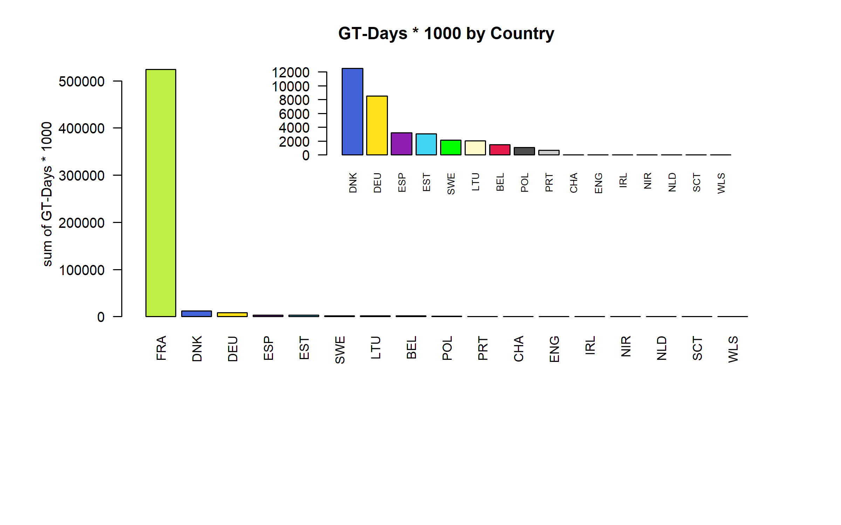 Figure 4.1.1.4. GT-Days * 1000 by Country ( represent 57.37 % of all GT-Days * 1000 )

## Effort by fleet

### Overall

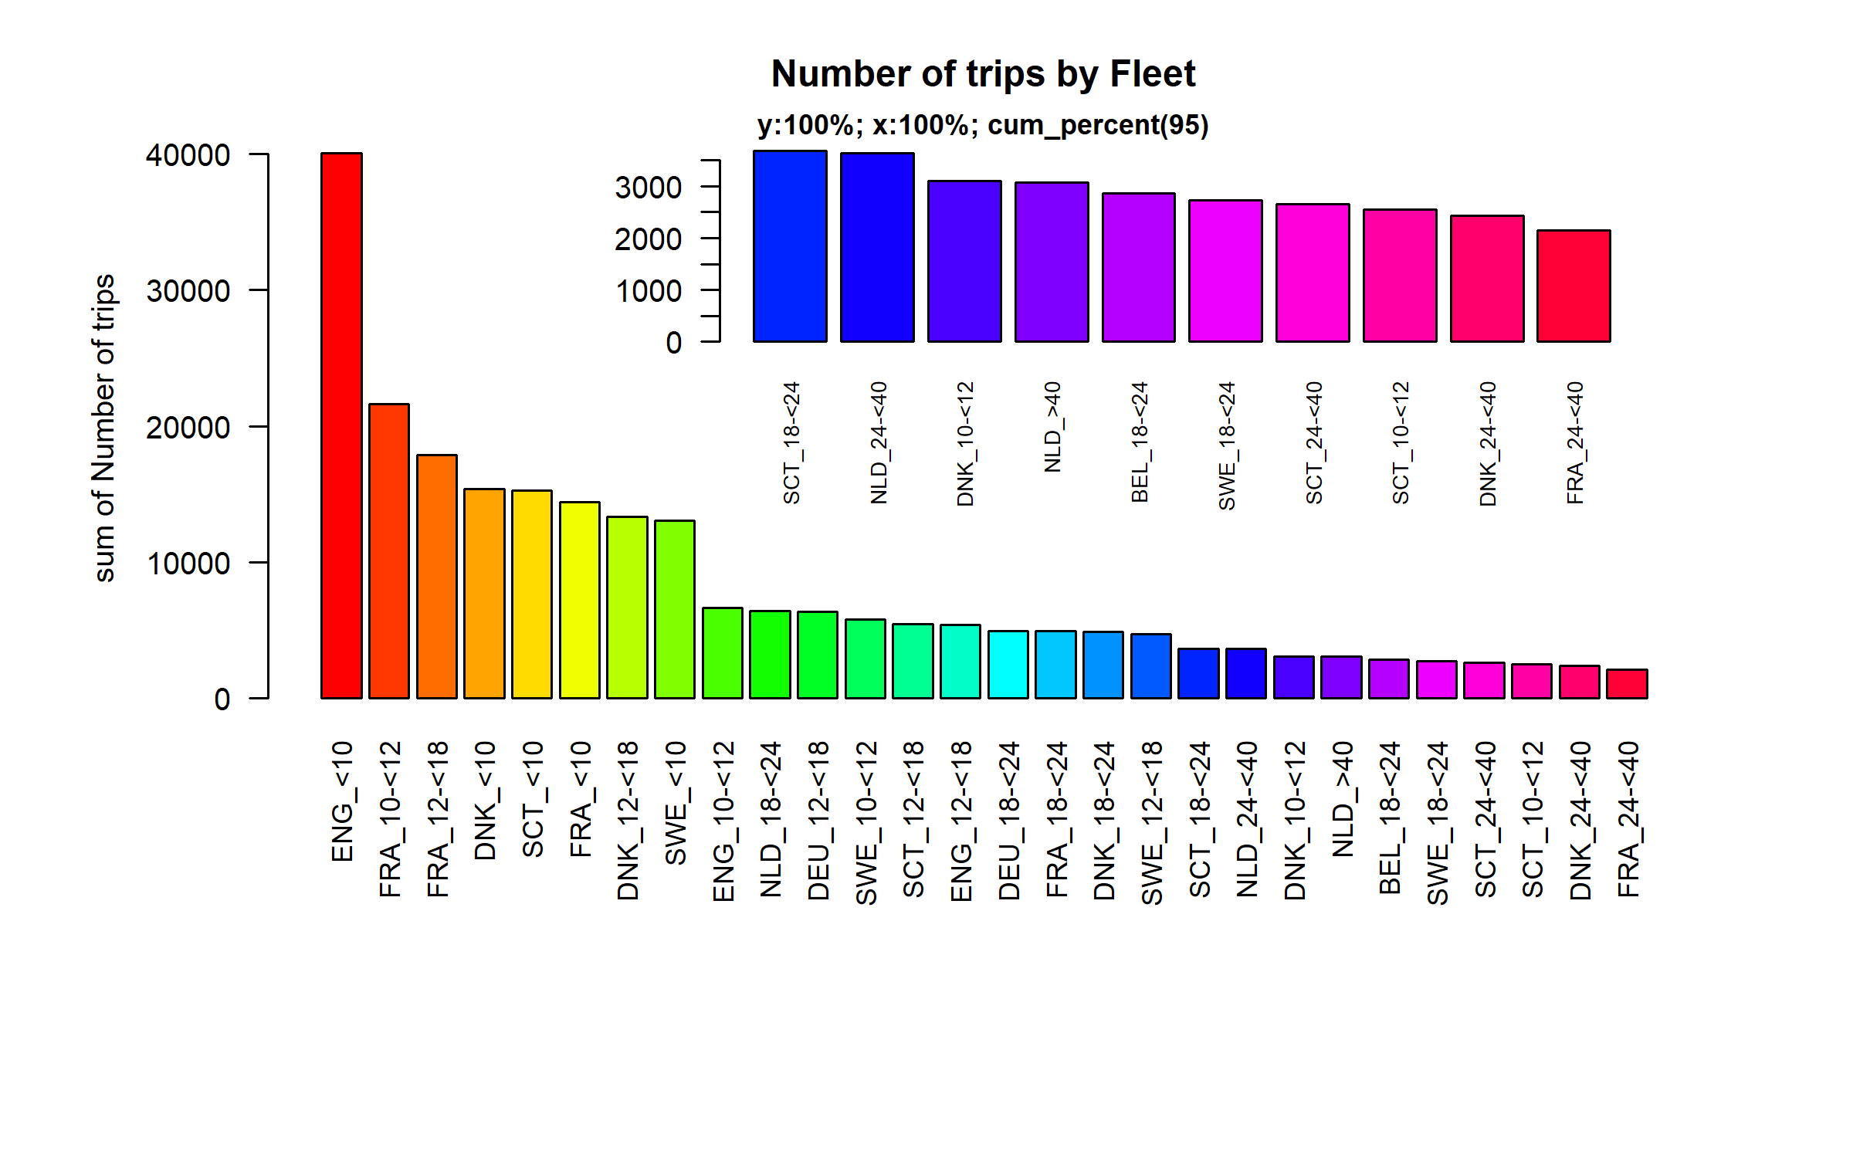 Figure 4.2.1.1. Number of trips by Fleet. Fleet displayed comprise 95% of the total Number of trips.

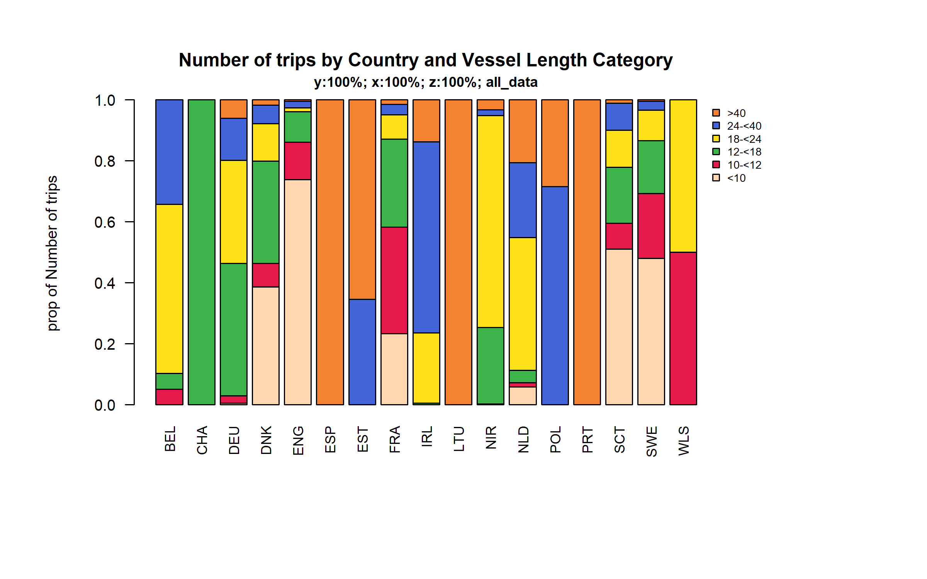 Figure 4.2.1.2. Number of trips by Country and Vessel Length Category.

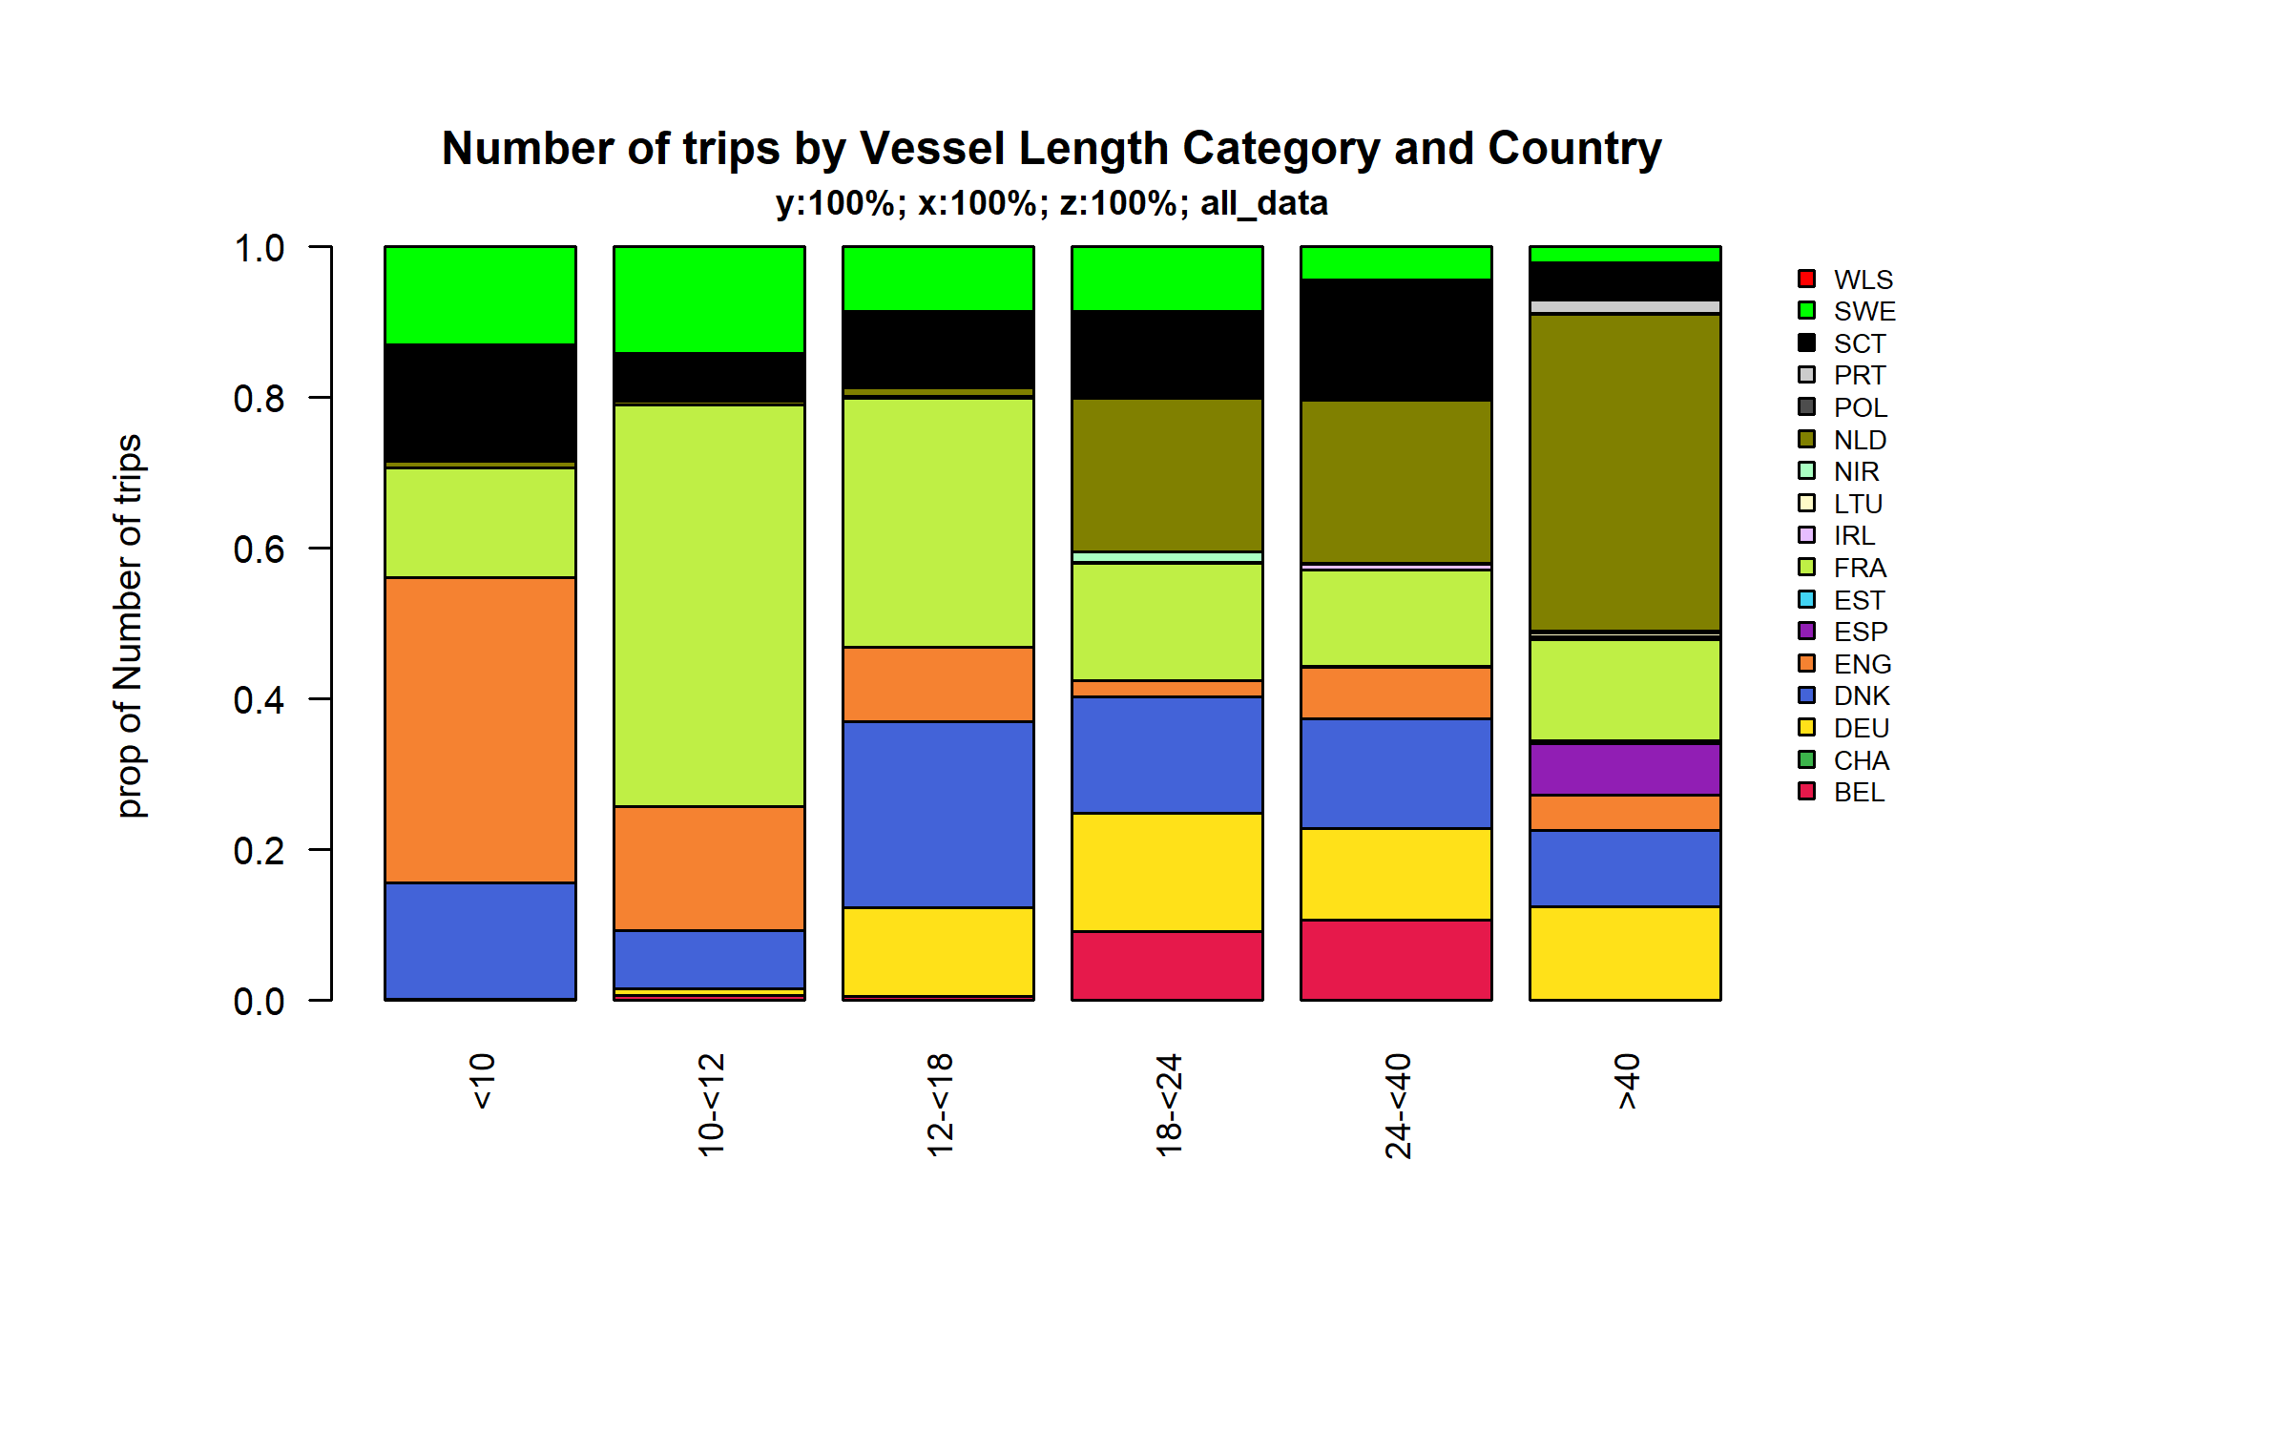 Figure 4.2.1.3. Number of trips by Vessel Length Category and Country.

## Effort by area

### Below 10 meters

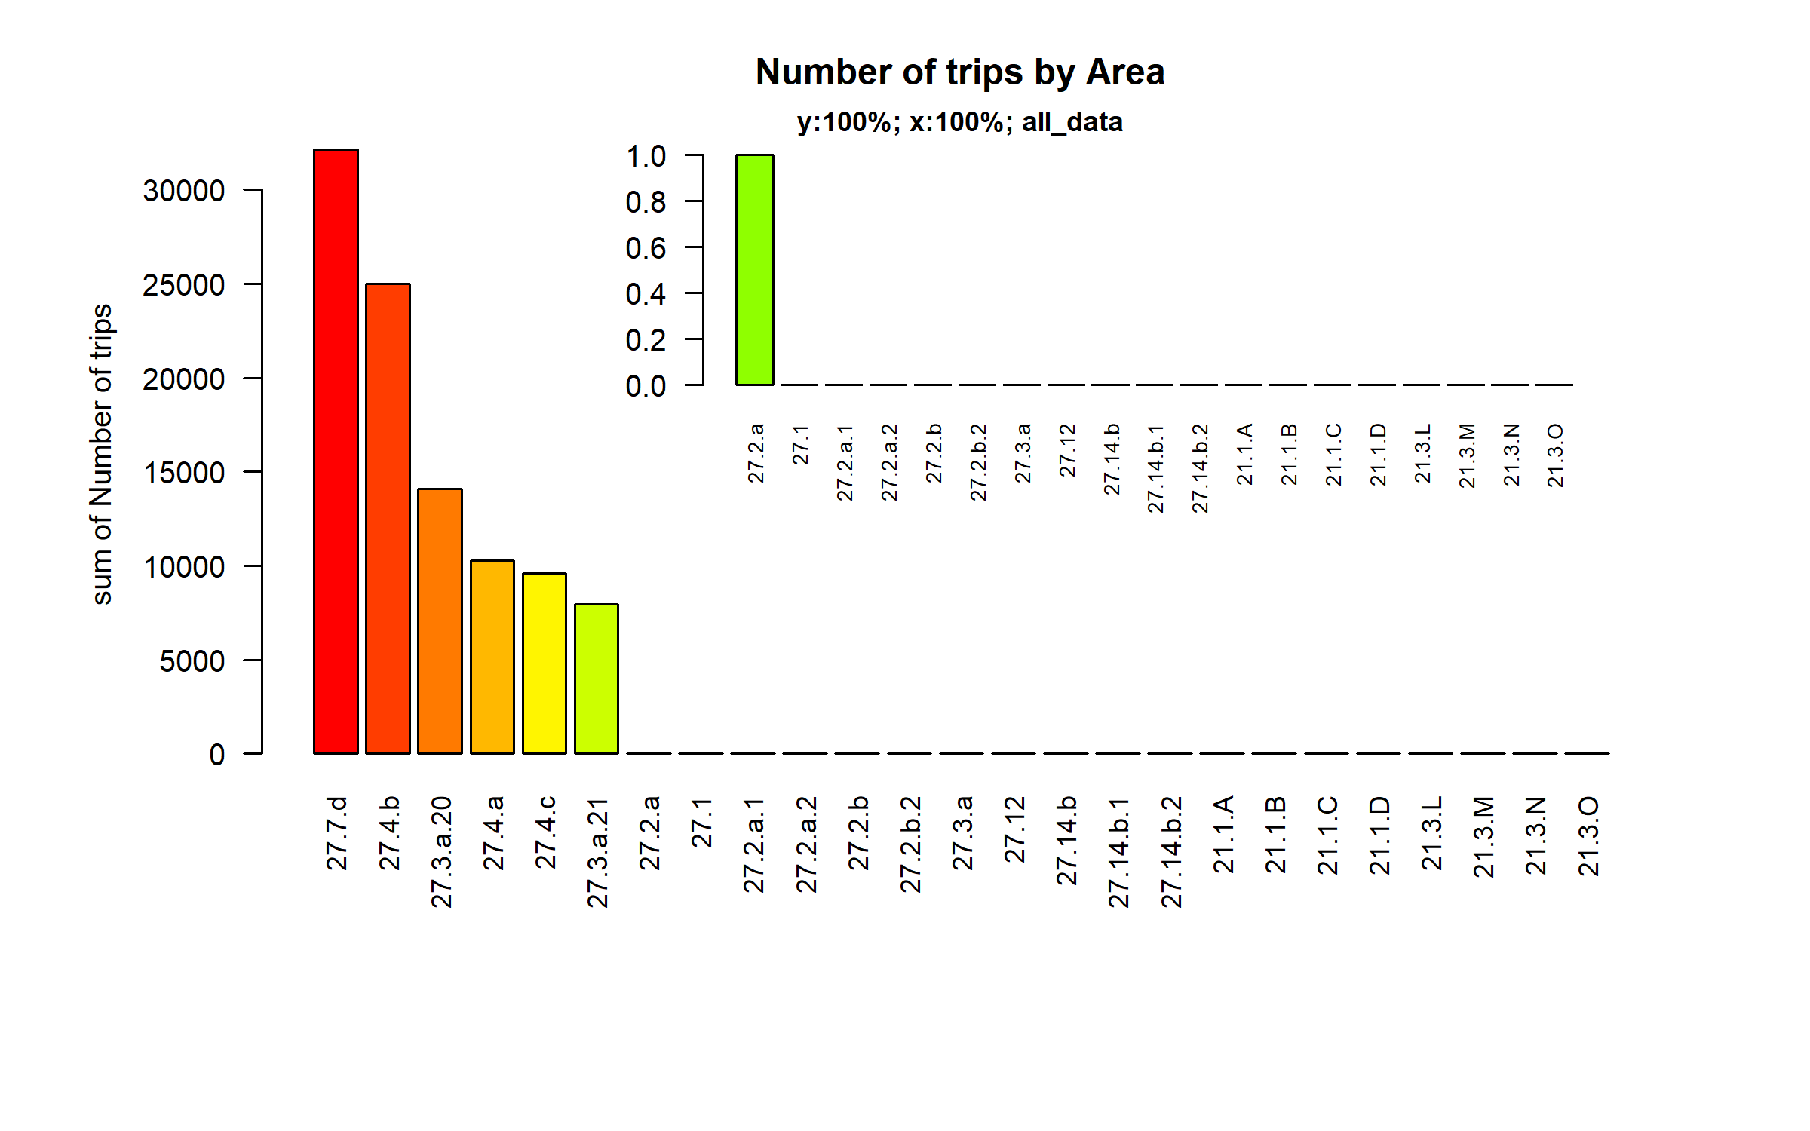 Figure 4.3.1.1. Number of trips by Area.

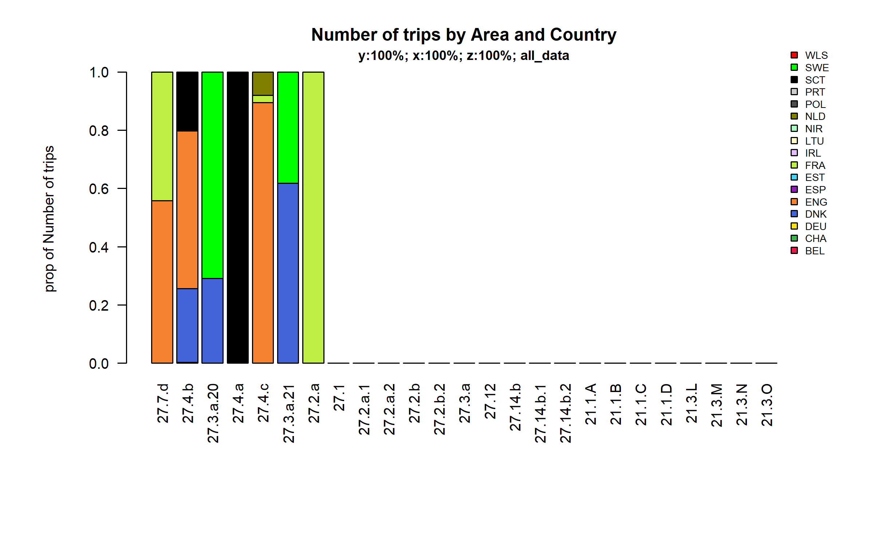 Figure 4.3.1.2. Number of trips by Area and Country.

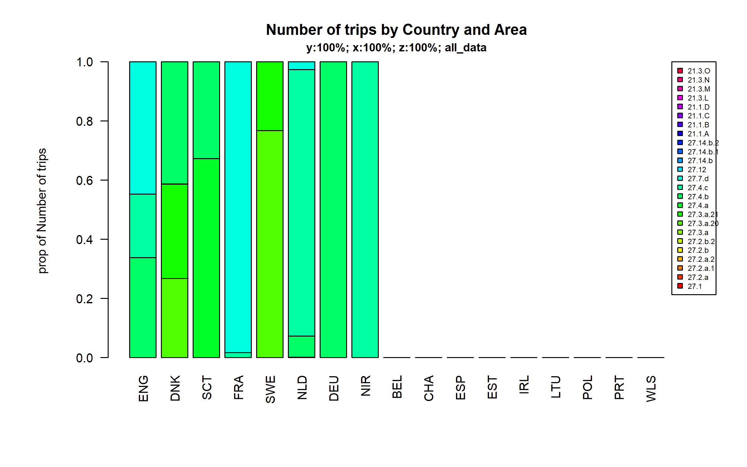 Figure 4.3.1.3. Number of trips by Country and Area.

### 10 meter and above

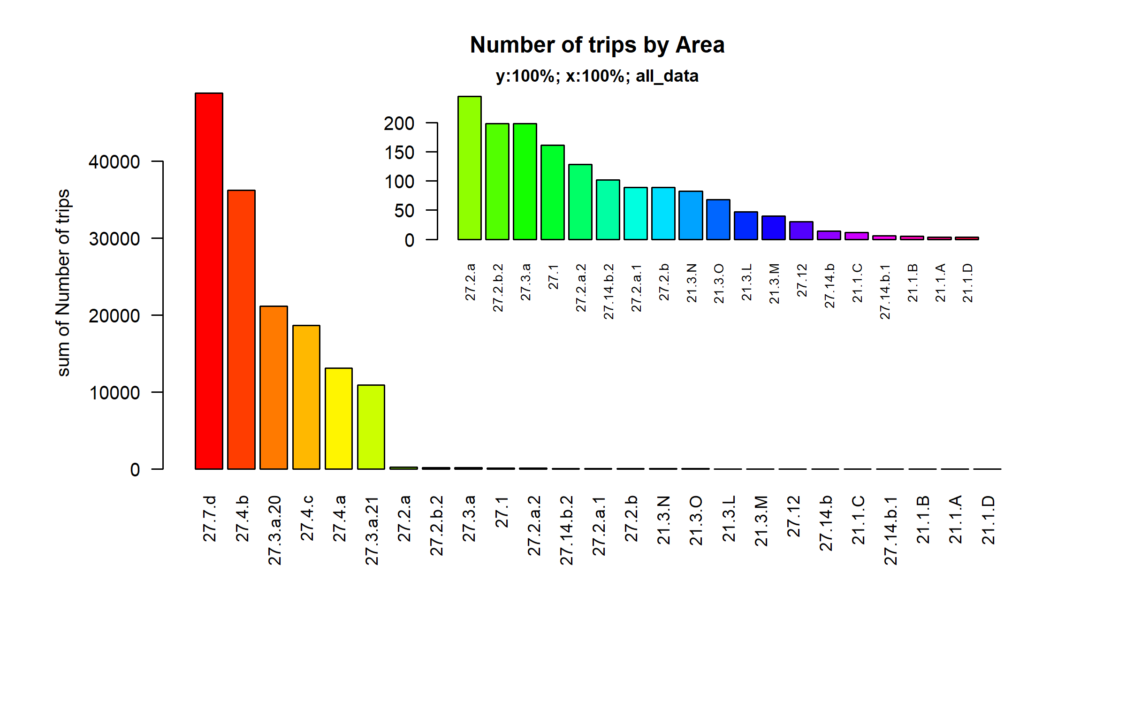 Figure 4.3.2.1. Number of trips by Area.

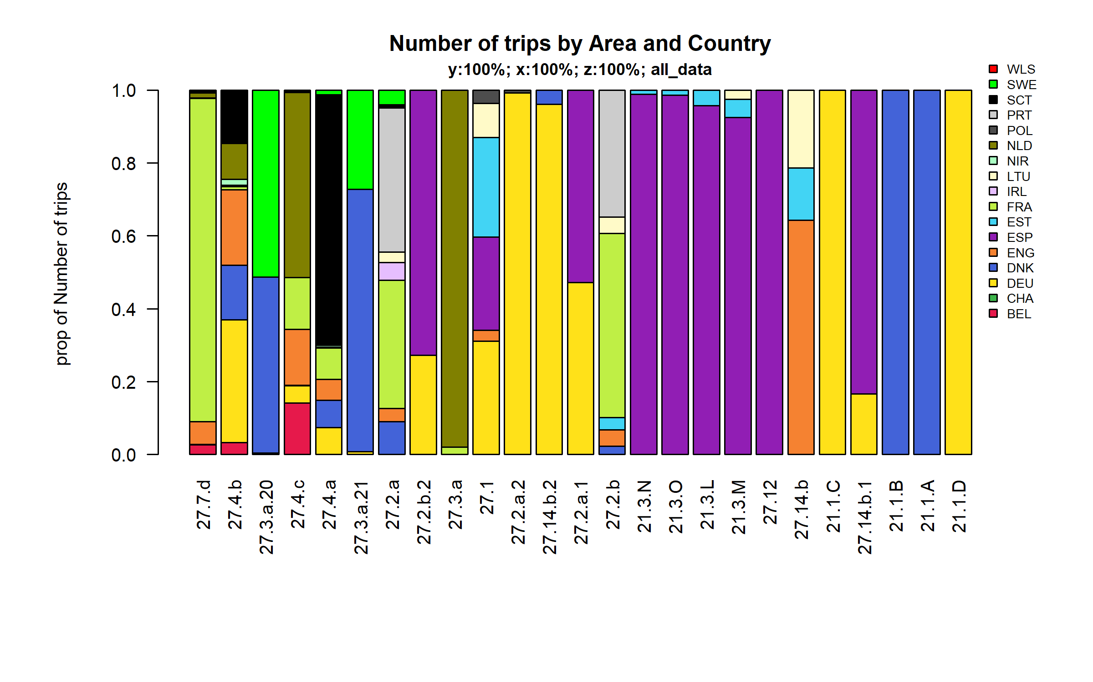 Figure 4.3.2.2. Number of trips by Area and Country.

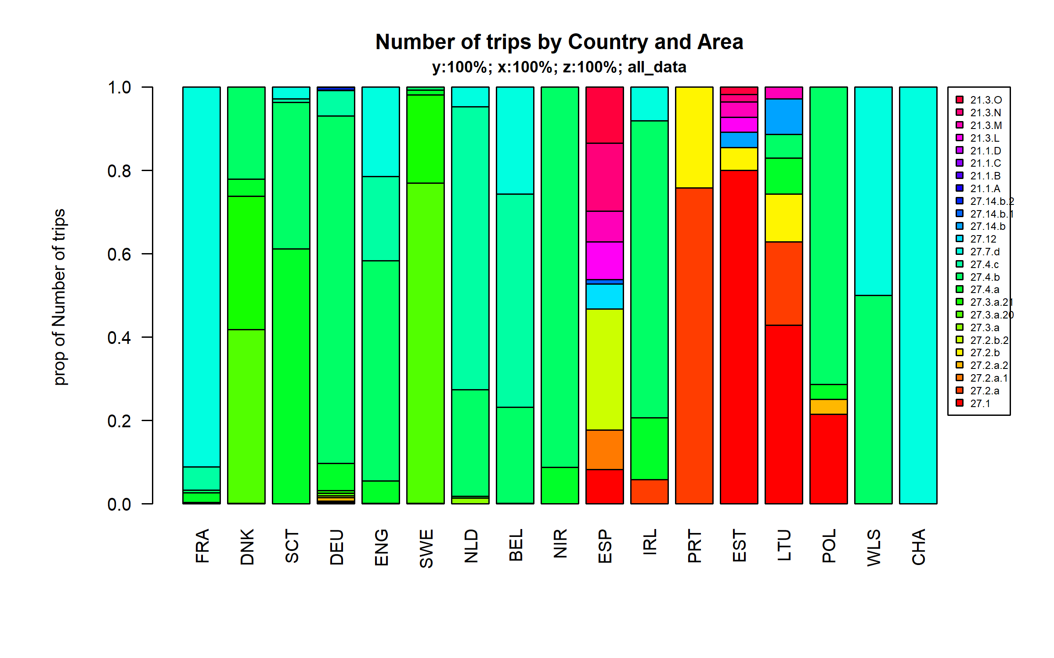 Figure 4.3.2.3. Number of trips by Country and Area.

## Effort by metier

### Below 10 meters

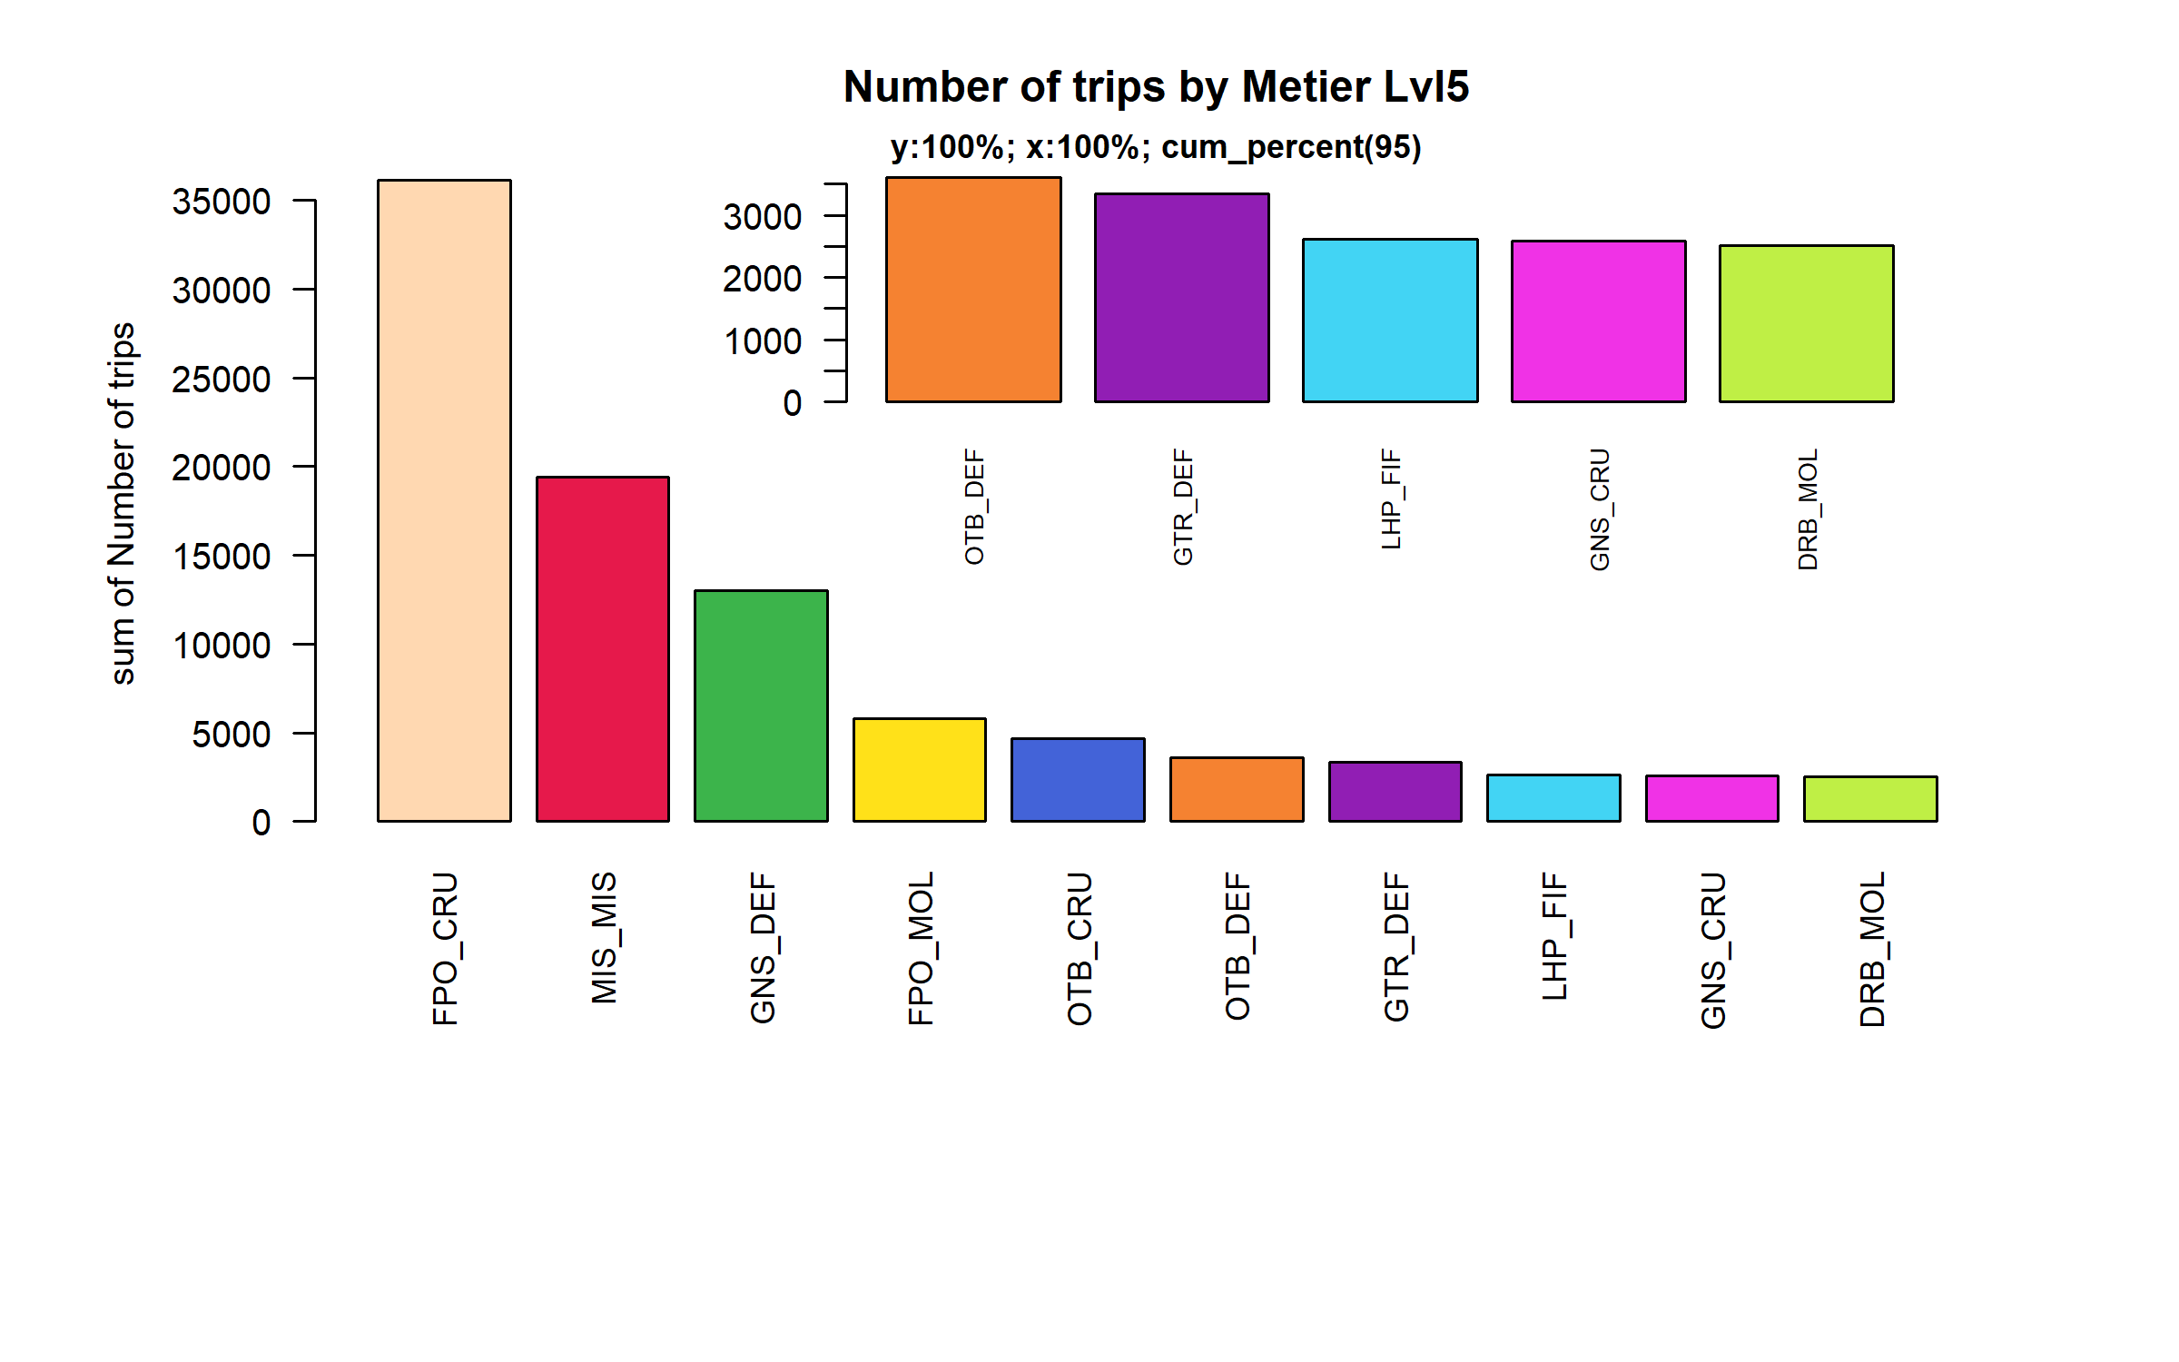 Figure 4.4.1.1. Number of trips by Metier Lvl5. Metier Lvl5 displayed comprise 95% of the total Number of trips.

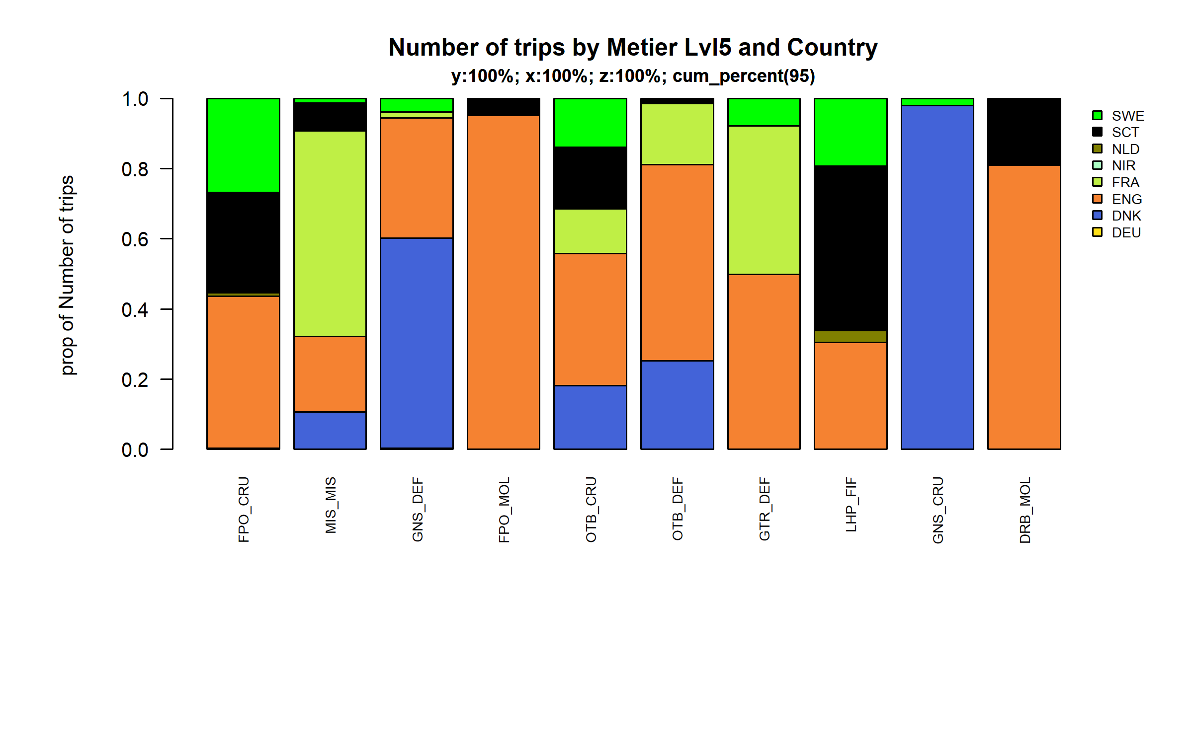 Figure 4.4.1.2. Number of trips by Metier Lvl5 and Country . Metier Lvl5 and Country displayed comprise 95 % of the total Number of trips .

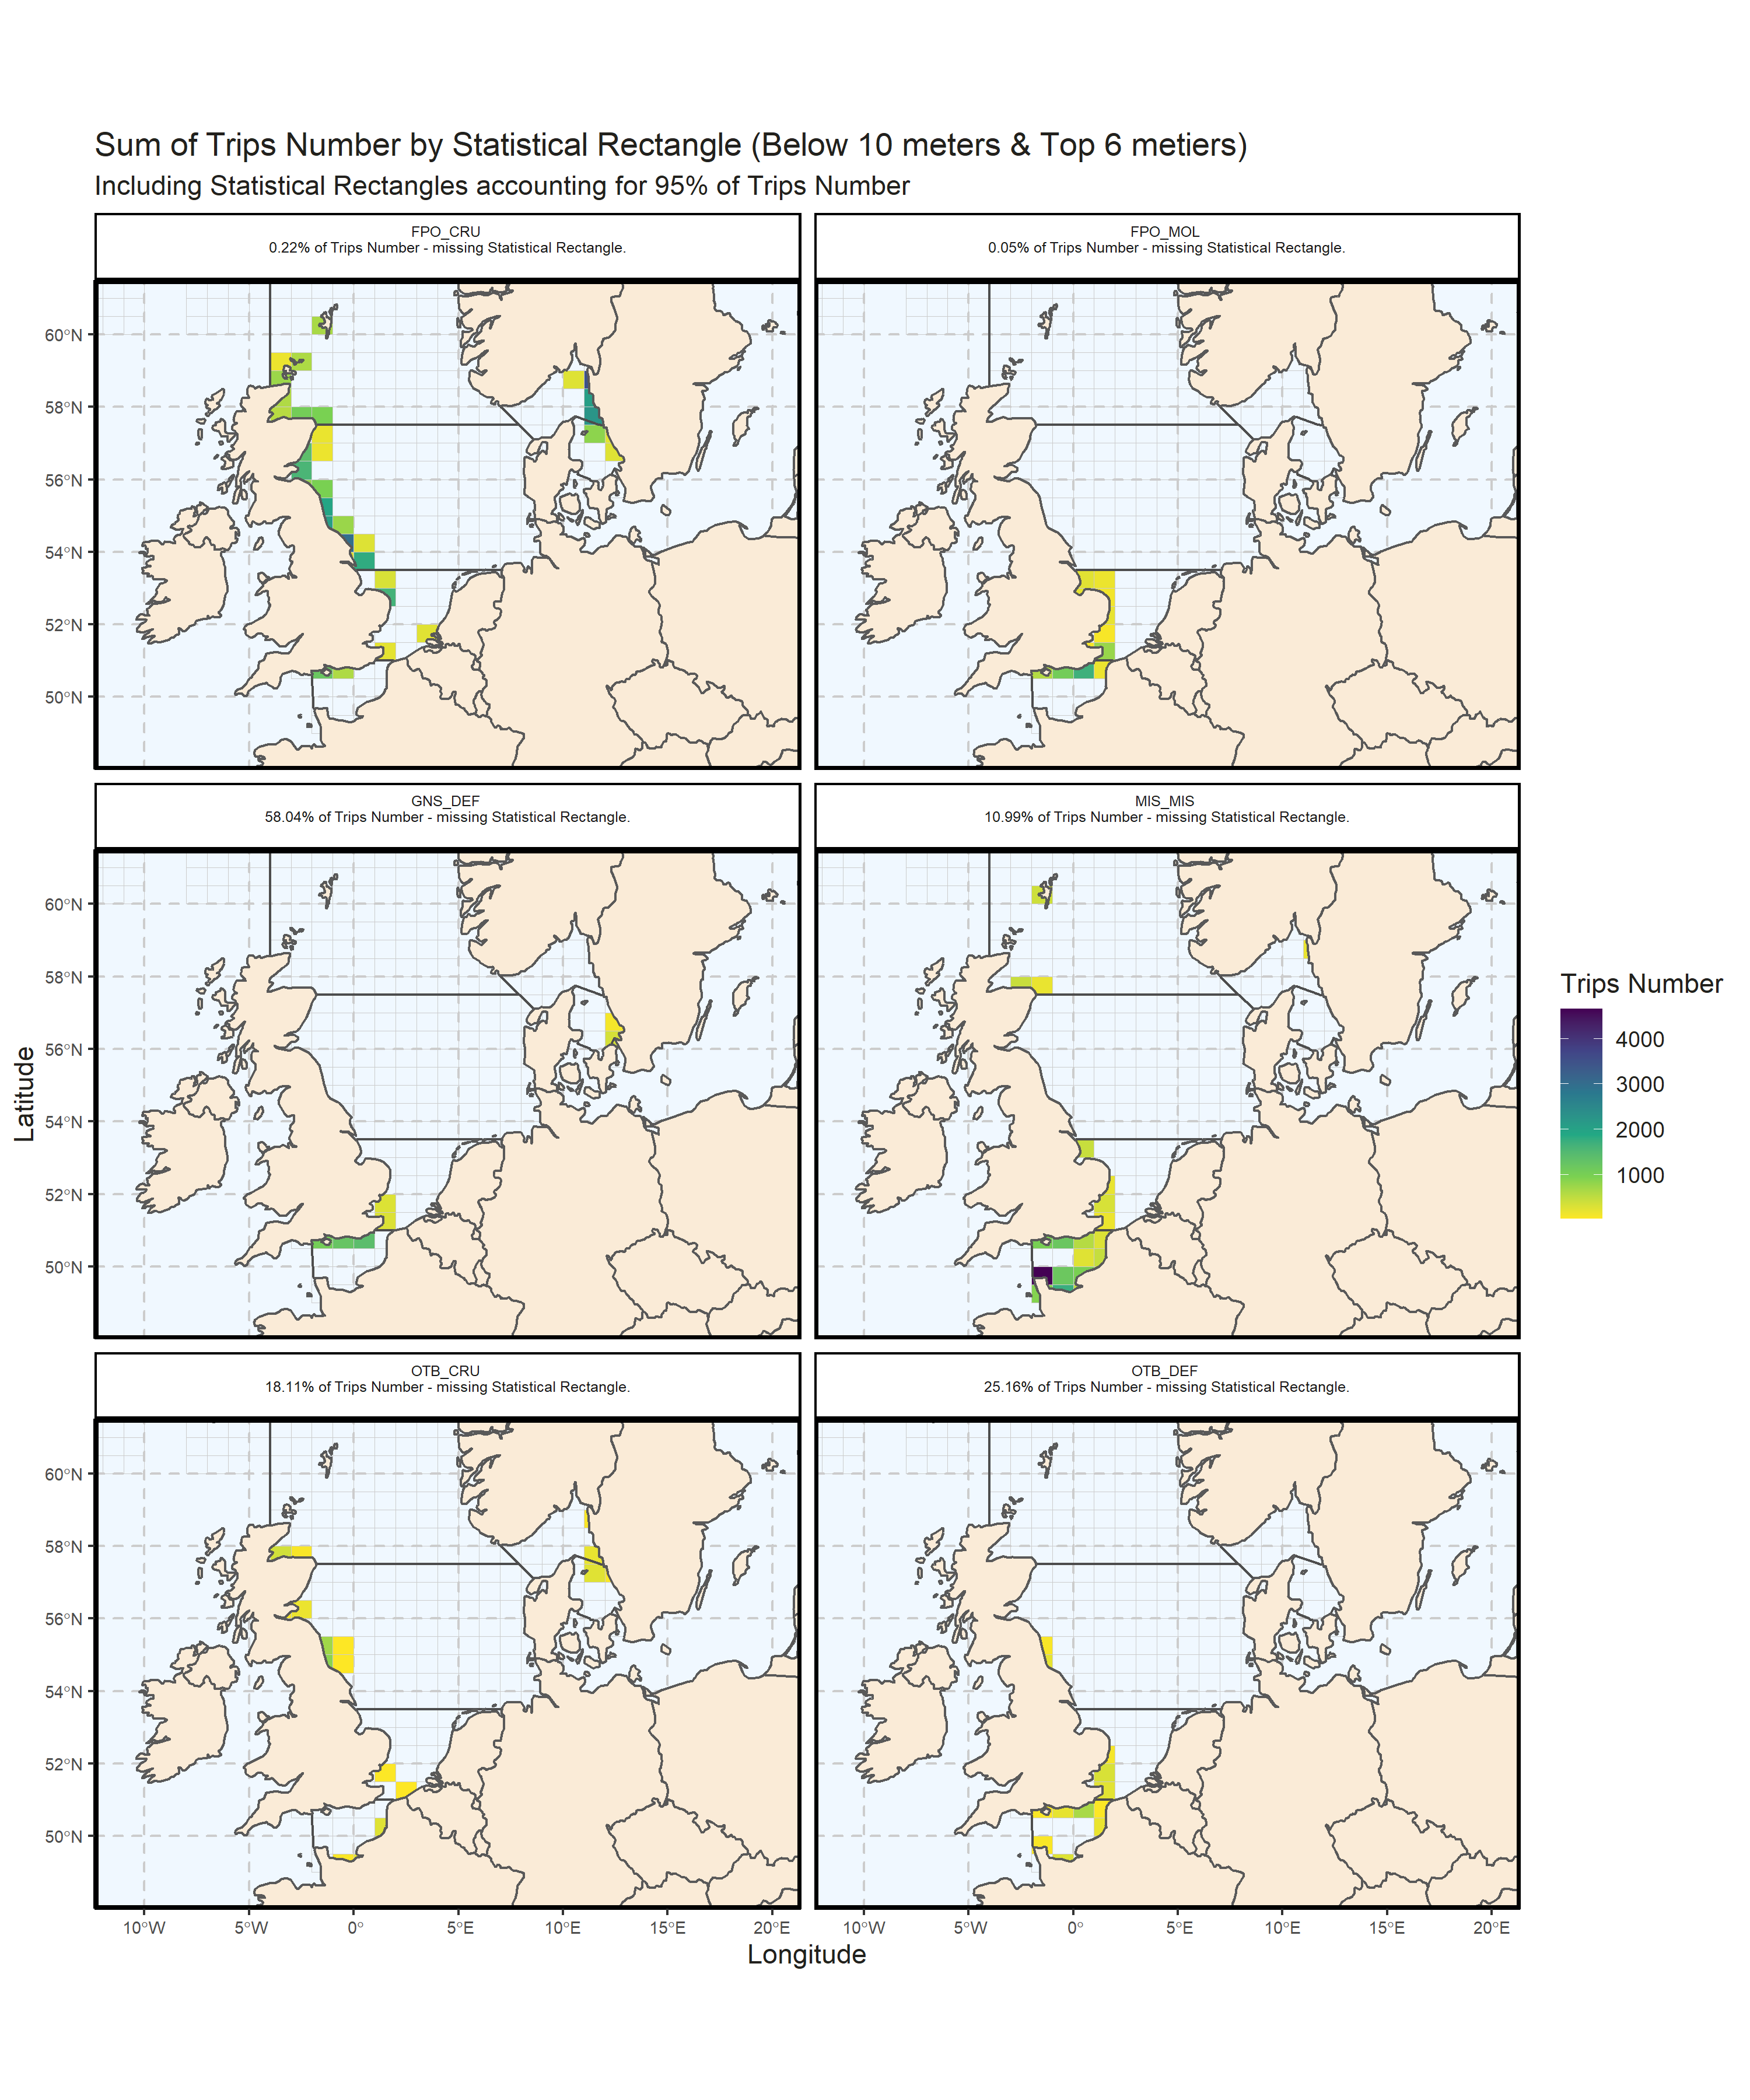 Figure 4.4.1.3. Sum of Trips Number by Statistical Rectangle (Below 10 meters & Top 6 metiers) . Including Statistical Rectangles accounting for 95% of Trips Number .

### 10 meter and above

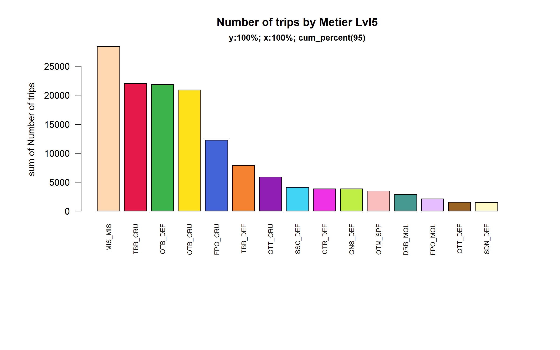 Figure 4.4.2.1. Number of trips by Metier Lvl5. Metier Lvl5 displayed comprise 95% of the total Number of trips.

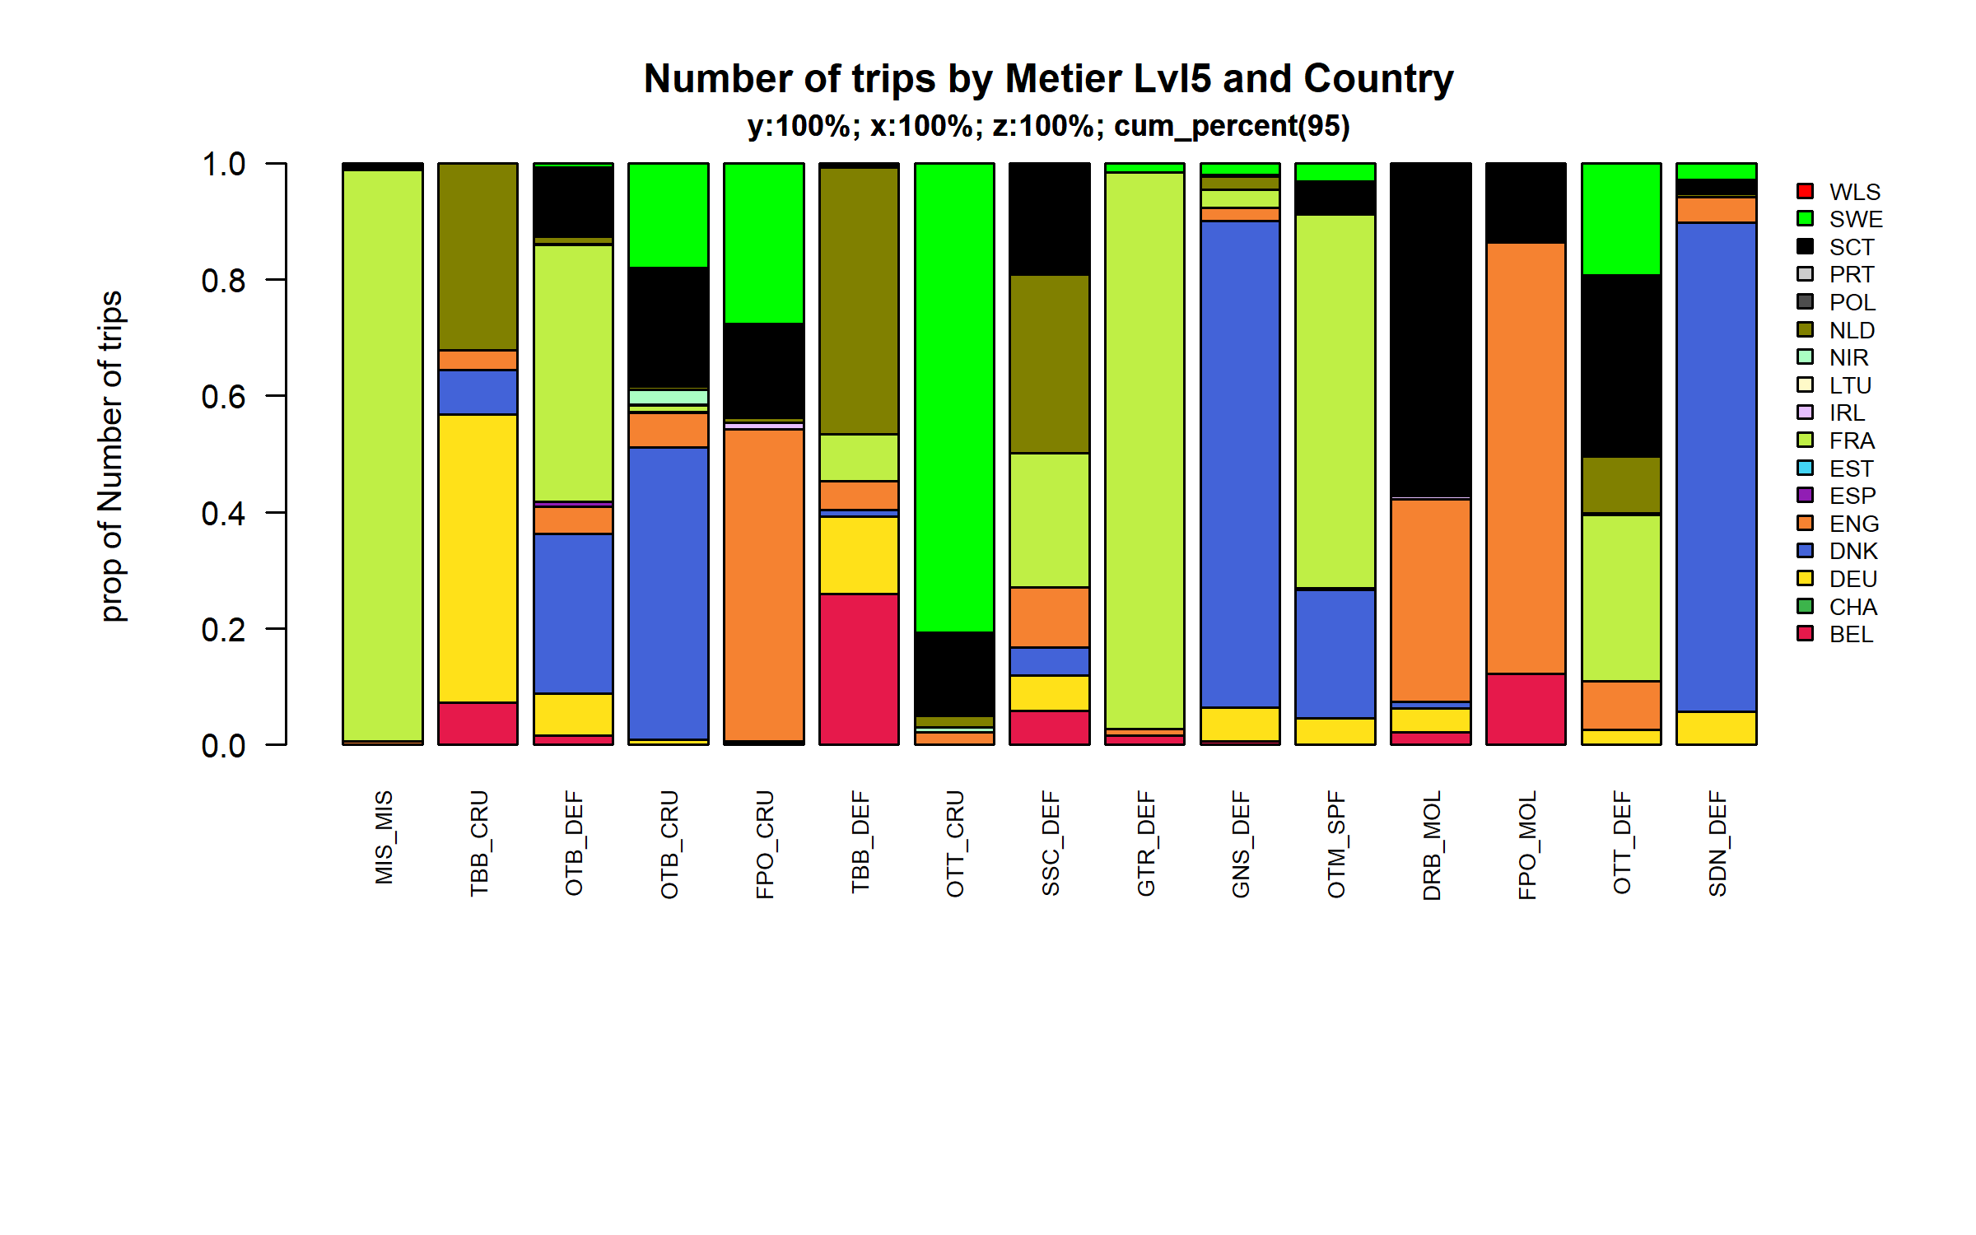 Figure 4.4.2.2. Number of trips by Metier Lvl5 and Country . Metier Lvl5 and Country displayed comprise 95 % of the total Number of trips .

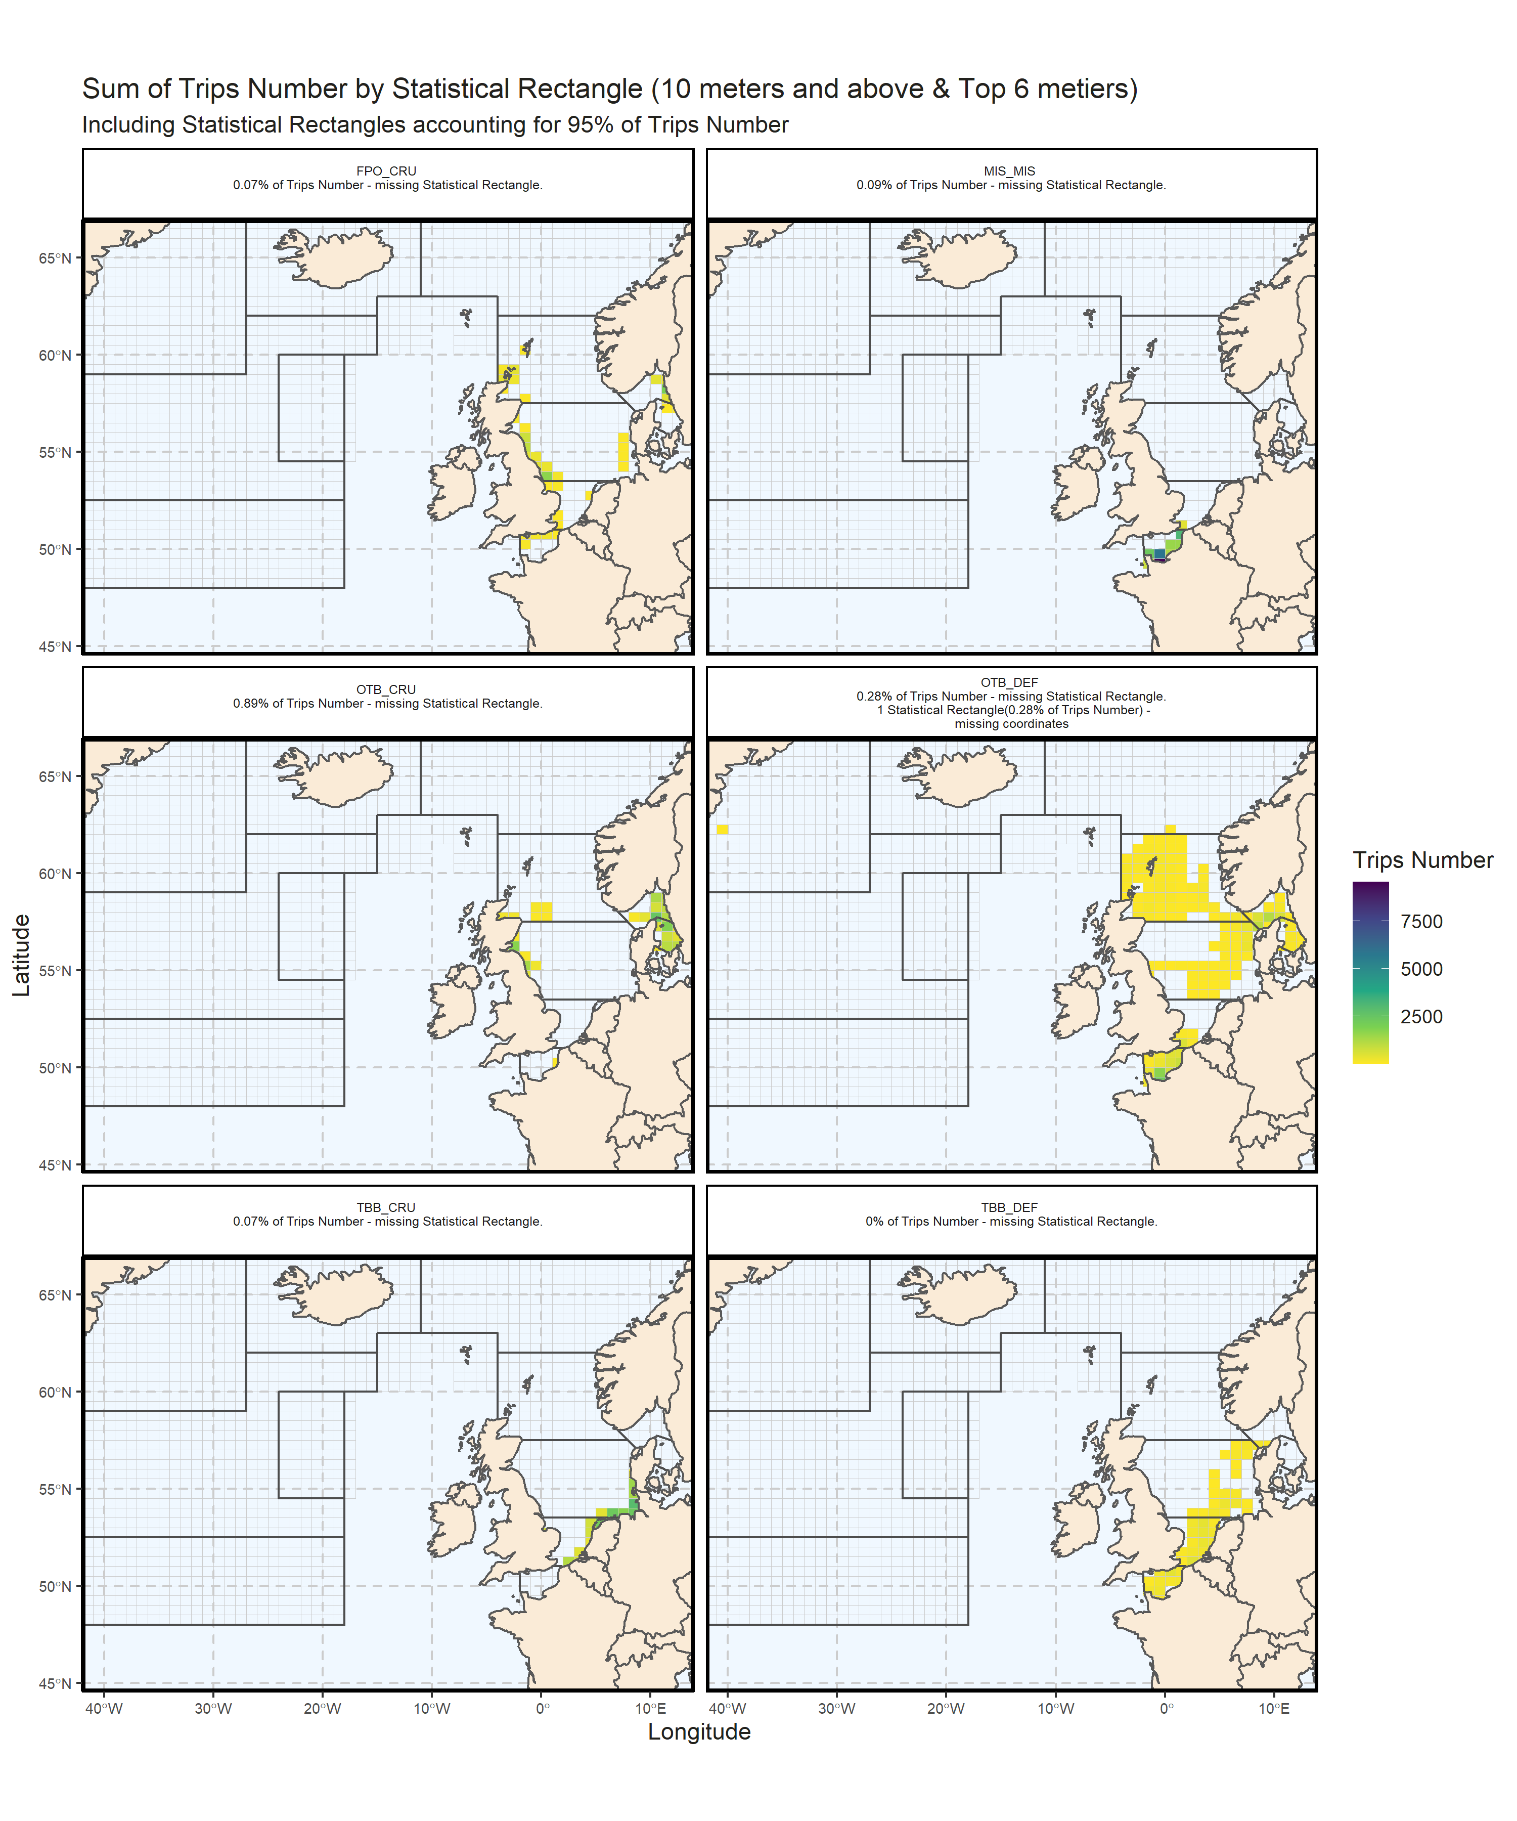 Figure 4.4.2.3. Sum of Trips Number by Statistical Rectangle (10 meters and above & Top 6 metiers) . Including Statistical Rectangles accounting for 95% of Trips Number .

## Effort by harbour

### Below 10 meters

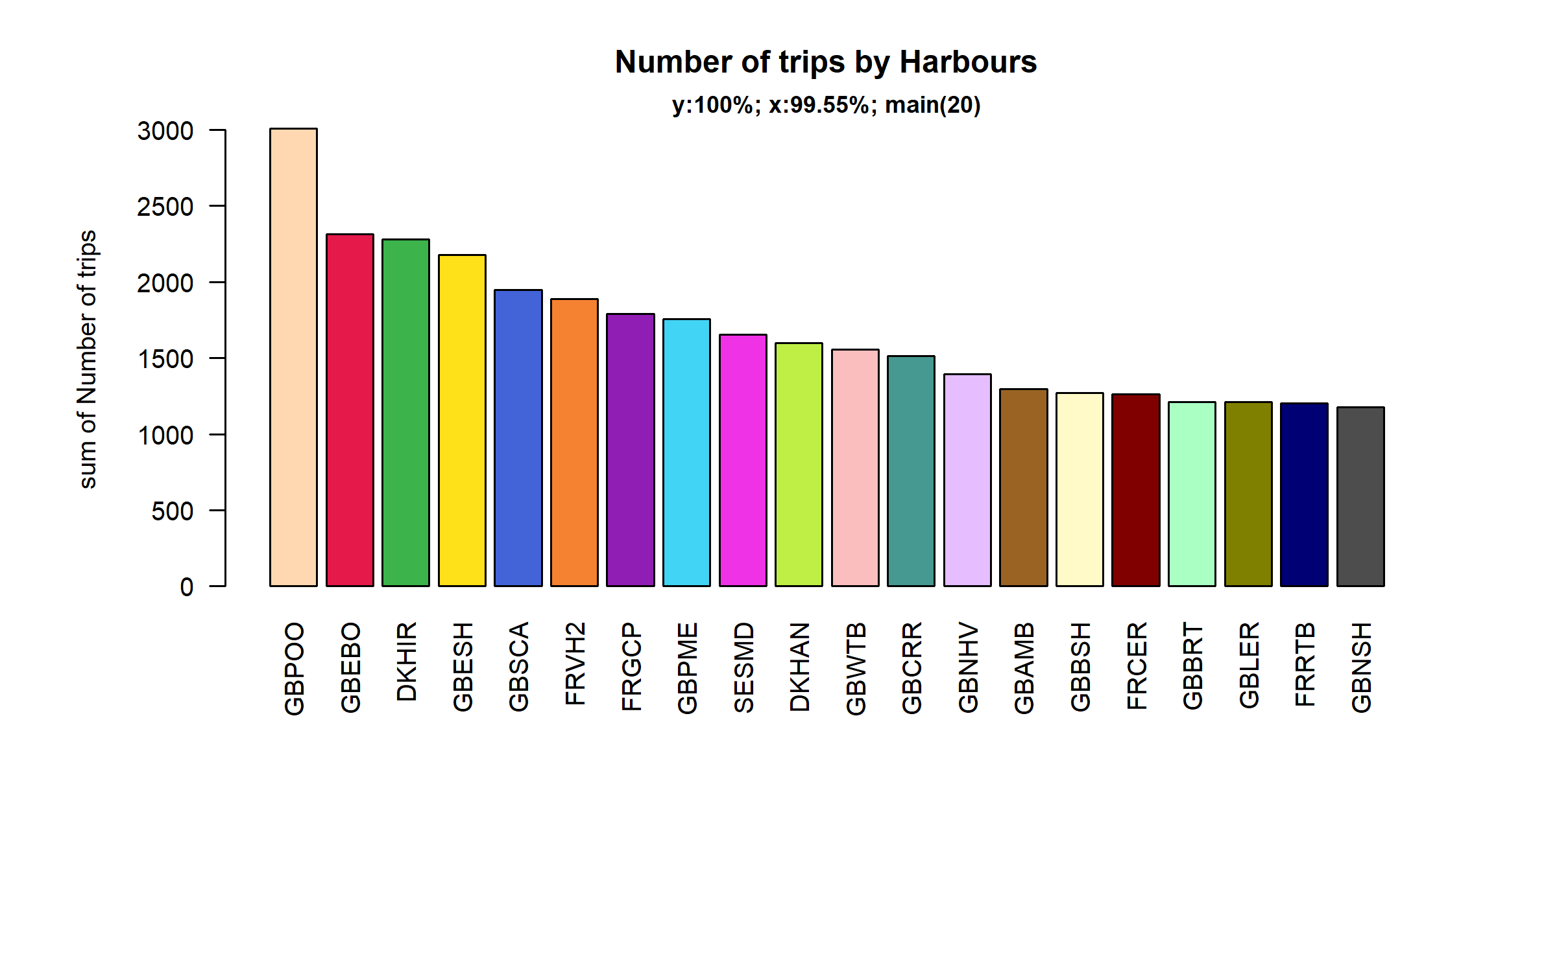 Figure 4.5.1.1. Number of trips in the 20 main Harbours ( 99.55% of rows entering analysis had known Harbours).

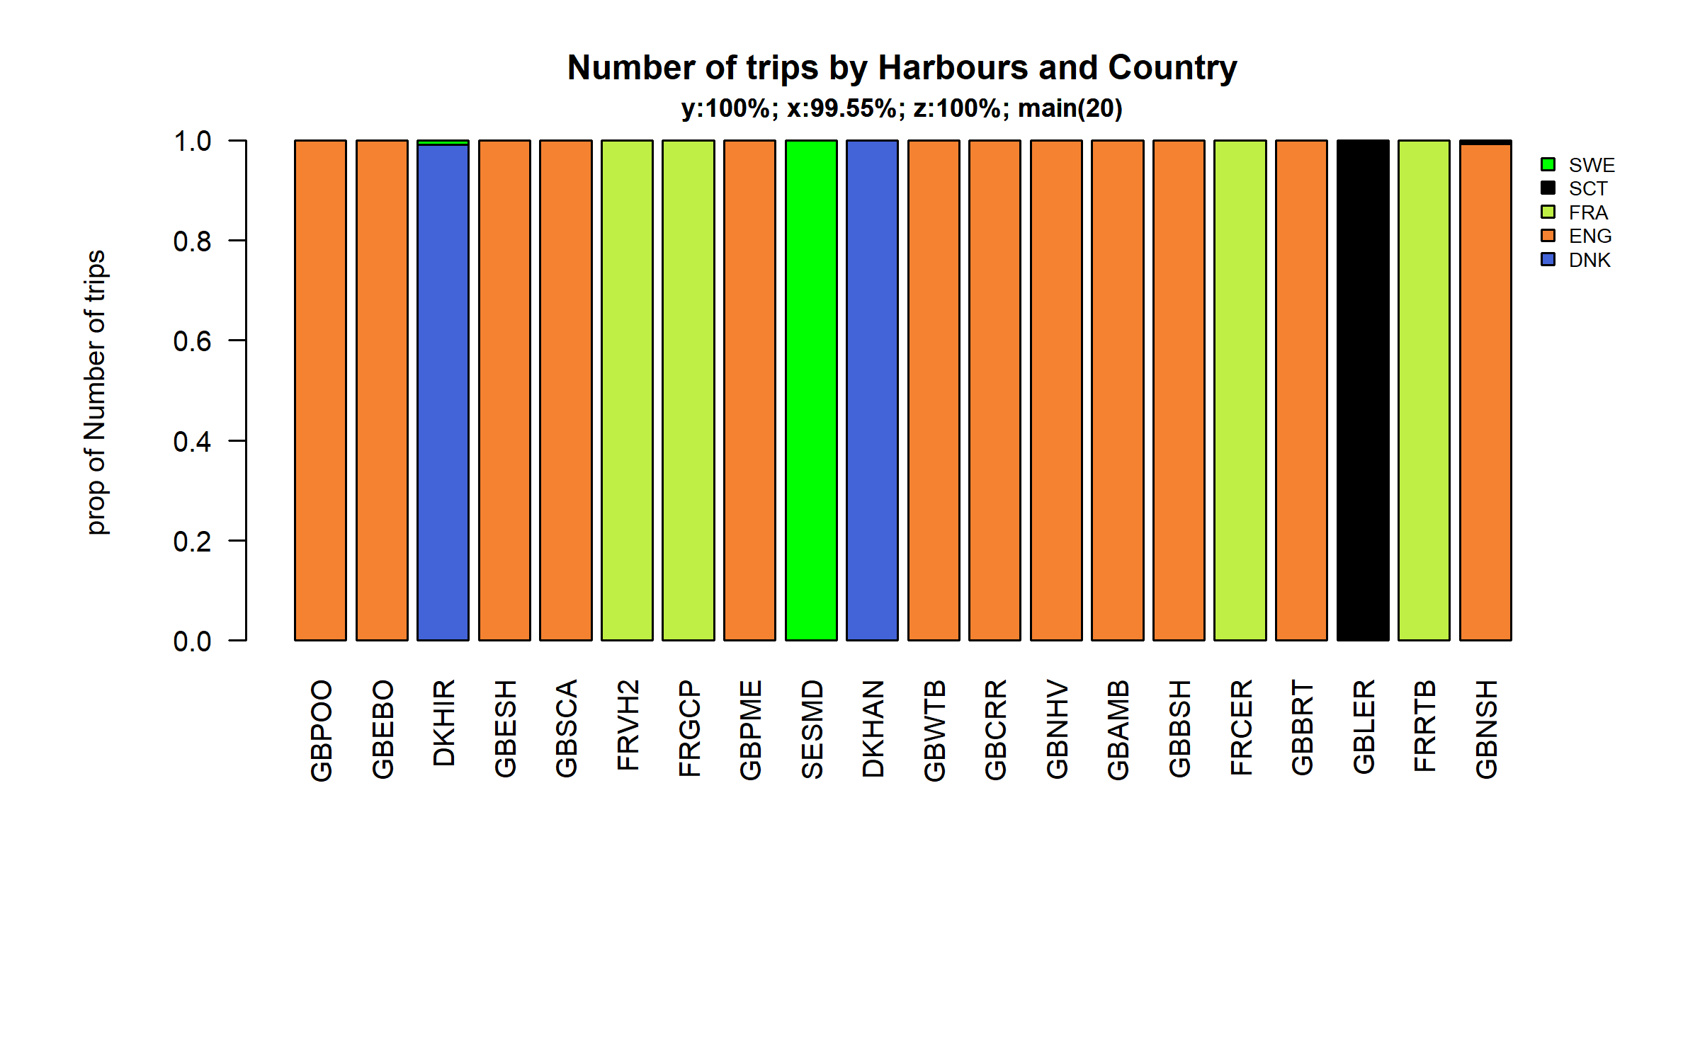 Figure 4.5.1.2. Number of trips in the 20 main Harbours ( 99.55 % of rows entering analysis had known Harbours ) and Country .

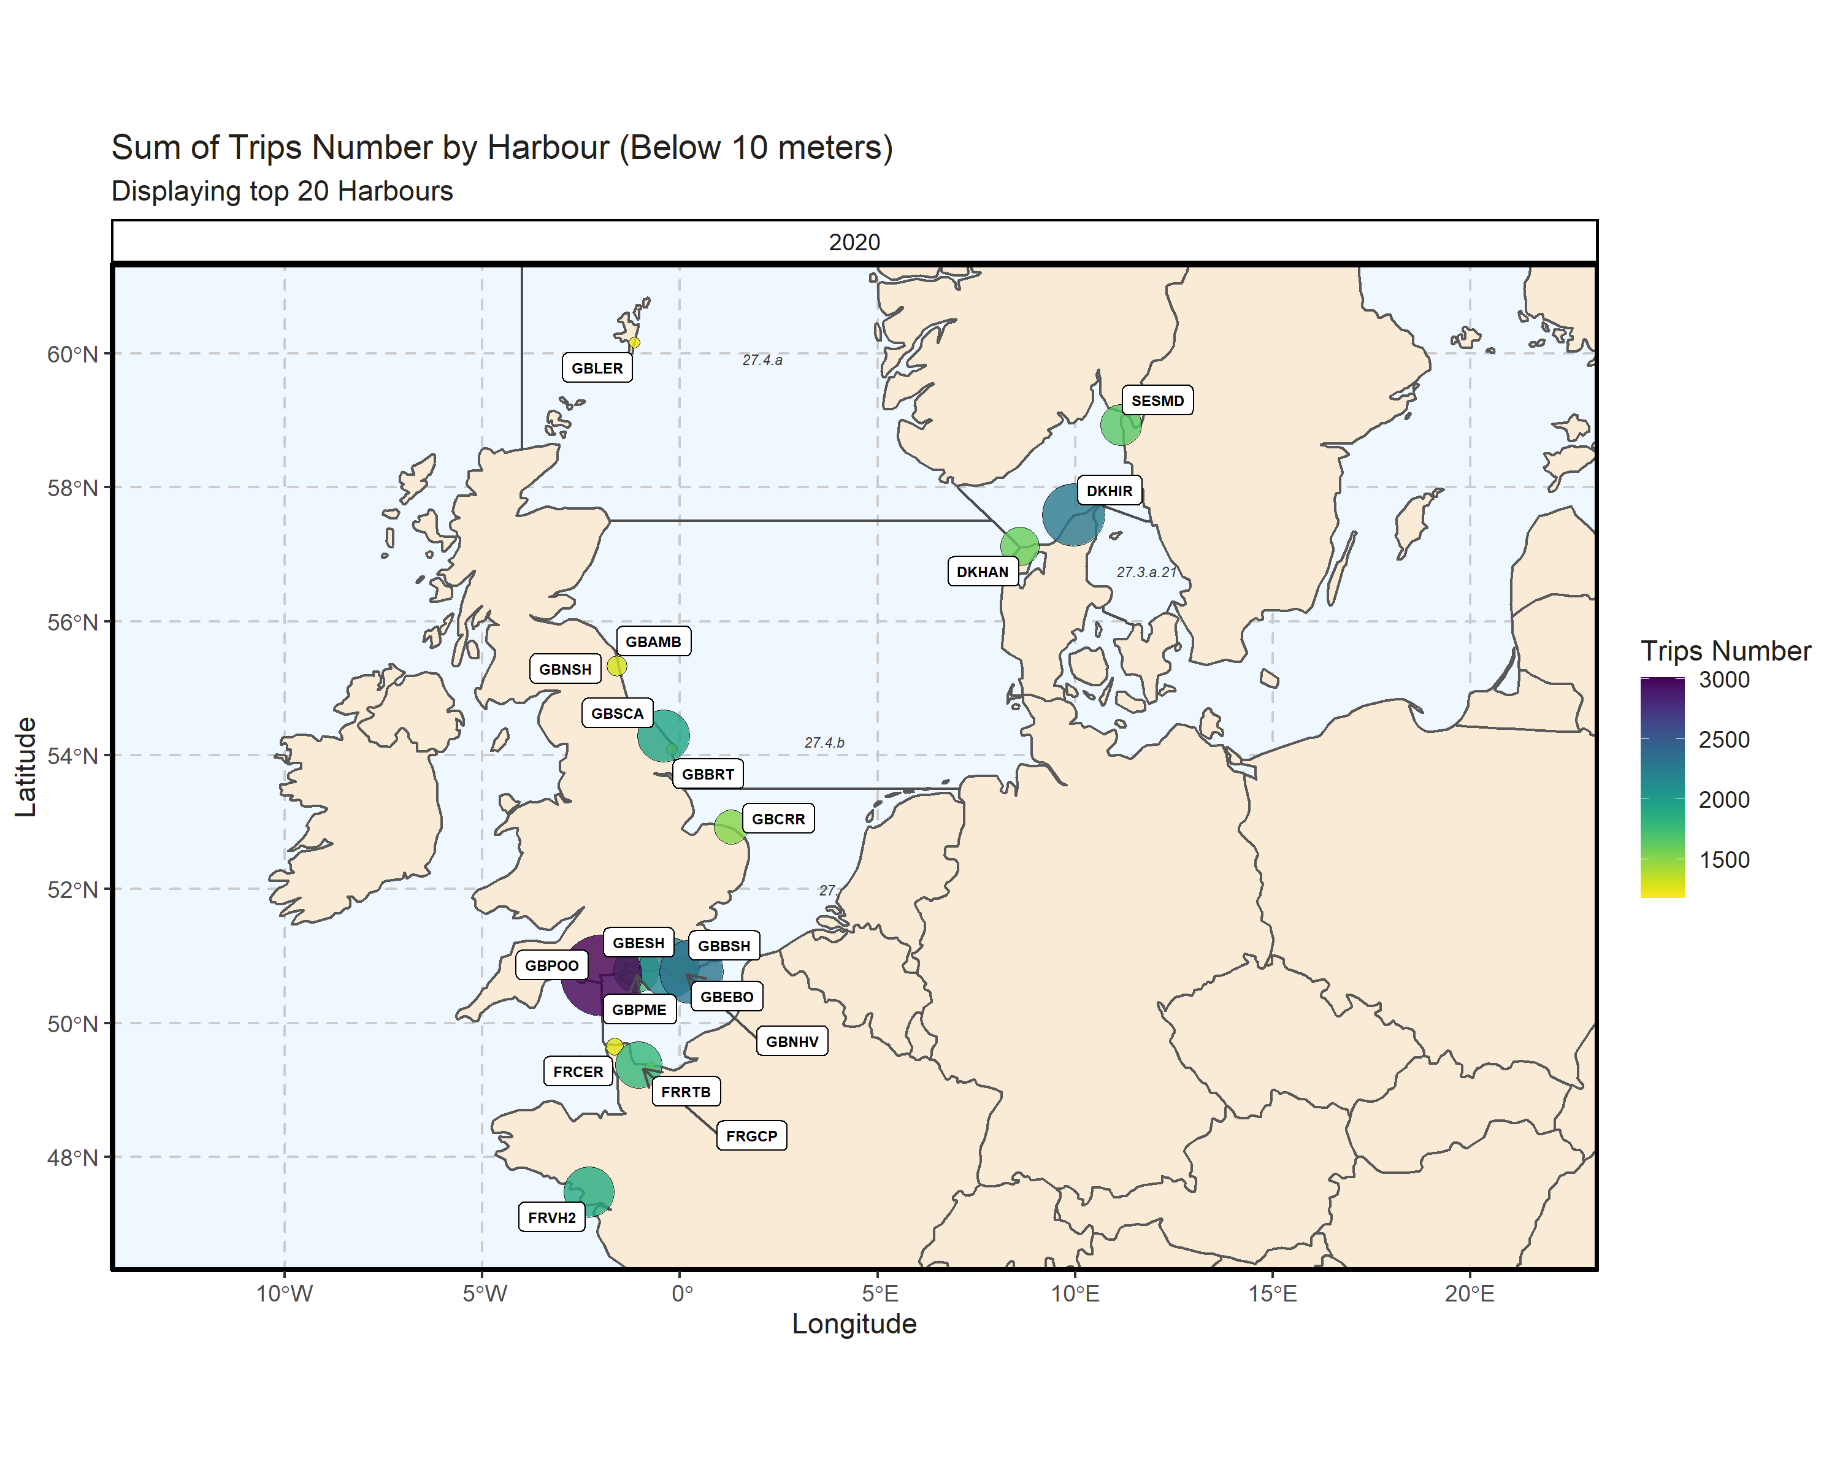 Figure 4.5.1.3. Sum of Trips Number by Harbour (Below 10 meters). Displaying top 20 Harbours. 0.21% of Trips Number - reported for missing Harbour 1 Harbour with missing coordinates (1.57% of TripsNumber) - not presented on the map.

### 10 meter and above

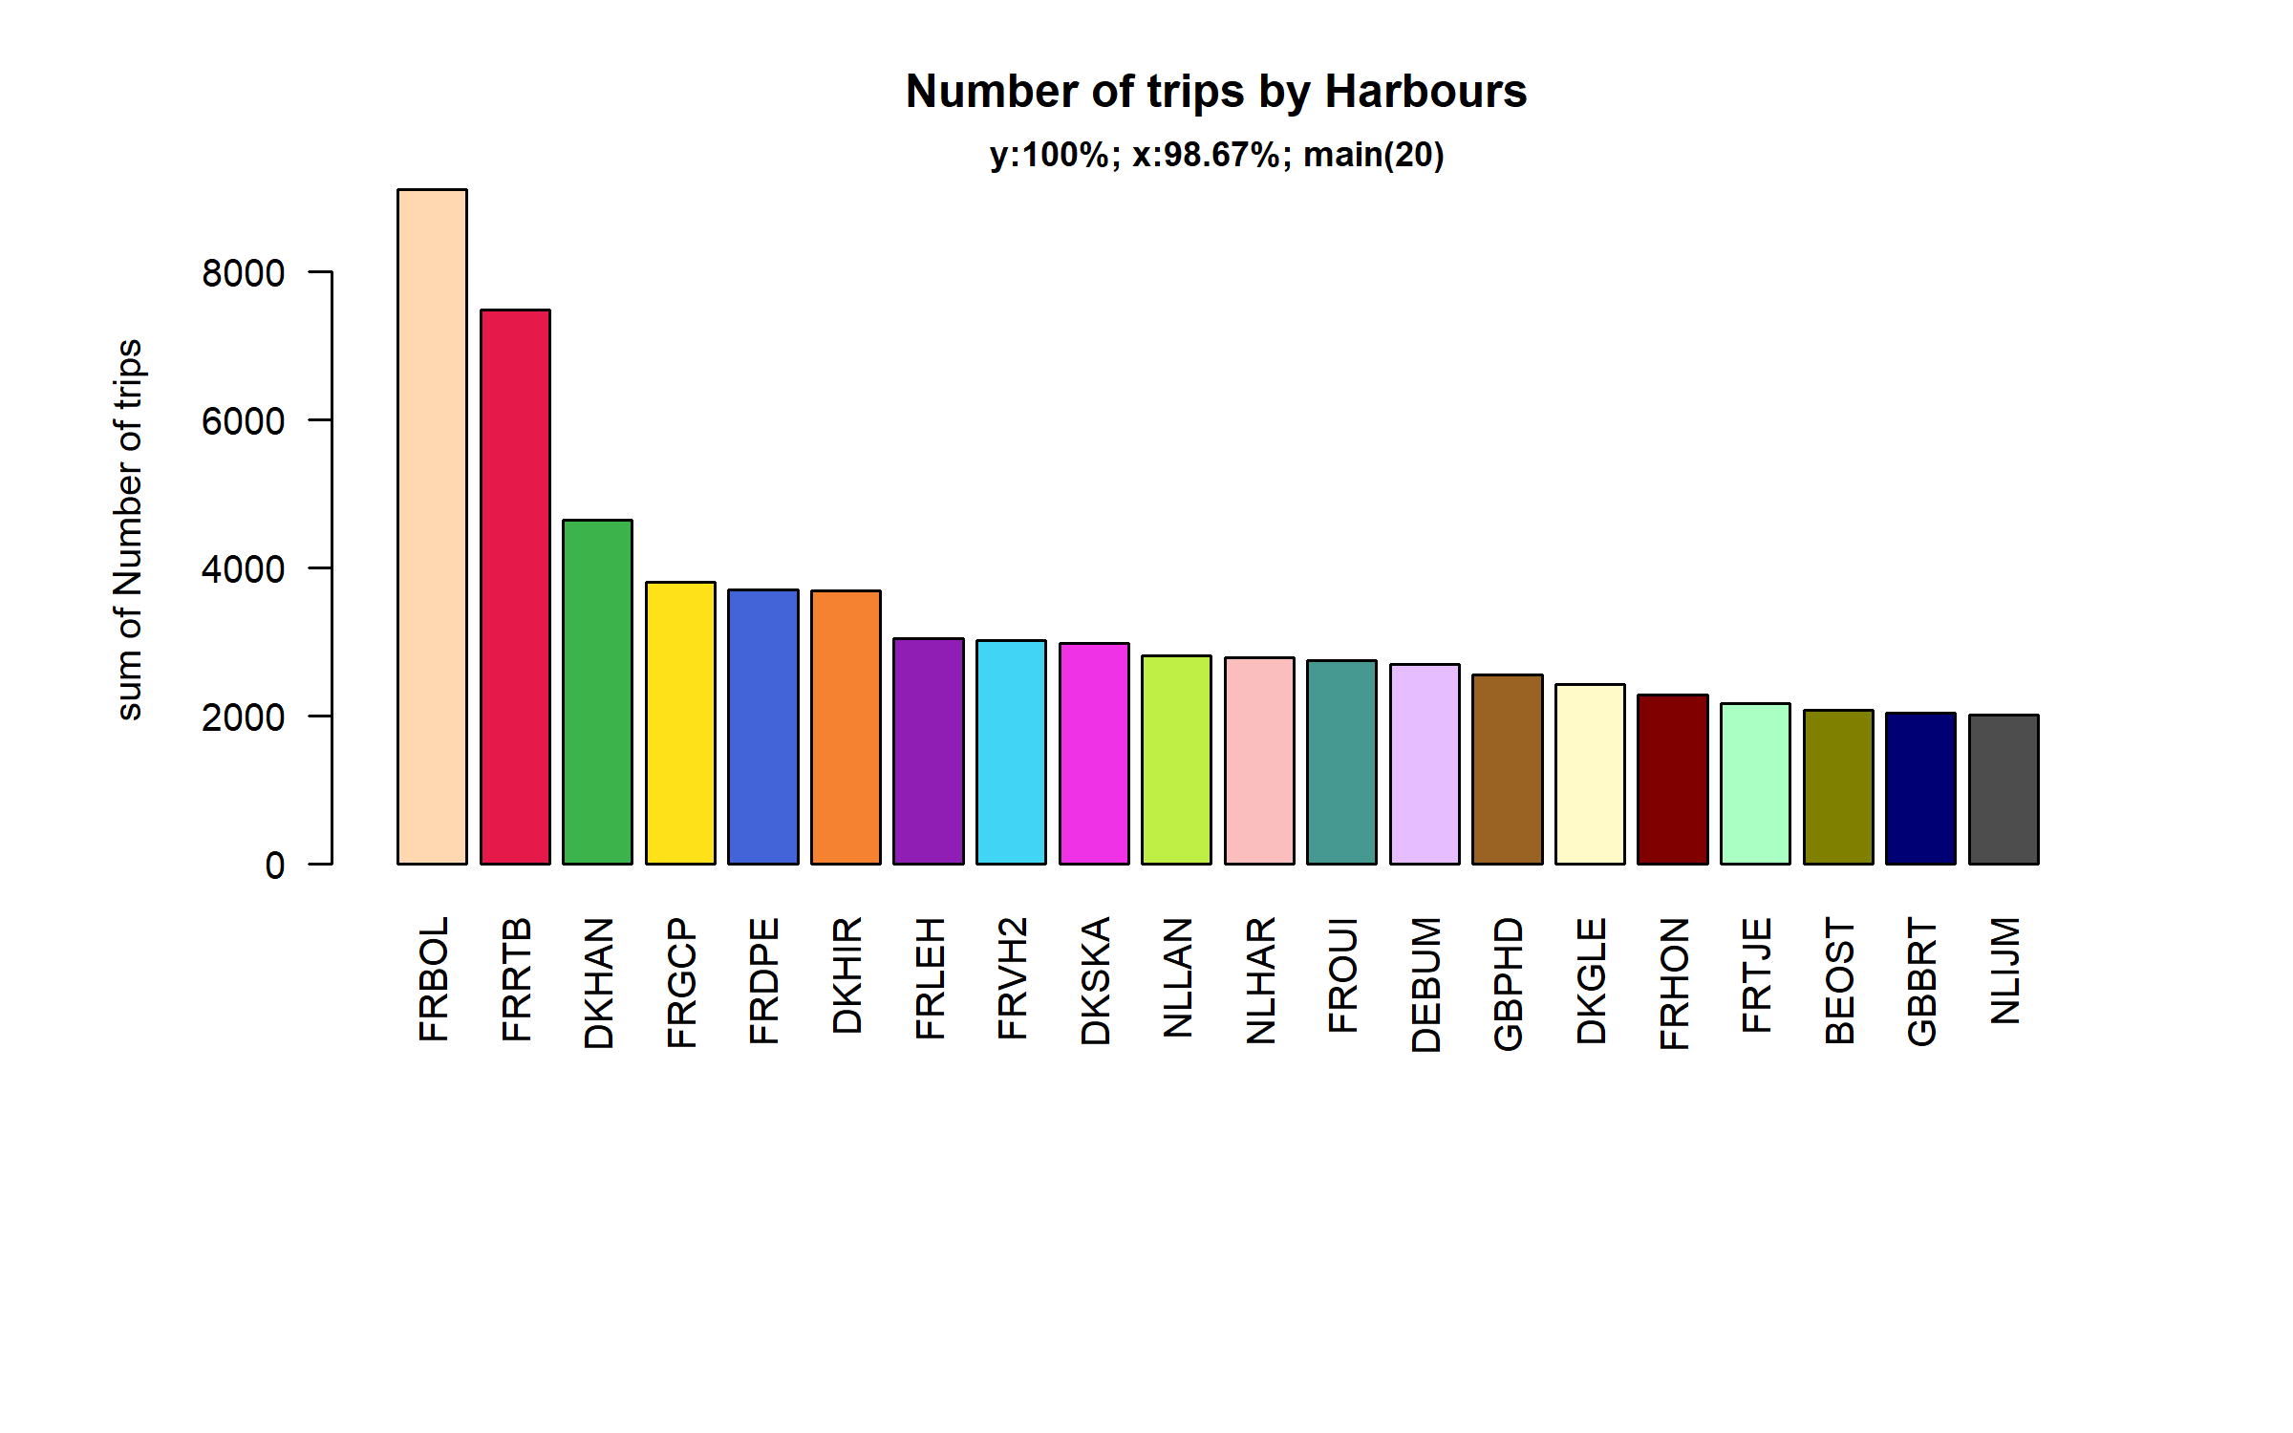 Figure 4.5.2.1. Number of trips in the 20 main Harbours ( 98.67% of rows entering analysis had known Harbours).

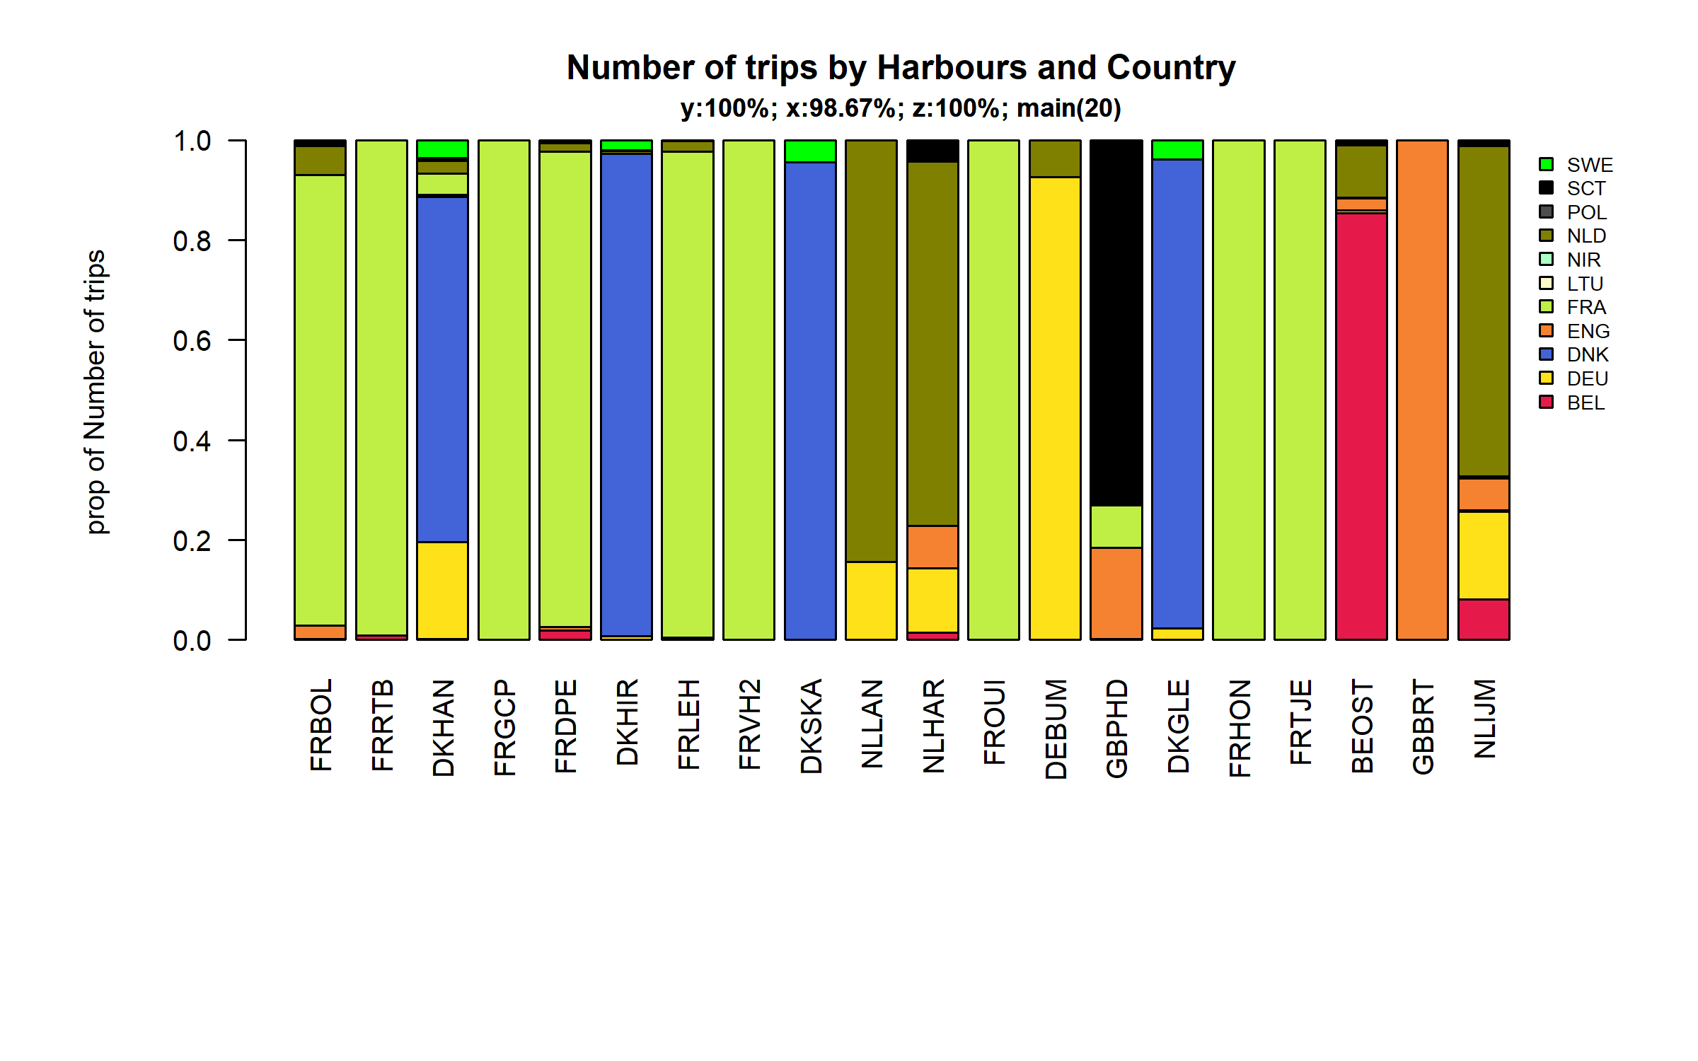 Figure 4.5.2.2. Number of trips in the 20 main Harbours ( 98.67 % of rows entering analysis had known Harbours ) and Country .

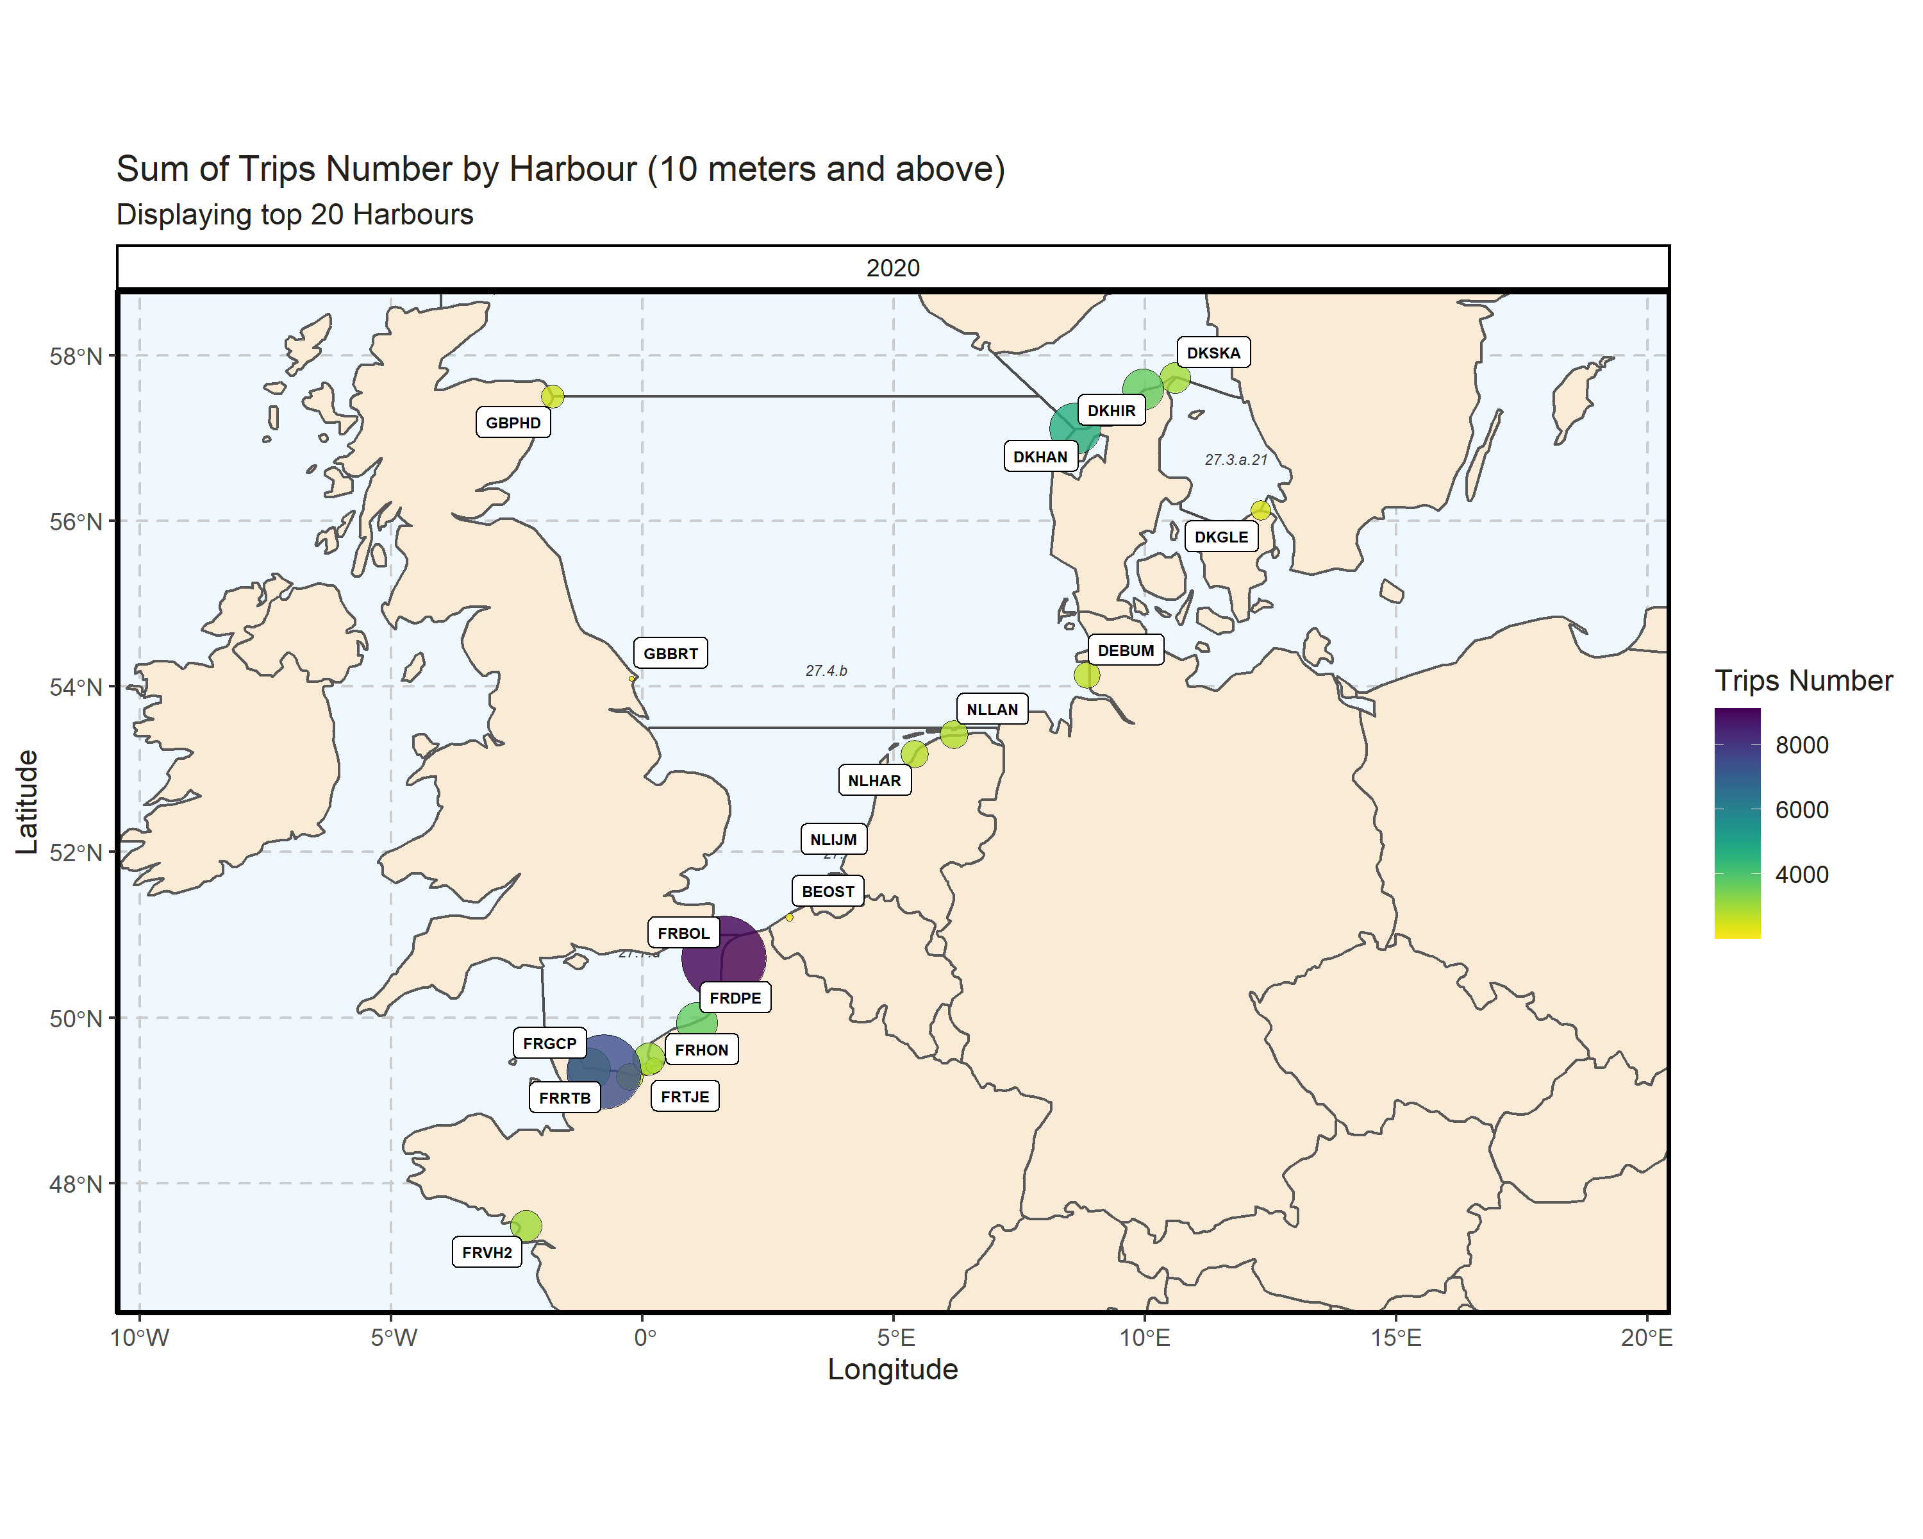 Figure 4.5.2.3. Sum of Trips Number by Harbour (10 meters and above). Displaying top 20 Harbours. 0.73% of Trips Number - reported for missing Harbour

## Spatial distribution of effort

### Below 10 meters

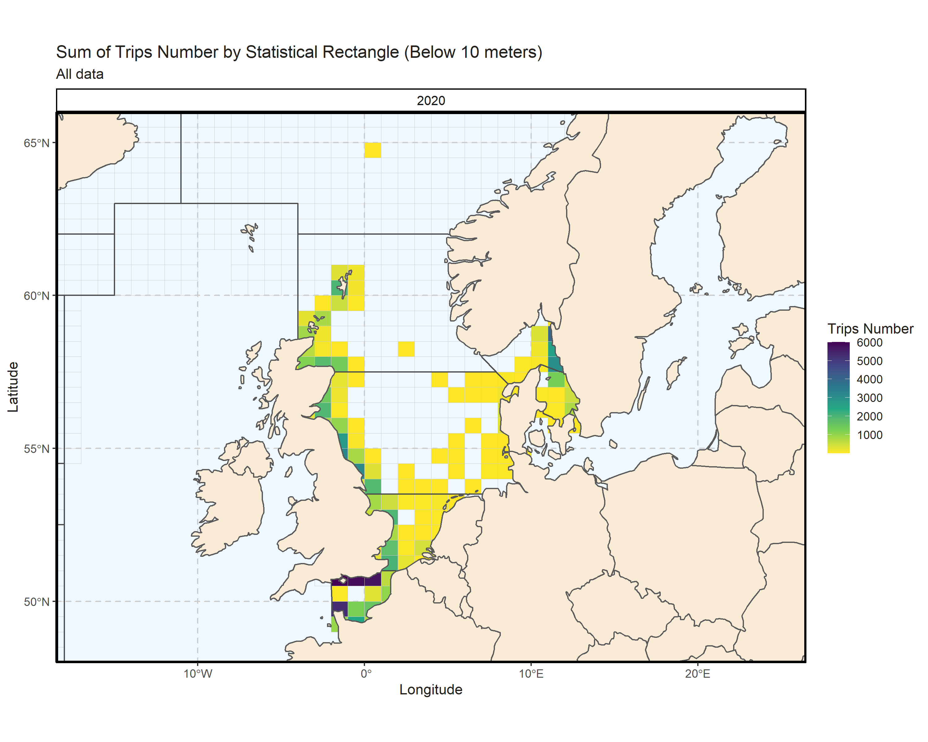 Figure 4.6.1.1. Sum of Trips Number by Statistical Rectangle (Below 10 meters). All data. 14.63% of Trips Number - reported for missing Statistical Rectangle.

### 10 meter and above

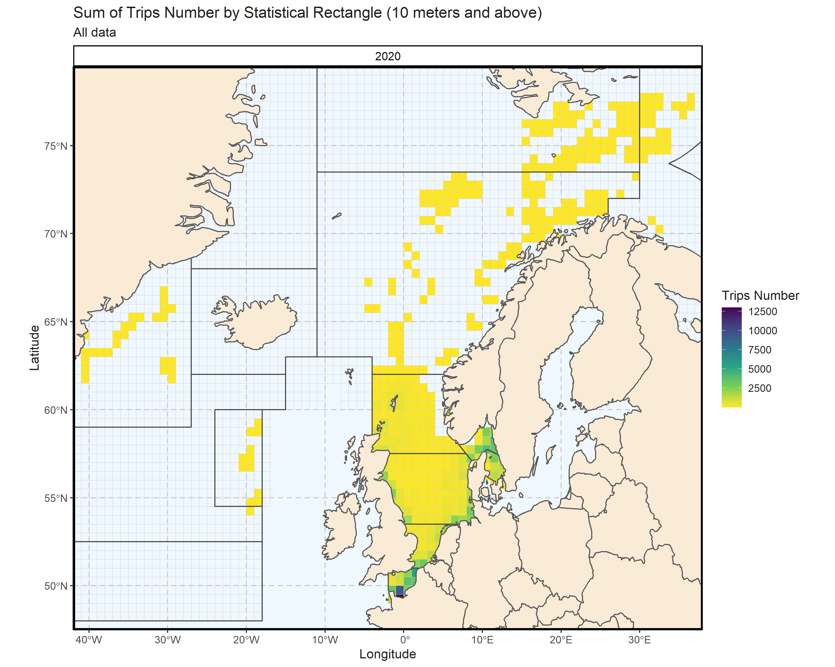 Figure 4.6.2.1. Sum of Trips Number by Statistical Rectangle (10 meters and above). All data. 0.26% of Trips Number - reported for missing Statistical Rectangle. 1 Statistical Rectangle with missing coordinates (0.2% of Trips Number) - not presented on the map.

###### Page break

#### Dates of data extraction

The data referring to the present year was collected under the RCG 2021 data call for the 2020 data for the Baltic Sea, North Sea, Eastern Arctic and the North Atlantic regions and downloaded from the system on the 24th of April 2021 with the exception of information detailed in section “2. Overall Fleet Evolution” which was extracted from the EU Fleet Register (<https://webgate.ec.europa.eu/fleet-europa/index_en>) on the 14th of April 2021.

#### Catch groups

| Region | Period | Species | Catch_group | tons |
| --- | --- | --- | --- | --- |
| NSEA | 2020 | Brachyura | crustaceans | 343 |
| NSEA | 2020 | Cancer pagurus | crustaceans | 15882 |
| NSEA | 2020 | Carcinus maenas | crustaceans | 106 |
| NSEA | 2020 | Chaceon affinis | crustaceans | 0 |
| NSEA | 2020 | Crangon crangon | crustaceans | 28319 |
| NSEA | 2020 | Crustacea | crustaceans | 9 |
| NSEA | 2020 | Eriocheir sinensis | crustaceans | 2 |
| NSEA | 2020 | Galatheidae | crustaceans | 0 |
| NSEA | 2020 | Homarus gammarus | crustaceans | 5269 |
| NSEA | 2020 | Liocarcinus depurator | crustaceans | 1 |
| NSEA | 2020 | Lithodes maja | crustaceans | 1 |
| NSEA | 2020 | Maja squinado | crustaceans | 348 |
| NSEA | 2020 | Necora puber | crustaceans | 1116 |
| NSEA | 2020 | Nephrops norvegicus | crustaceans | 12933 |
| NSEA | 2020 | Palaemon longirostris | crustaceans | 6 |
| NSEA | 2020 | Palaemon serratus | crustaceans | 182 |
| NSEA | 2020 | Palinurus | crustaceans | 0 |
| NSEA | 2020 | Palinurus elephas | crustaceans | 0 |
| NSEA | 2020 | Pandalus borealis | crustaceans | 22823 |
| NSEA | 2020 | Pandalus montagui | crustaceans | 1 |
| NSEA | 2020 | Pasiphaea tarda | crustaceans | 4 |
| NSEA | 2020 | Penaeus | crustaceans | 1 |
| NSEA | 2020 | Agonus cataphractus | demersal | 0 |
| NSEA | 2020 | Alepocephalus bairdii | demersal | 193 |
| NSEA | 2020 | Anarhichas | demersal | 1323 |
| NSEA | 2020 | Anarhichas denticulatus | demersal | 18 |
| NSEA | 2020 | Anarhichas lupus | demersal | 6166 |
| NSEA | 2020 | Anarhichas minor | demersal | 114 |
| NSEA | 2020 | Aphanopus carbo | demersal | 40 |
| NSEA | 2020 | Argentina | demersal | 309 |
| NSEA | 2020 | Argentina silus | demersal | 204 |
| NSEA | 2020 | Argentina sphyraena | demersal | 61 |
| NSEA | 2020 | Argyrosomus regius | demersal | 4 |
| NSEA | 2020 | Balistidae | demersal | 0 |
| NSEA | 2020 | Brosme brosme | demersal | 68 |
| NSEA | 2020 | Callionymus lyra | demersal | 0 |
| NSEA | 2020 | Caproidae | demersal | 22 |
| NSEA | 2020 | Centrolophus niger | demersal | 12 |
| NSEA | 2020 | Chelidonichthys cuculus | demersal | 615 |
| NSEA | 2020 | Chelidonichthys lucerna | demersal | 3096 |
| NSEA | 2020 | Chelon labrosus | demersal | 47 |
| NSEA | 2020 | Conger conger | demersal | 1588 |
| NSEA | 2020 | Coryphaenoides rupestris | demersal | 548 |
| NSEA | 2020 | Ctenolabrus rupestris | demersal | 1 |
| NSEA | 2020 | Cyclopterus lumpus | demersal | 246 |
| NSEA | 2020 | Dicentrarchus | demersal | 0 |
| NSEA | 2020 | Dicentrarchus labrax | demersal | 595 |
| NSEA | 2020 | Dicentrarchus punctatus | demersal | 0 |
| NSEA | 2020 | Diplodus | demersal | 0 |
| NSEA | 2020 | Echiichthys vipera | demersal | 7 |
| NSEA | 2020 | Enchelyopus cimbrius | demersal | 0 |
| NSEA | 2020 | Epigonus telescopus | demersal | 0 |
| NSEA | 2020 | Epinephelus marginatus | demersal | 0 |
| NSEA | 2020 | Eutrigla gurnardus | demersal | 3062 |
| NSEA | 2020 | Gadiculus argenteus | demersal | 16 |
| NSEA | 2020 | Gadiformes | demersal | 1 |
| NSEA | 2020 | Gadus morhua | demersal | 57947 |
| NSEA | 2020 | Gaidropsarus | demersal | 73 |
| NSEA | 2020 | Gaidropsarus ensis | demersal | 2 |
| NSEA | 2020 | Helicolenus dactylopterus | demersal | 3 |
| NSEA | 2020 | Labridae | demersal | 2 |
| NSEA | 2020 | Labrus bergylta | demersal | 61 |
| NSEA | 2020 | Labrus mixtus | demersal | 0 |
| NSEA | 2020 | Liza aurata | demersal | 3 |
| NSEA | 2020 | Liza ramada | demersal | 1 |
| NSEA | 2020 | Lophiidae | demersal | 12058 |
| NSEA | 2020 | Macrourus berglax | demersal | 107 |
| NSEA | 2020 | Melanogrammus aeglefinus | demersal | 23180 |
| NSEA | 2020 | Merlangius merlangus | demersal | 10977 |
| NSEA | 2020 | Merluccius bilinearis | demersal | 1565 |
| NSEA | 2020 | Merluccius merluccius | demersal | 15376 |
| NSEA | 2020 | Micromesistius poutassou | demersal | 14222 |
| NSEA | 2020 | Molva dypterygia | demersal | 123 |
| NSEA | 2020 | Molva macrophthalma | demersal | 0 |
| NSEA | 2020 | Molva molva | demersal | 7896 |
| NSEA | 2020 | Mora moro | demersal | 0 |
| NSEA | 2020 | Mugil | demersal | 9 |
| NSEA | 2020 | Mugil cephalus | demersal | 0 |
| NSEA | 2020 | Mugilidae | demersal | 63 |
| NSEA | 2020 | Mullus | demersal | 21 |
| NSEA | 2020 | Mullus barbatus | demersal | 2 |
| NSEA | 2020 | Mullus surmuletus | demersal | 3337 |
| NSEA | 2020 | Myoxocephalus scorpius | demersal | 0 |
| NSEA | 2020 | Ophidiidae | demersal | 0 |
| NSEA | 2020 | Pagellus bogaraveo | demersal | 1 |
| NSEA | 2020 | Pagellus erythrinus | demersal | 0 |
| NSEA | 2020 | Phycis blennoides | demersal | 74 |
| NSEA | 2020 | Phycis chesteri | demersal | 3 |
| NSEA | 2020 | Phycis phycis | demersal | 81 |
| NSEA | 2020 | Pollachius pollachius | demersal | 1044 |
| NSEA | 2020 | Pollachius virens | demersal | 31656 |
| NSEA | 2020 | Polyprion americanus | demersal | 0 |
| NSEA | 2020 | Scorpaena | demersal | 0 |
| NSEA | 2020 | Scorpaena scrofa | demersal | 0 |
| NSEA | 2020 | Sebastes | demersal | 7651 |
| NSEA | 2020 | Sebastes mentella | demersal | 6969 |
| NSEA | 2020 | Sebastes norvegicus | demersal | 684 |
| NSEA | 2020 | Sparidae | demersal | 366 |
| NSEA | 2020 | Sparus aurata | demersal | 10 |
| NSEA | 2020 | Spondyliosoma cantharus | demersal | 959 |
| NSEA | 2020 | Symphodus melops | demersal | 5 |
| NSEA | 2020 | Trachinus draco | demersal | 406 |
| NSEA | 2020 | Triglidae | demersal | 78 |
| NSEA | 2020 | Trisopterus luscus | demersal | 1455 |
| NSEA | 2020 | Trisopterus minutus | demersal | 7 |
| NSEA | 2020 | Urophycis tenuis | demersal | 167 |
| NSEA | 2020 | Zeus faber | demersal | 307 |
| NSEA | 2020 | Zoarces viviparus | demersal | 0 |
| NSEA | 2020 | Zoarcidae | demersal | 0 |
| NSEA | 2020 | Alosa | diadromous | 0 |
| NSEA | 2020 | Alosa alosa | diadromous | 0 |
| NSEA | 2020 | Alosa fallax | diadromous | 2 |
| NSEA | 2020 | Anguilla anguilla | diadromous | 31 |
| NSEA | 2020 | Coregonus lavaretus | diadromous | 34 |
| NSEA | 2020 | Gasterosteus | diadromous | 0 |
| NSEA | 2020 | Oncorhynchus mykiss | diadromous | 0 |
| NSEA | 2020 | Osmerus eperlanus | diadromous | 19 |
| NSEA | 2020 | Petromyzon marinus | diadromous | 1 |
| NSEA | 2020 | Salmo salar | diadromous | 0 |
| NSEA | 2020 | Salmo trutta | diadromous | 2 |
| NSEA | 2020 | Alopias vulpinus | elasmobranchs | 5 |
| NSEA | 2020 | Amblyraja radiata | elasmobranchs | 0 |
| NSEA | 2020 | Centroscyllium fabricii | elasmobranchs | 0 |
| NSEA | 2020 | Chimaera monstrosa | elasmobranchs | 2 |
| NSEA | 2020 | Dasyatis pastinaca | elasmobranchs | 0 |
| NSEA | 2020 | Dipturus batis | elasmobranchs | 9 |
| NSEA | 2020 | Galeorhinus galeus | elasmobranchs | 44 |
| NSEA | 2020 | Galeus melastomus | elasmobranchs | 0 |
| NSEA | 2020 | Hydrolagus affinis | elasmobranchs | 2 |
| NSEA | 2020 | Lamna nasus | elasmobranchs | 0 |
| NSEA | 2020 | Leucoraja circularis | elasmobranchs | 13 |
| NSEA | 2020 | Leucoraja naevus | elasmobranchs | 233 |
| NSEA | 2020 | Mustelus | elasmobranchs | 1070 |
| NSEA | 2020 | Mustelus asterias | elasmobranchs | 5 |
| NSEA | 2020 | Mustelus mustelus | elasmobranchs | 143 |
| NSEA | 2020 | Prionace glauca | elasmobranchs | 0 |
| NSEA | 2020 | Raja | elasmobranchs | 3840 |
| NSEA | 2020 | Raja asterias | elasmobranchs | 0 |
| NSEA | 2020 | Raja brachyura | elasmobranchs | 328 |
| NSEA | 2020 | Raja clavata | elasmobranchs | 2036 |
| NSEA | 2020 | Raja microocellata | elasmobranchs | 28 |
| NSEA | 2020 | Raja montagui | elasmobranchs | 371 |
| NSEA | 2020 | Raja undulata | elasmobranchs | 47 |
| NSEA | 2020 | Rajella lintea | elasmobranchs | 1 |
| NSEA | 2020 | Rajidae | elasmobranchs | 5 |
| NSEA | 2020 | Rajiformes | elasmobranchs | 1 |
| NSEA | 2020 | Rostroraja alba | elasmobranchs | 5 |
| NSEA | 2020 | Scyliorhinidae | elasmobranchs | 1 |
| NSEA | 2020 | Scyliorhinus | elasmobranchs | 86 |
| NSEA | 2020 | Scyliorhinus canicula | elasmobranchs | 2137 |
| NSEA | 2020 | Scyliorhinus stellaris | elasmobranchs | 265 |
| NSEA | 2020 | Selachii | elasmobranchs | 4 |
| NSEA | 2020 | Squalidae | elasmobranchs | 14 |
| NSEA | 2020 | Squalus acanthias | elasmobranchs | 28 |
| NSEA | 2020 | Squatina squatina | elasmobranchs | 0 |
| NSEA | 2020 | Arnoglossus laterna | flatfish | 0 |
| NSEA | 2020 | Bothidae | flatfish | 0 |
| NSEA | 2020 | Dicologlossa cuneata | flatfish | 0 |
| NSEA | 2020 | Glyptocephalus cynoglossus | flatfish | 2220 |
| NSEA | 2020 | Hippoglossoides platessoides | flatfish | 1887 |
| NSEA | 2020 | Hippoglossus hippoglossus | flatfish | 8290 |
| NSEA | 2020 | Lepidorhombus spp. | flatfish | 2958 |
| NSEA | 2020 | Limanda ferruginea | flatfish | 611 |
| NSEA | 2020 | Limanda limanda | flatfish | 5003 |
| NSEA | 2020 | Microchirus variegatus | flatfish | 48 |
| NSEA | 2020 | Microstomus kitt | flatfish | 4582 |
| NSEA | 2020 | Pegusa lascaris | flatfish | 51 |
| NSEA | 2020 | Platichthys flesus | flatfish | 1773 |
| NSEA | 2020 | Pleuronectes platessa | flatfish | 35794 |
| NSEA | 2020 | Pleuronectiformes | flatfish | 0 |
| NSEA | 2020 | Reinhardtius hippoglossoides | flatfish | 12679 |
| NSEA | 2020 | Scophthalmus maximus | flatfish | 4746 |
| NSEA | 2020 | Scophthalmus rhombus | flatfish | 3250 |
| NSEA | 2020 | Solea senegalensis | flatfish | 0 |
| NSEA | 2020 | Solea solea | flatfish | 9673 |
| NSEA | 2020 | Soleidae | flatfish | 0 |
| NSEA | 2020 | Zeugopterus punctatus | flatfish | 0 |
| NSEA | 2020 | Brama brama | large pelagic | 0 |
| NSEA | 2020 | Coryphaena hippurus | large pelagic | 0 |
| NSEA | 2020 | Istiophoridae | large pelagic | 0 |
| NSEA | 2020 | Makaira nigricans | large pelagic | 0 |
| NSEA | 2020 | Sarda sarda | large pelagic | 0 |
| NSEA | 2020 | Scomberomorus | large pelagic | 0 |
| NSEA | 2020 | Scombrinae Rafinesque | large pelagic | 0 |
| NSEA | 2020 | Sphyraena | large pelagic | 0 |
| NSEA | 2020 | Thunnus | large pelagic | 0 |
| NSEA | 2020 | Thunnus thynnus | large pelagic | 3 |
| NSEA | 2020 | Aequipecten opercularis | molluscs | 27 |
| NSEA | 2020 | Argopecten irradians | molluscs | 0 |
| NSEA | 2020 | Bivalvia | molluscs | 33 |
| NSEA | 2020 | Buccinum undatum | molluscs | 16086 |
| NSEA | 2020 | Cephalopoda | molluscs | 358 |
| NSEA | 2020 | Cerastoderma edule | molluscs | 9069 |
| NSEA | 2020 | Corbicula fluminea | molluscs | 283 |
| NSEA | 2020 | Crassostrea gigas | molluscs | 29 |
| NSEA | 2020 | Ensis ensis | molluscs | 5001 |
| NSEA | 2020 | Glycymeris glycymeris | molluscs | 2335 |
| NSEA | 2020 | Illex | molluscs | 294 |
| NSEA | 2020 | Illex illecebrosus | molluscs | 420 |
| NSEA | 2020 | Littorina | molluscs | 1 |
| NSEA | 2020 | Littorina littorea | molluscs | 0 |
| NSEA | 2020 | Loliginidae | molluscs | 1809 |
| NSEA | 2020 | Loligo | molluscs | 1747 |
| NSEA | 2020 | Loligo vulgaris | molluscs | 971 |
| NSEA | 2020 | Mercenaria mercenaria | molluscs | 20 |
| NSEA | 2020 | Mollusca | molluscs | 2 |
| NSEA | 2020 | Mytilus edulis | molluscs | 4010 |
| NSEA | 2020 | Octopodidae | molluscs | 85 |
| NSEA | 2020 | Octopus | molluscs | 6 |
| NSEA | 2020 | Octopus vulgaris | molluscs | 0 |
| NSEA | 2020 | Ostrea edulis | molluscs | 95 |
| NSEA | 2020 | Pecten maximus | molluscs | 33739 |
| NSEA | 2020 | Ruditapes decussatus | molluscs | 0 |
| NSEA | 2020 | Sepia officinalis | molluscs | 3284 |
| NSEA | 2020 | Sepia orbignyana | molluscs | 0 |
| NSEA | 2020 | Sepiidae | molluscs | 717 |
| NSEA | 2020 | Solen | molluscs | 73 |
| NSEA | 2020 | Spisula | molluscs | 0 |
| NSEA | 2020 | Spisula solida | molluscs | 7002 |
| NSEA | 2020 | Spisula solidissima | molluscs | 0 |
| NSEA | 2020 | Todarodes sagittatus | molluscs | 7 |
| NSEA | 2020 | Venus verrucosa | molluscs | 0 |
| NSEA | 2020 | Abramis brama | other | 0 |
| NSEA | 2020 | Actinopterygii | other | 16 |
| NSEA | 2020 | Asterias rubens | other | 0 |
| NSEA | 2020 | Aurelia aurita | other | 16 |
| NSEA | 2020 | Blicca bjoerkna | other | 0 |
| NSEA | 2020 | Cyprinus carpio | other | 0 |
| NSEA | 2020 | Echinoidea | other | 0 |
| NSEA | 2020 | Echinus esculentus | other | 0 |
| NSEA | 2020 | Esox lucius | other | 2 |
| NSEA | 2020 | Myxine glutinosa | other | 16 |
| NSEA | 2020 | Perca fluviatilis | other | 33 |
| NSEA | 2020 | Perciformes | other | 7 |
| NSEA | 2020 | Rutilus rutilus | other | 19 |
| NSEA | 2020 | Sander lucioperca | other | 2 |
| NSEA | 2020 | Scardinius erythrophthalmus | other | 1 |
| NSEA | 2020 | Scombridae | other | 5 |
| NSEA | 2020 | Tinca tinca | other | 0 |
| NSEA | 2020 | Ammodytes | small pelagic | 202612 |
| NSEA | 2020 | Belone belone | small pelagic | 67 |
| NSEA | 2020 | Clupea harengus | small pelagic | 325503 |
| NSEA | 2020 | Clupeidae | small pelagic | 1 |
| NSEA | 2020 | Engraulis encrasicolus | small pelagic | 78 |
| NSEA | 2020 | Sardina pilchardus | small pelagic | 853 |
| NSEA | 2020 | Scomber japonicus | small pelagic | 0 |
| NSEA | 2020 | Scomber scombrus | small pelagic | 211900 |
| NSEA | 2020 | Sprattus sprattus | small pelagic | 168183 |
| NSEA | 2020 | Trachurus spp. | small pelagic | 9335 |
| NSEA | 2020 | Trisopterus esmarkii | small pelagic | 65781 |

#### Mean Landings per stock, 2018-2020

Landings per year, stock, species, area and vessel flag country can be found in “landings_per_stock_2018_2020.csv” for 2018-2020.

Warning: This stock allocation represents variable stock from the RDB and does not represent the currently assessed stock units. The stock variable in the RDB is currently being updated.

| Region | Stock | BEL | CHA | DEU | DNK | ENG | ESP | EST | FRA | IRL | LTU | LVA | NIR | NLD | POL | PRT | SCT | SWE | WLS |
| --- | --- | --- | --- | --- | --- | --- | --- | --- | --- | --- | --- | --- | --- | --- | --- | --- | --- | --- | --- |
| NSEA | Alepocephalus bairdii-P | - | - | - | - | - | 253 | - | - | - | - | - | - | - | - | - | - | - | - |
| NSEA | Amblyraja radiata-P | - | - | 0 | - | 0 | - | - | - | - | - | - | - | - | 1 | - | - | - | - |
| NSEA | anp-78ab | - | - | - | - | - | - | - | - | - | - | - | - | 2 | - | - | - | - | - |
| NSEA | bli-comb | - | - | - | - | - | 16 | - | - | - | - | - | - | - | - | - | - | - | - |
| NSEA | bll-all | - | - | - | - | - | - | - | - | - | - | - | - | 21 | - | - | - | - | - |
| NSEA | Cancer pagurus-P | - | - | 0 | - | - | - | - | - | 0 | - | - | - | - | - | - | - | - | - |
| NSEA | cod-347d | 6 | - | 87 | 2942 | 69 | - | - | 20 | - | - | - | - | 5 | - | - | 6 | 420 | 0 |
| NSEA | cod-arct | - | - | 3020 | - | 1396 | 2412 | 892 | - | - | 447 | - | - | - | 1236 | 129 | - | - | - |
| NSEA | cod-iceg | - | - | 5 | - | - | - | - | - | - | - | - | - | - | - | - | - | - | - |
| NSEA | cod-kat | - | - | 0 | 86 | - | - | - | - | - | - | - | - | - | - | - | - | 22 | - |
| NSEA | Coregonus lavaretus-P | - | - | 0 | 39 | - | - | - | - | - | - | - | - | - | - | - | - | - | - |
| NSEA | Crangon crangon-P | - | - | 2 | - | - | - | - | 98 | - | - | - | - | - | - | - | - | - | - |
| NSEA | dab-7de | 47 | - | 0 | - | 168 | - | - | 155 | - | - | - | - | 88 | - | - | 93 | - | 0 |
| NSEA | eel-eur | 0 | - | - | - | 4 | - | - | 1 | - | - | - | - | 0 | - | - | 0 | - | - |
| NSEA | Esox lucius-P | - | - | 0 | 3 | - | - | - | - | - | - | - | - | 0 | - | - | - | - | - |
| NSEA | Gadus morhua-P | - | - | - | - | - | 32 | 386 | - | 0 | - | - | - | - | - | - | - | - | - |
| NSEA | ggu-7de | 1 | - | - | - | 2 | - | - | 5 | - | - | - | - | 1 | - | - | - | - | - |
| NSEA | ggu-kask | - | - | - | - | - | - | - | - | - | - | - | - | 16 | - | - | - | - | - |
| NSEA | ghl-arct | - | - | 12 | - | 681 | 18 | 580 | - | - | 257 | 11 | - | - | 73 | 0 | - | - | - |
| NSEA | Glyptocephalus cynoglossus-P | - | - | - | - | - | - | - | - | 0 | - | - | - | - | - | - | - | - | - |
| NSEA | had-34 | - | - | - | - | - | - | - | 0 | - | - | - | - | 2 | - | - | - | - | - |
| NSEA | had-7b-k | 1 | - | - | - | - | - | - | 5 | - | - | - | - | 0 | - | - | - | - | - |
| NSEA | had-arct | - | - | 23 | - | 418 | 15 | 1 | - | - | - | - | - | - | 11 | 2 | - | - | - |
| NSEA | her-47d3 | 66 | - | 9451 | 62 | 1914 | - | - | 9410 | - | - | - | - | 10141 | - | - | 254 | - | - |
| NSEA | her-mix(3a22-47d3) | 4 | - | 30240 | 109151 | 13196 | - | - | 16106 | 251 | 2011 | - | 14833 | 34993 | 22 | - | 62836 | 28510 | - |
| NSEA | hke-nrtn | - | - | - | - | - | - | - | 0 | - | - | - | - | 12 | - | - | - | - | - |
| NSEA | hom-nsea | - | - | 933 | 222 | - | - | - | 1042 | - | 418 | - | - | 627 | - | - | - | 0 | - |
| NSEA | hom-west | - | - | 2 | 12 | - | - | - | 5 | - | 0 | - | - | 18 | - | - | - | 0 | - |
| NSEA | Homarus gammarus-P | - | - | 0 | - | - | - | - | - | - | - | - | - | - | - | - | - | - | - |
| NSEA | Lepidopus caudatus-P | - | - | - | - | - | 4 | - | - | - | - | - | - | - | - | - | - | - | - |
| NSEA | Lepidorhombus whiffiagonis-P | - | - | 0 | - | - | - | - | 0 | - | - | - | - | 0 | - | - | - | - | - |
| NSEA | Leucoraja naevus-P | 1 | - | - | - | 1 | - | - | 2 | - | - | - | - | - | - | - | - | - | - |
| NSEA | Limanda limanda-P | - | - | - | - | - | - | - | - | - | - | - | - | 268 | - | - | - | - | - |
| NSEA | lin-comb | - | - | 0 | - | - | - | - | - | - | - | - | - | - | - | - | - | - | - |
| NSEA | Lophius piscatorius-P | - | - | - | - | - | - | - | - | - | - | - | - | 44 | - | - | - | - | - |
| NSEA | mac-nea | - | - | - | - | - | - | - | - | - | - | - | - | 0 | - | - | - | - | - |
| NSEA | Merlangius merlangus-P | - | - | 0 | - | - | - | - | - | - | - | - | - | - | - | - | - | - | - |
| NSEA | Merluccius merluccius-P | - | - | 0 | - | - | - | - | - | - | - | - | - | - | - | - | - | - | - |
| NSEA | Microstomus kitt-P | 50 | - | 0 | - | 149 | - | - | 24 | - | - | - | - | 5 | - | - | 21 | - | 0 |
| NSEA | Mullus barbatus-P | 0 | - | - | - | - | - | - | - | - | - | - | - | 0 | - | - | - | - | - |
| NSEA | nep-IIIaN | - | - | 0 | 2763 | - | - | - | - | - | - | - | - | - | - | - | - | 1198 | - |
| NSEA | nep-IIIaS | - | - | 13 | 2178 | - | - | - | - | - | - | - | - | - | - | - | - | 661 | - |
| NSEA | Nephrops norvegicus-P | - | - | - | - | - | - | - | - | 0 | - | - | - | - | - | - | - | - | - |
| NSEA | pan-barn | - | - | - | 774 | 455 | - | 8214 | - | - | 3942 | 443 | - | - | 651 | - | - | - | - |
| NSEA | pan-farn | - | - | - | 13 | - | - | - | - | - | - | - | - | - | - | - | - | 2 | - |
| NSEA | pan-flad | - | - | - | 215 | 0 | - | - | - | - | - | - | - | - | - | - | - | 101 | - |
| NSEA | Platichthys flesus-P | - | - | 0 | 152 | - | - | - | - | - | - | - | - | - | - | - | - | 3 | - |
| NSEA | ple-2123 | - | - | 2 | 358 | - | - | - | - | - | - | - | - | - | - | - | - | 33 | - |
| NSEA | ple-7d | 1302 | - | 0 | - | 300 | - | - | 1636 | - | - | - | 4 | 74 | - | - | 88 | - | - |
| NSEA | ple-nsea | - | - | 24 | 4676 | - | - | - | - | - | - | - | - | - | - | - | - | 60 | - |
| NSEA | Pleuronectes platessa-P | - | - | 0 | - | - | - | - | - | 0 | - | - | - | - | - | - | - | - | - |
| NSEA | Raja clavata-P | 95 | - | - | - | 198 | - | - | 1137 | 0 | - | - | - | 24 | - | - | - | - | - |
| NSEA | Raja montagui-P | 9 | - | - | - | 6 | - | - | 20 | - | - | - | - | 3 | - | - | 2 | - | 0 |
| NSEA | Reinhardtius hippoglossoides-P | - | - | - | - | - | 77 | - | - | - | - | - | - | - | - | - | - | - | - |
| NSEA | rng-comb | - | - | - | - | - | 664 | - | - | - | - | - | - | - | - | - | - | - | - |
| NSEA | Rostroraja alba-P | - | - | - | - | - | - | - | - | - | - | - | - | - | - | - | 0 | - | - |
| NSEA | sai-3a46 | - | - | - | - | - | - | - | 2 | - | - | - | - | 28 | - | - | - | - | - |
| NSEA | sai-arct | - | - | 100 | - | 177 | 3 | - | - | - | - | - | - | - | 1 | 1 | - | - | - |
| NSEA | Salmo salar-P | - | - | - | 0 | - | - | - | - | - | - | - | - | - | - | - | - | - | - |
| NSEA | Salmo trutta-P | - | - | - | 0 | - | - | - | - | - | - | - | - | - | - | - | - | 0 | - |
| NSEA | Sander lucioperca-P | 0 | - | 0 | 1 | - | - | - | - | - | - | - | - | - | - | - | - | - | - |
| NSEA | Sardina pilchardus-P | 1 | - | 89 | 1 | 1 | - | - | 798 | - | 13 | - | - | 13 | - | - | 0 | 0 | - |
| NSEA | sbs-all | 7 | - | - | - | 201 | - | - | 136 | - | - | - | - | 13 | - | - | - | - | - |
| NSEA | Sebastes-P | - | - | 0 | 0 | 0 | - | - | 1 | - | - | - | - | - | - | - | - | 0 | - |
| NSEA | smn-arct | - | - | 2 | - | - | 8 | - | - | - | - | - | - | - | 6 | - | - | - | - |
| NSEA | smr-arct | - | - | 27 | - | - | - | - | - | - | - | - | - | - | 4 | - | - | - | - |
| NSEA | sol-eche | 647 | 0 | 0 | - | 274 | - | - | 1008 | - | - | - | - | 0 | - | - | 41 | - | - |
| NSEA | sol-kask | - | - | - | - | - | - | - | - | - | - | - | - | 50 | - | - | - | - | - |
| NSEA | spr-ech | - | - | - | 135 | 1 | - | - | 1 | - | - | - | - | - | - | - | - | - | - |
| NSEA | tur-all | - | - | - | - | - | - | - | - | - | - | - | - | 48 | - | - | - | - | - |
| NSEA | usk-arct | - | - | 0 | - | - | - | - | - | - | - | - | - | - | - | - | - | - | - |
| NSEA | usk-oth | - | - | - | - | - | - | - | 0 | - | - | - | - | - | - | - | - | - | - |
| NSEA | wfl-kask | - | - | - | - | - | - | - | - | - | - | - | - | 1 | - | - | - | - | - |
| NSEA | whg-47d | 109 | - | 0 | - | 41 | - | - | 1999 | - | - | - | - | 418 | - | - | 21 | - | 0 |
| NSEA | whg-kask | - | - | - | - | - | - | - | 0 | - | - | - | - | 0 | - | - | - | - | - |
| NSEA | NA | 11994 | 11 | 84429 | 422196 | 121743 | 28667 | 6553 | 78741 | 18765 | 3985 | 401 | 10672 | 71811 | 5965 | 4486 | 157204 | 34559 | 119 |